Methodology for the estimation of the population-weighted density according to the size of buildings in each census blocks

The Italian Census blocks (derived by the National Statistical Office - ISTAT) include areas smaller close to the urban centres and other larger located in the peri-urban and rural area.

Figure 1. Census blocks of Varese city (on the left). Census blocks close to Campo dei fiori park (on the right).
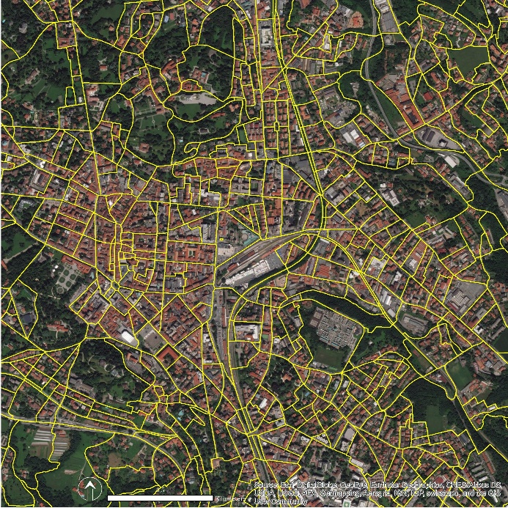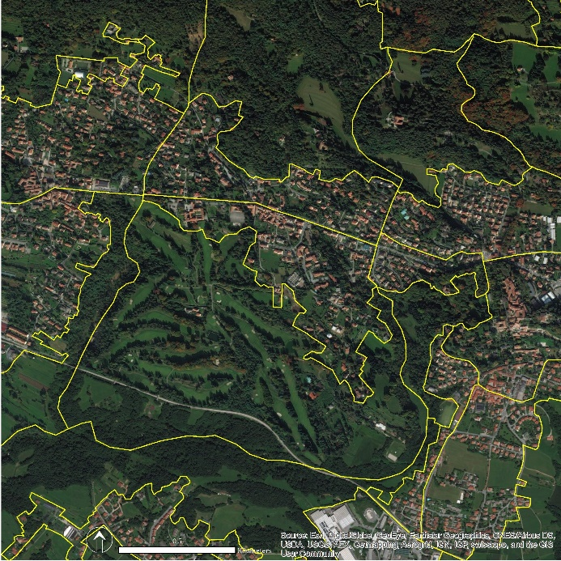
Differently from the urban census blocks, the larger blocks include natural and rural areas with low dense and discontinuous urban fabric. Therefore, in the larger blocks are included area populated and other empty dominated by non-anthropic use (natural, semi-natural or agricultural).
The population data provided by census blocks are distributed on the particle extension assigning a population value also in the area without residential urban fabrics.
Considering that, the population density was estimated starting from buildings data available from the Local Topographic database (DBT) to overpass the problem of census block dimensions confering a population data to each building included in the Area of Interest (AOI).

Figure 2. Buildings of Varese city (on the left) and close to Campo dei fiori park (on the right).
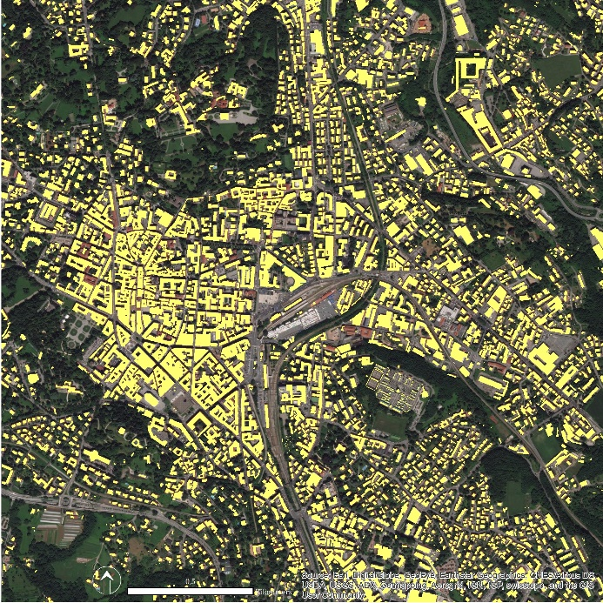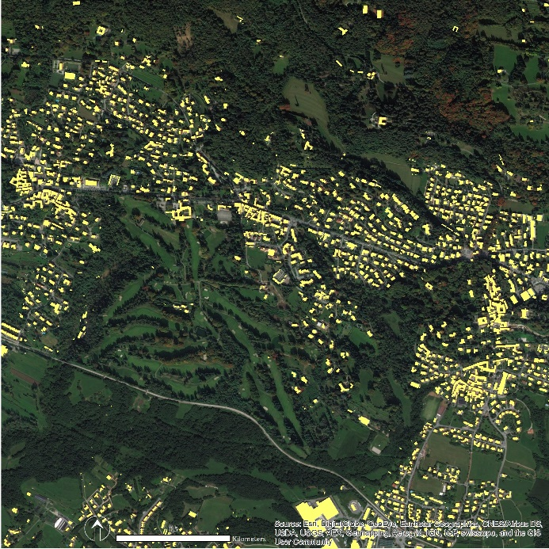
The estimation was conducted using the information included in the attribute table of the Buildings shapefile (as a DBT layer), that is:
- The principal use of buildings (residential, commercial, tertiary, industrial, services). For the population density estimation are selected only buildings for residential use;
- Area of the base of the building (hectares);
- The height of buildings (meters).

From the ratio between Area and Heights was calculate the Volume of each building and the total floor using as a standard height of 2.70 meters as required by the Italian Ministerial Decree 5/07/1975 for housing eligibility. As mentioned in the Regional Law 1/2001 focused on the theoretical estimation of population capacity, the Volume of buildings was related to 150 mc as a standard volume required for each person. The results allow having a more precise distribution of inhabitant on the building size (Figure 3).

Figure 3. The distribution of the population density based on the size of buildings in each census blocks
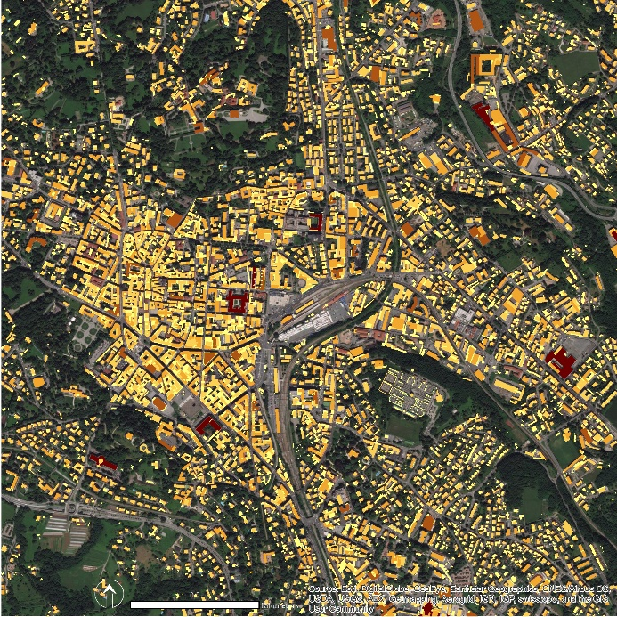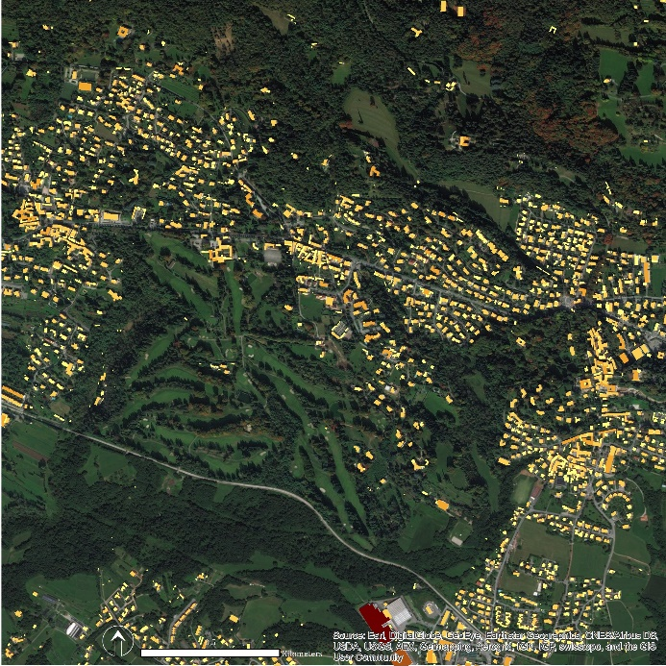
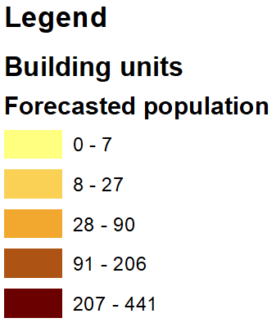

www.istat.it

