Supplementary Material 1

Worldwide distribution and phylogeography of the agave weevil Scyphophorus acupunctatus (Coleoptera: Dryophthoridae): the rise of an overlooked invasion

Andrea Viviano, Arturo Cocco, Paolo Colangelo, Giuseppe Marco Delitala, Roberto Antonio Pantaleoni, Laura Loru

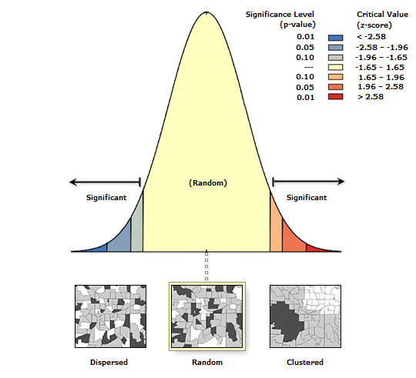
Figure S1. Global Moran’s I analysis results, Moran ‘s Index = 0.03, z-score = 0.18, P-value = 0.86. Given the Z-score of 0.18, the pattern is not significantly different from random.

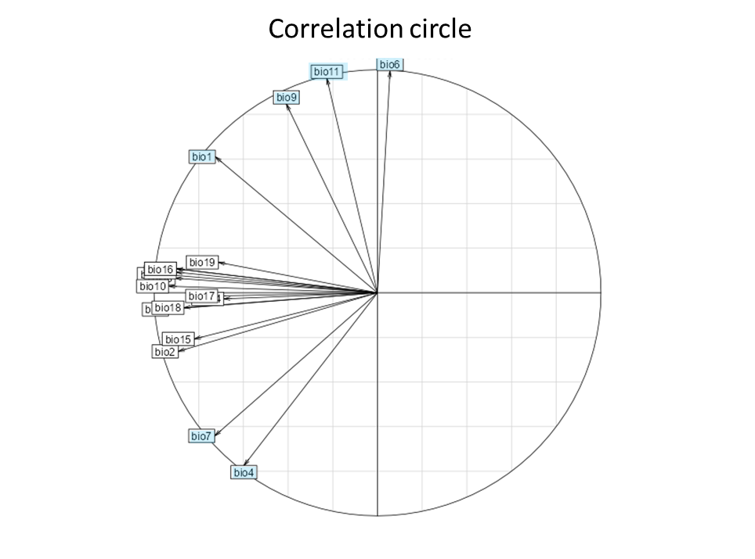
Figure S2. Results of the Principal Component Analysis (PCA) to obtain correlation structure among climatic variable layers. Represented variables: bio_1, mean annual air temperature; bio_2, mean diurnal air temperature range, bio_3, isothermality; bio_4, temperature seasonality; bio_5, mean daily maximum air temperature of the warmest month; bio_6, mean daily minimum air temperature of the coldest month; bio_7, annual range of air temperature; bio_8, mean daily mean air temperatures of the wettest quarter; bio_9, mean daily mean air temperatures of the driest quarter; bio_10, mean daily mean air temperatures of the warmest quarter; bio_11, mean daily mean air temperatures of the coldest quarter; bio_12, annual precipitation amount; bio_13, precipitation amount of the wettest month; bio_14, precipitation amount of the driest month; bio_15, precipitation seasonality; bio_16, mean monthly precipitation amount of the wettest quarter; bio_17, mean monthly precipitation amount of the driest quarter; bio_18, mean monthly precipitation amount of the warmest quarter; bio_19, mean monthly precipitation amount of the coldest quarter. Correlation circle of the 19 climatic variables obtained from Worldclim. The selected variables are highlighted in light blue.

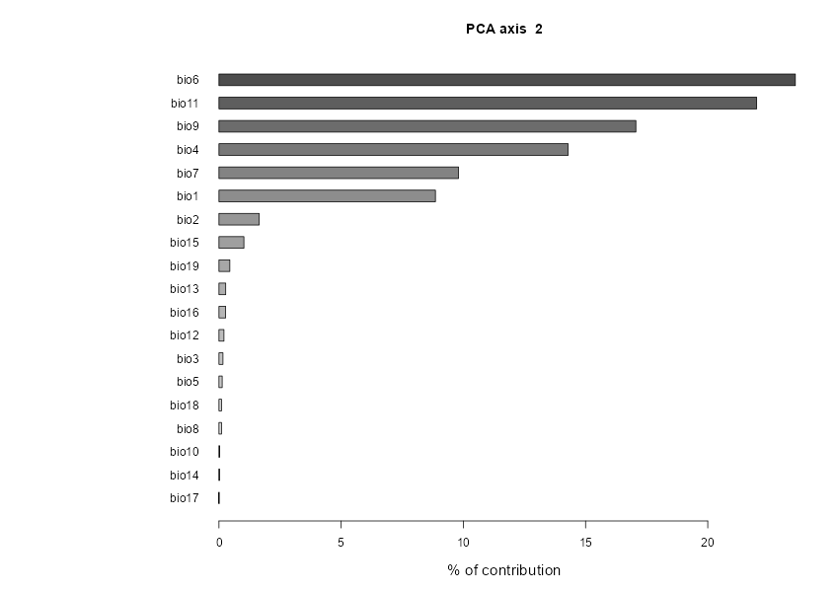
Figure S3. Contribution percentage of each variable.

Table S1. Relative importance of each variable in each model. Higher red values suggest a stronger influence of the variable on the model predictions.
 | RF | GAM | MAXENT.Phillips | GLM
bio_6 | 0.06 | 0.39 | 0.21 | 0.62
bio_9 | 0.08 | 0.19 | 0.17 | 0.13
bio_11 | 0.27 | 1.00 | 0.60 | 0.91
bio_4 | 0.09 | 0.64 | 0.33 | 0.71
bio_7 | 0.11 | 0.41 | 0.23 | 0.61
bio_1 | 0.22 | 0.75 | 0.47 | 0.77

Table S2. VIF values of the selected variables for values <3 with no multicollinearity issues. Decimal rounded numbers (correlation threshold =0.7).

Variable | VIF values
Bio 6 | 1.77
Bio 7 | 2.24
Bio 1 | 2.39
Bio 4 | 2.80
Bio 11 | 2.62
Bio 9 | 1.19

Table S3. Performance of different modelling methods in evaluating three indicators, namely AUC, COR, and TSS.
methods | AUC | COR | TSS
glm | 0.95 | 0.67 | 0.78
brt | 0.60 | 0.43 | 0.58
rf | 0.99 | 0.90 | 0.90
maxent | 0.93 | 0.61 | 0.77
FDA | 0.57 | 0.41 | 0.63
GBM | 0.27 | 0.43 | 0.61
MARS | 0.55 | 0.21 | 0.37
bioclim | 0.75 | 0.40 | 0.49
GAM | 0.96 | 0.84 | 0.79

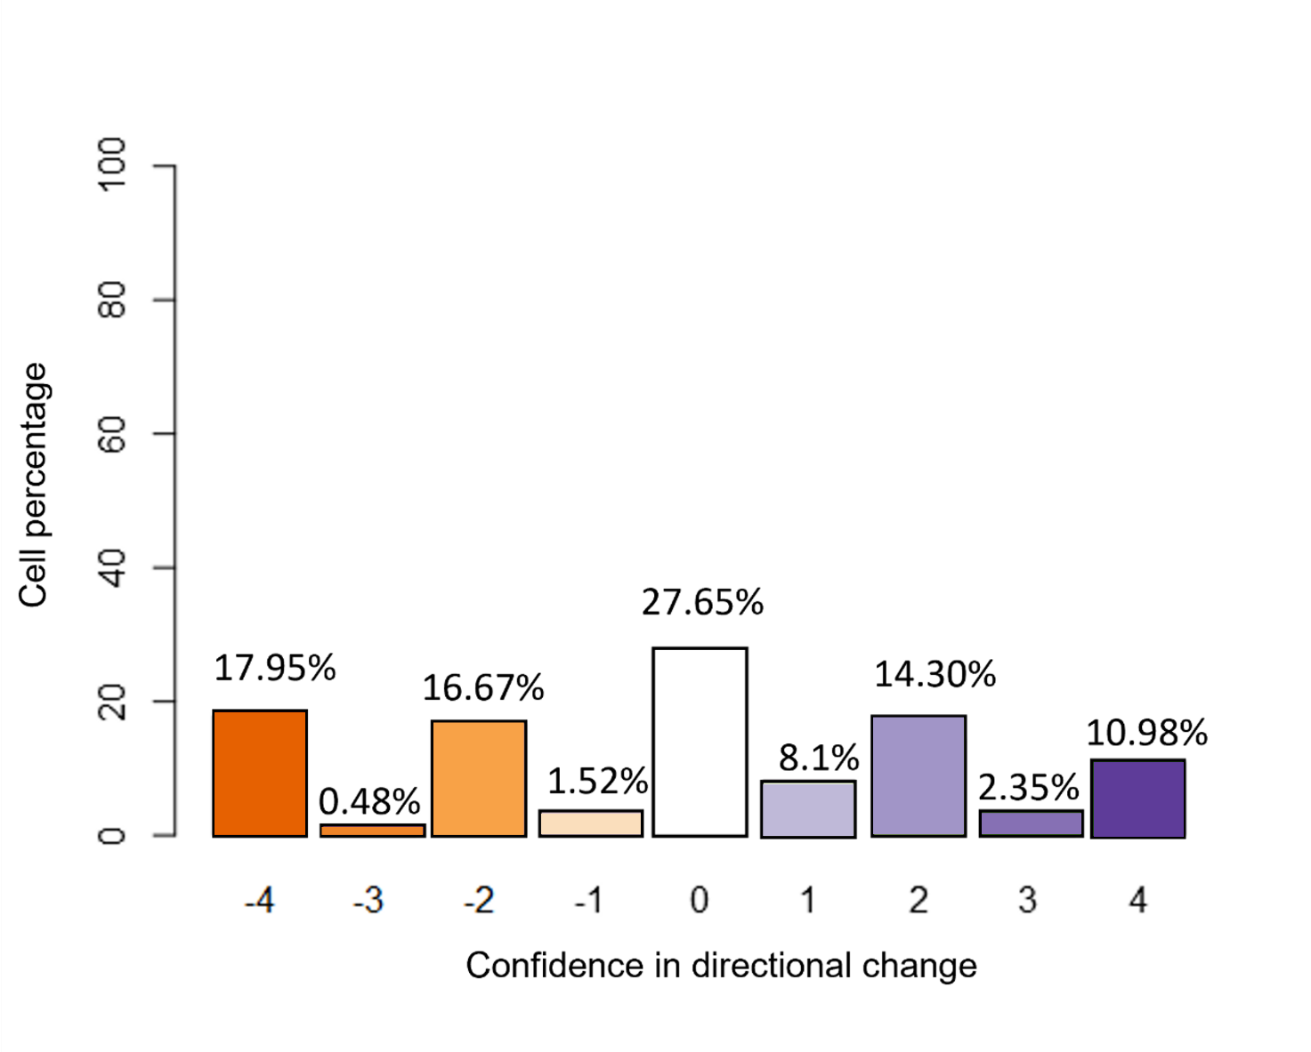
Figure S4. Bar plot of confidence in directional change in the predictions of RCP 2.6 showing the frequency of the different levels of agreement between the algorithms. In dark orange, high agreement in predicting a suitability decrease, in light orange intermediate agreement in predicting a suitability decrease. In dark and light violet high and intermediate agreement in predicting increase in suitability are represented, respectively. The white bar shows high disagreement between the algorithms.

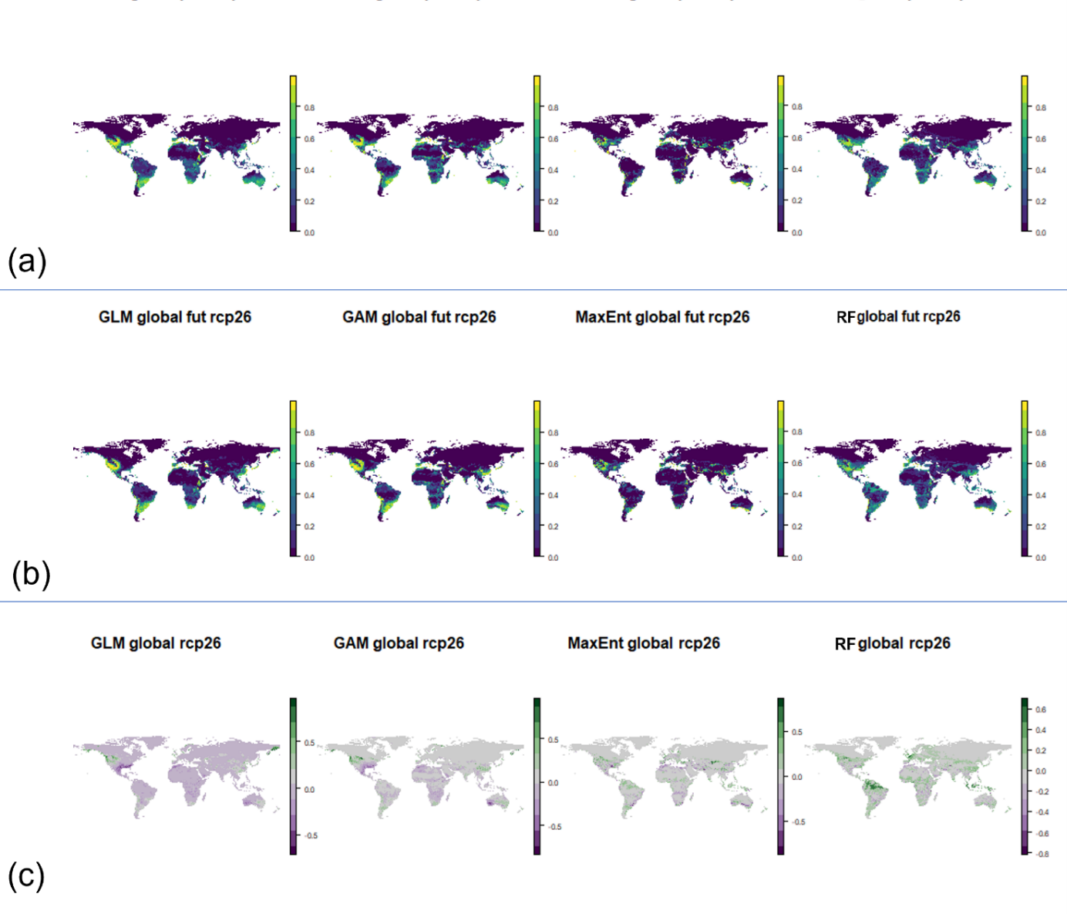
Figure S5. Projections of the four models resampled by mean at 10 km to improve the visibility of the geographic pattern, the future predictions are referred to the RCP 2.6; (a) Current climatic suitability predicted by GLM, GAM, Maxent and RF; (b) future climatic suitability predicted by GLM, GAM, Maxent and RF (c); subtraction values (future-current conditions) resulted from GLM, GAM, Maxent and RF predictions.

Figure S6. Multivariate Environmental Similarity Surfaces (MESS) maps for Scyphophorus acupunctatus obtained with Dismo R package for a) current prediction and b) future prediction. Map shows the similarity of the environmental variables between training and projection data. Environmental similarity ranged from positive values (black) to negative (white).

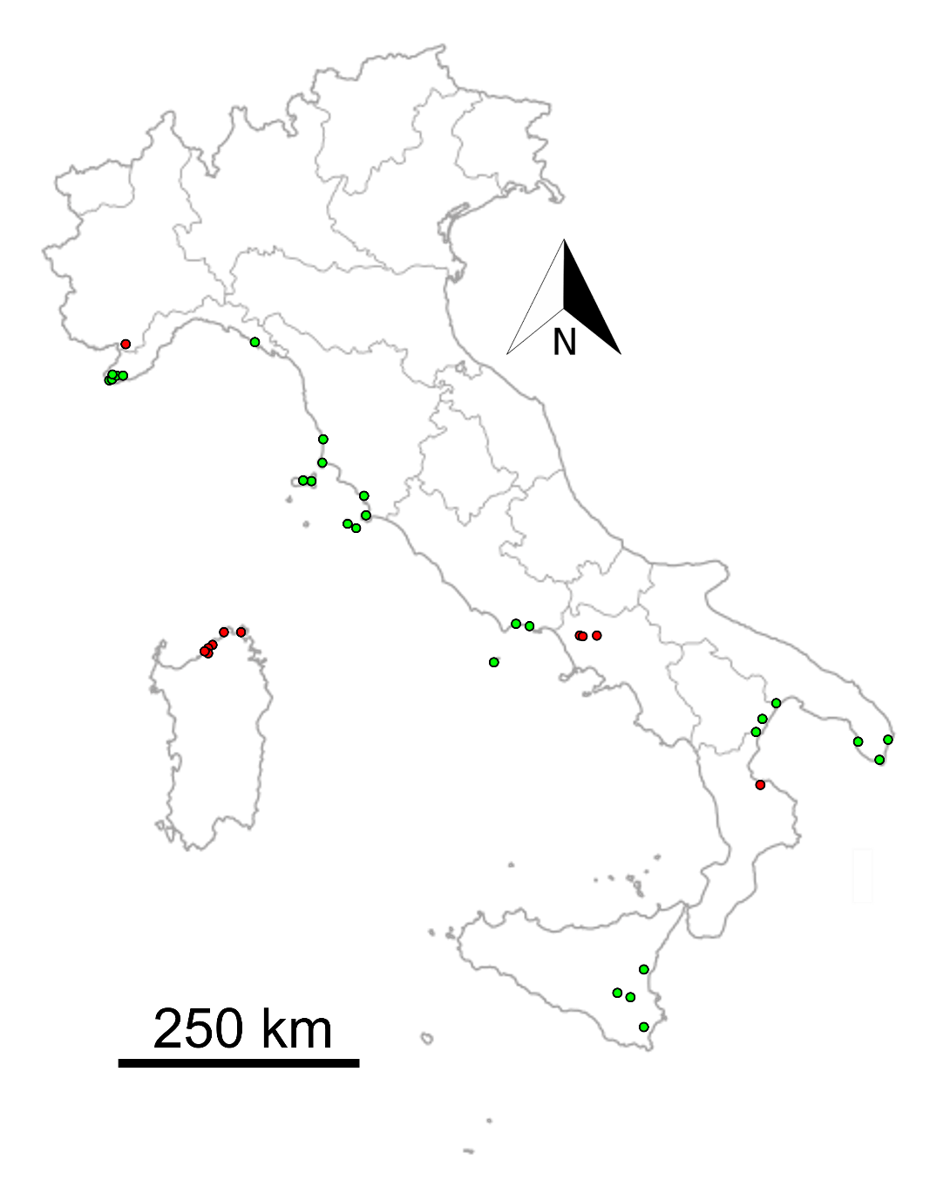
Figure S7. Current distribution of Scyphophorus acupunctatus in Italy. Red dots refer to regions where the presence of the agave weevil was not reported before this work.

