Supplementary information
Table S1. List of the different modalities for the diet trait. The colored cells indicate the specific modality combination that is displayed by a certain number of species within the regional pool. Numbers inside colored cells indicate the probability that a certain species displays such modality.
N species with that combination | Planktivorous | Piscivorous | Benthivorous | Generalist
8 | 0 | 0 | 1 | 0
5 | 0 | 0 | 0 | 1
2 | 0 | 0.5 | 0.5 | 0
2 | 0 | 0.75 | 0.25 | 0
2 | 1 | 0 | 0 | 0
1 | 0 | 0.1 | 0.9 | 0
1 | 0 | 0.2 | 0.8 | 0
1 | 0 | 1 | 0 | 0
1 | 0.33 | 0 | 0.33 | 0.33
1 | 0.4 | 0.4 | 0.2 | 0
1 | 0.5 | 0 | 0 | 0.5
1 | 0.5 | 0 | 0.5 | 0
1 | 0.75 | 0 | 0.25 | 0

Table S2. Trait values for all fish species. The included traits and modalities are further described in Table 1.
Species | Diet generalist | Diet benthivorous | Diet piscivorous | Diet planktivorous | Habitat | Fin | Body type | Development mode | Length class | Temperature adaptation | Territorial behavior | Parental care | Pharyngeal bones | Habitat switching
Abramis brama | 1 | 0 | 0 | 0 | demersal | forked | deep | addher | 21_30cm | warm | YES | NO | YES | YES
Alburnus alburnus | 0.5 | 0 | 0 | 0.5 | pelagic | forked | normal | addher | 10_20cm | warm | NO | NO | YES | YES
Blicca bjoerkna | 1 | 0 | 0 | 0 | demersal | forked | deep | addher | 10_20cm | warm | NO | NO | YES | YES
Clupea harengus | 0 | 0.25 | 0 | 0.75 | pelagic | forked | normal | addher | 10_20cm | cold | NO | NO | NO | YES
Coregonus maraena | 0.33 | 0.33 | 0 | 0.33 | demersal | forked | normal | scattered | 31_40cm | cold | NO | NO | NO | YES
Esox lucius | 0 | 0 | 1 | 0 | demersal | emerginated | elongated | addher | 41_50cm | warm | YES | NO | NO | NO
Gadus morhua | 0 | 0.25 | 0.75 | 0 | demersal | truncated | normal | pelagic | 41_50cm | cold | NO | NO | NO | YES
Gasterosteus aculeatus | 0 | 0.5 | 0 | 0.5 | benthopelagic | emerginated | normal | addher | 0_10cm | warm | YES | YES | YES | YES
Gobius niger | 0 | 1 | 0 | 0 | demersal | rounded | elongated | addher | 0_10cm | warm | YES | YES | YES | NO
Gymnocephalus cernuus | 0 | 1 | 0 | 0 | demersal | emerginated | normal | addher | 10_20cm | warm | NO | NO | NO | YES
Hyperoplus lanceolatus | 0 | 0.2 | 0.4 | 0.4 | benthopelagic | forked | elongated | scattered | 21_30cm | cold | NO | NO | NO | YES
Leuciscus idus | 0 | 0.9 | 0.1 | 0 | benthopelagic | forked | normal | addher | 21_30cm | warm | NO | NO | YES | YES
Myoxocephalus scorpius | 1 | 0 | 0 | 0 | demersal | rounded | normal | addher | 21_30cm | cold | NO | YES | YES | NO
Neogobius melanostomus | 0 | 1 | 0 | 0 | demersal | rounded | elongated | addher | 10_20cm | warm | YES | YES | YES | YES
Nerophis ophidion | 0 | 0 | 0 | 1 | benthopelagic | absent | elongated | ovovivipar | 10_20cm | warm | NO | YES | NO | NO
Osmerus eperlanus | 0 | 0.5 | 0.5 | 0 | pelagic | forked | elongated | addher | 10_20cm | cold | NO | NO | YES | YES
Perca fluviatilis | 0 | 0.5 | 0.5 | 0 | demersal | emerginated | deep | addher | 31_40cm | warm | NO | NO | NO | YES
Platichthys flesus | 0 | 1 | 0 | 0 | demersal | rounded | flat | pelagic | 41_50cm | warm | NO | NO | YES | YES
Platichthys solemdali | 0 | 1 | 0 | 0 | demersal | rounded | flat | scattered | 41_50cm | warm | NO | NO | YES | YES
Rutilus rutilus | 1 | 0 | 0 | 0 | benthopelagic | forked | deep | addher | 21_30cm | warm | NO | NO | YES | YES
Sander lucioperca | 0 | 0.25 | 0.75 | 0 | demersal | emerginated | normal | addher | 41_50cm | warm | YES | YES | NO | YES
Scardinius erythrophthalmus | 1 | 0 | 0 | 0 | benthopelagic | forked | deep | addher | 10_20cm | warm | NO | NO | YES | YES
Sprattus sprattus | 0 | 0 | 0 | 1 | pelagic | forked | normal | scattered | 10_20cm | warm | NO | NO | NO | YES
Taurulus bubalis | 0 | 0.8 | 0.2 | 0 | demersal | rounded | deep | mass_clump | 10_20cm | cold | YES | YES | YES | NO
Triglopsis quadricornis | 0 | 1 | 0 | 0 | demersal | rounded | elongated | mass_clump | 10_20cm | cold | YES | YES | YES | YES
Vimba vimba | 0 | 1 | 0 | 0 | benthopelagic | forked | normal | addher | 21_30cm | warm | NO | NO | YES | YES
Zoarces viviparus | 0 | 1 | 0 | 0 | demersal | rounded | elongated | vivipar | 21_30cm | cold | NO | NO | NO | NO

Table S3. Functional distinctiveness, WPUE and relative WPUE of the fish species present in the regional pool starting from the most distinct taxon. Quartiles used to classify species distinctiveness are also included. Round goby is highlighted in bold.
Taxon | Distinctiveness | Quartile | WPUE | Relative WPUE (%)
Nerophis ophidion | 0.622 | 4 | 0.035 | 0.001
Taurulus bubalis | 0.613 | 4 | 1.965 | 0.043
Triglopsis quadricornis | 0.590 | 4 | 28.480 | 0.624
Gobius niger | 0.572 | 4 | 3.374 | 0.074
Myoxocephalus scorpius | 0.524 | 4 | 112.608 | 2.468
Zoarces viviparus | 0.516 | 4 | 12.754 | 0.279
Gasterosteus aculeatus | 0.509 | 3 | 46.790 | 1.025
Esox lucius | 0.498 | 3 | 209.115 | 4.582
Neogobius melanostomus | 0.493 | 3 | 47.489 | 1.041
Gadus morhua | 0.466 | 3 | 378.637 | 8.297
Hyperoplus lanceolatus | 0.450 | 3 | 9.198 | 0.202
Sander lucioperca | 0.448 | 3 | 103.964 | 2.278
Sprattus sprattus | 0.444 | 3 | 56.747 | 1.243
Platichthys solemdali | 0.441 | 2 | 219.433 | 4.808
Clupea harengus | 0.439 | 2 | 325.619 | 7.135
Platichthys flesus | 0.430 | 2 | 113.616 | 2.490
Osmerus eperlanus | 0.413 | 2 | 51.314 | 1.124
Coregonus maraena | 0.410 | 2 | 175.805 | 3.852
Rutilus rutilus | 0.396 | 2 | 677.492 | 14.846
Alburnus alburnus | 0.383 | 2 | 68.927 | 1.510
Perca fluviatilis | 0.376 | 1 | 1096.342 | 24.024
Abramis brama | 0.373 | 1 | 153.638 | 3.367
Scardinius erythrophthalmus | 0.355 | 1 | 103.821 | 2.275
Leuciscus idus | 0.353 | 1 | 145.838 | 3.196
Vimba vimba | 0.348 | 1 | 41.026 | 0.899
Blicca bjoerkna | 0.333 | 1 | 261.331 | 5.727
Gymnocephalus cernuus | 0.331 | 1 | 118.164 | 2.589

Table S4. Importance of predictors for the fitted GAMM and RF.
RF
 | IncNodePurity | sd | IncMSE | sd
Bottom temperature | 0.471 | 0.009 | 37.004 | 0.897
Location | 0.455 | 0.010 | 38.097 | 0.817
Richness | 0.414 | 0.008 | 38.233 | 1.057
Distance to offshore | 0.316 | 0.006 | 30.381 | 0.895
Chlorophyll | 0.280 | 0.005 | 25.858 | 0.971
Depth | 0.269 | 0.004 | 28.202 | 0.857
Evenness | 0.269 | 0.003 | 19.965 | 1.009
Bottom salinity | 0.233 | 0.004 | 28.830 | 0.815
Bottom oxygen | 0.192 | 0.003 | 27.328 | 0.942
Time step | 0.175 | 0.006 | 27.429 | 0.807
Gear type | 0.090 | 0.004 | 20.307 | 0.597
GAMM
 | Importance | Containing models
Location x time step (random) | 1 | 341
Distance to offshore | 1.000 | 243
Richness | 1.000 | 222
Gear type (random) | 0.967 | 186
Bottom temperature | 0.943 | 196
Evenness | 0.936 | 175
Bottom oxygen | 0.761 | 184
Depth | 0.758 | 183
Bottom salinity | 0.278 | 169
Chlorophyll | 0.254 | 166

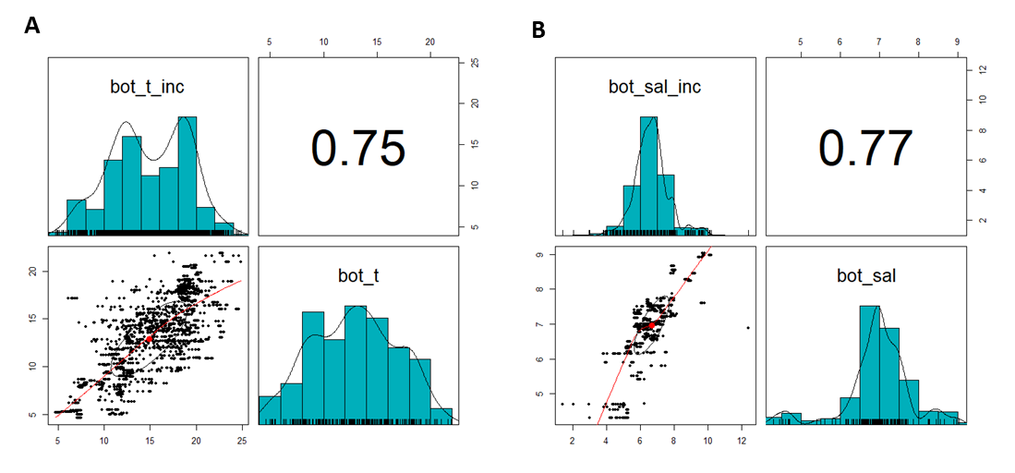
Figure S1. Correlation between model-derived and in-situ data of bottom temperature (A) and bottom salinity (B). The upper-left panel in each figure corresponds to the available in-situ data.

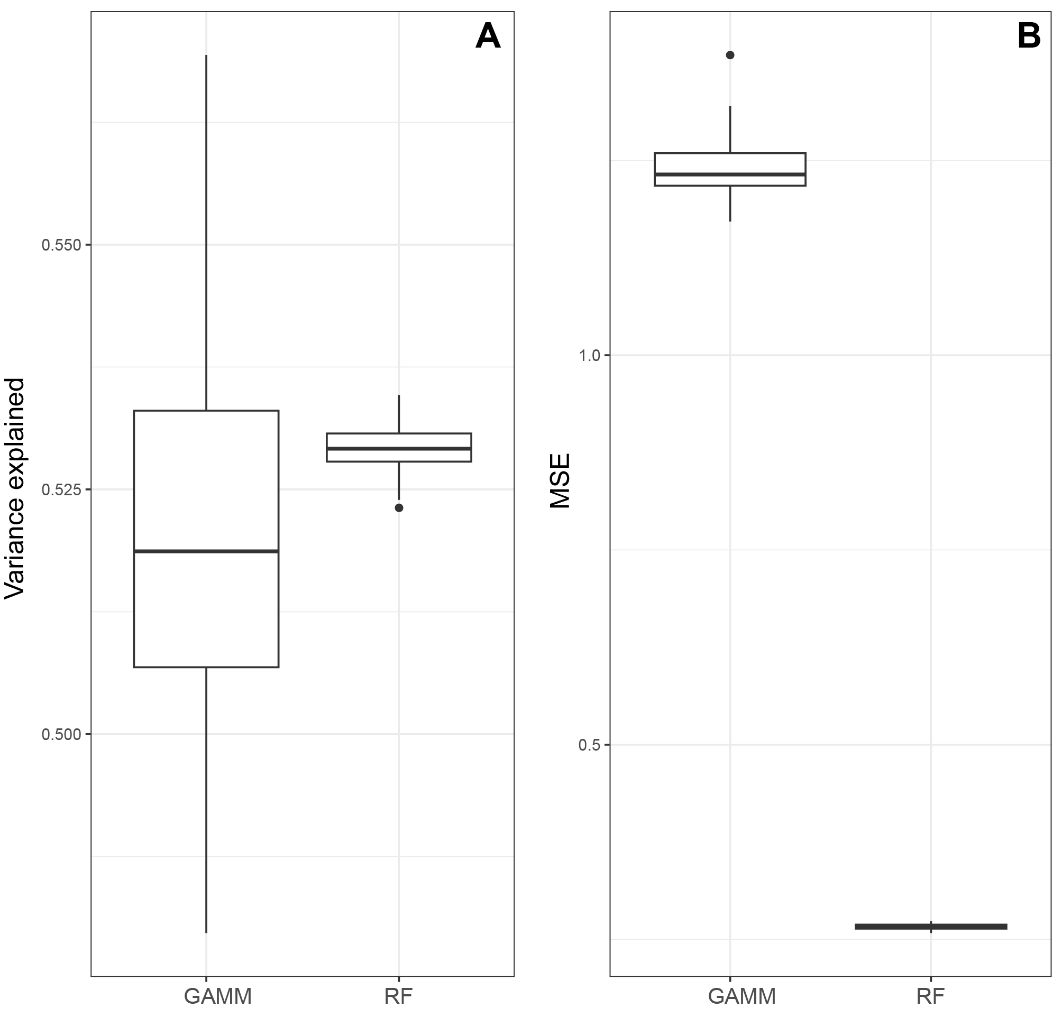
Figure S2. Plots showing the comparison between variance explained (A) and mean squared error (MSE; B) between GAMM and RF after the cross-validation process.

