Title
The Caddisfly Collective: Methods of assessing Trichoptera diversity on a continental scale with community scientists

Authors
Kelly M. Murray-Stoker* and Shannon J. McCauley
Department of Ecology and Evolutionary Biology, University of Toronto, 25 Willcocks Street, Toronto, ON, Canada, M5S 3B2; Department of Biology, University of Toronto Mississauga, 3359 Mississauga Road, Mississauga, ON, Canada, L5L 1C6
*Corresponding Author: k.murraystoker@utoronto.ca

Supplementary Material 1
Included documents:
- Instruction sheet distributed to participants of The Caddisfly Collective, detailing how to collect and return specimens (Page 2)
- Data sheet distributed to participants of The Caddisfly Collective to fill out for each collecting event (Page 3)

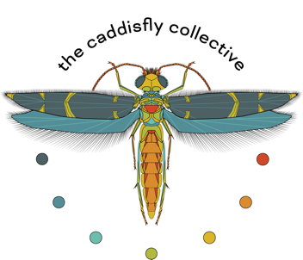

2021 Caddisfly Collection Instructions

Thank you so much for participating in this project! Read through the instructions before collecting and email Kelly Murray-Stoker with any questions! info@caddisflycollective.com

Before collecting
- Check kit for all required materials: plastic bin, USB-powered UV light, data sheet(s), data labels, pencil, 1 500-mL plastic bottle filled with propylene glycol for each site at which you plan to collect, makeshift funnel.
- Gather any of your own supplies that might be helpful: insect repellant, headlamp/flashlight, paper towels/clothes/wet wipes.
- Whether a USB power bank was supplied in your kit, or you are using your own, make sure it is fully charged.
- Choose your location and make sure collecting is not prohibited and you are following any local rules! Make note of sunset and plan to arrive in time to set up. Take a buddy if you can for safety!

At the collecting site
- Find a spot as close to the riverbank as possible, with enough flat surface to lay the plastic bin. Take photos of your site and set-up (and of yourself if you wish!).
- Record site data on the datasheet (Google Maps can be used for GPS coordinates).
- Empty one bottle of propylene glycol into the plastic bin. It is NOT a hazardous substance in any way, but it is a bit sticky. Lay the UV light across the width of the bin so that it is above the surface of the glycol. The light cylinder should be perpendicular to the flow of the river.
- If you were given more than one bottle in your kit, record the bottle # you are using on the data sheet.
- Once the sun has set and it has gotten dark, turn on the light by plugging it into the power bank and make a note of the time.
- Watch the caddisflies come in! Caddisflies are harmless and will not bite or sting you. (Most other insects that will come to the light are also harmless, but it’s a good idea to have the insect repellant for any mosquitoes, ticks, etc. that would be attracted to you.)
- While waiting, fill out the data label and any remaining observations on the data sheet.
- Try to run the light for at least 30 minutes and up to 1 hour. If the caddisflies are extremely abundant and are beginning to overwhelm the trap, you can turn the light off early. Make note of the time the light was turned off.
- Return the propylene glycol + all insects from the bin to the plastic bottle using the makeshift funnel. It may take two people to do. Place a data label into the bottle.

After collecting
- Make sure the bottle(s) are tightly closed and a double check that a data label with date and site information has been dropped in. Place the bottle(s) within a plastic bag.
- Enclose the bottle(s) and data sheet(s) in the mailing envelope included in your kit. Keep the light and other supplies!
- Drop the envelope off at the Post Office.
- Send an email confirming you have sent the samples and please attach any photos of your site and of yourself collecting, if you would like! We’d love to feature participants on our website and social media.
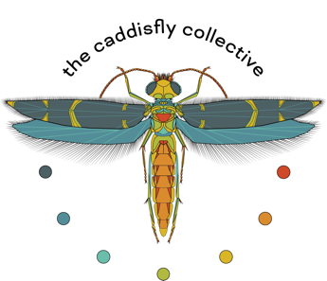

2021 Community Science Data Sheet

Date: Bottle #:

Names of collectors:

Location (Waterbody, City, State/Province, Country):

GPS Coordinates:

Comments about weather, estimated temperature:

Time light turned on:

Time light turned off:

Other wildlife/plant life observations at the site:

General comments about your experience of collecting, observations about the river/site, thoughts about any potential ecological changes or pressures in the area:

