Appendix 2. Scales counts and measures collected with ImageJ from photographic material of genetically-determined specimens of Paroedura manongavato sp. nov. (ACP5940; ACP4725; ACP4991).

Appendix 2.1. Dorsal scales longitudinal counts (character DorL, three repetitions) from photographic material of genetically-determined specimens of Paroedura manongavato sp. nov. (first row: ACP5940; second row: ACP4725; third row: ACP4991). Photographs by JLR.
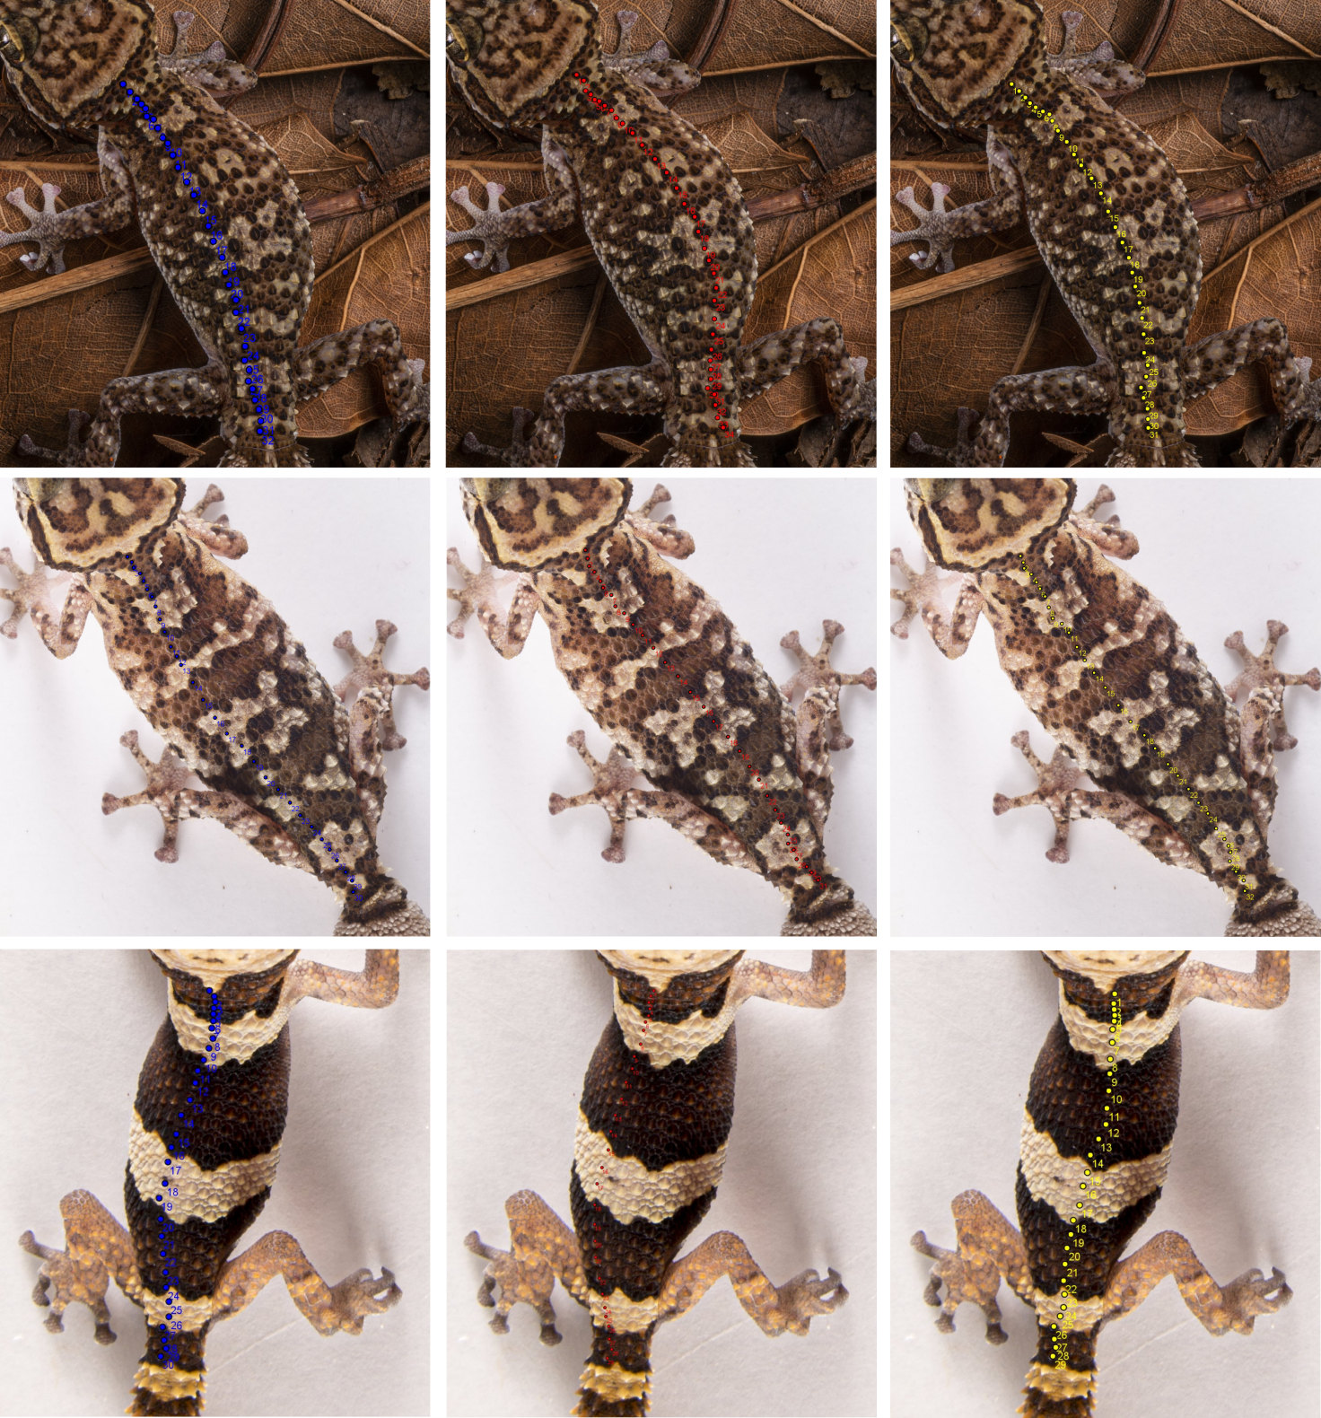

Appendix 2.2. Interorbital scales counts (character IO) from photographic material of genetically-determined specimens of Paroedura manongavato sp. nov. (first row: ACP5940 and ACP4725; second row: ACP2761 (holotype) and ACP4991). Photographs of ACP5940, ACP4725 and ACP4991 by JLR; photogtaph of ACP2761 by CP.
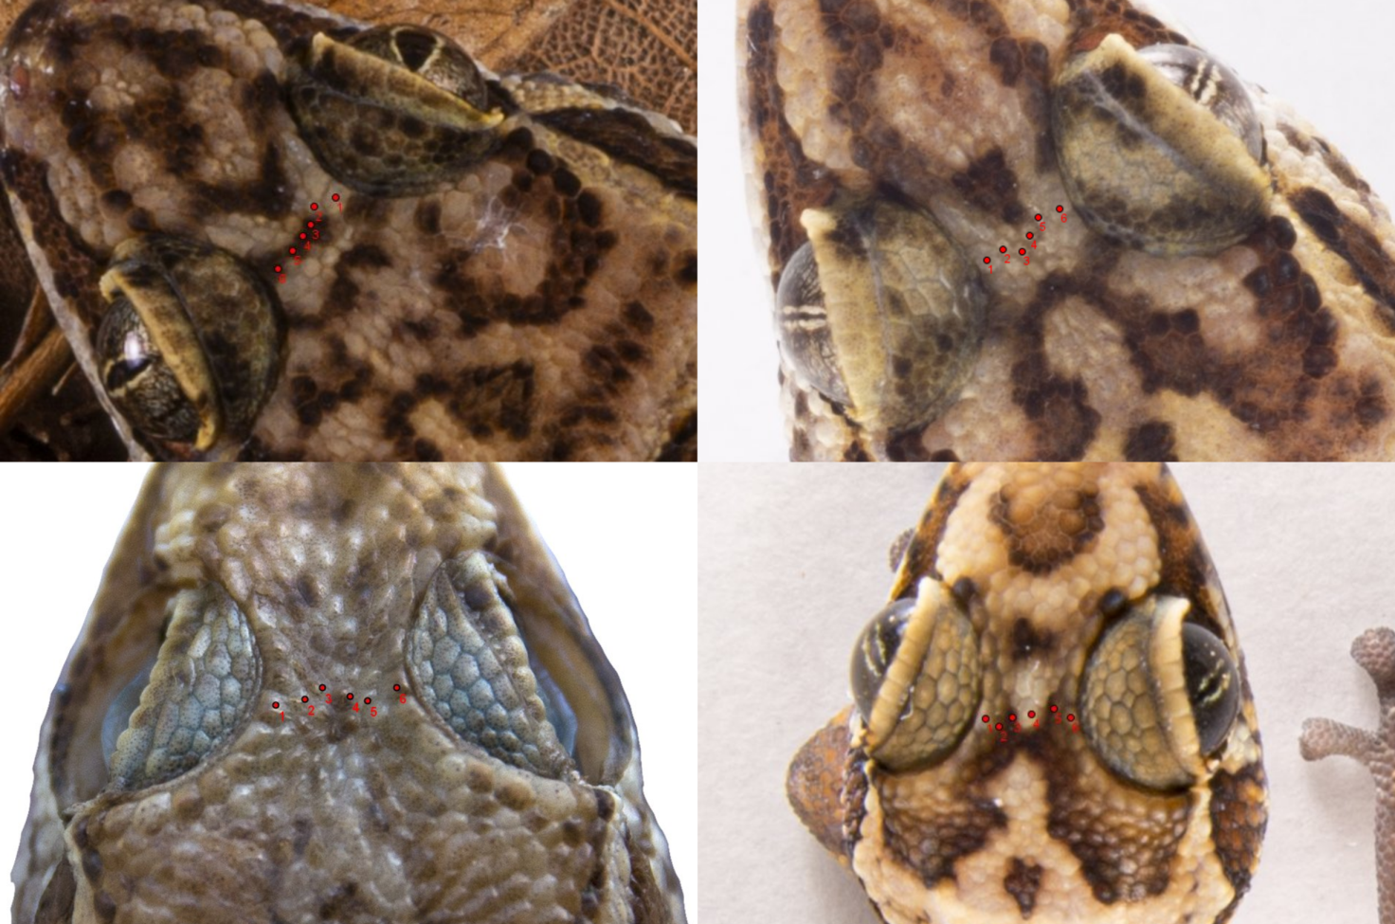

Appendix 2.3. Snout tip scales counts (character SeP) from photographic material of genetically-determined specimens of Paroedura manongavato sp. nov. (first picture: ACP5940; second picture: ACP4725; third picture: ACP4991). Photographs by JLR.
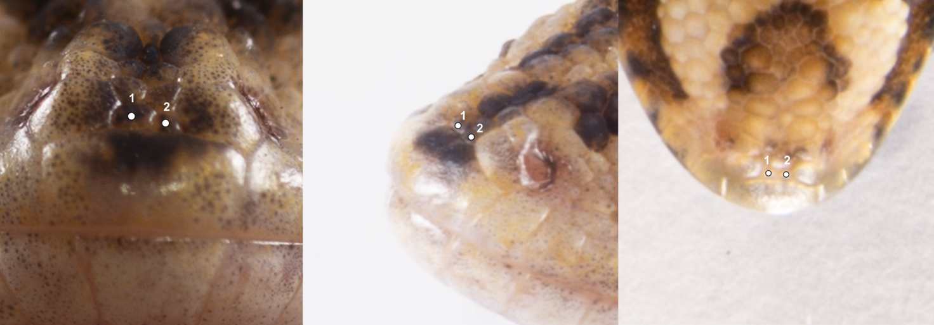

Appendix 2.4. Measures of specimen ACP4725. Characters: SVL, snout–vent length; TL, tail length; HL, head length from the anterior margin of the ear opening to the tip of the snout; HW, maximum head width; distE, minimum distance between the bony edges of the orbits in dorsal view; ED, maximum eye diameter; FoL, foot length (from ankle to tip of the 3th toe, left side); HAL, hand length, distance between the wrist and the tip of the longest finger (until the insertion of the claw, which is not included, left side). Photographs by JLR.
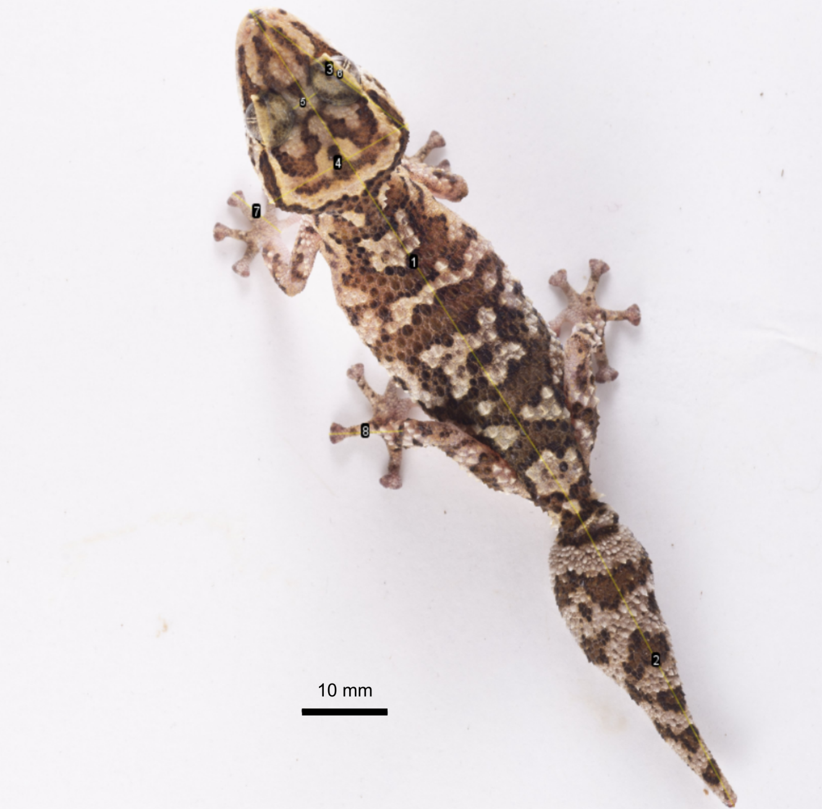
 | Measure | Length (mm)
1 | SVL | 73.024
2 | TL | 40.01
3 | HW | 24.042
4 | HL | 19.281
5 | distE | 3.275
6 | ED | 5.421
7 | HAL | 7.45
8 | FoL | 8.857

