(a) | (b)
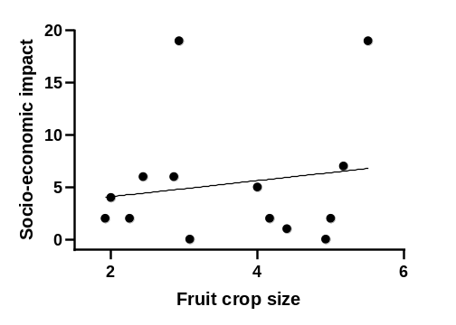 | 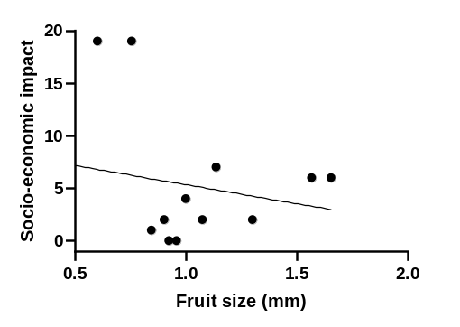
(c) | (d)
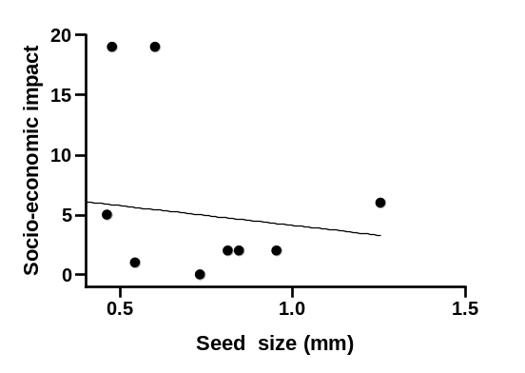 | 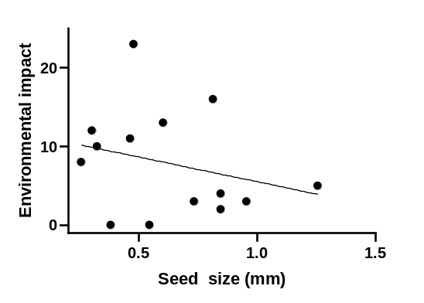
(e) | (f)
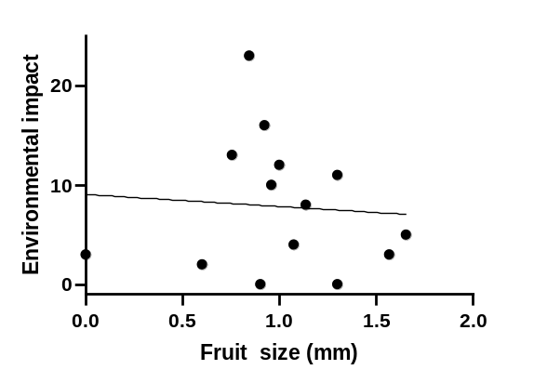 | 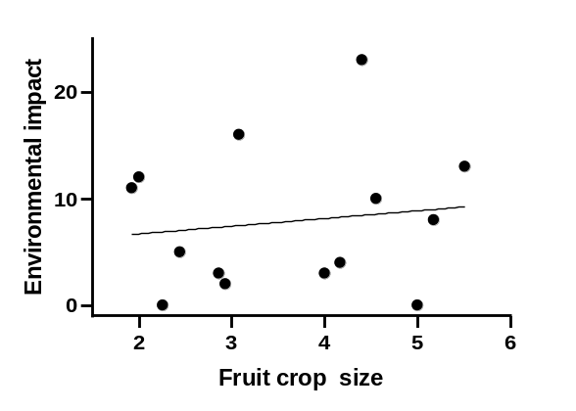

Figure 3. Relationship between socio-economic impacts with log-transformed morphological traits: (a) mean fruit crop size, (b) mean fruit size, (c) mean seed size, and environmental impacts with log-transformed morphological traits: (d) mean seed size, (e) mean fruit size, and (f) mean fruit crop size. (Each dot represents a species)

