Supplementary Material
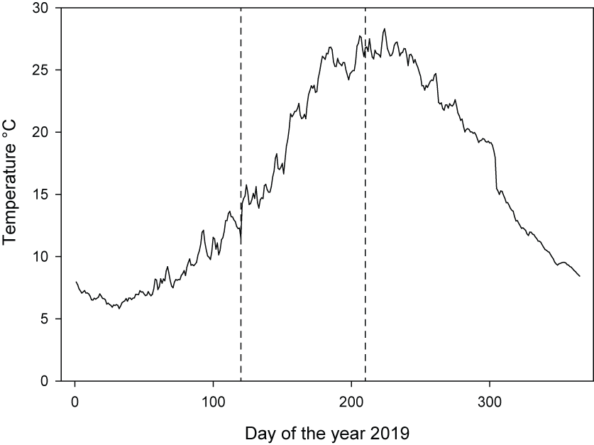Supplementary Figure 1 – Daily average water temperature in the Torbiere del Sebino reserve in 2019. Vertical dashed lines represent the boundaries of the period of the year that was considered in the bioenergetic modeling (chick growing period).

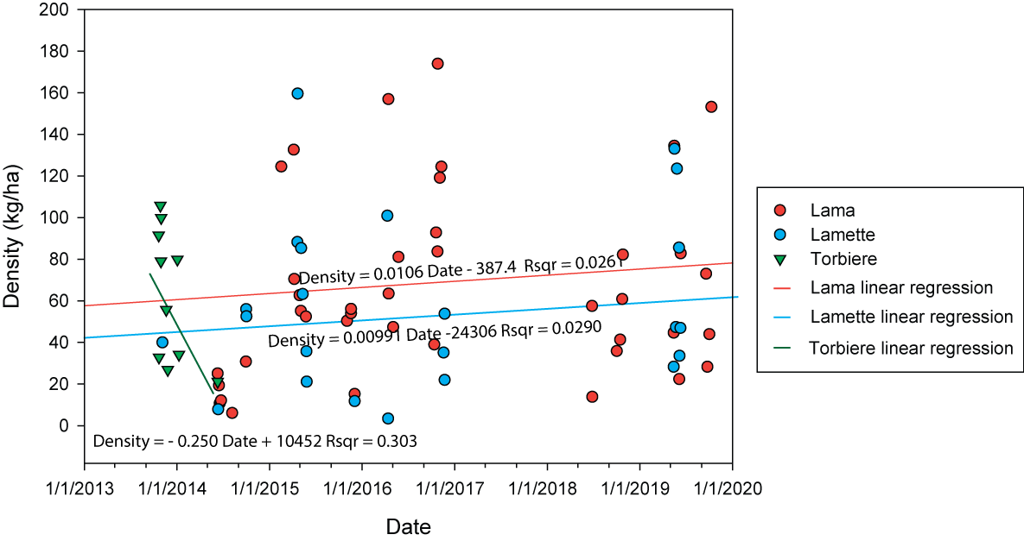Supplementary Figure 2 – Wels catfish density trends detected through sampling events along the shoreline of different areas of the Torbiere del Sebino reserve in 2013–2019, using boat-mounted electrofishing. Each dot represents a single sampling event, solid lines represent linear regression trends (equations and R² displayed next to each line).

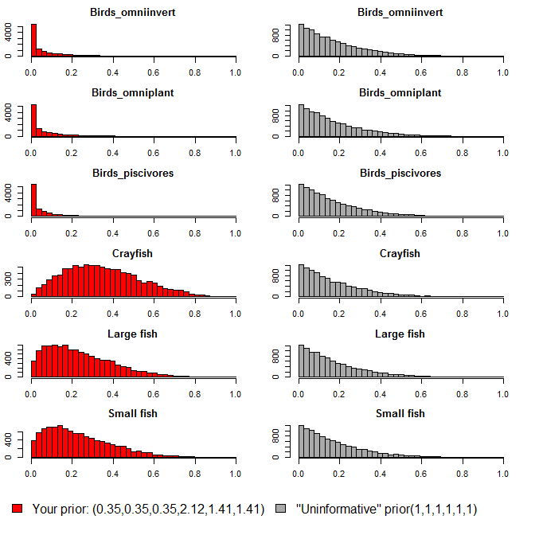
Supplementary Figure 3 – Comparison between uninformative (right) and informative (left) priors. Informative priors were derived from our preliminary stomach content analysis and were tured into hyperparameters which were rescaled to have the same mean, but different variance, keeping the relative contributions the same.

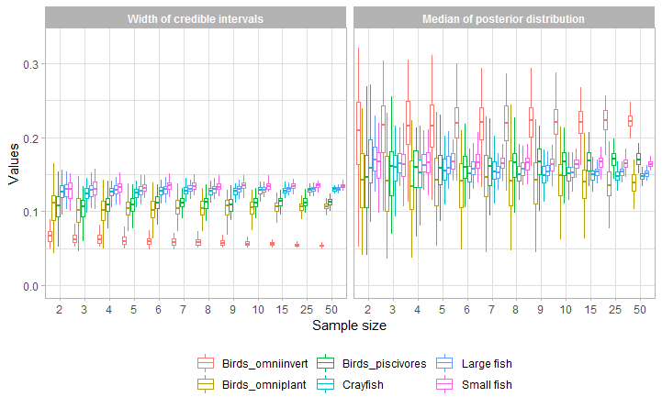a)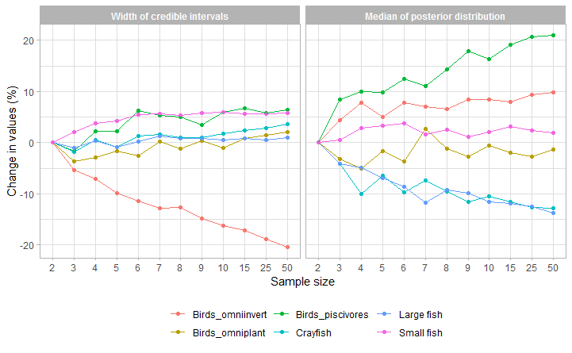b)
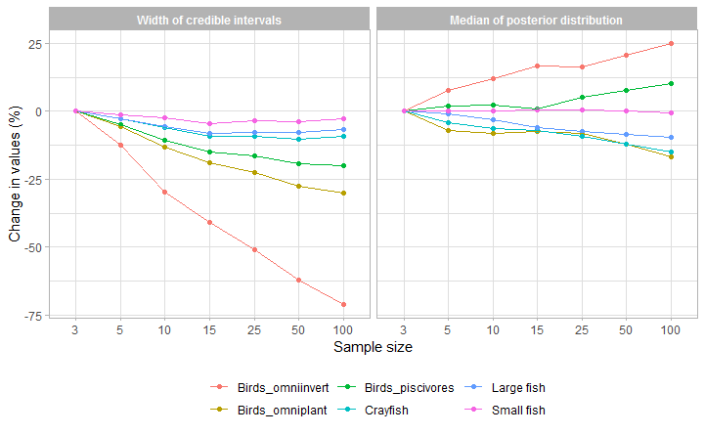c)
Supplementary Figure 6 – Sample size effects on the width of credible intervals and medians of posterior distributions for the 6 prey categories used in the mixing model. Putative prey sample size, expressed as values (boxplots, a) and percentage change in values (dot and line plots, b). Consumer sample size, expressed as percentage change in values (dot and line plots, c).

Supplementary Table 1 – Length, weight, stable isotope ratios of C and N, and percentage of each element and their ratio, for all the specimens sampled in this study.
Category | Common name | Scientific name | TL (mm) | W (g) | d13C | d15N | %C | %N | C/N
Consumer | Wels catfish | Silurus glanis | 1780 | 41970 | -25.559 | 12.177 | 47.915 | 14.836 | 3.230
 | Wels catfish | Silurus glanis | 1765 | 45300 | -24.629 | 11.886 | 47.260 | 14.528 | 3.253
 | Wels catfish | Silurus glanis | 1670 | 27500 | -24.134 | 12.378 | 47.500 | 14.588 | 3.256
 | Wels catfish | Silurus glanis | 1815 | 45800 | -24.465 | 12.169 | 47.800 | 14.016 | 3.410
 | Wels catfish | Silurus glanis | 1830 | 39500 | -24.528 | 8.732 | 34.262 | 9.765 | 3.509
 | Wels catfish | Silurus glanis | 1540 | 21300 | -20.197 | 11.569 | 47.113 | 14.427 | 3.266
 | Wels catfish | Silurus glanis | 1860 | 41000 | -22.692 | 11.523 | 45.782 | 14.078 | 3.252
 | Wels catfish | Silurus glanis | 1915 | 51600 | -22.251 | 12.233 | 46.550 | 14.421 | 3.228
 | Wels catfish | Silurus glanis | 1735 | 32500 | -21.505 | 11.259 | 44.685 | 13.580 | 3.291
 | Wels catfish | Silurus glanis | 1895 | 43100 | -18.565 | 9.459 | 47.291 | 14.442 | 3.275
 | Wels catfish | Silurus glanis | 1035 | 8450 | -25.901 | 14.448 | 46.054 | 14.271 | 3.227
 | Wels catfish | Silurus glanis | 1070 | 9670 | -23.210 | 11.900 | 45.503 | 14.147 | 3.216
 | Wels catfish | Silurus glanis | 1090 | 8480 | -25.335 | 12.589 | 45.842 | 14.204 | 3.227
 | Wels catfish | Silurus glanis | 1115 | 9680 | -25.327 | 13.037 | 46.336 | 14.405 | 3.217
 | Wels catfish | Silurus glanis | 1125 | 90430 | -24.832 | 13.807 | 47.661 | 13.616 | 3.500
 | Wels catfish | Silurus glanis | 1270 | 16950 | -25.617 | 12.781 | 46.290 | 14.371 | 3.221
 | Wels catfish | Silurus glanis | 1465 | 24500 | -23.985 | 10.593 | 70.548 | 2.161 | 32.651
 | Wels catfish | Silurus glanis | 1530 | 22000 | -22.552 | 11.933 | 48.368 | 12.738 | 3.797
 | Wels catfish | Silurus glanis | 1425 | 16930 | -24.575 | 12.608 | 49.759 | 12.684 | 3.923
 | Wels catfish | Silurus glanis | 980 | 6680 | -26.442 | 14.922 | 45.866 | 14.282 | 3.211
 | Wels catfish | Silurus glanis | 1090 | 9950 | -25.321 | 13.062 | 45.665 | 14.364 | 3.179
 | Wels catfish | Silurus glanis | 1320 | 17190 | -26.408 | 14.594 | 45.913 | 14.316 | 3.207
 | Wels catfish | Silurus glanis | 1070 | 8400 | -25.608 | 13.014 | 45.714 | 14.196 | 3.220
 | Wels catfish | Silurus glanis | 1200 | 9250 | -25.801 | 13.857 | 45.992 | 14.276 | 3.222
 | Wels catfish | Silurus glanis | 1120 | 8200 | -25.505 | 13.551 | 45.750 | 14.363 | 3.185
 | Wels catfish | Silurus glanis | 980 | 7030 | -25.846 | 13.912 | 45.833 | 14.321 | 3.200
 | Wels catfish | Silurus glanis | 1535 | 23100 | -26.398 | 12.214 | 45.805 | 14.329 | 3.197
 | Wels catfish | Silurus glanis | 1510 | 25100 | -23.163 | 11.909 | 46.102 | 14.163 | 3.255
 | Wels catfish | Silurus glanis | 1290 | 25100 | -25.630 | 12.278 | 46.379 | 14.200 | 3.266
 | Wels catfish | Silurus glanis | 1225 | 13050 | -22.621 | 11.564 | 45.612 | 14.237 | 3.204
 | Wels catfish | Silurus glanis | 1175 | 10420 | -23.636 | 11.877 | 46.644 | 14.179 | 3.290
Small fish | Mosquitofish | Gambusia affinis/holbrooki | 43 | 0.5 | -26.876 | 12.978 | 43.786 | 10.832 | 4.042
 | Mosquitofish | Gambusia affinis/holbrooki | 31 | 0.3 | -24.369 | 11.312 | 46.924 | 10.162 | 4.618
 | Italian riffle dace | Leucos aula | 83 | 4.6 | -25.909 | 11.355 | 45.942 | 12.735 | 3.608
 | Italian riffle dace | Leucos aula | 107 | 11.2 | -23.610 | 11.856 | 43.752 | 12.123 | 3.609
 | Italian bleak | Alburnus alborella | 101 | 8.1 | -24.822 | 11.035 | 44.976 | 12.952 | 3.473
 | Italian bleak | Alburnus alborella | 64 | 2 | -16.616 | 8.963 | 50.217 | 13.189 | 3.808
 | Crucian carp/Goldfish | Carassius auratus | 124 | 103 | -26.613 | 11.827 | 58.536 | 9.217 | 6.351
 | Rudd | Scardinius hesperidicus | 149 | 43.5 | -25.147 | 11.933 | 48.320 | 11.937 | 4.048
 | Rudd | Scardinius hesperidicus | 370 | 827 | -22.460 | 12.049 | 48.358 | 14.425 | 3.352
 | Pumpkinseed | Lepomis gibbosus | 103 | 22 | -24.388 | 11.389 | 47.170 | 13.472 | 3.501
 | Pumpkinseed | Lepomis gibbosus | 55 | 2.2 | -24.494 | 10.159 | 44.851 | 13.220 | 3.393
Large fish | Largemouth black bass | Micropterus salmoides | 314 | 496.9 | -23.744 | 12.987 | 44.011 | 13.315 | 3.305
 | Largemouth black bass | Micropterus salmoides | 169 | 67.6 | -25.076 | 11.000 | 47.323 | 13.618 | 3.475
 | European perch | Perca fluviatilis | 133 | 24.3 | -22.777 | 11.800 | 46.653 | 13.708 | 3.403
Crayfish | Red swamp crayfish | Procambarus clarkii | 96 | 9.6 | -22.909 | 9.534 | 45.073 | 13.645 | 3.303
 | Red swamp crayfish | Procambarus clarkii | 100 | 15.8 | -23.338 | 11.604 | 46.044 | 14.201 | 3.242
 | Red swamp crayfish | Procambarus clarkii | 111 | 16.8 | -23.695 | 12.174 | 41.073 | 12.203 | 3.366
 | Red swamp crayfish | Procambarus clarkii | 120 | 23.1 | -22.533 | 9.323 | 36.081 | 9.648 | 3.740
 | Red swamp crayfish | Procambarus clarkii | 113 | 15.2 | -22.705 | 9.318 | 41.809 | 12.193 | 3.429
 | Red swamp crayfish | Procambarus clarkii | 96 | 17.3 | -22.687 | 8.588 | 44.799 | 12.955 | 3.458
 | Red swamp crayfish | Procambarus clarkii | 105 | 17.2 | -22.949 | 8.355 | 39.151 | 10.689 | 3.663
 | Red swamp crayfish | Procambarus clarkii | 83 | 7 | -20.869 | 8.445 | 34.939 | 8.369 | 4.175
Rodents | Rat (?) | Rattus sp. (?) |  |  | -23.124 | 11.049 | 47.019 | 14.244 | 3.301
Birds | Mute swan | Cygnus olor |  |  | -15.155 | 7.836 | 46.515 | 14.437 | 3.222
 | Mute swan | Cygnus olor |  |  | -21.193 | 9.265 | 75.495 | 23.220 | 3.251
 | Mute swan | Cygnus olor |  |  | -17.539 | 7.771 | 46.143 | 14.382 | 3.208
 | Mute swan | Cygnus olor |  |  | -23.157 | 6.749 | 45.377 | 14.226 | 3.190
 | Mute swan | Cygnus olor |  |  | -18.382 | 8.388 | 44.920 | 13.804 | 3.254
 | Mute swan | Cygnus olor |  |  | -16.347 | 9.723 | 45.425 | 14.228 | 3.193
 | Mute swan | Cygnus olor |  |  | -16.745 | 9.681 | 45.020 | 13.973 | 3.222
 | Mute swan | Cygnus olor |  |  | -14.882 | 9.048 | 45.836 | 14.153 | 3.239
 | Mute swan | Cygnus olor |  |  | -15.524 | 8.060 | 45.880 | 14.241 | 3.222
 | Mute swan | Cygnus olor |  |  | -13.899 | 8.277 | 46.107 | 14.142 | 3.260
 | Moorhen | Gallinula chloropus |  |  | -19.840 | 16.693 | 45.440 | 14.116 | 3.219
 | Moorhen | Gallinula chloropus |  |  | -18.707 | 15.924 | 45.644 | 14.119 | 3.233
 | Moohren | Gallinula chloropus |  |  | -29.314 | 9.861 | 47.775 | 14.606 | 3.271
 | Moohren | Gallinula chloropus |  |  | -20.379 | 8.544 | 46.636 | 13.727 | 3.397
 | Mallard | Anas platyrhynchos |  |  | -23.810 | 7.436 | 47.496 | 14.261 | 3.330
 | Mallard | Anas platyrhynchos |  |  | -22.205 | 7.924 | 46.519 | 14.261 | 3.262
 | Mallard | Anas platyrhynchos |  |  | -23.036 | 7.946 | 45.986 | 13.833 | 3.324
 | Mallard | Anas platyrhynchos |  |  | -22.967 | 7.469 | 44.609 | 13.664 | 3.265
 | Mallard | Anas platyrhynchos |  |  | -23.208 | 11.016 | 43.796 | 13.678 | 3.202
 | Mallard | Anas platyrhynchos |  |  | -22.759 | 7.742 | 45.352 | 14.052 | 3.228
 | Mallard | Anas platyrhynchos |  |  | -18.510 | 7.656 | 46.340 | 14.472 | 3.202
 | Mallard | Anas platyrhynchos |  |  | -18.158 | 7.348 | 45.908 | 14.107 | 3.254
 | Mallard | Anas platyrhynchos |  |  | -27.036 | 10.543 | 42.164 | 13.078 | 3.224
 | Mallard | Anas platyrhynchos |  |  | -22.878 | 8.067 | 44.083 | 13.451 | 3.277
 | Mallard | Anas platyrhynchos |  |  | -24.755 | 8.931 | 42.492 | 13.166 | 3.228
 | Mallard | Anas platyrhynchos |  |  | -24.680 | 8.566 | 45.900 | 14.263 | 3.218
 | Mallard | Anas platyrhynchos |  |  | -24.841 | 8.792 | 45.241 | 14.172 | 3.192
 | Water rail | Rallus aquaticus |  |  | -28.434 | 6.168 | 46.144 | 13.759 | 3.354
 | Water rail | Rallus aquaticus |  |  | -28.289 | 6.156 | 46.179 | 14.192 | 3.254
 | Water rail | Rallus aquaticus |  |  | -28.613 | 6.342 | 45.908 | 14.163 | 3.242
 | Water rail | Rallus aquaticus |  |  | -28.497 | 5.975 | 46.754 | 14.181 | 3.297
 | Water rail | Rallus aquaticus |  |  | -28.760 | 6.198 | 44.460 | 13.726 | 3.239
 | Water rail | Rallus aquaticus |  |  | -28.541 | 6.219 | 46.286 | 14.188 | 3.262
 | Water rail | Rallus aquaticus |  |  | -28.700 | 6.048 | 46.427 | 14.271 | 3.253
 | Common coot | Fulica atra |  |  | -21.988 | 11.391 | 49.362 | 14.735 | 3.350
 | Common coot | Fulica atra |  |  | -23.920 | 7.599 | 44.685 | 13.579 | 3.291
 | Common coot | Fulica atra |  |  | -19.419 | 8.519 | 45.442 | 13.427 | 3.384
 | Common coot | Fulica atra |  |  | -20.549 | 8.432 | 46.753 | 14.152 | 3.304
 | Common coot | Fulica atra |  |  | -26.307 | 8.619 | 51.292 | 15.098 | 3.397
 | Common coot | Fulica atra |  |  | -24.154 | 7.506 | 46.386 | 14.173 | 3.273
 | Common coot | Fulica atra |  |  | -24.007 | 7.755 | 44.686 | 13.738 | 3.253
 | Common coot | Fulica atra |  |  | -24.293 | 7.831 | 43.991 | 13.469 | 3.266
 | Red-crested pochard | Netta rufina |  |  | -18.377 | 10.875 | 46.146 | 14.093 | 3.274
 | Great crested grebe | Podiceps cristatus |  |  | -24.229 | 12.563 | 46.651 | 14.171 | 3.292
 | Great cormorant | Phalacrocorax carbo |  |  | -21.280 | 15.354 | 47.677 | 14.227 | 3.351
 | Great cormorant | Phalacrocorax carbo |  |  | -29.101 | 12.080 | 45.591 | 10.901 | 4.182

Supplementary Table 2 – Species-specific consumption, respiration and egestion/excretion parameters of the Wisconsin bioenergetic model for wels catfish used in our study.
Consumption | Equation | 2
 | CA | 0.25
 | CB | -0.21
 | CQ | 2.8
 | CTO | 25
 | CTM | 39
Respiration | Equation | 2
 | RA | 0.019
 | RB | -0.19
 | RQ | 2
 | RTO | 25
 | RTM | 39
 | ACT | 2
 | SDA | 0.15
Egestion / Excretion | Equation | 1
 | FA | 0.2
 | UA | 0.07

Supplementary Table 3 – Full model parameters for the Wisconsin bioenergetic model for wels catfish used in our study. Energy and water content of predator and prey items (Cummins and Wuycheck ,1971), dry weight to wet weight conversion factors (Hartman and Brandt, 1995; Hanson et al. 1997 ), start and end weights for each cohort modelled, as well as cohort-specific dietary proportions derived from the stable isotope mixing models.
Predator energy density (joules/g wet weight) |  |  |  |  | Prey energy density (joules/g wet weight)
 |  | Wels_catfish |  |  | Small_fish | Birds | Large_fish | Crayfish | Rodents
 |  | 6973 |  |  | 7950 | 7750 | 7100 | 3500 | 6500

Fish
1 g dry weight = |  | 3 g wet weight |  | 66% water
Birds
1 g dry weight = |  | 3.13 g wet weight |  | 68% water
Crayfish
1 g dry weight = |  | 5 g wet weight |  | 80% water
Rodents
1 g dry weight = |  | 3.15 g wet weigh |  | 69% water

 | Start Size (cm) |  | End Size (cm) |  | Start Weight (kg) |  | End Weight (kg) |  | Weight gain (kg)
Cohort 1 (avg) | 116.5 |  | 129 |  | 9.585 |  | 12.562 |  | 2.977
Cohort 2 (avg) | 163 |  | 173 |  | 23.369 |  | 27.369 |  | 4
 |  | Prey % of Diet
 |  | Small fish |  | Birds |  | Large fish |  | Crayfish |  | Rodents
Cohort 1 (avg) |  | 0.475 |  | 0.057 |  | 0.156 |  | 0.122 |  | 0.19
Cohort 2 (avg) |  | 0.1 |  | 0.168 |  | 0.08 |  | 0.172 |  | 0.48

Supplementary table 4 – Average weight of adult males and females of each waterbird species nesting in the reserve.
 | Average weight per adult male (kg) | Average weight per adult female (kg)
Cygnus olor | 11.5 | 8.75
Phalacrocorax carbo | 3 | 3
Netta rufina | 1.15 | 1.1
Fulica atra | 0.89 | 0.75
Gallinula chloropus | 0.34 | 0.34
Anas platyrhynchos | 1.1 | 0.9
Podiceps cristatus | 1.05 | 1.05
Tachybaptus ruficollis | 0.15 | 0.15
Rallus aquaticus | 0.14 | 0.097
Ardea purpurea | 0.93 | 0.93
Ixobrychus minutus | 0.145 | 0.145
Nycticorax nycticorax | 0.87 | 0.87

