Supporting Information for

Growing up in a new world: trait divergence between rural, urban, and invasive populations of an amphibian urban invader

Max Mühlenhaupt*, James Baxter-Gilbert, Buyisile G. Makhubo, Julia L. Riley, John G. Measey

03.09.2021

*Corresponding author: Max Mühlenhaupt (max.muehlenhaupt@sunrisepc.de)

Supplementary Figures
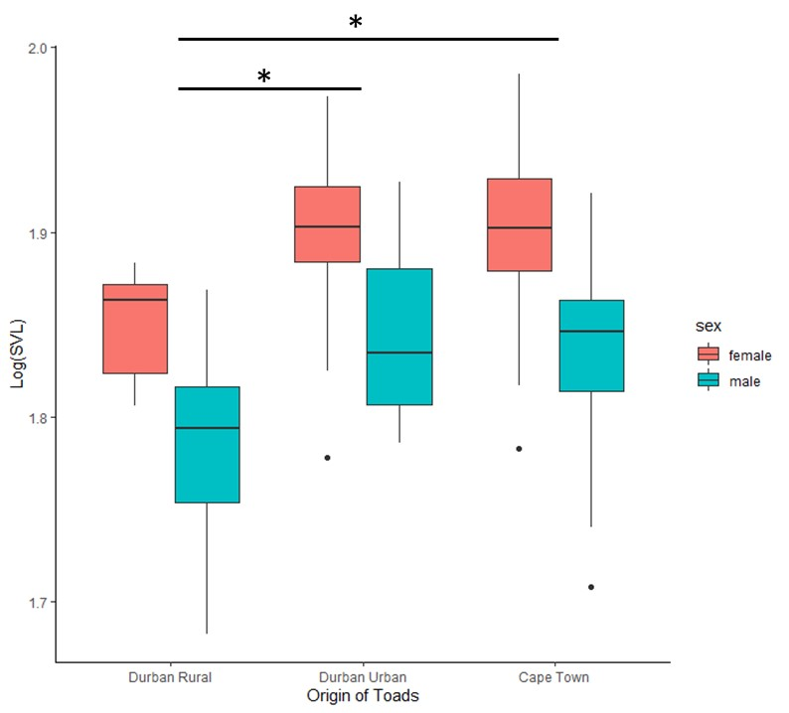
Supplementary Figure 1. Snout-vent length (SVL) of adult toads used for breeding in our tadpole common garden study separated by origin and sex: a linear model examining differences in log-transformed SVL among toads of different sex and origin showed that female toads were bigger than male toads (F_{1, 84} = 35.106, p < 0.001). Post-hoc Tukey-adjusted multiple comparisons (Lenth et al. 2018) showed that Durban Rural toads were smaller than Durban Urban toads (β = -0.054, SE = 0.013, t_{3, 84} = -4.261, p < 0.001), likewise Cape Town toads were bigger than Durban Rural toads (β = 0.047, SE = 0.013, t_{3, 84} = -3.530, p = 0.002) but Cape Town and Durban Urban toads did not differ in size (β = -0.006, SE = 0.012, t_{3, 84} = -0.545, p = 0.849).

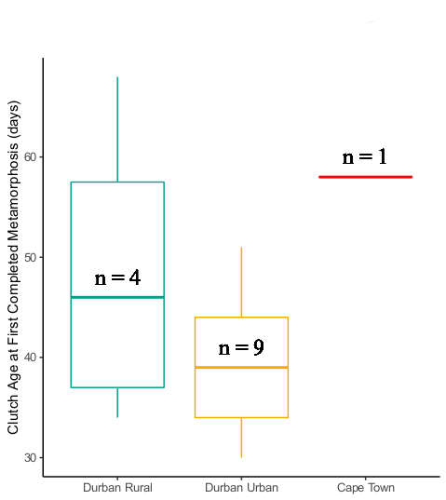
Supplementary Figure 2. Age at which the first individual of a clutch completed metamorphosis (Gosner stage 46; Gosner, 1960) by origin: sample sizes for each origin are added on top of the median line. The average age in days at first completed metamorphosis was 48.5 ± 7.805, 39.333 ± 2.386, and 58 ± 0 (mean ± Standard Errors) for Durban Rural, Durban Urban and Cape Town, respectively. This part of the experiment could not be completed due to the beginning of the Covid-19 outbreak. Given the low sample size, we decided to include this result in the supplementary materials. Note that for Cape Town there was one clutch aged 70 days and another clutch aged 57 days, respectively without a metamorph at the termination of the experiment, thus, the mean age at first metamorphosis for Cape Town could potentially be higher if we had been able to carry on with the experiment.

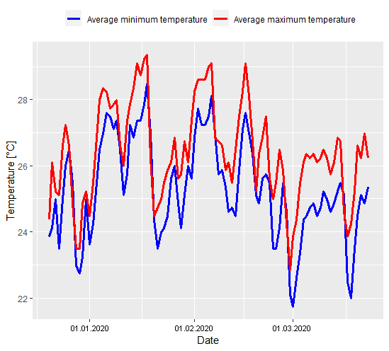
Supplementary Figure 3. Average maximum and minimum temperatures in mesocosms during the experiment: we placed data loggers in four randomly chosen mesocosms that recorded water temperatures every hour for the entirety of the experiment. We averaged the daily maximum (red line) and minimum (blue line) temperatures of those mesocosms and present the temperature changes during our common garden experiment.

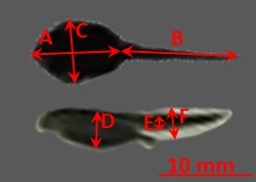
Supplementary Figure 4. Tadpole morphological measurements: (A) snout-vent length (SVL), (B) tail length, (C) maximal body width, (D) maximal body height, (E) maximal tail muscle height, and (F) maximal tail fin height (each in mm). The background of the photos has been removed and replaced with grey to enhance visibility.

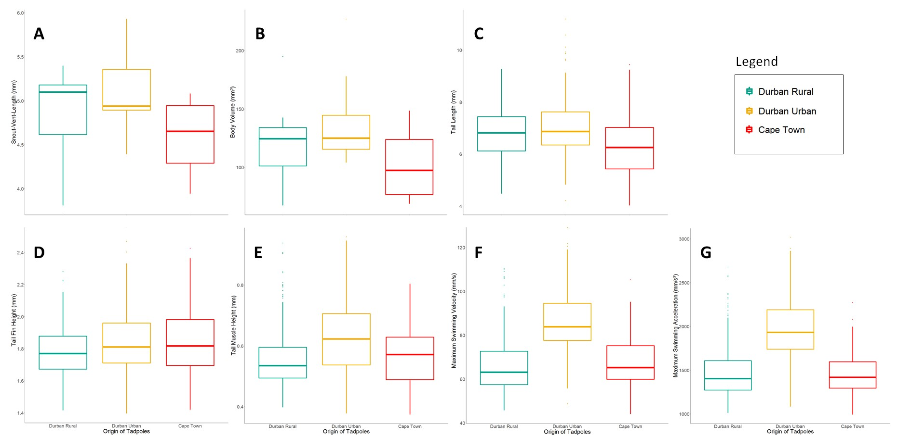
Supplementary Figure 5. Trait differentiation of 40/41 days old tadpoles: (A) snout-vent length, (B) body volume, (C) tail length, (D) tail fin height, (E) tail muscle height, (F) maximum swimming velocity, and (G) maximum swimming acceleration of tadpoles of native rural (Durban Rural), native urban (Durban Urban), non-native urban (Cape Town) origin at the age of 40/41 days. No trait that is presented in this figure was significantly different between origin populations (Table 4 and 5). All morphological and performance variables were log-transformed prior to analysis and predicted data was back-transformed before plotting. Presented are boxplots. The boxes denote the interquartile ranges (IQR), the bars inside the boxes correspond with the predicted medians from the models. The whiskers extend to 1.5 × IQR. The circles correspond with data points with values higher than 1.5 × IQR.

Supplementary Table 1. Detailed list of sample sizes for tadpole measurements across age: numbers below the specific traits correspond to the total number of tadpoles measured at the specific age. Numbers in brackets correspond to the total number of clutches, the tadpoles were randomly selected from. Due to logistical reasons, breeding was carried out in batches with adult toads that were available at the time from December 2019 to March 2020 (see Methods). Because of Covid-19 pandemic restrictions starting at the end of March 2020 in South Africa, sample sizes are significantly lower for measurements at higher ages.

 | Durban Rural |  |  |  | Durban Urban |  |  |  |  | Cape Town
Traits  Age (Days) | SVL, body width, tail length | Body height, tail fin height, tail muscle height | Maximum velocity, maximum acceleration | SVL, body width, tail length |  | Body height, tail fin height, tail muscle height |  | Maximum velocity, maximum acceleration |  | SVL, body width, tail length | Body height, tail fin height, tail muscle height | Maximum velocity, maximum acceleration
2 | 20  (1) | 20  (1) | 20  (1) | 20  (1) |  | 20  (1) |  | 20  (1) |  | 0
3 | 179  (9) | 179  (9) | 179  (9) | 220  (11) |  | 219  (11) |  | 220  (11) |  | 160  (8) | 160  (8) | 159  (8)
4 | 0 |  |  |  | 32  (2) |  | 32  (2) |  | 32  (2) | 20  (1) | 20  (1) | 20  (1)
10 | 180  (9) | 180  (9) | 180  (9) | 220  (11) |  | 220  (11) |  | 220  (11) |  | 160  (8) | 160  (8) | 160  (8)
12 | 20  (1) | 19  (1) | 20  (1) | 20  (1) |  | 15  (1) |  | 20  (1) |  | 0
20 | 200  (10) | 200  (10) | 200  (10) | 180  (9) |  | 179  (9) |  | 180  (9) |  | 160  (8) | 160  (8) | 160  (8)
30 | 200  (10) | 199  (10) | 200  (10) | 180  (9) |  | 180  (9) |  | 180  (9) |  | 80  (4) | 80  (4) | 80  (4)
40 | 120  (6) | 120  (6) | 120  (6) | 180  (9) |  | 180  (9) |  | 180  (9) |  | 80  (4) | 80  (4) | 80  (4)
41 | 40  (2) | 40  (2) | 40  (2) | 0 |  |  |  |  |  | 0
50 | 60  (3) | 60  (3) | 60  (3) | 180  (9) |  | 180  (9) |  | 180  (9) |  | 60  (3) | 60  (3) | 60  (3)
60 | 60  (3) | 60  (3) | 60  (3) | 100  (5) |  | 100  (5) |  | 100  (5) |  | 40  (2) | 40  (2) | 40  (2)

Supplementary Table 2. Results of post-hoc multiple comparisons testing for differences in morphological and performance traits between guttural toad tadpoles of native rural origin (Durban Rural), native urban origin (Durban Urban), and invasive urban origin (Cape Town) raised in a common garden environment. All variables were log-transformed prior to analysis. Presented are coefficient estimates (β) with their corresponding standard errors (SE). Test statistics (z) and p-values (p_{corr}) corrected using a “tukey” adjustment (Lenth et al. 2018) are given.
Model | Origin Comparison | Model Output
 |  | β | SE | z | p_{corr}
Snout-Vent Length | Cape Town – Durban Rural | -0.064 | 0.052 | -1.239 | .430
Snout-Vent Length | Cape Town – Durban Urban | -0.026 | 0.052 | -0492 | .875
Snout-Vent Length | Durban Rural – Durban Urban | 0.039 | 0.042 | 0.915 | .631
Body Volume | Cape Town – Durban Rural | -0.22 | 0.186 | -1.187 | .461
Body Volume | Cape Town – Durban Urban | -0.114 | 0.185 | -0.614 | .812
Body Volume | Durban Rural – Durban Urban | 0.107 | 0.152 | 0.702 | .762
Tail Muscle Height | Cape Town – Durban Rural | 0.013 | 0.042 | 0.306 | .950
Tail Muscle Height | Cape Town – Durban Urban | -0.002 | 0.042 | -0.041 | .999
Tail Muscle Height | Durban Rural – Durban Urban | -0.015 | 0.034 | -0.424 | .906
Tail Fin Height | Cape Town – Durban Rural | 0.045 | 0.078 | 0.577 | .833
Tail Fin Height | Cape Town – Durban Urban | 0.040 | 0.778 | 0.517 | .863
Tail Fin Height | Durban Rural – Durban Urban | -0.005 | 0.064 | -0.073 | .997
Tail Length | Cape Town – Durban Rural | -0.009 | 0.010 | -0.992 | .582
Tail Length | Cape Town – Durban Urban | -0.014 | 0.009 | -1.522 | .280
Tail Length | Durban Rural – Durban Urban | -0.005 | 0.008 | -0.608 | .816
Maximum Swimming Velocity | Cape Town – Durban Rural | -0.030 | 0.109 | -0.288 | .959
Maximum Swimming Velocity | Cape Town – Durban Urban | -0.046 | 0.109 | -0.423 | .906
Maximum Swimming Velocity | Durban Rural – Durban Urban | -0.016 | 0.089 | -0.179 | .983
Maximum Swimming Acceleration | Cape Town – Durban Rural | -0.056 | 0.049 | -1.142 | .488
Maximum Swimming Acceleration | Cape Town – Durban Urban | -0.051 | 0.049 | -1.036 | .554
Maximum Swimming Acceleration | Durban Rural – Durban Urban | 0.006 | 0.041 | 0.136 | .990

Supplementary Table 3. Results of post-hoc multiple comparisons testing for differences in morphological and performance traits at the age 40/41 days between between guttural toad tadpoles of native rural origin (Durban Rural), native urban origin (Durban Urban), and invasive urban origin (Cape Town) raised in a common garden environment. All variables were log-transformed prior to analysis. Presented are model coefficient estimates (β) with their corresponding standard errors (SE). Test statistics (z) and p-values (p_{corr}) corrected using a “tukey” adjustment (Lenth et al. 2018) are given.
Model | Origin Comparison | Model Output
 |  | β | SE | z | p_{corr}
Snout-Vent Length | Cape Town – Durban Rural | -0.025 | 0.033 | -0.778 | .717
Snout-Vent Length | Cape Town – Durban Urban | -0.043 | 0.033 | -1.303 | .393
Snout-Vent Length | Durban Rural – Durban Urban | -0.017 | 0.028 | -0.618 | .810
Body Volume | Cape Town – Durban Rural | -0.070 | 0.094 | -0.740 | .740
Body Volume | Cape Town – Durban Urban | -0.141 | 0.095 | -1.497 | .293
Body Volume | Durban Rural – Durban Urban | -0.072 | 0.081 | -0.890 | .647
Tail Muscle Height | Cape Town – Durban Rural | 0.010 | 0.089 | 0.113 | .993
Tail Muscle Height | Cape Town – Durban Urban | -0.029 | 0.089 | -0.327 | .943
Tail Muscle Height | Durban Rural – Durban Urban | -0.039 | 0.073 | -0.538 | .852
Tail Fin Height | Cape Town – Durban Rural | 0.024 | 0.018 | 1.344 | .371
Tail Fin Height | Cape Town – Durban Urban | 0.018 | 0.018 | 1.006 | .573
Tail Fin Height | Durban Rural – Durban Urban | -0.006 | 0.015 | -0.402 | .915
Tail Length | Cape Town – Durban Rural | -0.014 | 0.012 | -1.193 | .458
Tail Length | Cape Town – Durban Urban | -0.017 | 0.012 | -1.469 | .306
Tail Length | Durban Rural – Durban Urban | -0.003 | 0.010 | -0.335 | .940
Maximum Swimming Velocity | Cape Town – Durban Rural | 0.007 | 0.090 | 0.083 | .996
Maximum Swimming Velocity | Cape Town – Durban Urban | -0.078 | 0.090 | -0.865 | .663
Maximum Swimming Velocity | Durban Rural – Durban Urban | -0.085 | 0.074 | -1.160 | .477
Maximum Swimming Acceleration | Cape Town – Durban Rural | -0.008 | 0.109 | -0.077 | .997
Maximum Swimming Acceleration | Cape Town – Durban Urban | -0.112 | 0.109 | -1.027 | .560
Maximum Swimming Acceleration | Durban Rural – Durban Urban | -0.103 | 0.089 | -1.162 | .476

