Table 1. Definitions for two descriptors of the costs in our InvaCost database: (a) environment where the cost occurred and (b) impacted sector by the cost. Note that aquatic entries unassigned to either “aquatic” or “semi-aquatic” were deemed as “diverse aquatic”. Similarly, entries unattributable between “terrestrial” and “aquatic” or “semi-aquatic” environments were deemed “diverse/unspecified”.
a. Environment | Description
Aquatic | Species that completes its life cycle completely within water. Reproduction, development and foraging all occur within water. Species may briefly occur in or use terrestrial habitats (e.g. overland movements of crayfish).
Semi-aquatic | (a) Species that habitually utilizes both aquatic and terrestrial habitats, for reproduction, development and/or foraging (e.g. Aedes albopictus, Neovison vison, Branta canadensis) or (b) emergent plant species that commonly occurs in wetlands (marshes, swamps, peatlands) (e.g. Phragmites australis, Spartina alterniflora).
Terrestrial | Species that completes its life cycle completely on land. Reproduction, development and foraging all occur on land. Species may briefly occur in or use aquatic habitats (e.g. for bathing, or crossing water bodies during migrations).
b. Sector | Description
Agriculture | Considered at its broadest sense, food and other useful products produced by human activities through using natural and/plant resources from their ecosystems (e.g. crop growing, livestock breeding, beekeeping, land management)
Authorities-Stakeholders | Governmental services and/or official organizations (e.g. conservation agencies, forest services, associations) that allocate efforts for the management sensu lato of biological invasions (e.g. control programs, eradication campaigns, research funding)
Environment | Impacts on natural resources, ecological processes and/or ecosystem services that have been valued by authors such as disruption of native habitats or degradation of local habitats
Fishery | Fish-based activities and services such as fishing and aquaculture
Forestry | Forest-based activities and services such as timber production/industries and private forests
Health | Every item directly or indirectly related to the sanitary state of people such as vector control, medical care and other derived damage on human productivity and well-being
Public and social welfare | Activities, goods or services contributing - directly or indirectly - to the human well-being and safety in our societies, including local infrastructures (e.g. electric system), quality of life (e.g. income, recreational activities), personal goods (e.g. private properties, lands), public services (e.g. transports, water regulation), and market activities (e.g. tourism, trade)

Table 2. Description of country-specific socioeconomic indicators from World Bank (2020)
Factor | Unit | Description
Total Area | km² | Area per country
Agricultural area | km² | Agricultural area per country
Forest area | km² | Forest area per country
Urban area | km² | Urban area per country
Human population size | Number of people | Number of people per country
GDP | US $ | Gross domestic product
Container port traffic | TEU: 20 foot equivalent units | National and international flow of containers from land to sea transport modes, and vice versa
Research effort as expenditure in R&D | US $ | Money spent on public institutions, universities and private non-profit institutions
Scientific and technical journal articles | Number of articles | Total number of published articles per country
Number of researchers | Number of researchers | Total number of researchers per country
Imports of goods and services | US $ | Value of all goods and other market services received from the rest of the world.

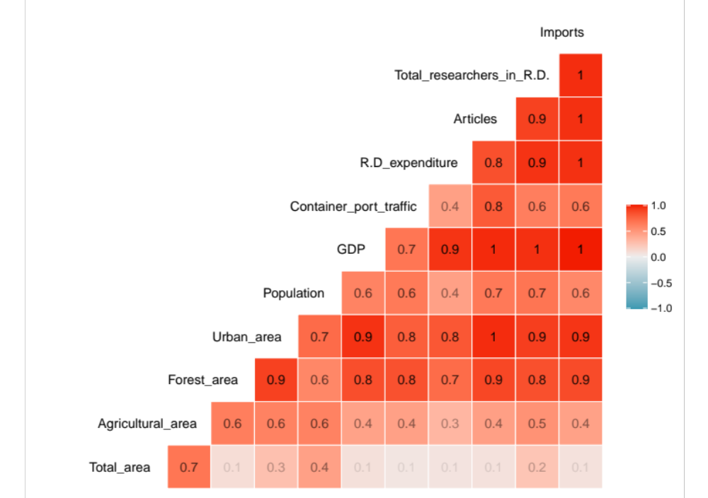
Figure 1 Correlations between key country indicators from the World Bank (2020).

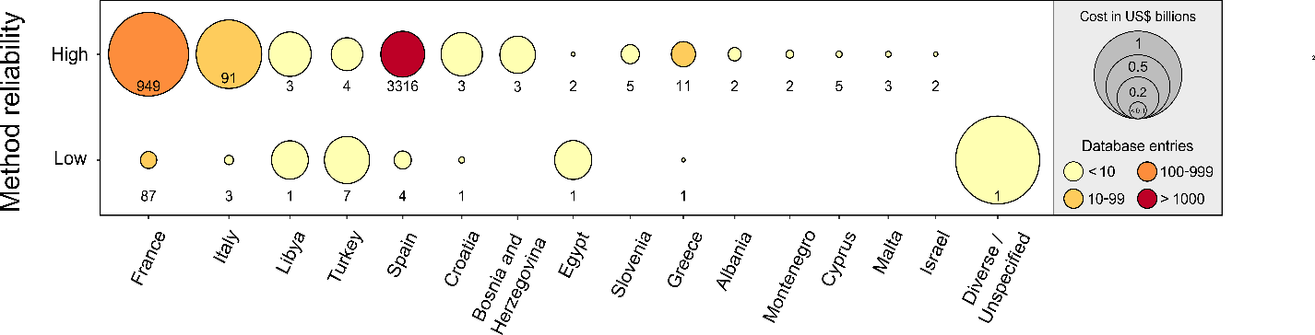
Figure 2. Balloon plot indicating observed invasion costs and cost entry numbers for Mediterranean countries according to method reliability ("High/Low"). The numbers inside/adjacent to each balloon correspond to the sample size (also indicated by shading).

Table 3 Costs (in 2017 million $) of IAS in the Mediterranean by Class in terms of "Total" and "Observed" costs
Class | Total cost |  | Observed cost
Actinopterygii | 5.872 | 5.872
Amphibia | 1.605 | 1.605
Aves | 0.831 | 0.831
Bivalvia | 40.318 | 21.230
Chytridiomycetes | 0.011 | 0.011
Crustacea | 0.899 | 0.899
Diverse/Unspecified | 87.474 | 82.037
Gastropoda | 4.284 | 4.284
Insecta | 3,554.345 | 1,734.603
Liliopsida | 111.783 | 97.950
Magnoliopsida | 9,350.166 | 1,593.031
Malacostraca | 3.422 | 3.422
Mammalia | 65.068 | 39.427
Pinopsida | 0.140 | 0.140
Polychaeta | 0.009 | 0.009
Polypodiopsida | 1.949 | 1.949
Reptilia | 0.641 | 0.558
Scyphozoa | 0.059 | 0.059
Secernentea | 14,084.184 | 0.000
Sordariomycetes* | 0.000 | 0.000
Ulvophyceae | 0.204 | 0.204
*6.05 x 10⁻⁶

Table 4 Ranking of top 10 most costly IAS in the Mediterranean (in 2017 billion $) in terms of "Total" and "Observed" costs
 | Species | Total costs |  |  | Species | Observed costs
1 | Bursaphelenchus xylophilus | 14.084 |  | 1 | Ambrosia artemisiifolia | 1.394
2 | Cochliomyia hominivorax | 1.537 |  | 2 | Bactrocera oleae | 0.842
3 | Ambrosia artemisiifolia | 1.394 |  | 3 | Cochliomyia hominivorax | 0.340
4 | Bactrocera oleae | 0.842 |  | 4 | Tuta absoluta | 0.225
5 | Diabrotica virgifera | 0.378 |  | 5 | Ceratitis capitata | 0.147
6 | Harmonia axyridis | 0.231 |  | 6 | Aedes albopictus | 0.121
7 | Tuta absoluta | 0.225 |  | 7 | Ambrosia polystachya | 0.091
8 | Ceratitis capitata | 0.147 |  | 8 | Eichhornia crassipes | 0.062
9 | Aedes albopictus | 0.134 |  | 9 | Rhynchophorus ferrugineus | 0.026
10 | Ambrosia polystachya | 0.091 |  | 10 | Myocastor coypus | 0.025

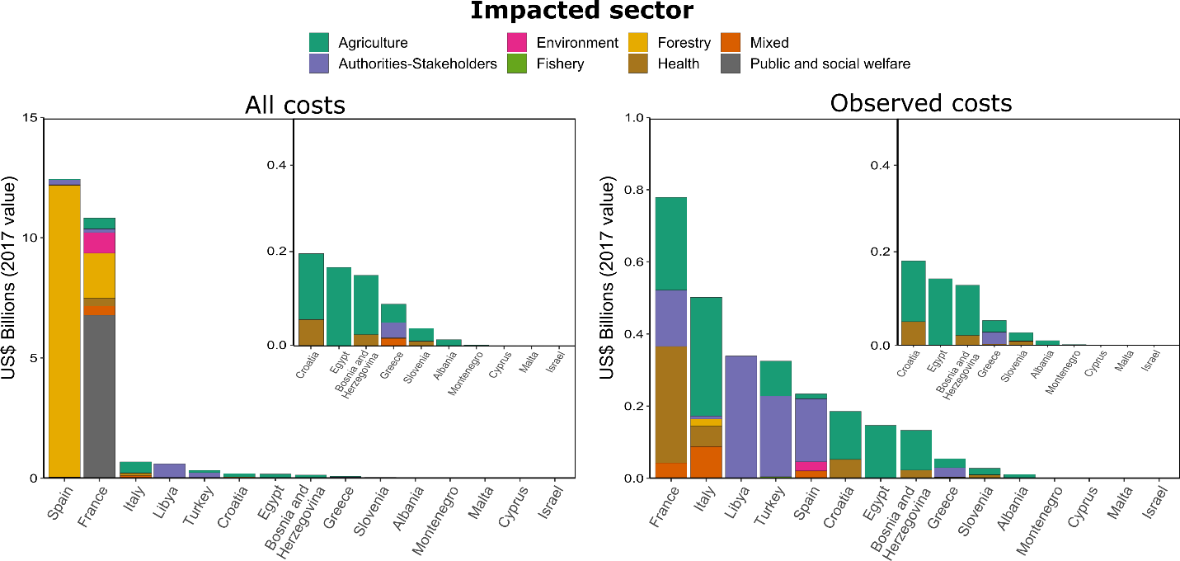
Figure 3. Types of costs by country and per impacted sector in US billion $ (2017 values) - All costs considered (left) and Observed costs only (right).

Table 5 Origin of IAS (with observed damage costs) in the Mediterranean, presence, countries reporting costs, habitats invaded, introduction pathway, main impact and use (if any).

Species | Origin | Presence | Observed damage costs | Habitats  invaded | Pathway | Introduction | Main impact | Use
Aedes albopictus | Southeast Asia, Indian ocean Pacific islands | Albania, Bosnia and Herzegovina, Croatia, France, Greece, Israel, Italy, Montenegro, Slovenia, Spain | France, Italy, Spain | Coastal areas  Cultivated land  Disturbed areas  Estuaries  Forests  Grasslands  Lakes  Rivers  Shrublands  Wetlands | Contaminant | Unintentional | Animal and human health | None
Ambrosia artemisiifolia | C. America  N. America | Albania, Algeria, Bosnia and Herzegovina, Croatia, Egypt, France, Greece, Israel, Italy, Libya, Montenegro, Slovenia, Spain, Turkey | France, Italy | Disturbed areas | Contaminant | Unintentional | Health and agriculture | None
Ambrosia polystachya | C. America  N. America | Algeria, Bosnia and Herzegovina, France, Montenegro, Slovenia, Spain, Turkey | France | Disturbed areas | Contaminant | Unintentional | Health and agriculture | None
Bactrocera oleae | Africa | Albania, Algeria, Croatia, Cyprus, Egypt, France, Greece, Italy, Lybia, Malta, Montenegro, Morocco, Tunisia, Slovenia, Spain | Mediterranean basin in general | Areas of cultivated or wild olive trees | Contaminant | Unintentional | Agriculture | None
Ceratitis capitata | Africa | Albania, Algeria, Bosnia and Herzegovina, Croatia, Cyprus, France, Greece, Israel, Italy, Lebanon, Libya, Malta, Montenegro, Morocco, Slovenia, Spain, Syria, Tunisia, Turkey | Egypt | Disturbed areas  Forests  Cultivated land | Contaminant | Unintentional | Agriculture | None
Dikerogammarus villosus | Ponto-Caspian region | France, Italy | Italy | Estuaries  Irrigation channels  Lagoons  Lakes  Reservoirs  Rivers/streams | Stowaway | Unintentional | Aquaculture  Biodiversity | None
Dreissena polymorpha | Black, Caspian and Aral Seas | Albania, Croatia, France, Greece, Italy, Slovenia, Spain and Turkey | Spain | Estuaries  Inshore marine &  Inland saline areas  Irrigation channels  Lagoons  Lakes  Ponds  Rivers | Contaminant | Unintentional | Biodiversity  Damage to structures  Environmental | None
Drosophila suzukii | Eastern Asia  Southern Asia | Bosnia and Herzegovina, Croatia, Cyprus, France, Greece, Israel, Montenegro, Morocco, Slovenia, Spain, Turkey | Italy | Disturbed areas  Forests  Cultivated land  Shrublands | Contaminant | Unintentional | Agriculture | None
Ficopomatus enigmaticus | Australasia | Croatia, Egypt, Greece, Israel, Italy, Morocco, Slovenia, Spain, Tunisia, Turkey | France | Estuaries  Lagoons  Inshore marine &  Inland saline areas | Unknown | Unintentional | Ports and marinas (ships, piers, harbour management, structures) | None
Halyomorpha halys | China  Japan  Korea  Taiwan | Albania, Bosnia and Herzegovina, Croatia, France, Greece, Malta, Slovenia, Spain, Turkey | Italy | Disturbed areas  Forests  Cultivated land | Contaminant | Unintentional | Agriculture, human health, environment | None
Lagocephalus sceleratus | Indo-West  Pacific | Algeria, Croatia, Cyprus, Greece, Egypt, Israel, Italy, Lebanon, Libya, Malta, Spain, Tunisia, Turkey | Cyprus  Turkey | Shallow, medium-high temperature marine waters | NA | Unintentional | Artisanal fisheries  Biodiversity  Human health | None
Myocastor coypus | S. America | Croatia, Greece, Israel, Slovenia, Spain, Turkey | France, Italy | Riverbanks  Wetlands  Coastal areas  Lakes  Rivers | Escape from confinement, Release in nature, Transport-Stowaway | Intentional | Environmental | Fur exploitation
Procambarus clarkii | N. Mexico  S. USA | Cyprus, Egypt, France, Greece, Israel, Italy | Spain | Cultivated land  Swamps  Irrigation channels  Lakes  Reservoirs  Rivers  Ponds | Escape from confinement | Intentional | Environmental | Food industry
Rhopilema nomadica | Africa | Greece, Israel, Lebanon, Syria, Turkey | Israel | Inshore marine | NA | NA | Biodiversity  Environmental  Fisheries  Human health  Infrastructure  Livelihoods  Tourism | None
Tuta absoluta | Peru | Albania, Algeria, Bosnia and Herzegovina, Croatia, Cyprus, Egypt, France, Italy, Lebanon, Libya, Malta, Montenegro, Morocco, Slovenia, Spain, Syria, Tunisia, Turkey | Greece | Cultivated land | Unknown | Unintentional | Agriculture | None
Zeuzera pyrina | NA | Algeria, Cyprus, Egypt, France, Israel, Italy, Libya, Malta, Morocco, Spain and Syria | Egypt | NA | NA | NA | Agriculture  Forestry | NA

Sources: InvaCost (Diagne et al., 2020) and CABI (2020)
Notes: "Forests" in the column "Habitats invaded" includes both managed and natural forests

