Only hypothesis 1 and 2 were tested using IC. We have copied the results of the analysis using a model input into the summary() function in R for simplicity but we also did this analysis using forward stepwise regression. We fit the best distribution before selecting these models as shown here https://stats.stackexchange.com/questions/132652/how-to-determine-which-distribution-fits-my-data-best.

Hypothesis 1:

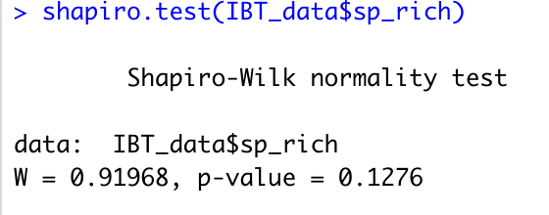
Species richness is normally distributed

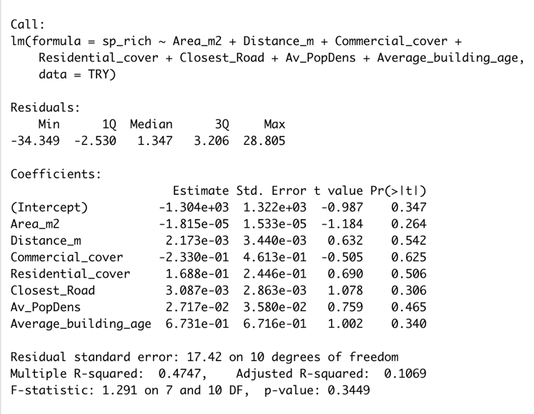

From the manuscript:
Of the candidate models, 36 were kept as part of the confidence set of the average model, including the Null model. The most parsimonious model (with the lowest AICc value) only included distance from the “unfragmented” forest (Estimate (E) = 0.0040) (Figure 2). However, when considering the confidence interval of the effect of distance to the “unfragmented” forest (Confidence interval (CI) = -0.0008, 0.0091), it could not explain species richness.

Results are the identical (confidence intervals cross zero).

Hypothesis 2:

PART 1

Native and non-native (exotic) in a binomial distribution model (we did a distribution fit)

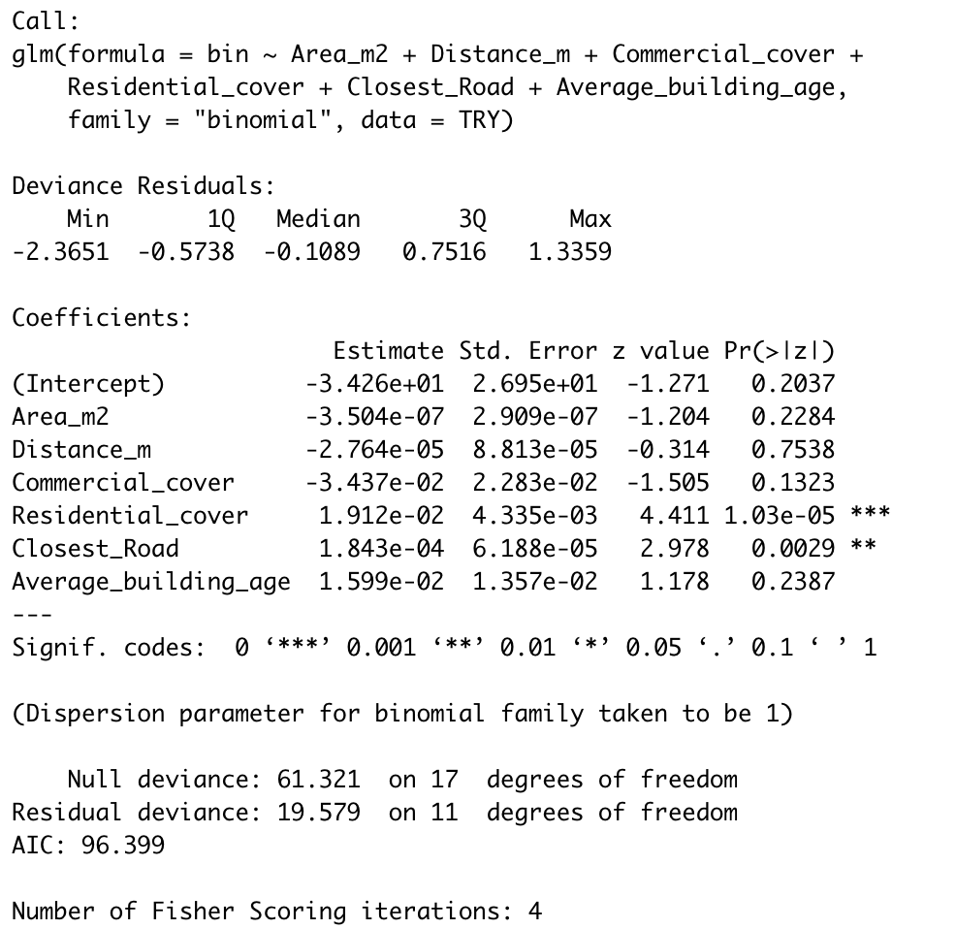

From the manuscript:

Area and distance to the unfragmented forested area were not included in the most parsimonious models (Figure 3A and B). The most parsimonious model included residential zoning (E = 0.0036), the average year of construction (E = 0.0077) (Figure 3C), and the distance to the closest road (E = 0.0000) (Figure 3D). The average model from the confidence interval set of models provided similar results; residential zoning (CI = 0.0019, 0.0050), the average year of construction (CI = 0.0032, 0.0125), and distance to the closest road (CI = 0.0000, 0.0001) had confidence intervals that showed a positive effect on the non-native to native species ratio. On the contrary, commercial zoning (CI = -0.4368, 0.0572), area (CI = -0.0000, 0.0000), and distance from the “unfragmented” forest (CI = -0.0022, 0.0024) were deemed as irrelevant.

Here, the results differ slightly, but considering the confidence intervals gives us the same results, residential zoning and distance to the closest road are important both in model inclusion and have estimates with confidence intervals that do not cross 0, but the average year of construction has an estimate that could be 0. The exact social factor that affects species composition was not our main focus.
PART 2

Native and non-native (exotic) plotted separately:
Non-native species distribution:
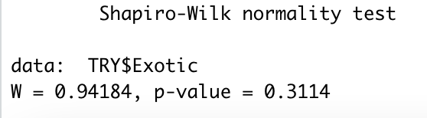
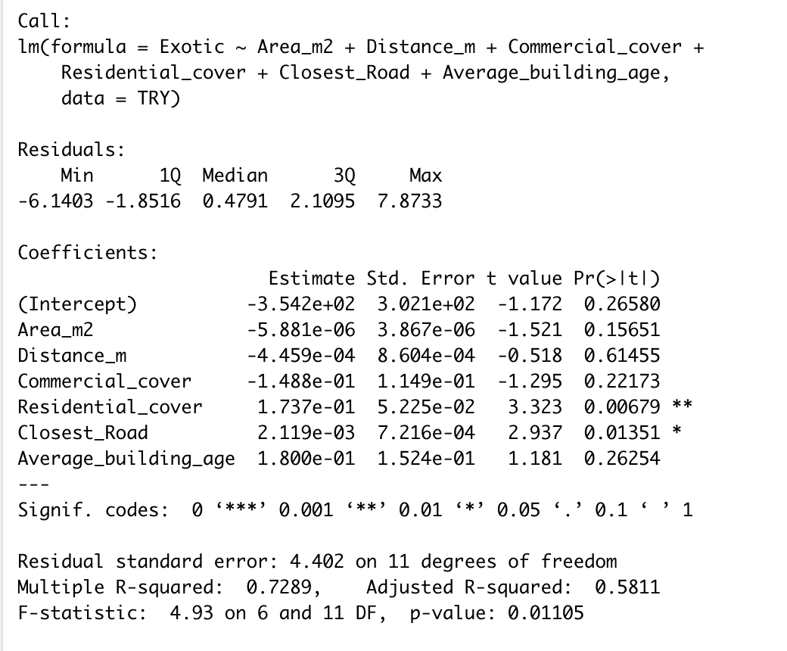

From the manuscript:

When analyzing the effect of spatial and urban landscape variables on non-native species alone, 18 models were kept as part of the confidence interval set for the model average. The most parsimonious model included a positive effect of the distance to the closest road (E = 0.0014) and residential zoning (E = 0.1743) on the number of non-native species. Similarly, only the distance to the closest road (CI = 0.0004, 0.0026) and residential zoning (CI = 0.0751, 0.2665) had confidence intervals that did not include zero in the model average. Despite the effect of the average year of construction (CI = -0.0662, 0.5207) on the non-native to native species ratio, it did not affect non-native species richness.

Native species distribution:
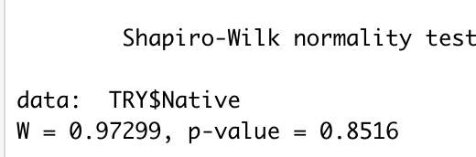

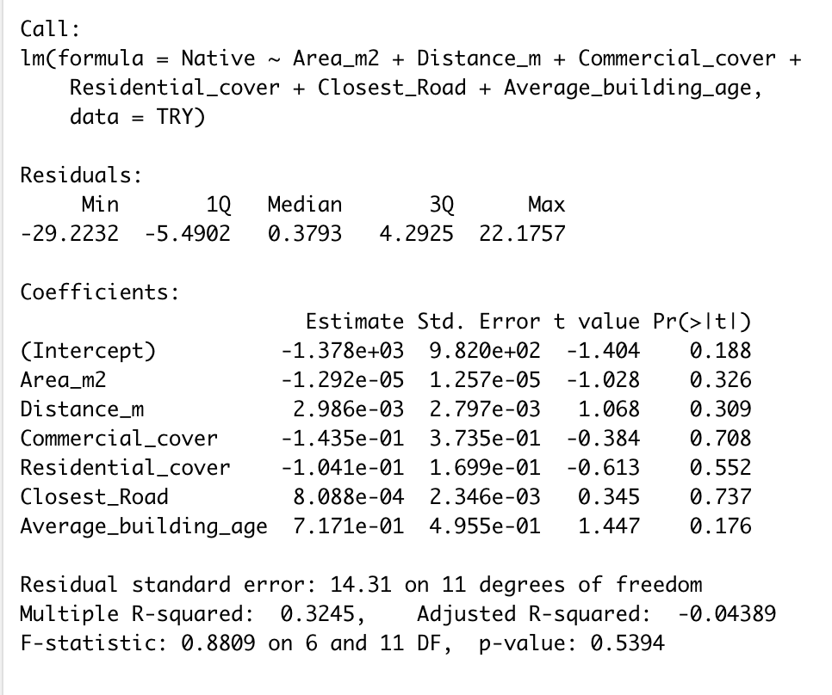

From the manuscript :
When analyzing the effect of spatial and urban landscape variables on native species alone, 31 models were kept as part of the confidence interval set for the model average. The most parsimonious model was the null model. The model average had no variable with confidence intervals that did not cross zero.

