SUPPLEMENTARY
Supplementary Table 1. List of specimens used for phylogenetic analyses: species and samples name (as it presented in Figures 2-6). Locality number as indicated in Figure 1 and Table 1.
Samples label | Locality | Genes |  |  |  |  | Citation
Samples label | Locality | Cyt b | COI | IRBP | GHR | RAG1 | Citation
Main dataset
C. langbianis
BN1409007 | 1 | KY068736 |  |  | KY068898 | KY068571 | Zhang et al. 2016
BN1409011 | 1 | KY068737 |  |  | KY068899 |  | Zhang et al. 2016
TQ-12 | 5 |  | MK957014 | MK957093 |  |  | NEW DATA
TQ-51 | 5 | MK957037 | MK957015 | MK957094 | MK957070 |  | NEW DATA
TQ-117 | 5 |  |  |  | MK957071 |  | NEW DATA
TD-40 | 6 | KY068782 |  |  |  | KY068618 | Zhang et al. 2016
TD-50 | 6 |  |  |  | KY068947 | KY068619 | Zhang et al. 2016
12-229 | 7 | KF154041 |  |  |  |  | Balakirev et al. 2014
12-237 | 7 | KF154042 |  |  |  |  | Balakirev et al. 2014
IZCAZ ZIN101501 | 7 | KT734678 |  | KT734703 | KT734724 |  | Ge et al. unpublished
IZCAZ ZIN101502 | 7 | KT734679 |  | KT734704 | KT734725 |  | Ge et al. unpublished
HN127 | 11 | HM031674 |  | KF769345 |  |  | Lu et al. 2012
HN128 | 11 | HM031673 |  | KF769346 |  |  | Lu et al. 2012
HN131 | 11 | KF740122 |  | KF769348 |  |  | Lu et al. 2012
IZCAS HN12007 | 11 | KT734674 |  | KT734701 |  |  | Ge et al. unpublished
IZCAS HN12008 | 11 | KT734675 |  |  |  |  | Ge et al. unpublished
YP22627 | 11 | KY068792 |  |  | KY068956 | KY068628 | Zhang et al. 2016
HN11248 | 12 |  |  | KT734699 | KT734716 |  | Ge et al. unpublished
HN11249 | 12 |  |  | KT734700 | KT734717 |  | Ge et al. unpublished
R3795 | 13 | HM217433 | HM217561 | HM217670 |  |  | Pages et al. 2010
R3796 | 13 | HM217434 | HM217562 | HM217671 |  |  | Pages et al. 2010
CMF 960411.4 | 13 |  | JF444991 |  |  |  | Eger et al. unpublished
CMF 960411.5 | 13 |  | JF444992 |  |  |  | Eger et al. unpublished
QB17-3 | 14 |  | MK957016 |  |  |  | NEW DATA
QB17-78 | 14 |  | MK957017 |  |  |  | NEW DATA
15-019 | 15 | MK957038 |  | MK957095 | MK957072 | MK957117 | NEW DATA
15-020 | 15 | MK957039 | MK957019 | MK957096 | MK957073 | MK957118 | NEW DATA
15-025 | 15 | MK957040 | MK957020 | MK957097 | MK957074 | MK957119 | NEW DATA
15-026 | 15 | MK957041 | MK957021 | MK957098 | MK957075 | MK957120 | NEW DATA
15-027 | 15 | MK957042 |  | MK957099 | MK957076 | MK957121 | NEW DATA
15-033 | 15 | MK957043 | MK957022 | MK957100 | MK957077 | MK957122 | NEW DATA
15-038 | 15 | MK957044 | MK957023 |  | MK957078 | MK957123 | NEW DATA
16-044 | 15 | MK957045 | MK957024 | MK957101 | MK957079 | MK957124 | NEW DATA
16-049 | 15 | MK957046 | MK957025 | MK957102 | MK957080 | MK957125 | NEW DATA
IZCAZ ZIN965516 | 15 | KT734680 |  | KT734705 |  | KT734726 | Ge et al. unpublished
16-035 | 16 | MK957047 | MK957026 |  | MK957081 |  | NEW DATA
16-036 | 16 | MK957048 | MK957027 | MK957103 | MK957082 | MK957126 | NEW DATA
16-010 | 17 | MK957049 | MK957028 | MK957104 | MK957083 | MK957127 | NEW DATA
CCP-AO 0004 | 18 |  | JF445224 |  |  |  | Eger et al. unpublished
BD-7 ZIN97678 | 19 | FJ665434 | KF154023 | KT734706 | KF154045 |  | Balakirev & Rozhnov. 2010
BD-9 ZIN97679 | 19 | JN105093 | JN105100 | JN105085 | KF154046 |  | Balakirev & Rozhnov. 2010
BD-10 ZIN97680 | 19 | GU457006 |  | KT734708 | KF154047 |  | Balakirev & Rozhnov. 2010
BD-26 ZIN97682 | 19 | FJ665437 | KF154024 | KF372974 | KF154048 |  | Balakirev & Rozhnov. 2010
BD-48 | 19 | GU457007 |  |  | KF154049 |  | Balakirev & Rozhnov. 2010
BD-50 ZIN97685 | 19 | GU457008 |  | KT734711 | KF154050 |  | Balakirev & Rozhnov. 2010
BD-109 ZIN97684 | 19 | GU457009 |  | KT734710 | KT734727 |  | Balakirev & Rozhnov. 2010
BD10-6 | 19 | KF154037 |  |  | KF154051 |  | Balakirev et al. 2014
C. thomasi
ABTC 69097 | 2 | EU349739 |  | EU349840 |  | EU349881 | Rowe et al. 2008
17-100 | 3 | MK957050 | MK957029 | MK957105 | MK957084 |  | NEW DATA
MC-68 | 4 | JQ755933 | KF154025 | JQ755964 | KF154068 |  | Balakirev et al. 2014
MC-80 | 4 | JQ755934 |  | JQ755965 | KF154069 |  | Balakirev et al. 2014
TQ-13 | 5 | MK957051 | MK957030 | MK957106 | MK957085 |  | NEW DATA
TQ-50 | 5 | MK957052 | MK957018 |  | MK957086 | MK957128 | NEW DATA
TQ-110 | 5 | MK957053 | MK957031 | MK957107 | MK957087 | MK957129 | NEW DATA
TQ-117 | 5 | MK957054 | MK957032 |  |  |  | NEW DATA
18-029 | 10 | MK957055 |  | MK957108 | MK957088 | MK957130 | NEW DATA
18-076 | 10 | MK957056 | MK957033 |  | MK957089 |  | NEW DATA
18-083 | 10 |  | MK957034 | MK957109 | MK957090 | MK957131 | NEW DATA
NA18-16 | 10 | MK957057 |  | MK957110 | MK957091 |  | NEW DATA
CMF 960423.2 | 13 |  | JF444990 |  |  |  | Eger et al. unpublished
15-046 | 15 | MK957058 | MK957035 | MK957111 | MK957092 |  | NEW DATA
16-045 | 15 | MK957059 | MK957036 | MK957112 |  |  | NEW DATA
C. chiropus
12-031 | 20 |  |  | JX173168 |  |  | Balakirev et al. 2014
12-037 | 20 |  | KF154029 |  | KF154072 | MK957132 | Balakirev et al. 2014
12-042 | 20 | MK957060 | KF154030 | MK957113 | KF154073 | MK957133 | Balakirev et al. 2014
12-057 | 20 | MK957061 | KF154031 | MK957114 |  |  | Balakirev et al. 2014
12-062 | 20 | MK957062 |  | KF372975 |  |  | Balakirev et al. 2014
12-063 | 20 | MK957063 | KF154032 | MK957115 |  | MK957134 | Balakirev et al. 2014
12-068 | 20 | MK957064 |  | MK957116 | KF154074 |  | Balakirev et al. 2014
12-070 | 20 | MK957065 |  | KF372976 | KF154075 | MK957135 | Balakirev et al. 2014
12-082 | 20 | MK957066 | KF154033 | KF372977 | KF154076 | MK957136 | Balakirev et al. 2014
12-083 | 20 | MK957067 | KF154034 |  | KF154077 | MK957137 | Balakirev et al. 2014
IZCAS ZIN100961 | 20 | KT734677 |  | KT734702 | KT734723 |  | Ge et al. unpublished
MD9-6 | 21 | GU827392 | KF154026 |  | KF154070 |  | Balakirev and Rozhnov 2010
MD10-14 | 21 | MK957068 |  |  | KF154071 |  | NEW DATA
MD10-15 | 21 | MK957069 |  |  |  |  | NEW DATA
AB96 | 21 | KF154039 |  |  | KF154071 |  | Balakirev et al. 2014
Lo7 | 22 | KF154040 | KF154028 |  |  |  | Balakirev et al. 2014
BT10-2 | 23 | KF154038 | KF154027 |  |  |  | Balakirev et al. 2014
External Groups
K63 N. bukit |  | FJ665441 | JQ755857 | JQ755957 |  |  | Balakirev and Rozhnov 2010
BD34 N. bukit |  | GU456972 |  |  | KF154052 |  | Balakirev and Rozhnov 2010
Z201401505 N. lotipes |  |  |  |  |  | KY068675 | Zhang et al. 2016
Rattus norvegicus |  | KM114605 |  | NM001191832 | NM017094 | NM053468
Mus musculus |  | HQ675031 |  | NM015745 | BC075720 | AY241462
Balakirev AE, Rozhnov VV. 2010. Species composition in the genus Niviventer (Rodentia, Muridae) based on studies of the cytochrome b gene of mtDNA. Moscow Univ Biol Sci Bull 4:170-173.
Balakirev AE, Abramov AV, Rozhnov VV. 2014. Phylogenetic relationships in the Niviventer-Chiromyscus complex (Rodentia, Muridae) inferred from molecular data, with description of a new species. ZooKeys 451:109-136.
Lu L, Chesters D, Zhang W, Li G, Ma Y, Ma H, Song X, Wu H, Meng F, Zhu C, Liu Q. 2012. Mammal Investigation in Spotted Fever Focus with DNA-Barcoding and Taxonomic Implications on Rodents Species from Hainan of China. PLoS ONE 7(8):43479
Pages M, Chaval Y, Herbreteau V, Waengsothorn S, Cosson JF, Hugot JP, Morand S, Michaux J 2010. Revisiting the taxonomy of the Rattini tribe: a phylogeny-based delimitation of species boundaries. BMC Evol Biol 10:184.
Rowe KC, Reno ML, Richmond DM, Adkins RM, Steppan SJ. 2008. Pliocene colonization and adaptive radiations in Australia and New Guinea (Sahul): multilocus systematics of the old endemic rodents (Muroidea: Murinae) Mol. Phylogenet. Evol. 47 (1):84-101.
Zhang B, He K, Wan T, Chen P, Sun G, Liu S, Nguyen TS, Lin L, Jiang X. 2016. Multi-locus phylogeny using topotype specimens sheds light on the systematics of Niviventer (Rodentia, Muridae) in China. BMC Evol Biol 16(1):261.

Supplementary Table 2. The best fit models and basic nucleotide composition parameters for genes (partitions) used for Bayesian analyses. As accessed by Mega 6.0 models explorer modul by Maximum Likelihood fits.
Gene | Model | Number of  parameters | BIC  (Bayesian  Information  Criterion) | AICc (Akaike  Information  Criterion,  corrected) | lnL  (Maximum  Likelihood value) | Invar  (fraction of  invariant sites) | G  (Gamma  distribution) | R  (transition/  transversion bias) | Freq A | Freq T | Freq C | Freq G | A=>T | A=>C | A=>G | T=>A | T=>C | T=>G | C=>A | C=>T | C=>G | G=>A | G=>T | G=>C
GHR | K2+I | 103 | 4035,7 | 3183,23 | -1488 | 0,7894 | n/a | 1,1937 | 0,25 | 0,25 | 0,25 | 0,25 | 0,06 | 0,06 | 0,14 | 0,06 | 0,14 | 0,06 | 0,06 | 0,14 | 0,06 | 0,14 | 0,06 | 0,06
RAG1 | K2+G | 55 | 5309 | 4845,19 | -2368 | n/a | 0,1101 | 2,4955 | 0,25 | 0,25 | 0,25 | 0,25 | 0,04 | 0,04 | 0,18 | 0,04 | 0,18 | 0,04 | 0,04 | 0,18 | 0,04 | 0,18 | 0,04 | 0,04
IRBP | T92+G | 98 | 4277,7 | 3439,78 | -1622 | n/a | 0,0500 | 2,8492 | 0,20 | 0,20 | 0,30 | 0,30 | 0,03 | 0,04 | 0,22 | 0,03 | 0,22 | 0,04 | 0,03 | 0,15 | 0,04 | 0,15 | 0,03 | 0,04
Cyt b | TN93+G+I | 136 | 10806 | 9553,15 | -4640 | 0,4621 | 1,4825 | 3,7734 | 0,31 | 0,28 | 0,29 | 0,12 | 0,03 | 0,03 | 0,05 | 0,03 | 0,31 | 0,01 | 0,03 | 0,30 | 0,01 | 0,12 | 0,03 | 0,03
COI | T92+I | 86 | 2949,4 | 2307,27 | -1067 | 0,7042 | n/a | 4,5192 | 0,31 | 0,31 | 0,19 | 0,19 | 0,03 | 0,02 | 0,16 | 0,03 | 0,16 | 0,02 | 0,03 | 0,25 | 0,02 | 0,25 | 0,03 | 0,02

Abbreviations: BIC: Bayesian Information Criterion, AICc: Akaike Information Criterion, corrected; lnL: Maximum Likelihood value (Nei and Kumar 2000); GTR: General Time Reversible; HKY: Hasegawa-Kishino-Yano; TN93: Tamura-Nei; T92: Tamura 3-parameter; K2: Kimura 2-parameter; JC: Jukes-Cantor.
Nei M., Kumar S. 2000. Molecular evolution and phylogenetics. Oxford University Press, New York.

Supplementary Table 3 Descriptive statistics (mean, range, standard deviation) for skull measurements (mm) of adult C. langbianis specimens from Vietnam.
Characters | C. langbianis (Southern lineage) |  |  |  |  | C. langbianis (Northern lineage) |  |  |  |  | ANOVA
Characters | n | Mean | Min | Max | Std.Dev. | n | Mean | Min | Max | Std.Dev. | F | p
ONL | 7 | 35.621 | 34.970 | 36.750 | 0.615 | 28 | 37.150 | 34.170 | 39.360 | 1.493 | 6.559 | 0.015*
BBC | 7 | 15.653 | 15.380 | 15.890 | 0.194 | 28 | 15.093 | 14.190 | 15.760 | 0.380 | 13.708 | 0.001**
HBC | 7 | 10.400 | 9.550 | 11.000 | 0.507 | 28 | 9.997 | 9.490 | 10.710 | 0.325 | 7.390 | 0.011*
ZB | 7 | 16.868 | 16.282 | 17.308 | 0.338 | 28 | 17.531 | 15.640 | 18.760 | 0.816 | 4.419 | 0.044*
IB | 7 | 5.806 | 5.513 | 6.026 | 0.219 | 28 | 6.227 | 5.600 | 6.550 | 0.255 | 16.267 | 0.000**
LR | 7 | 11.520 | 11.154 | 11.923 | 0.309 | 28 | 12.363 | 10.770 | 13.800 | 0.786 | 5.798 | 0.022*
BR | 7 | 5.788 | 5.256 | 6.026 | 0.261 | 28 | 6.317 | 5.610 | 6.990 | 0.305 | 16.679 | 0.000**
BZP | 7 | 3.443 | 3.205 | 3.590 | 0.156 | 28 | 3.578 | 3.020 | 4.130 | 0.294 | 1.677 | 0.205
LD | 7 | 9.121 | 8.974 | 9.231 | 0.115 | 28 | 9.834 | 8.510 | 10.760 | 0.560 | 9.615 | 0.004**
LIF | 7 | 6.209 | 5.769 | 6.410 | 0.244 | 28 | 6.607 | 5.930 | 7.440 | 0.471 | 4.185 | 0.049*
BIF | 7 | 2.527 | 2.308 | 2.692 | 0.122 | 28 | 2.761 | 2.430 | 3.070 | 0.160 | 12.045 | 0.002**
LBP | 7 | 5.604 | 5.256 | 5.897 | 0.231 | 28 | 6.576 | 6.020 | 7.290 | 0.344 | 48.114 | 0.000**
BBP | 7 | 3.370 | 3.077 | 3.718 | 0.192 | 28 | 3.664 | 2.730 | 4.190 | 0.301 | 5.668 | 0.023*
PPL | 7 | 11.960 | 11.667 | 12.308 | 0.231 | 27 | 13.114 | 11.550 | 14.550 | 0.767 | 14.829 | 0.001**
BMF | 7 | 2.436 | 2.179 | 2.564 | 0.148 | 28 | 2.805 | 2.380 | 3.420 | 0.271 | 11.764 | 0.002**
LB | 7 | 5.027 | 4.872 | 5.128 | 0.116 | 28 | 5.200 | 4.400 | 5.800 | 0.352 | 1.410 | 0.244
CLM1-3 | 7 | 5.714 | 5.385 | 6.410 | 0.338 | 28 | 6.266 | 5.650 | 6.660 | 0.270 | 22.800 | 0.000**
BM1 | 7 | 1.758 | 1.667 | 1.795 | 0.050 | 28 | 1.7964 | 1.620 | 1.940 | 0.079 | 1.442 | 0.239
Bm1 | 7 | 1.548 | 1.538 | 1.603 | 0.024 | 27 | 1.616 | 1.480 | 1.790 | 0.077 | 5.216 | 0.029*
CLm1-3 | 7 | 5.842 | 5.513 | 6.026 | 0.194 | 27 | 6.209 | 5.390 | 6.670 | 0.306 | 9.007 | 0.005**
Footnotes: (*) p ≤ 0.05, (**) p ≤ 0.01

Supplementary Table 4. Descriptive statistics (mean, range, standard deviation) for skull measurements (mm) of adult C. thomasi specimens from Vietnam.
Characters | C. thomasi (Southern lineage) |  |  |  |  | C. thomasi (Northern lineage) |  |  |  |  | ANOVA
Characters | n | Mean | Min | Max | Std.Dev. | n | Mean | Min | Max | Std.Dev. | F | p
ONL | 6 | 40.23 | 38.49 | 41.73 | 1.329 | 7 | 41.22 | 39.36 | 42.91 | 1.337 | 1.763 | 0.211
BBC | 6 | 16.12 | 15.65 | 16.87 | 0.467 | 7 | 16.15 | 15.88 | 16.46 | 0.247 | 0.023 | 0.882
HBC | 6 | 10.75 | 10.37 | 11.21 | 0.349 | 7 | 11.29 | 10.96 | 11.76 | 0.285 | 9.474 | 0.011*
ZB | 6 | 19.42 | 18.83 | 20.04 | 0.521 | 7 | 19.74 | 18.94 | 21.04 | 0.756 | 0.782 | 0.395
IB | 6 | 6.823 | 6.260 | 7.020 | 0.291 | 7 | 6.689 | 6.470 | 6.940 | 0.181 | 1.040 | 0.330
LR | 6 | 13.39 | 12.67 | 13.88 | 0.500 | 7 | 13.37 | 12.52 | 14.05 | 0.493 | 0.004 | 0.950
BR | 6 | 6.995 | 6.570 | 7.410 | 0.343 | 7 | 7.283 | 6.890 | 7.860 | 0.328 | 2.390 | 0.150
BZP | 6 | 3.763 | 3.510 | 4.100 | 0.256 | 7 | 3.963 | 3.750 | 4.240 | 0.185 | 2.660 | 0.131
LD | 6 | 10.75 | 9.780 | 11.38 | 0.695 | 7 | 11.10 | 10.44 | 12.01 | 0.499 | 1.159 | 0.305
LIF | 6 | 7.063 | 6.730 | 7.350 | 0.273 | 7 | 7.579 | 6.980 | 8.050 | 0.440 | 6.143 | 0.031*
BIF | 6 | 2.953 | 2.760 | 3.140 | 0.138 | 7 | 3.183 | 2.830 | 3.510 | 0.211 | 5.142 | 0.044*
LBP | 6 | 7.238 | 6.940 | 7.620 | 0.292 | 7 | 7.330 | 6.640 | 7.770 | 0.388 | 0.225 | 0.645
BBP | 6 | 4.005 | 3.860 | 4.100 | 0.094 | 7 | 4.156 | 3.980 | 4.340 | 0.162 | 3.986 | 0.071
PPL | 6 | 14.27 | 13.13 | 14.96 | 0.686 | 7 | 15.13 | 14.11 | 16.20 | 0.620 | 5.599 | 0.037*
BMF | 6 | 3.075 | 2.740 | 3.390 | 0.251 | 7 | 3.241 | 2.720 | 3.580 | 0.316 | 1.076 | 0.322
LB | 6 | 5.008 | 4.700 | 5.210 | 0.232 | 7 | 5.127 | 4.910 | 5.340 | 0.182 | 1.072 | 0.323
CLM1-3 | 6 | 6.967 | 6.700 | 7.250 | 0.215 | 7 | 7.377 | 7.080 | 7.840 | 0.294 | 8.002 | 0.016*
BM1 | 6 | 1.963 | 1.860 | 2.140 | 0.096 | 7 | 2.049 | 1.970 | 2.200 | 0.085 | 2.901 | 0.117
Bm1 | 6 | 1.768 | 1.690 | 1.860 | 0.062 | 7 | 1.870 | 1.740 | 1.960 | 0.066 | 8.112 | 0.016*
CLm1-3 | 6 | 6.820 | 6.640 | 6.950 | 0.124 | 7 | 7.154 | 6.940 | 7.360 | 0.153 | 18.23 | 0.001**
Footnotes: (*) p ≤ 0.05, (**) p ≤ 0.01

Supplementary Table 5 Descriptive statistics (mean, range, standard deviation) for skull measurements (mm) of adult C. chiropus specimens from Vietnam.
Chiromyscus chiropus
Characters | n | Mean | Min | Max | Std.Dev.
ONL | 14 | 38.311 | 35.910 | 41.020 | 1.537
BBC | 15 | 15.326 | 14.800 | 15.870 | 0.347
HBC | 15 | 10.467 | 9.970 | 10.870 | 0.297
ZB | 15 | 18.163 | 16.680 | 20.070 | 0.992
IB | 15 | 6.415 | 6.100 | 6.840 | 0.214
LR | 15 | 12.301 | 11.370 | 13.240 | 0.639
BR | 15 | 6.701 | 4.040 | 7.470 | 0.811
BZP | 15 | 3.716 | 3.270 | 4.200 | 0.277
LD | 15 | 10.227 | 8.880 | 11.610 | 0.693
LIF | 15 | 7.642 | 6.510 | 8.590 | 0.694
BIF | 15 | 3.089 | 2.800 | 3.490 | 0.212
LBP | 15 | 6.894 | 6.410 | 7.540 | 0.315
BBP | 15 | 3.640 | 3.170 | 4.060 | 0.255
PPL | 14 | 13.496 | 12.360 | 14.380 | 0.656
BMF | 15 | 2.755 | 2.500 | 3.180 | 0.195
LB | 14 | 5.214 | 4.960 | 5.370 | 0.137
CLM1-3 | 15 | 6.676 | 6.170 | 7.050 | 0.230
BM1 | 15 | 1.910 | 1.820 | 2.000 | 0.057
Bm1 | 15 | 1.708 | 1.540 | 1.980 | 0.113
CLm1-3 | 15 | 6.557 | 6.130 | 6.900 | 0.216

Supplementary Table 6. Results of multivariate analyses.
Factor loadings and cumulative variance for the principal components in the principal components analysis illustrated in Fig. 7A and canonical correlations and cumulative variance for the canonical variates in the discriminant function analysis illustrated in Fig. 7B.
Characters | PCA |  |  | DFA
Characters | PC 1 | PC 2 | PC 3 | CAN 1 | CAN 2 | CAN 3
ONL | -0.940 | 0.219 | 0.056 | -0.378 | -0.061 | -0.068
BBC | -0.656 | -0.061 | 0.320 | -0.276 | 0.251 | -0.299
HBC | -0.738 | -0.166 | 0.339 | -0.313 | 0.084 | -0.413
ZB | -0.927 | 0.074 | 0.058 | -0.360 | -0.030 | -0.076
IB | -0.851 | 0.022 | 0.008 | -0.356 | -0.138 | 0.078
LR | -0.796 | 0.290 | 0.100 | -0.288 | 0.009 | 0.126
BR | -0.756 | 0.103 | 0.031 | -0.271 | -0.120 | -0.043
BZP | -0.690 | -0.043 | -0.216 | -0.163 | -0.063 | -0.066
LD | -0.892 | 0.282 | 0.113 | -0.293 | -0.096 | -0.020
LIF | -0.748 | -0.034 | -0.113 | -0.216 | -0.329 | -0.235
BIF | -0.812 | -0.065 | -0.208 | -0.290 | -0.325 | -0.180
LBP | -0.788 | -0.007 | -0.182 | -0.421 | -0.290 | 0.136
BBP | -0.707 | 0.311 | 0.348 | -0.271 | 0.023 | 0.066
PPL | -0.896 | 0.232 | -0.033 | -0.399 | -0.094 | 0.002
BMF | -0.668 | 0.270 | 0.053 | -0.267 | -0.006 | 0.113
LB | -0.190 | 0.363 | -0.785 | 0.021 | -0.111 | 0.050
CLM1-3 | -0.865 | -0.279 | -0.181 | -0.516 | -0.212 | -0.106
BM1 | -0.754 | -0.555 | -0.065 | -0.380 | -0.113 | -0.245
Bm1 | -0.777 | -0.391 | 0.023 | -0.357 | -0.098 | -0.152
CLm1-3 | -0.844 | -0.345 | -0.173 | -0.469 | -0.159 | -0.133
Cumulative variance (%) | 60.9 | 67.3 | 73.3 | 53.6 | 79.0 | 96.8

Supplementary Figure 1. Cranial and dental measurements used in this study, following Musser & Newcomb (1983) and Musser et al. (2006).

Supplementary Figure 2. The phylogenetic tree (COI, Bayesian inference) for Chiromyscus genetic lineages radiation. The posterior probability values are presented at the nodes and the branch lengths (longer scale bar at the bottom) are indicated above the nodes. The sample labels and locality numeration are indicated as in Figure 1 and Supplementary Table 1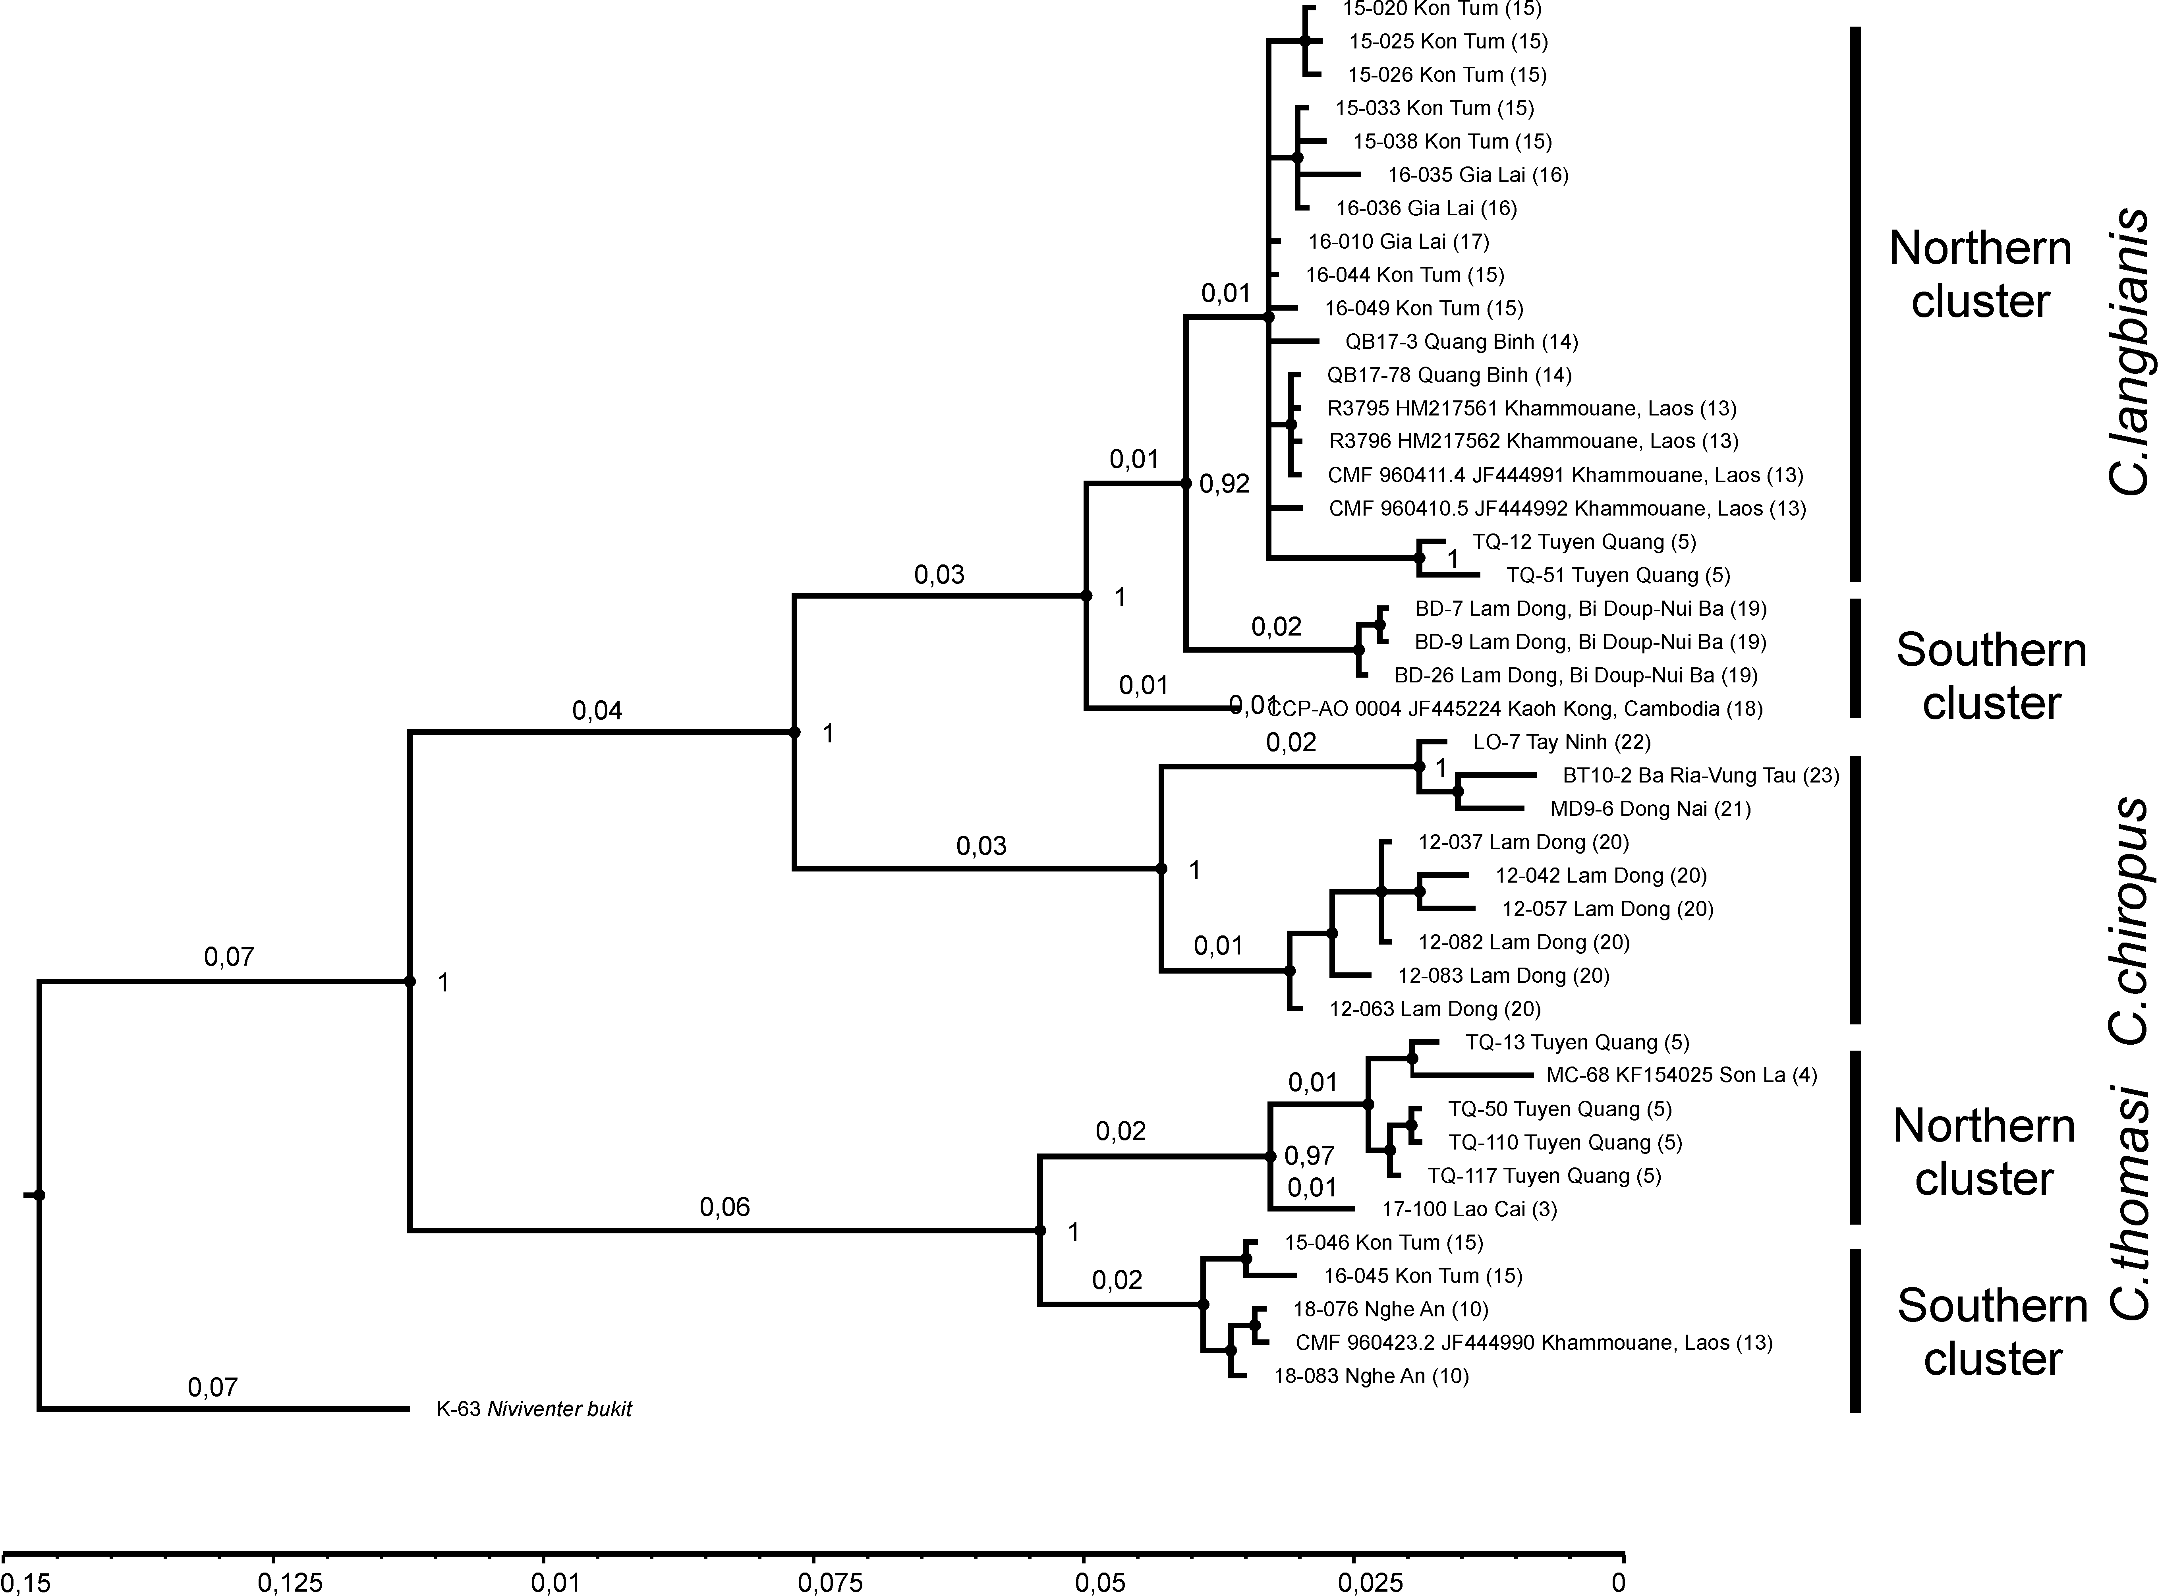

Supplementary Figure 3. The phylogenetic tree (RAG1, Bayesian inference) for Chiromyscus genetic lineages radiation. The posterior probability values are presented at the nodes, and the branch lengths (longer scale bar at the bottom) are indicated above the nodes. The sample labels and locality numeration are indicated as in Figure 1 and Supplementary Table 1.
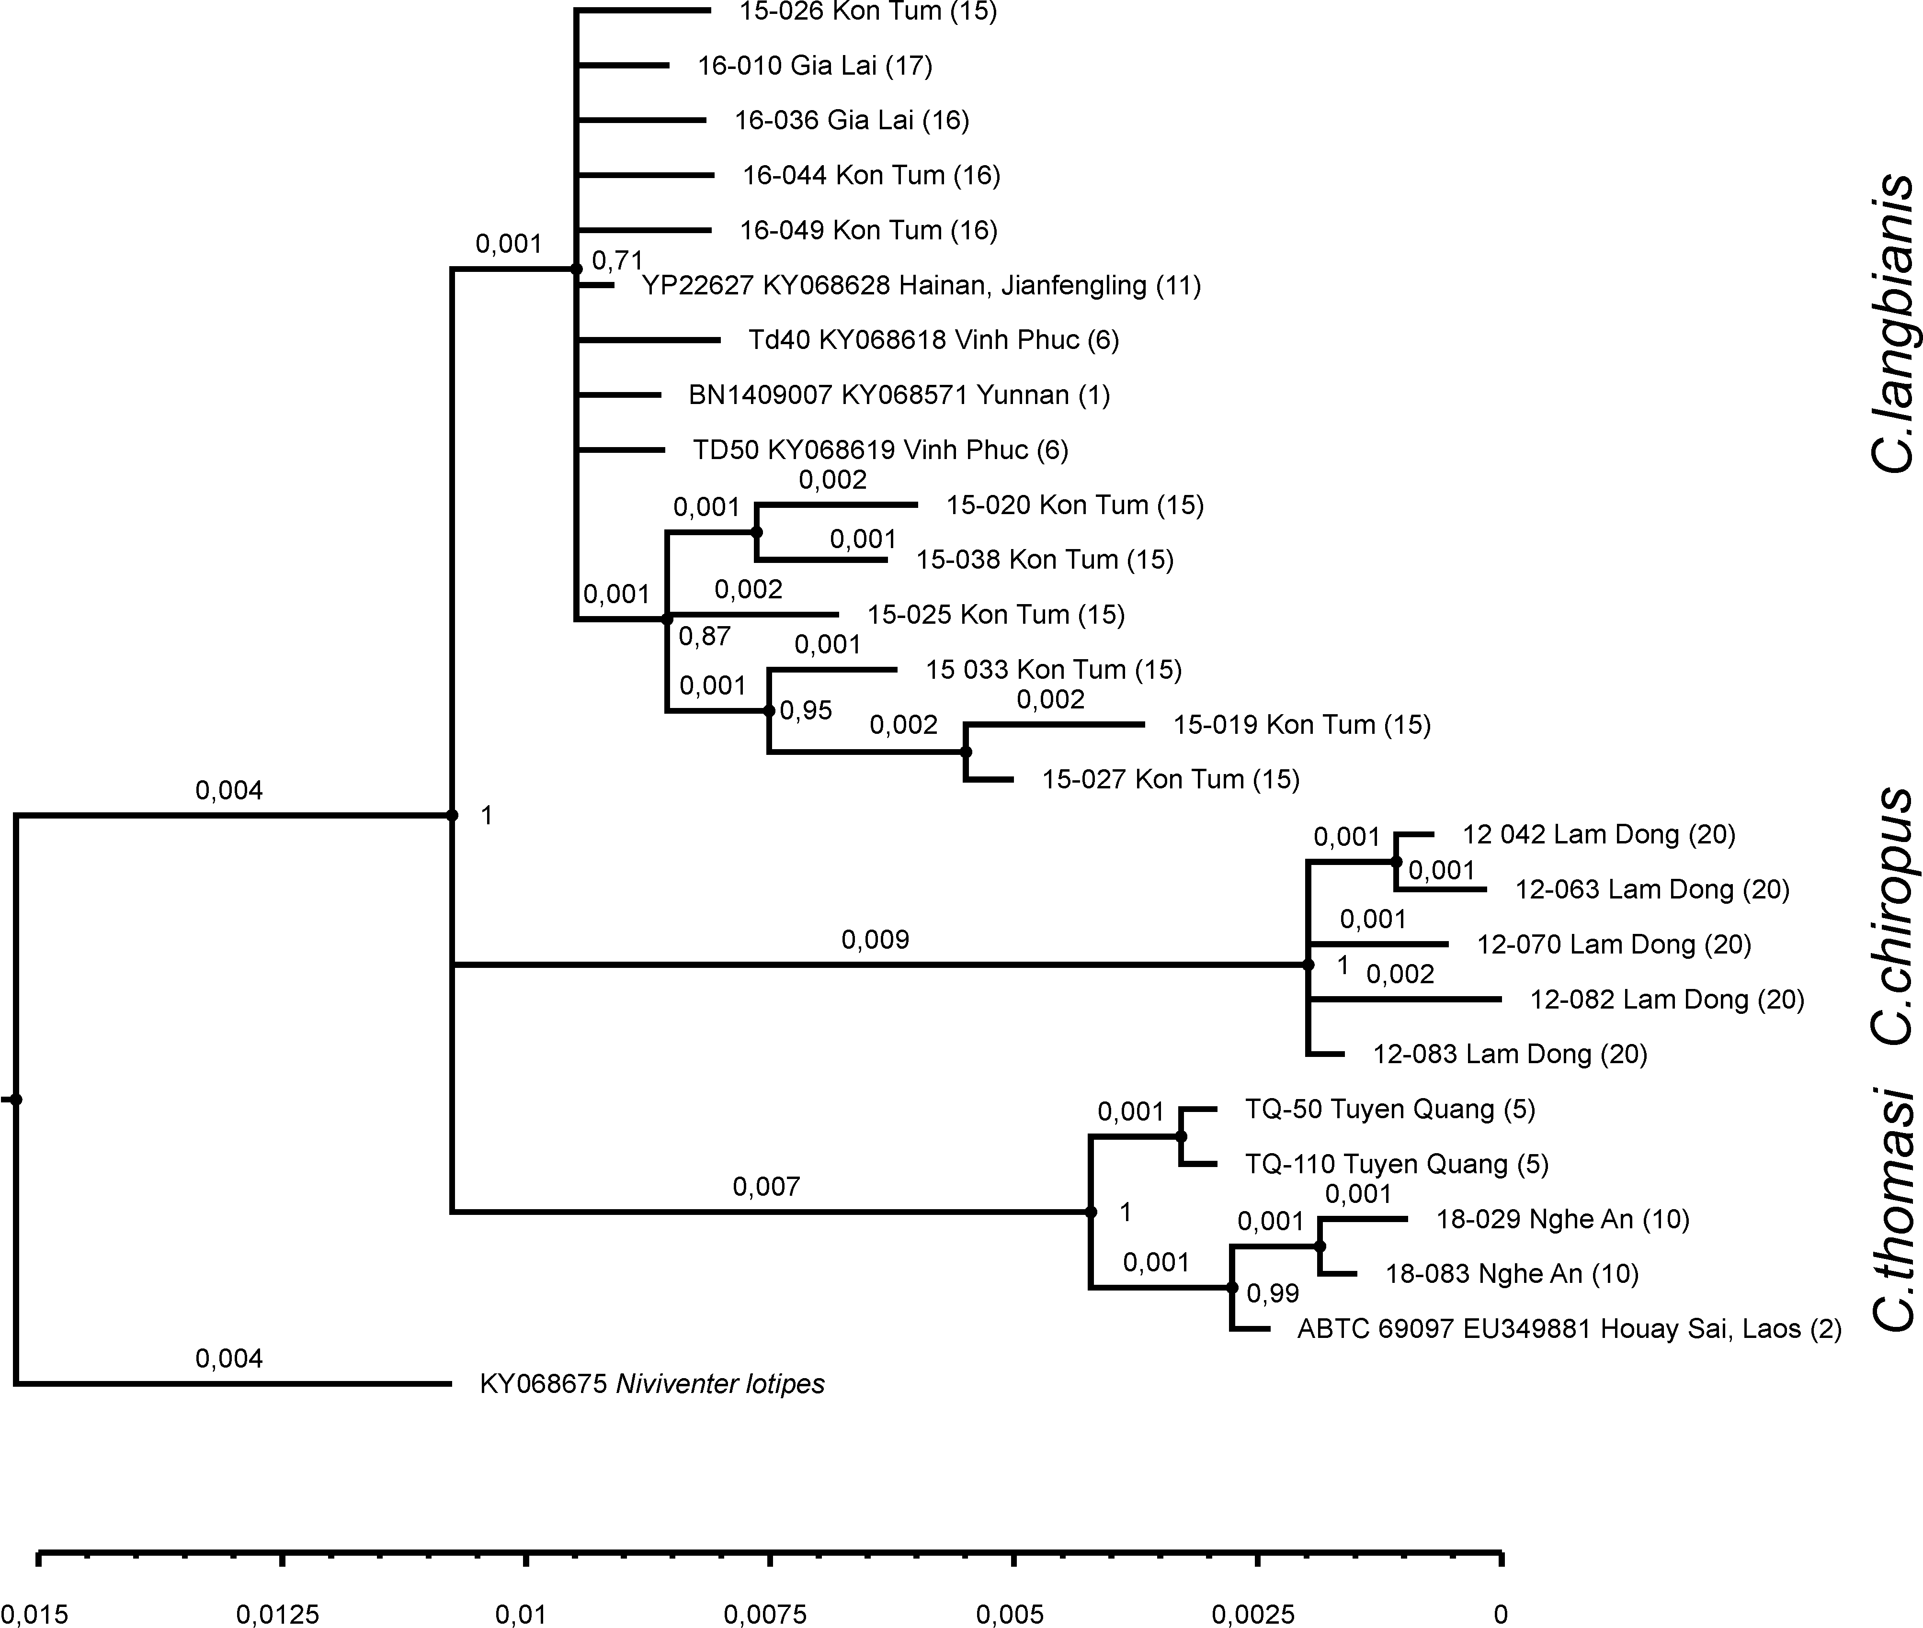

Supplementary Figure 4. The phylogenetic tree (GHR, Bayesian inference) for Chiromyscus genetic lineages radiation. The posterior probability values are presented at the nodes, and the branch lengths (longer scale bar at the bottom) are indicated above the nodes. The sample labels and locality numeration are indicated as in Figure 1 and Supplementary Table 1.
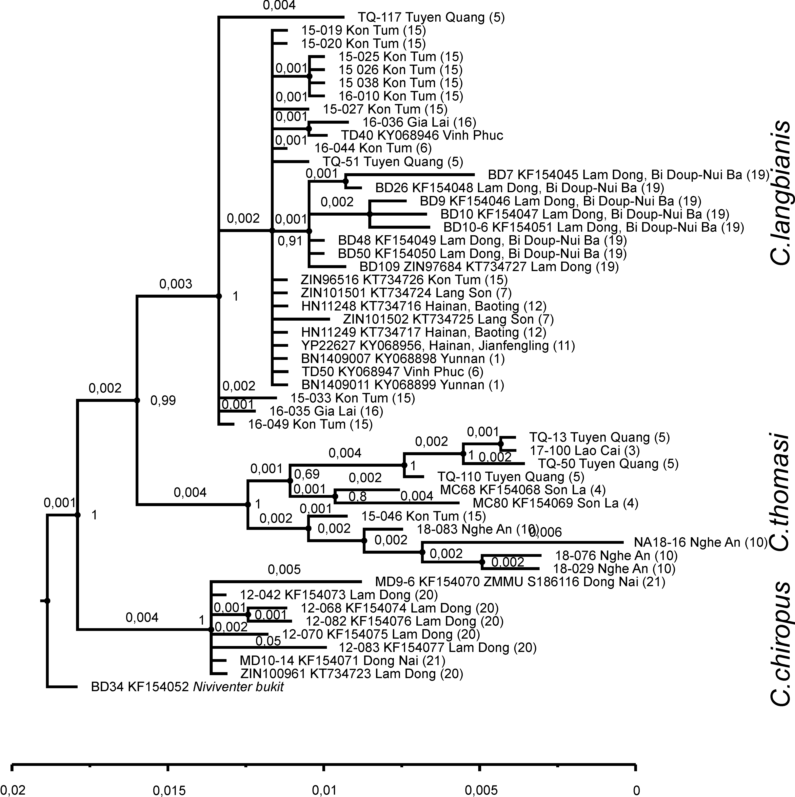

Supplementary Figure 5. The phylogenetic tree (IRBP, Bayesian inference) for Chiromyscus genetic lineages radiation. The posterior probability values are presented at the nodes, and the branch lengths (longer scale bar at the bottom) are indicated above the nodes. The sample labels and locality numeration are indicated as in Figure 1 and Supplementary Table 1.
