Supplementary - Left male palps of Pinelema bailongensis species group, retrolateral view

Taxonomic study of the Pinelema bailongensis species group (Araneae, Telemidae), with descriptions of six new species
By Huifeng Zhao, Zhiyuan Yao, Yang Song & Shuqiang Li

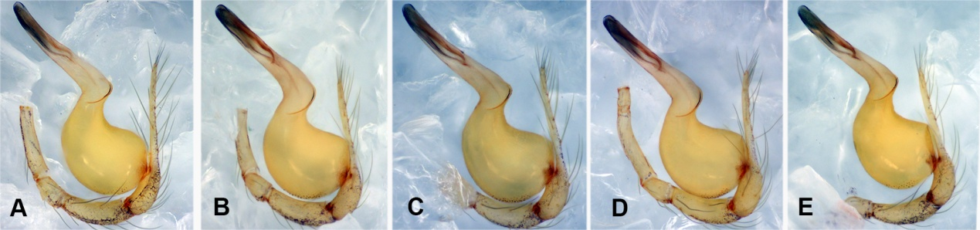

Figure S1. Pinelema bailongensis Wang & Li, 2012

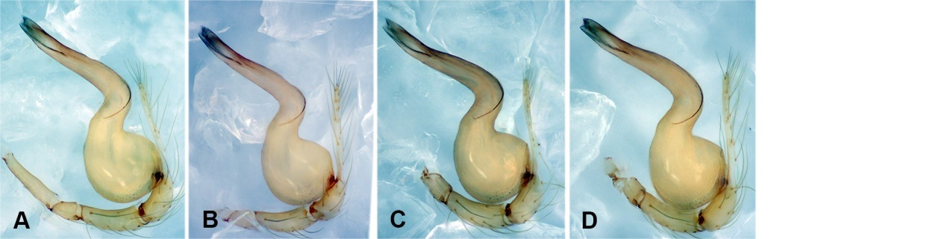

Figure S2. Pinelema cheni Zhao & Li sp. n. A: holotye, B–D: paratypes

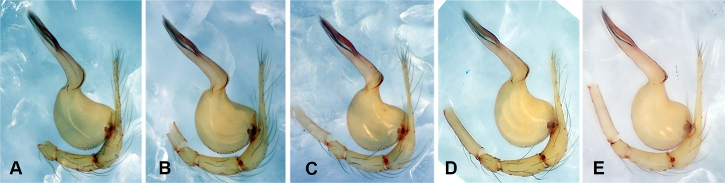

Figure S3. Pinelema cordata (Wang & Li, 2010) comb. n.

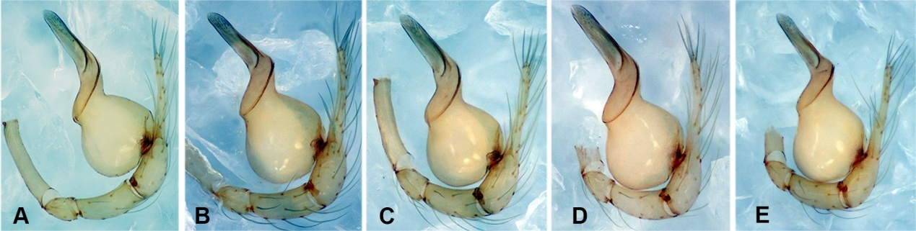

Figure S4. Pinelema huoyan Zhao & Li sp. n.
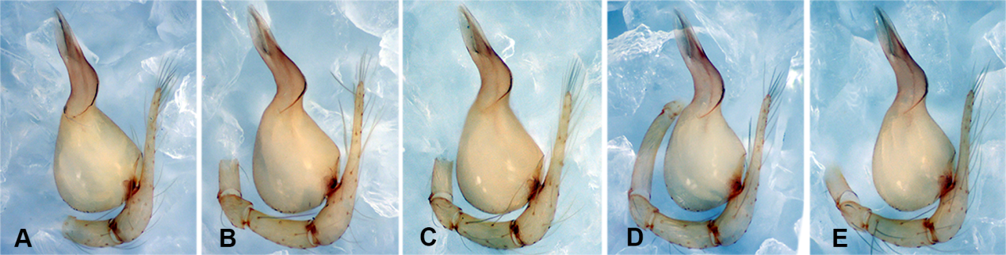

Figure S5. Pinelema liangxi (Zhu & Chen, 2002) comb. n.

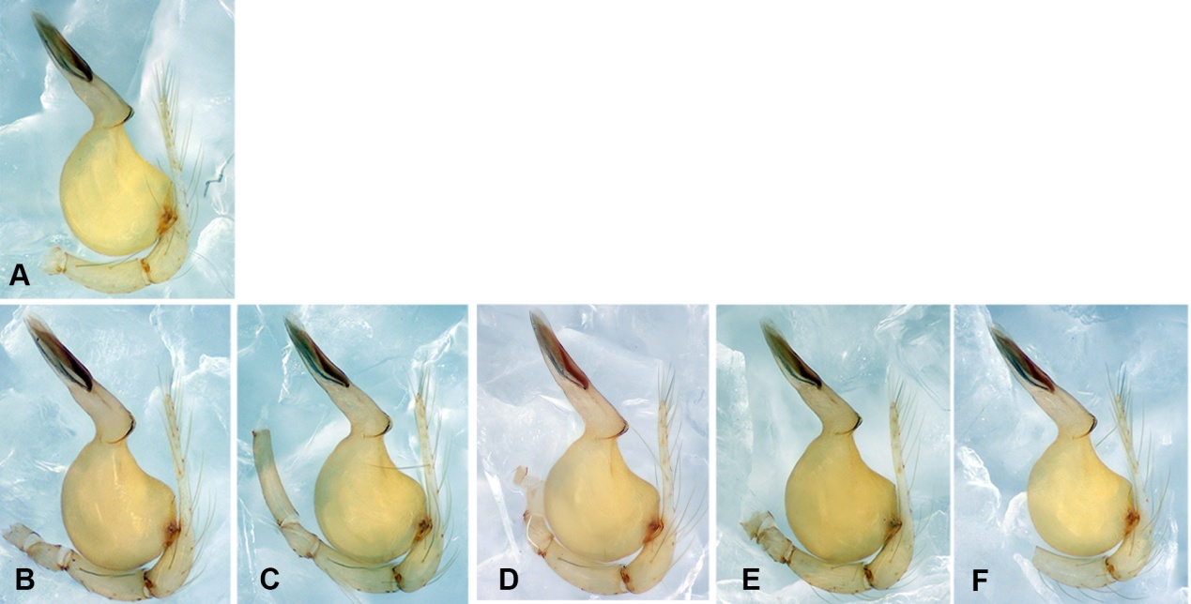

Figure S6. Pinelema lizhuang Zhao & Li sp. n. A: holotye, B–F: paratypes

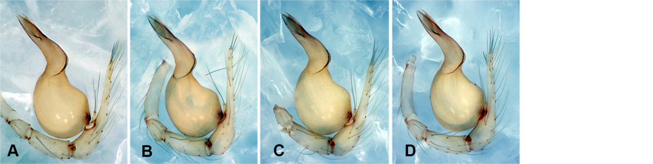

Figure S7. Pinelema strentarsi (Lin & Li, 2010) comb. n.

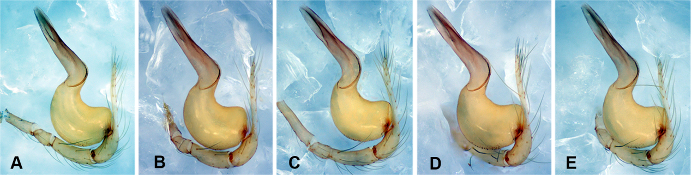

Figure S8. Pinelema wangshang Zhao & Li sp. n. A: holotye, B–E: paratypes
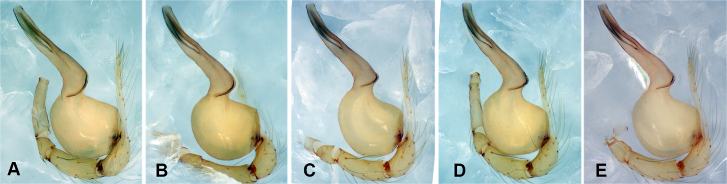

Figure S9. Pinelema wenyang Zhao & Li sp. n. A: holotye, B–E: paratypes

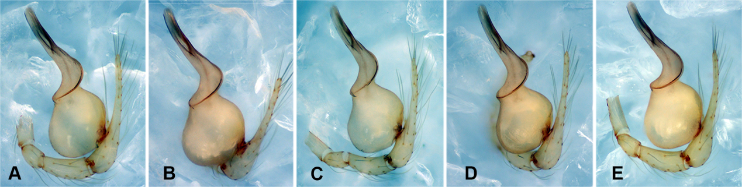

Figure S10. Pinelema xiushuiensis Wang & Li, 2016.

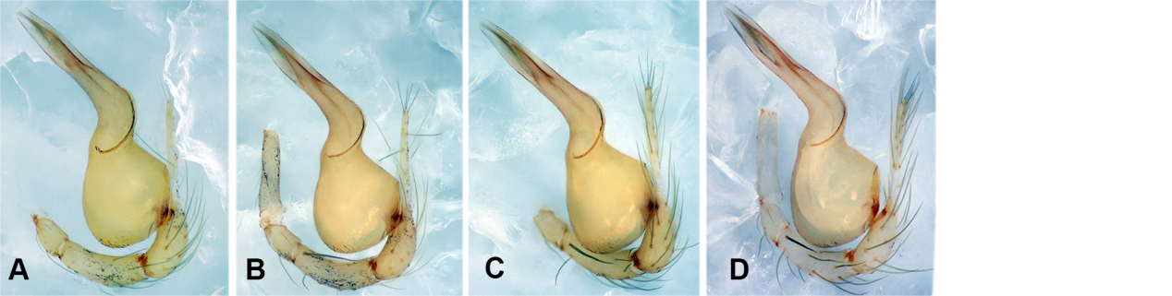

Figure S11. Pinelema yunchuni Zhao & Li sp. n. A: holotye, B–D: paratypes

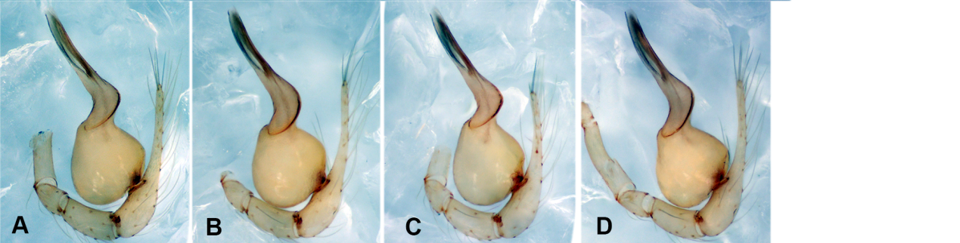
Figure S12. Pinelema zhewang (Chen & Zhu, 2009) comb. n.

