Supplementary file 1
SuppTable 1. Species used in the Russulales analyses and their GenBank accession numbers of nrITS and nrLSU sequences. Newly generated sequences are shown in bold.
Species | Sample no. | Locality | GenBank Accession no.
 |  |  | ITS | LSU
Albatrellus ovinus* | PV 22-89 | Czech Republic | AF506396 | AF506396
Albatrellus subrubescens* | PV 154-95 | Czech Republic | AF506395 | AF506395
Aleurocystidiellum disciforme* | NH 13003 | Russia | AF506402 | AF506402
Aleurocystidiellum subcruentatum* | NH 12874 | Germany | AF506403 | AF506403
Aleurodiscus amorphus* | KHL 4240 | Sweden | AF506397 | AF506397
Amylonotus africanus* | Ipulet F1883 | Uganda | KJ807070 | KJ807083
Amylonotus labyrinthinus* | Yuan 1475 | China | KM107860 | KM107878
Amylosporus bracei* | 1008/77 | USA | KM267724 | KJ807076
Amylosporus campbellii* | Gilbertson 14806 | USA | KM107861 | KM107879
Amylosporus casuarinicola* | Dai 6914 | China | KJ807068 | –
Amylosporus rubellus* | Dai 9233 | China | KJ807071 | KJ807084
Amylosporus succulentus* | Dai 7802 | China | KM213669 | KM213671
Amylostereum areolatum* | NH 8041 | Romania | AF506405 | AF506405
Amylostereum laevigatum* | NH 2863 | Sweden | AF506407 | AF506407
Asterostroma cervicolor | KHL9239 | Puerto Rico | AF506408 | AF506408
Asterostroma macrosporum | TMI 25697 | Japan | NR119394 | –
Asterostroma muscicola | TMI 25860 | Japan | AB439551 | AB439551
Auricularia mesenterica* | EL 66-97 | USA | AF506492 | AF506492
Auriscalpium vulgare* | EL 33-95 | Sweden | AF506375 | AF506375
Baltazaria eurasiaticogalactina | CBS 666.84 | France | – | AY293211
Baltazaria galactina | NH4863 | Sweden | AF506466 | AF506466
Baltazaria neogalactina | CBS 758.86 | France | – | –
Baltazaria octopodites | FLOR 56442 | São Paulo - Brazil | MH260024 | MH260043 MH260044 MH260045 MH260046
Baltazaria octopodites | FLOR 56449 | São Paulo - Brazil | MH260025 | MH260047
Baltazaria octopodites | FLOR 56460 | Santa Catarina - Brazil | MH260032 | MH260050
Baltazaria octopodites | FLOR 63715 | Paraná - Brazil | MH260042 | MH260060
Baltazaria octopodites | INPA 280140 | Amazonas - Brazil | MH260038 MH260039 MH260040 MH260041 | MH260056 MH260057 MH260058 MH260059
Basidioradulum radula* | NH 9453 | Finland | AF347105 | AF347105
Boidinia aculeata* | Wu 890714-52 | China | AF506433 | AF506433
Boidinia granulata* | Wu 9209-34 | China | AY048880 | AY048880
Boidinia propinqua* | KHL 10931 | Jamaica | AF506379 | AF506379
Bondarzewia montana* | DAOM 415 | Canada | DQ200923 | DQ234539
Bondarzewia podocarpi* | Dai 9261 | China | KJ583207 | KJ583221
Byssoporia terrestris* | Hjm 18172 | Sweden | DQ389664 | DQ389664
Confertobasidium olivaceoalbum | FP90196 | USA | AF511648 | AF511648
Dendrophora albobadia | TDeAB1029 | – | AF119522 | AF119522
Dentipellicula leptodon* | GB 11123 | Uganda | EU118625 | EU118625
Dentipellicula taiwaniana* | Cui 8346 | China | JQ349114 | JQ349100
Dentipellis coniferarum* | Cui 10063 | China | JQ349106 | JQ349092
Dentipellis fragilis* | Dai 9009 | China | JQ349108 | JQ349094
Dentipellis microspora* | Cui 10035 | China | JQ349112 | JQ349098
Dentipellis parmastoi* | Cui 8513 | China | JQ349113 | JQ349099
Dentipellopsis dacrydicola* | Dai 12004 | China | JQ349104 | JQ349089
Dentipratulum bialoviesense* | GG 1645 | France | AF506389 | AF506389
Dichostereum durum | FG1985 | France | AF506429 | AF506429
Dichostereum effuscatum | GG930915 | France | AF506390 | AF506390
Dichostereum granulosum | NH7137/696 | Canada | AF506391 | AF506391
Dichostereum pallescens | NH7046/673 | Canada | AF506392 | AF506392
Duportella lassa | SP6129 | Russia | KJ509191 | KJ509191
Echinodontium ryvardenii* | Ryvarden 43370 | Italy | AF506431 | AF506431
Echinodontium sulcata* | KHL 8267 | Russia | AF506414 | AF506414
Echinodontium tinctorium* | NH 6695 | Canada | AF506430 | AF506430
Entomocorticium sp. | FL_19 | USA | KJ620518 | KJ620518
Exidia glandulosa* | EL Mar-97 | Sweden | AF506493 | AF506493
Exidia recisa* | EL 15-98 | Sweden | AF347112 | AF347112
Gloeocystidiellum bisporum* | KHL 11135 | Norway | AY048877 | AY048877
Gloeocystidiellum clavuligerum* | NH 11185 | Spain | AF310088 | AF310088
Gloeocystidiellum compactum* | Wu 880615-21 | China | AF506434 | AF506434
Gloeocystidiellum formosanum* | Wu 9404-16 | China | AF506439 | AF506439
Gloeocystidiellum porosum* | NH 10434 | Denmark | AF310094 | AF310094
Gloeocystidiopsis cryptacanthus* | KHL 10334 | Puerto Rico | AF506442 | AF506442
Gloeocystidiopsis flammea | CBS 324.66 | C. African Rep. | AF506437 | AF506437
Gloeodontia columbiensis* | NH 11118 | Spain | AF506444 | AF506444
Gloeodontia discolor* | KHL 10099 | Puerto Rico | AF506445 | AF506445
Gloeodontia pyramidata* | Ryvarden 15502 | Colombia | AF506446 | AF506446
Gloeodontia subasperispora* | KHL 8695 | Norway | AF506404 | AF506404
Gloeopeniophorella convolvens* | KHL 10103 | Puerto Rico | AF506435 | AF506435
Gloiodon nigrescens* | Desjardin 7287 | Bali | AF506450 | AF506450
Gloiodon strigosus* | JS 26147 | Norway | AF506449 | AF506449
Gloiothele lactescens* | EL8-98 | Sweden | AF506453 | AF506453
Gloiothele lamellosa | CBS404.83 | Madagascar | AF506487 | AF506487
Gloiothele torrendii | JB18615 | France | AF506455 | AF506455
Hericium abietis* | NH 6990 | Canada | AF506456 | AF506456
Hericium alpestre* | NH 13240 | Russia | AF506457 | AF506457
Hericium americanum* | DAOMF-21467 | Canada | AF506458 | AF506458
Hericium cirrhatum* | Tübingen F794 | Germany | AF506385 | AF506385
Hericium coralloides* | NH 282 | Sweden | AF506459 | AF506459
Hericium erinaceus* | NH 12163 | Russia | AF506460 | AF506460
Heterobasidion annosum* | Korhonen 06129/6 | Russia | KJ583211 | KJ583225
Heterobasidion parviporum* | Korhonen 04121/3 | Finland | KJ583212 | KJ583226
Lachnocladiaceae | S1PMB7 | Thailand | AB365531 | AB365531
Lachnocladiaceae | S335WS151 | Thailand | AB365532 | AB365532
Lachnocladium cf. brasiliense | CALD 161213-1 | Espírito Santo - Brazil | MH260037 | MH260055
Lachnocladium cf. brasiliense | KM 57848 | Puerto Rico | MH260034 MH260035MH260036 | MH260052 MH260053 MH260054
Lachnocladium schweinfurthianum | KM 49740 | Cameroon | MH260033 | MH260051
Lachnocladium sp. | KHL10556 | Jamaica | AF506461 | AF506461
Lachnocladium sp. | BK171002-23 | – | DQ154110 | DQ154110
Lactarius leonis* | SJ 91016 | Sweden | AF506411 | AF506411
Larssoniporia incrustatocystidiata* | Dai 13607 | China | KM107863 | KM107880
Larssoniporia tropicalis* | Ryvarden 45363 | Belize | KJ513294 | KJ807089
Laxitextum bicolor* | NH 5166 | Sweden | AF310102 | AF310102
Lentinellus auricula* | KGN 280994 | Sweden | AF506415 | AF506415
Lentinellus cochleatus* | KGN 96-09-28 | Sweden | AF506417 | AF506417
Lentinellus omphalodes* | JJ 2077 | Sweden | AF506418 | AF506418
Lentinellus ursinus* | EL 73-97 | USA | AF506419 | AF506419
Lentinellus vulpinus* | KGN 98-08-25 | Sweden | AF347097 | AF347097
Megalocystidium luridum* | KHL 8635 | Norway | AF506422 | AF506422
Metulodontia nivea | NH13108 | Russia | AF506423 | AF506423
Parapterulicium subarbusculum | FLOR 56456 | Rio de Janeiro - Brazil | MH260026 | MH260048
Parapterulicium subarbusculum | FLOR 56459 | Rio de Janeiro - Brazil | MH260027 MH260028 MH260029 MH260030 MH260031 | MH260049
Peniophora incarnata | NH10271 | Denmark | AF506425 | AF506425
Peniophora nuda | FPL4756 | – | – | AF287880
Peniophora pini* | Hjm 18143 | Sweden | EU118651 | EU118651
Polyporoletus sublividus* | JA 30918 | – | DQ389663 | DQ389663
Pseudowrightoporia crassihypha* | Yuan 6247 | China | KM107873 | KM107892
Pseudowrightoporia cylindrospora* | Ryvarden 46609 | USA | KJ513290 | KJ807079
Pseudowrightoporia hamata* | Dai 8152 | China | KM107869 | KM107888
Pseudowrightoporia japonica* | KUC 20110908 | Korea | KC166692 | KC166692
Pseudowrightoporia oblongispora* | Yuan 6106 | China | KM107867 | KM107886
Pseudoxenasma verrucisporum* | EL 34-95 | Sweden | AF506426 | AF506426
Russula violacea* | SJ 93009 | Sweden | AF506465 | AF506465
Scytinostroma alutum | CBS 762.81 | France | – | AF393075
Scytinostroma caudisporum | CBS 746.86 | Gabon | – | AY293210
Scytinostroma ochroleucum* | TAA 159869 | Australia | AF506468 | AF506468
Scytinostroma odoratum* | KHL 8546 | Sweden | AF506469 | AF506469
Scytinostroma portentosum | EL11-99 | Sweden | AF506470 | AF506470
Scytinostromella nannfeldtii* | NH 7476 | Norway | AF506472 | AF506472
Sistotrema brinkmannii* | NH 11412 | Turkey | AF506473 | AF506473
Sistotrema coronilla* | NH 7598 | Canada | AF506475 | AF506475
Sistotrema muscicola* | KHL 8791 | Sweden | AF506474 | AF506474
Sistotrema sernanderi* | KHL 8576 | Sweden | AF506476 | AF506476
Stereum hirsutum* | NH 7960 | Romania | AF506479 | AF506479
Trichaptum abietinum* | NH 12842 | Finland | AF347104 | AF347104
Vararia insolita | CBS 667.81 | Ivory Coast | – | AF518665
Vararia investiens | TAA161422 | Norway | AF506484 | AF506484
Vararia ochroleuca* | JS 24400 | Norway | AF506485 | AF506485
Vesiculomyces citrinus | EL53-97 | Sweden | AF506486 | AF506486
Wrightoporia avellanea* | LR 41710 | Jamaica | AF506488 | AF506488
Wrightoporia lenta* | Dai 12850 | China | KM107874 | KM107893
Wrightoporia subavellanea* | Dai 11484 | China | KJ513295 | KJ807085
Wrightoporiopsis amylohypha* | Yuan 3460 | China | KM107875 | KM107894
Wrightoporiopsis biennis* | Cui 8457 | China | KJ807066 | KJ807074
*Sequences used from Chen et al. (2016).
Agaricomycetidae dataset analysis
For a broad phylogenetic placement, a multiple sequence alignment containing the nrLSU sequences of 886 Agaricomycetidae taxa was created by adding the sequences generated in this study to the dataset of Moncalvo et al. (2002) as adapted by (Dentinger and McLaughlin 2006). The dataset was aligned using the L-INS-i algorithm in MAFFT v7.311 (Katoh and Standley 2013). The alignments were examined and adjusted manually using MEGA 7 (Kumar et al. 2016).
Maximum likelihood (ML) analysis was performed using RAXML v8 (Stamatakis 2014) under a GTRGAMMA. The Best-score ML tree was calculated from 100 independent ML searches using the option -f d. The statistical support of clades in the best-tree were assessed non-parametric bootstrap (option -f b) with 10000 replicates. One sequence of Auricularia nigricans (Sw.) Birkebak, Looney & Sánchez-García was used as outgroup.
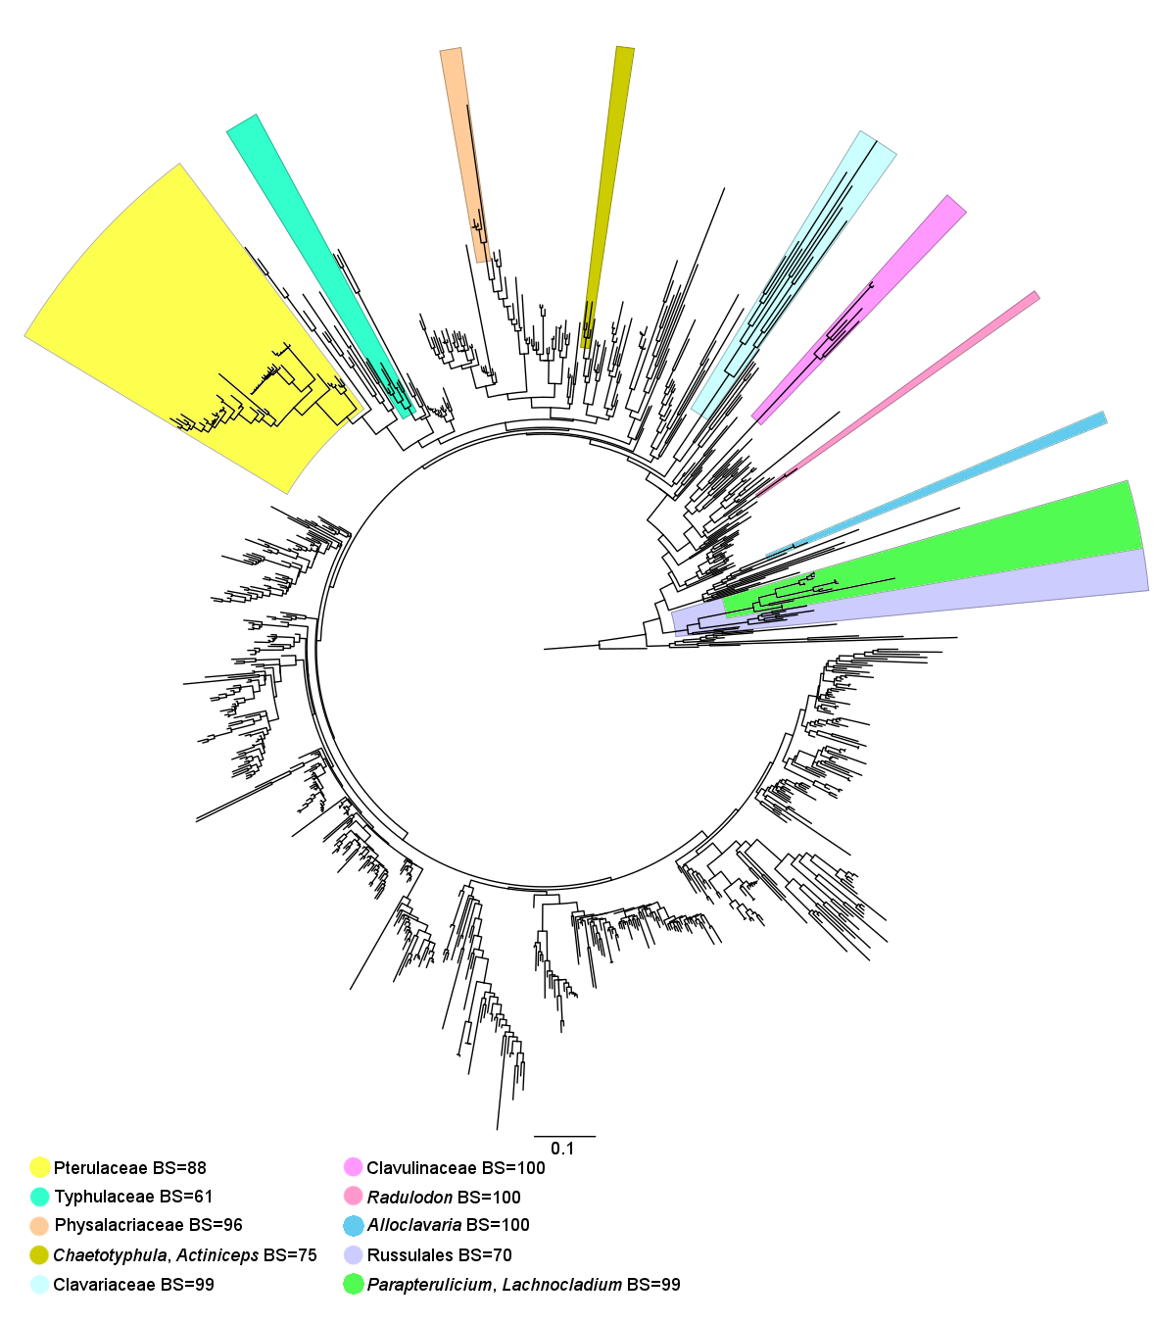
SuppFigure 1: Agaricomycetidae Best-score ML tree showing the position of Parapterulicium (green) into Russulales (lilac). Other highlighted clades indicates the position of other coralloid/clavarioid taxa.
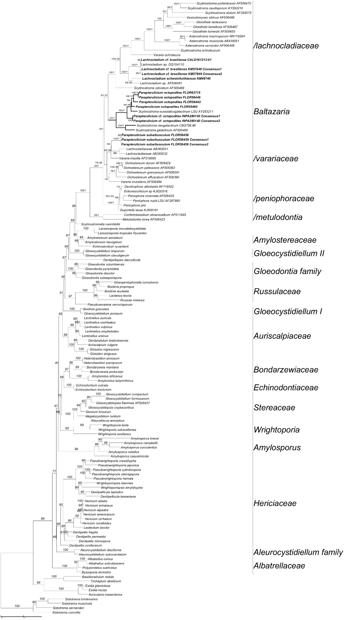
SuppFigure 2: Full best-score ML tree of Russulales with bootstrap support (1000 replicates).
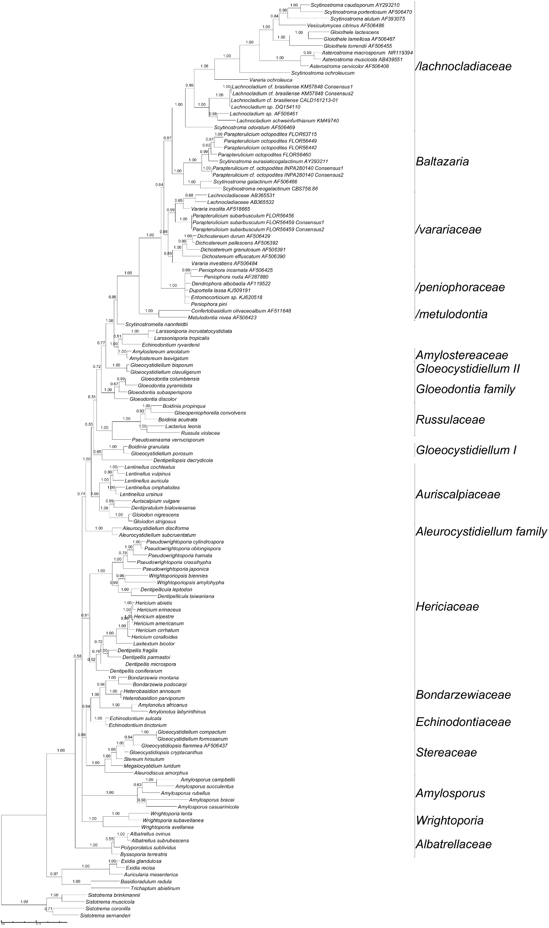
SuppFigure 3: Bayesian Inference tree topology with Bayesian Posterior Probability support values.

References
Dentinger BTM, McLaughlin DJ (2006) Reconstructing the Clavariaceae using nuclear large subunit rDNA sequences and a new genus segregated from Clavaria. Mycologia 98: 746-762.
Katoh K, Standley DM (2013) MAFFT multiple sequence alignment software version 7: improvements in performance and usability. Mol Biol Evol 30: 772-780.
Kumar S, Stecher G, Tamura K (2016) MEGA7: Molecular Evolutionary Genetics Analysis Version 7.0 for Bigger Datasets. Mol Biol Evol 33: 1870-1874.
Moncalvo J-M, Vilgalys R, Redhead SA, Johnson JE, James TY, Catherine Aime M, Hofstetter V, Verduin SJW, Larsson E, Baroni TJ, Greg Thorn R, Jacobsson S, Clémençon H, Miller OK (2002) One hundred and seventeen clades of euagarics. Molecular Phylogenetics and Evolution 23: 357-400.

