Applying surrogate species presences to correct sample bias in species distribution models; a case study using the Pilbara population of the Northern Quoll.

Supplementary data file 3:

biomod2: Weighted mean SDMs for individual algorithms and evaluation statistics.
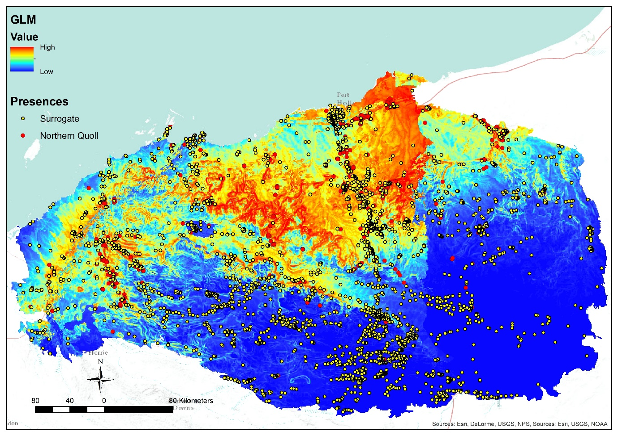
Figure 1. Weighted mean SDM for the Generalised Linear Model (GLM) algorithm.
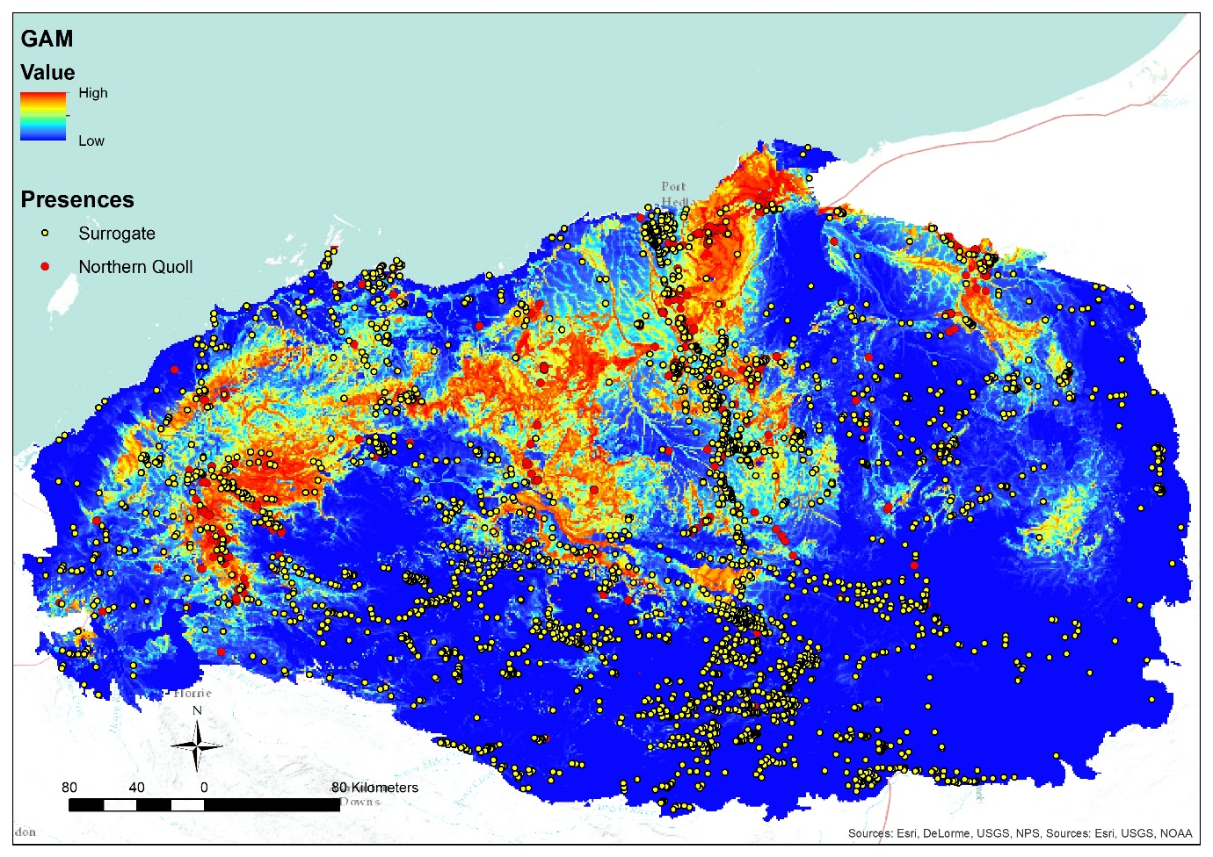
Figure 2. Weighted mean SDM for the Generalised Additive Model (GAM) algorithm.
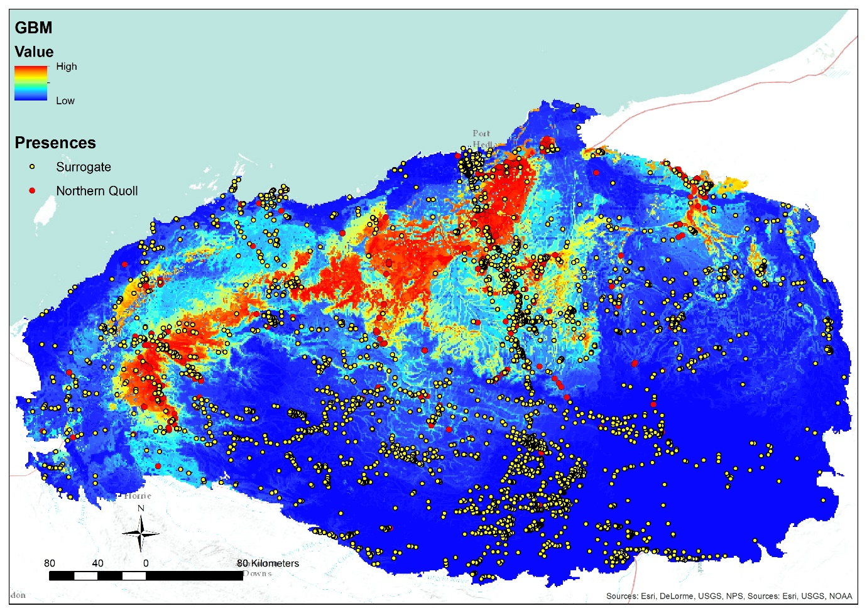
Figure 3. Weighted mean SDM for the Generalised Boosted Model (GBM) algorithm.
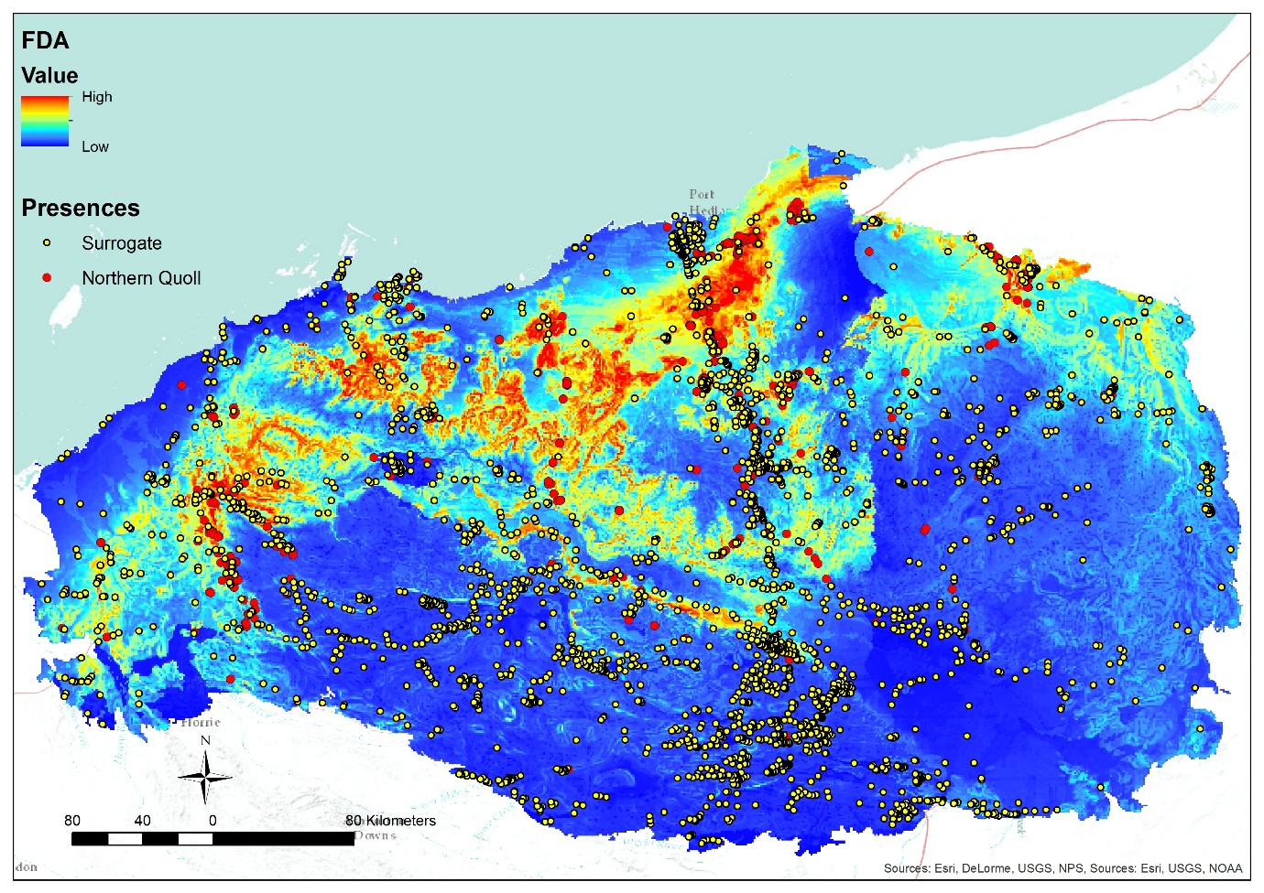
Figure 4. Weighted mean SDM for the Flexible Discriminate Analysis (FDA) algorithm.
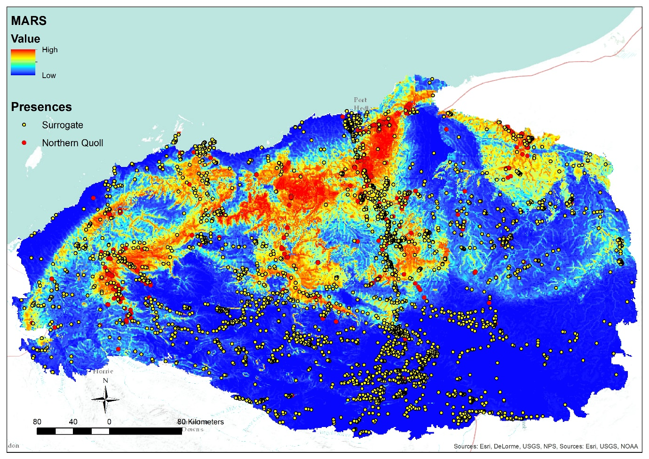
Figure 5. Weighted mean SDM for the Multiple Adaptive Regression Splines (MARS) algorithm.

Table 1, Evaluation scores for each algorithm by run using both ROC and TSS.
Score by Reciever Operator Characteristic (ROC)
 | RUN1 | RUN2 | RUN3 | RUN4 | RUN5 | RUN6 | RUN7 | RUN8 | RUN9 | RUN10
GLM | 0.827 | 0.820 | 0.841 | 0.828 | 0.837 | 0.818 | 0.823 | 0.819 | 0.823 | 0.837
GAM | 0.920 | 0.903 | 0.904 | 0.908 | 0.922 | 0.901 | 0.911 | 0.900 | 0.917 | 0.911
GBM | 0.933 | 0.917 | 0.934 | 0.930 | 0.937 | 0.920 | 0.925 | 0.915 | 0.934 | 0.927
FDA | 0.867 | 0.863 | 0.874 | 0.863 | 0.869 | 0.833 | 0.854 | 0.841 | 0.867 | 0.876
MARS | 0.900 | 0.886 | 0.906 | 0.895 | 0.913 | 0.891 | 0.884 | 0.887 | 0.899 | 0.892
Score by True Skill Statistic (TSS)
 | RUN1 | RUN2 | RUN3 | RUN4 | RUN5 | RUN6 | RUN7 | RUN8 | RUN9 | RUN10
GLM | 0.536 | 0.530 | 0.547 | 0.546 | 0.558 | 0.529 | 0.538 | 0.522 | 0.541 | 0.552
GAM | 0.725 | 0.699 | 0.661 | 0.704 | 0.719 | 0.664 | 0.681 | 0.661 | 0.680 | 0.682
GBM | 0.725 | 0.723 | 0.735 | 0.732 | 0.751 | 0.706 | 0.708 | 0.697 | 0.726 | 0.724
FDA | 0.576 | 0.627 | 0.633 | 0.593 | 0.633 | 0.560 | 0.579 | 0.552 | 0.616 | 0.624
MARS | 0.680 | 0.647 | 0.677 | 0.678 | 0.711 | 0.668 | 0.629 | 0.635 | 0.662 | 0.645

Table 2. Ensemble model (weighted mean) test results by run with mean values.
Run 1
 | Testing.data | Cutoff | Sensitivity | Specificity
TSS | 0.71 | 531.00 | 84.50 | 86.16
ROC | 0.92 | 530.50 | 84.50 | 86.16
Run 2
 | Testing.data | Cutoff | Sensitivity | Specificity
TSS | 0.70 | 556.00 | 82.37 | 87.69
ROC | 0.90 | 559.00 | 82.37 | 87.83
Run 3
 | Testing.data | Cutoff | Sensitivity | Specificity
TSS | 0.71 | 556.00 | 84.50 | 86.66
ROC | 0.92 | 654.50 | 79.94 | 91.33
Run 4
 | Testing.data | Cutoff | Sensitivity | Specificity
TSS | 0.72 | 525.00 | 86.02 | 85.49
ROC | 0.91 | 526.50 | 86.02 | 85.62
Run 5
 | Testing.data | Cutoff | Sensitivity | Specificity
TSS | 0.74 | 585.00 | 84.50 | 89.93
ROC | 0.92 | 592.50 | 84.50 | 90.19
Run 6
 | Testing.data | Cutoff | Sensitivity | Specificity
TSS | 0.69 | 520.00 | 85.11 | 84.19
ROC | 0.90 | 523.50 | 85.11 | 84.42
Run 7
 | Testing.data | Cutoff | Sensitivity | Specificity
TSS | 0.68 | 621.00 | 78.12 | 89.93
ROC | 0.91 | 629.50 | 78.12 | 90.23
Run 8
 | Testing.data | Cutoff | Sensitivity | Specificity
TSS | 0.67 | 534.00 | 79.94 | 87.03
ROC | 0.90 | 533.50 | 79.94 | 87.03
Run 9
 | Testing.data | Cutoff | Sensitivity | Specificity
TSS | 0.70 | 567.00 | 82.37 | 87.63
ROC | 0.92 | 585.50 | 81.76 | 88.46
Run 10
 | Testing.data | Cutoff | Sensitivity | Specificity
TSS | 0.70 | 567.00 | 82.68 | 87.23
ROC | 0.91 | 572.00 | 82.68 | 87.36
Mean
 | Testing.data | Cutoff | Sensitivity | Specificity
TSS | 0.70 | 556.20 | 83.01 | 87.19
ROC | 0.91 | 570.70 | 82.49 | 87.86

Table 3. Variable use by run/repetition and algorithm
Run 1
 | GLM | GAM | GBM | FDA | MARS
bio_19 | 0.006 | 0.080 | 0.002 | 0.090 | 0.000
bio_18 | 0.217 | 0.284 | 0.263 | 0.327 | 0.278
bio_9 | 0.234 | 0.268 | 0.398 | 0.00 | 0.305
dem | 0.597 | 0.277 | 0.371 | 0.506 | 0.429
slope | 0.182 | 0.164 | 0.189 | 0.144 | 0.210
water | 0.050 | 0.053 | 0.008 | 0.000 | 0.052
vegag | 0.037 | 0.157 | 0.019 | 0.196 | 0.042
Run 2
 | GLM | GAM | GBM | FDA | MARS
bio_19 | 0.000 | 0.091 | 0.008 | 0.061 | 0.000
bio_18 | 0.206 | 0.269 | 0.215 | 0.439 | 0.242
bio_9 | 0.285 | 0.261 | 0.396 | 0.000 | 0.315
dem | 0.619 | 0.296 | 0.340 | 0.488 | 0.468
slope | 0.145 | 0.155 | 0.172 | 0.140 | 0.216
water | 0.036 | 0.041 | 0.005 | 0.000 | 0.044
vegag | 0.044 | 0.173 | 0.029 | 0.192 | 0.039
Run 3
 | GLM | GAM | GBM | FDA | MARS
bio_19 | 0.010 | 0.075 | 0.004 | 0.104 | 0.000
bio_18 | 0.224 | 0.307 | 0.256 | 0.063 | 0.336
bio_9 | 0.239 | 0.327 | 0.419 | 0.550 | 0.271
dem | 0.625 | 0.237 | 0.334 | 0.298 | 0.388
slope | 0.136 | 0.076 | 0.195 | 0.179 | 0.195
water | 0.051 | 0.044 | 0.007 | 0.043 | 0.057
vegag | 0.043 | 0.215 | 0.017 | 0.101 | 0.000
Run 4
 | GLM | GAM | GBM | FDA | MARS
bio_19 | 0.009 | 0.089 | 0.004 | 0.098 | 0.000
bio_18 | 0.236 | 0.304 | 0.269 | 0.069 | 0.319
bio_9 | 0.246 | 0.310 | 0.396 | 0.496 | 0.230
dem | 0.601 | 0.264 | 0.348 | 0.371 | 0.436
slope | 0.183 | 0.124 | 0.223 | 0.232 | 0.289
water | 0.031 | 0.039 | 0.004 | 0.026 | 0.042
vegag | 0.038 | 0.179 | 0.023 | 0.020 | 0.000
Run 5
 | GLM | GAM | GBM | FDA | MARS
bio_19 | 0.014 | 0.073 | 0.002 | 0.049 | 0.000
bio_18 | 0.213 | 0.292 | 0.231 | 0.041 | 0.264
bio_9 | 0.235 | 0.303 | 0.410 | 0.402 | 0.310
dem | 0.631 | 0.287 | 0.361 | 0.471 | 0.423
slope | 0.161 | 0.090 | 0.189 | 0.114 | 0.208
water | 0.028 | 0.035 | 0.003 | 0.000 | 0.032
vegag | 0.041 | 0.184 | 0.025 | 0.069 | 0.027
Run 6
 | GLM | GAM | GBM | FDA | MARS
bio_19 | 0.010 | 0.085 | 0.002 | 0.039 | 0.000
bio_18 | 0.225 | 0.284 | 0.233 | 0.048 | 0.320
bio_9 | 0.289 | 0.327 | 0.406 | 0.422 | 0.262
dem | 0.591 | 0.264 | 0.381 | 0.361 | 0.432
slope | 0.177 | 0.111 | 0.23 | 0.127 | 0.243
water | 0.031 | 0.041 | 0.003 | 0.000 | 0.042
vegag | 0.038 | 0.197 | 0.017 | 0.120 | 0.000
Run 7
 | GLM | GAM | GBM | FDA | MARS
bio_19 | 0.005 | 0.099 | 0.003 | 0.000 | 0.000
bio_18 | 0.162 | 0.271 | 0.223 | 0.165 | 0.262
bio_9 | 0.226 | 0.288 | 0.404 | 0.359 | 0.300
dem | 0.671 | 0.305 | 0.377 | 0.416 | 0.450
slope | 0.182 | 0.126 | 0.221 | 0.194 | 0.187
water | 0.019 | 0.029 | 0.002 | 0.000 | 0. 000
vegag | 0.051 | 0.180 | 0.020 | 0.057 | 0.030
Run 8
 | GLM | GAM | GBM | FDA | MARS
bio_19 | 0.007 | 0.103 | 0.008 | 0.116 | 0.000
bio_18 | 0.227 | 0.314 | 0.255 | 0.066 | 0.316
bio_9 | 0.300 | 0.334 | 0.415 | 0.471 | 0.281
dem | 0.578 | 0.247 | 0.310 | 0.380 | 0.434
slope | 0.171 | 0.136 | 0.212 | 0.128 | 0.242
water | 0.019 | 0.028 | 0.002 | 0.000 | 0.031
vegag | 0.030 | 0.192 | 0.018 | 0.116 | 0.000
Run 9
 | GLM | GAM | GBM | FDA | MARS
bio_19 | 0.026 | 0.091 | 0.004 | 0.072 | 0.039
bio_18 | 0.227 | 0.308 | 0.234 | 0.235 | 0.317
bio_9 | 0.221 | 0.324 | 0.338 | 0.262 | 0.187
dem | 0.649 | 0.280 | 0.426 | 0.562 | 0.492
slope | 0.162 | 0.104 | 0.214 | 0.179 | 0.224
water | 0.027 | 0.037 | 0.002 | 0.000 | 0.038
vegag | 0.038 | 0.147 | 0.019 | 0.045 | 0.000
Run 10
 | GLM | GAM | GBM | FDA | MARS
bio_19 | 0.008 | 0.114 | 0.004 | 0.000 | 0.042
bio_18 | 0.210 | 0.318 | 0.202 | 0.239 | 0.32
bio_9 | 0.244 | 0.318 | 0.41 | 0.312 | 0.192
dem | 0.651 | 0.246 | 0.35 | 0.422 | 0.468
slope | 0.144 | 0.101 | 0.224 | 0.118 | 0.233
water | 0.026 | 0.046 | 0.005 | 0.000 | 0.050
vegag | 0.037 | 0.148 | 0.019 | 0.030 | 0.000

