Applying surrogate species presences to correct sample bias in species distribution models; a case study using the Pilbara population of the Northern Quoll.

Supplementary data file 1:

GIS data sets used in variable assessments and map of Pilbara vegetation systems.
Table 1. GIS data sets used in variable assessments. Bold indicates data-base and URL and italics indicate derived data.
WorldClim
(http://www.worldclim.org/)
BIO1 = Annual Mean Temperature
BIO2 = Mean Diurnal Range (Mean of monthly (max temp - min temp))
BIO3 = Isothermality (BIO2/BIO7) (* 100)
BIO4 = Temperature Seasonality (standard deviation *100)
BIO5 = Max Temperature of Warmest Month
BIO6 = Min Temperature of Coldest Month
BIO7 = Temperature Annual Range (BIO5-BIO6)
BIO8 = Mean Temperature of Wettest Quarter
BIO9 = Mean Temperature of Driest Quarter
BIO10 = Mean Temperature of Warmest Quarter
BIO11 = Mean Temperature of Coldest Quarter
BIO12 = Annual Precipitation
BIO13 = Precipitation of Wettest Month
BIO14 = Precipitation of Driest Month
BIO15 = Precipitation Seasonality (Coefficient of Variation)
BIO16 = Precipitation of Wettest Quarter
BIO17 = Precipitation of Driest Quarter
BIO18 = Precipitation of Warmest Quarter
BIO19 = Precipitation of Coldest Quarter
Climond
(https://www.climond.org/)
BIO34=Mean moisture index of warmest quarter
Climate Change in Australia (CSIRO)
(http://www.climatechangeinaustralia.gov.au/en/)
Relative Humidity Wettest Quarter
ESRI Online Databases
(http://www.esri.com/software/arcgis/arcgisonline/arcgis-open-data)
Background mapping, i.e. topographic imagery, boundaries and placenames
Landgate
(https://www2.landgate.wa.gov.au/bmvf/app/waatlas/)
Western Australian Fire Frequency
Pastoral Property (vesting)
Modis
(https://earthdata.nasa.gov/)
Fire Scar
Modis Burndate
Noramalised Digital Vegetation Index (NDVI)
Near Infrared Spectrography (NIRS)
Geoscience Australia
(http://www.ga.gov.au/search/index.html#/)
Total Magnetic Intensity
Gravity Anomaly
Land Tenure
Digital Elevation Model
Slope
Ruggedness
Water Courses
Euclidean Distance to Water Courses
Water Bodies
Euclidean Distance to Water Bodies
Geology
Land cover
Hydrology of Australia
Soils Mapping of Australia
Naturemap
(http://naturemap.dpaw.wa.gov.au/)
NQ Presences
CWR Terrestrial Mammal Presences
NQ Absences
Unites States Geological Survey (USGS)
(http://earthexplorer.usgs.gov/)
Landsat Mosaic
NDVI Colourised
Department of Agriculture and Food WA (DAFWA)
(https://www.agric.wa.gov.au/land-use-planning/maps-and-data)
Veg= Beards Vegetation Associations
Vegag= Department of Agriculture and Food Western Australia Vegetation Mapping (Rangelands)

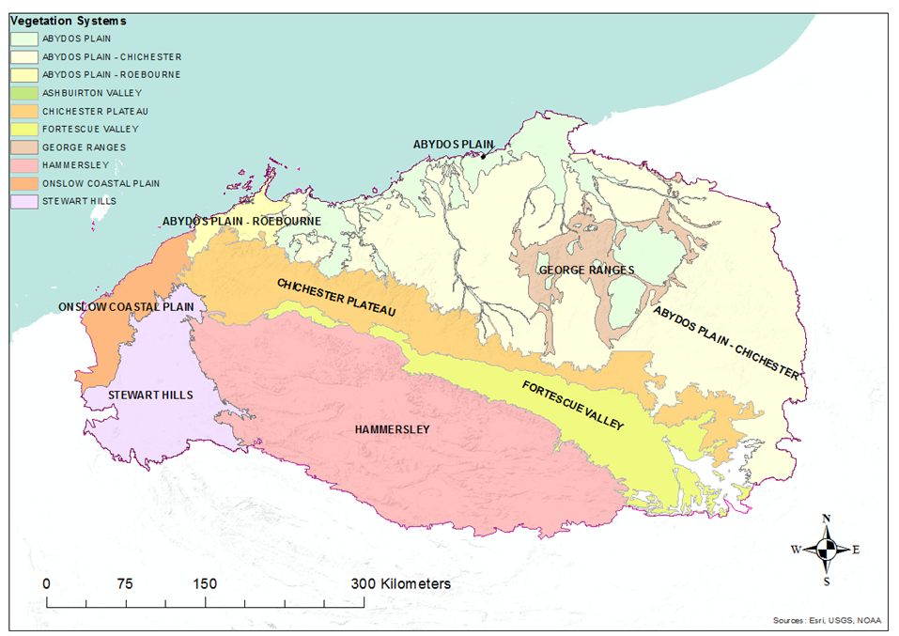
Figure 1. Pilbara vegetation systems. Taken from the Pilbara Pre-European Vegetation data set, Courtesy of the Western Australian Department of Parks and Wildlife

