Supplementary Information
Abundance Models
Growth models follow Rockwood & Witt (2015). Negative values of the intrinsic rate of increase (r) will lead to decreasing populations. To achieve abundances which do not vary over time, the starting abundance (N_{t}) may be set to the carrying capacity (K) with a logistic growth model.
Exponential Growth Model
Equation 1: $N_{t}=N_{0}e^{(rt)}$
Logistic Growth Model
Equation 2: $N_{t}=\frac{K}{\left(1+\left(\frac{\left(K- N_{0}\right)}{N_{0}}\right)e^{(-rt)}\right)}$
N_{t} = Abundance (in individuals) at time t
N₀ = Starting abundance (in individuals) at time 0
r = The intrinsic rate of increase
e ≈ 2.71828 (Ehlers constant)
K = Carrying capacity (in individuals)
Elasticity Analysis
Equation 3: $ξ= \left(\frac{p}{R}\right)\left(\frac{∂R}{∂p}\right)$
ξ = Elasticity
p = Parameter
R = Result
(Benton and Grant 1999, Teixeira Alves et al. 2021)
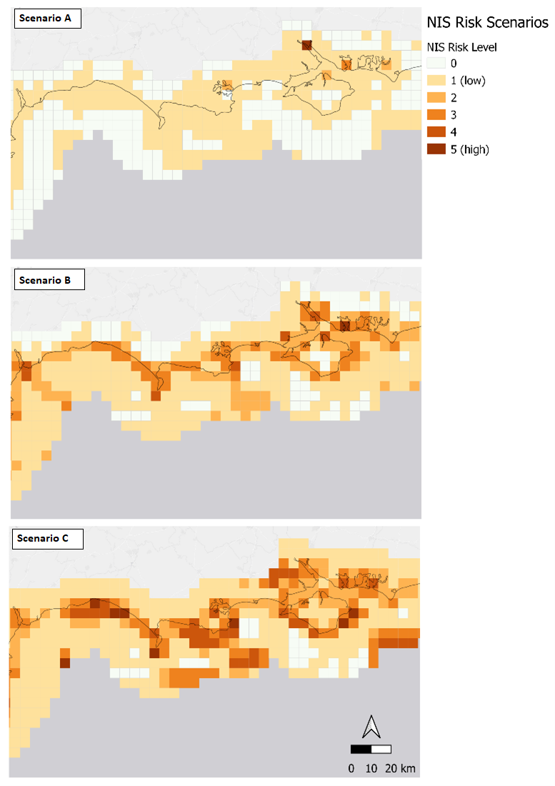
Supplementary Figure 1. Spatial representation of the site risk scores output from the Site Prioritisation Tool. Scenario A: monitoring focused on species introduction via ballast water or hull fouling, Scenario B: monitoring focused on sites where risk of NIS spread is greatest and Scenario C: monitoring focused on sites where the NIS impact is greatest. Categories 1 to 5 represent risk scores in the lowest and highest quantiles, respectively. Cells with no data are represented by 0. Figure created using ArcGIS Pro 2.9.0 (ESRI, California, 2021) and QGIS 3.16.15 Hannover (QGIS Development Team, 2020).

Supplementary Table 1. Data sources for each parameter used in the Site Prioritisation Tool
Model Category | Model Theme | Model Parameter | Data Description | Data Source | Analysis/Comment | Risk Metric for Cell Score
Introduction | Intentional introduction | Population density | Global human settlement population for year 2020 at resolution 100m.  Transformed from Mollweide (EPSG: 54009) to British National Grid 27700 in ArcGIS Pro using ‘Project Raster’ geoprocessing tool. | Global Human Settlement - Download - European Commission (europa.eu)  Date accessed: 01/02/2023 | Raster layer containing absolute number of inhabitants per cell (values expressed as decimals (float)).  Population per grid square, count, sum, mean, median, min, max, range, std, pct90 computed in ArcGIS Pro* using ‘Zonal statistics’ tool. “SUM” calculated the total number of inhabitants per grid cell. From this, population density was then calculated using the following formula: density = “SUM” / (“area_2”/ 1000000)  (area was divided by 1000000 to convert to km²). | Number of people per 5x5km² grid cell
Introduction | Intentional introduction | Road connectivity | Mapped main roads (motorways and A roads) of UK (lines). | OS map data  Date accessed: 22/08/2022 | Absence/presence of a road in grid cell. Also calculated length of individual roads per each grid cell (not in model), for potential future use using Sum Line Lengths tool in QGIS. Absence/ presence was assigned in R (cells containing values =0 assigned ‘absent’, cells containing values ≥1 assigned ‘present’). | Primary:  Presence (1) or absence (0) of road(s)  Secondary: road length in m
Introduction |  | Angling activity | Recreational Shore Fisher (RSF) activity level around the coast of England and Wales only (classified as high/low). | Data provided by Cefas (pers comm via Isla MacMillan) | Line polygons depicted activity levels along the England and Wales coastlines only. The length (km) of these lines was extracted per grid cell, with the activity level with the largest length (km) per grid cell extracted and utilised to depict the overall activity level of the cell.  Categories were then converted into 0 for no data; 1 for low impact and 2 for high impact to inform the model. | Levels no data (0), low activity (1) and high activity (2)
Introduction | Shipping (ballast & biofouling) | Ports and harbours | Dataset contains all freight tonnage traffic by port and by year, spatial information (points) for each port was added (latitude and longitude) spanning 2000-2020. | https://www.gov.uk/government/statistical-data-sets/port-and-domestic-waterborne-freight-statistics-port  Dataset: PORT0101: All freight tonnage traffic by port and year (filter by direction)  Date accessed: 25/07/2022 | Number of ports and harbours per grid cell was calculated using ‘Join attributes by location (summary)’ tool in QGIS. Summaries to calculate selected count, sum, and mean.  This was utilised as a proxy for activity. Also available is the tonnage per port and harbour for future use. | Count = Total number of ports and harbours
Introduction | Recreational boating | Slipways | Point locations of slipways around the UK | Data from http://www.boatlaunch.co.uk/  Date accessed: 05/05/2022 | As for ports and harbours, but number of slipways per grid square. | Total number of slipways
Introduction | Recreational boating | Routes/ activity (from outside UK) | Recreational activity cruising routes divided into heavy, medium, and low activity routes for the year 2012 | Data previously obtained from the Royal Yachting Association (Tidbury et al., 2016)  http://www.rya.org.uk/Pages/Home.aspx Date accessed: 12/02/2009 | A count of the number of routes per grid cell were calculated using ‘Sum Line Lengths’ vector tool whereby the total length of the line and count of number of lines in each grid cell were attributed to corresponding grid cell ID. There is potential to incorporate the activity level in future. | Number of non-domestic routes
Introduction | Recreational boating | Marina pontoons | Contains point locations of marinas around the UK including number of pontoons (as a proxy for marina size) | United Kingdom Hydrographic Office (UKHO) pers comms.  Date accessed: 18/11/2022 | As for ports and harbours, but number of marinas per grid square. Also obtained is number of pontoons (can be utilised as a proxy for activity) per marina for future incorporation into the model. | Total number of marinas
Introduction | Fishery and Aquaculture release | Commercial fishing effort |  | Defra Data Services Platform  (https://environment.data.gov.uk/dataset/bf55694c-3330-4c1d-a48e-db6bbe82ad77 )  Date accessed: 18/09/2023 | The fisheries effort squares overlapped with the 5x5km² coastal grid utilised in the model. Therefore, to avoid duplication of effort over multiple grid cells, the effort data was converted into centroid points, followed by an ‘intersect’ analysis to extract the sum of fishing effort per grid cell. | Sum of fishing effort per grid cell
Introduction | Fishery and Aquaculture release | Shellfish aquaculture sites | Data containing locations of shellfish farms in England and Wales for 2020, including information on import locations (farm, source easting and northing, export country), species, development stage, total number and total weight (kg) | Data from STARFISH (System for Tracking And Recording FIsh and SHellfish) database, a resource jointly owned by Cefas, Environment Agency, Welsh Government and Defra, to manage all data relating to Aquaculture Production Business authorisation and registration, aquatic animal imports and exports, the rearing and holding of non‐native species, and statutory aquatic disease testing and control.  Date accessed: 27/05/2022.  Data representing Scotland was provided by Marine Scotland and data for Northern Ireland was provided by Department of Agriculture, Environmental and Rural Affairs Northern Ireland (DAERA-NI; pers comms via Isla MacMillan). Both data provided for Scotland and Northern Ireland were for the year 2019. | Spatial information was transformed from easting northing to latitude longitude in R (4.1.2 (2021-11-01) -- "Bird Hippie") following method: https://stackoverflow.com/questions/50296985/convert-coordinates-from-british-national-grid-easting-northing-to-wgs84-lat  Number of shellfish farms calculated per grid cell. | Total number of shellfish sites
Introduction | Fishery and Aquaculture release | Domestic shellfish introductions | Data as for shellfish sites | Data as for shellfish farms.  Marine Scotland provided internal shellfish (Mussel and Oyster 2019) movement data, i.e. site to site within GB health zone including farm location data. Live movements that were going direct for human consumption were removed but movements for depuration were retained. | Number of movements into each site per grid cell were counted. | Number of movements INTO the sites
Introduction |  | Angling activity | (see above)
Establishment | Temperature | Sea surface temperature minimum | Surface temperature Min Present day | Bio-oracle (https://bio-oracle.org/, (Tyberghein et al. 2012, Assis et al. 2018) | Average temperature minimum per grid was extracted, however, NIS tolerances will dictate the risk associated with the environmental parameters. These values have been included in the model for species-specific investigation. | Temperature minimum
Establishment | Temperature | Sea surface temperature maximum | Surface temperature Max Present Day | Bio-oracle | As with sea surface temperature min. | Temperature maximum
Establishment | Salinity | Min | Surface salinity Min Present day | Bio-oracle | Average salinity minimum per grid cell was extracted, however, NIS tolerances will dictate the risk associated with the environmental parameters. These values have been included in the model for species-specific investigation. | Salinity minimum
Establishment | Salinity | Max | Surface Salinity Max Present day | Bio-oracle | As with salinity min. | Salinity maximum
Establishment | Substrate | Seabed substratum | Seabed substrate 1M (1:1000000 resolution) classification data. Folk 5 classification: Mud to Muddy Sand (1); Sand (2); Course-grained sediment (3); Mixed sediment (4); Rock and Boulders (5). | EMODnet (www.emodnet.eu/en) | NIS specific risk scores required? NIS habitat preference will dictate the risk associated with seabed substratum present in cell. Some way of generalising? To consider further.  Largest percentage of substrate type per grid cell was extracted and attributed to that cell, however, NIS tolerances will dictate the risk associated with the environmental parameters. These values have been included in the model for species-specific investigation. | Substrate type
Impact | Environment | MPAs | Spatial extent of protected areas including Great Britain (GB) and Northern Ireland (NI) Ramsar, GB and NI Special Area of Interest (SPA), GB and NI Special Area of Conservation (SAC), Marine Conservation Zone (MCZ), Offshore Marine Protected Areas (MPAs), OSPAR MPAs, UK SPAs with Marine Component. | These data were sourced from JNCC website https://mapper.mpa.jncc.gov.uk/  Date accessed: 5/05/2022 | Data were merged to form a single data layer to calculate coverage (%) per grid square using ‘Overlap analysis’ This calculated the extent of protected areas within each grid, greater impact was attributed to higher percentage coverage of protected areas per grid cell. | Coverage (%) of protected area per grid cell
Impact | Industry | Infrastructure | Offshore energy platforms (O&G, wind turbines)  Cooling system inlets/outlets | OSPAR offshore installations (2017) only  https://odims.ospar.org/en/maps/map-inventory-of-offshore-installations-2017/  Date accessed: 08/12/2023 | Number of offshore installations were extracted per grid cell including operational, decommissioned, closed-down, unknown, derogation, ‘being dismantled’, under construction. | Count of number of installations per grid cell
Spread | Recreational boating | Slipways | As above
Spread | Recreational boating | Routes (domestic) | As above | Data previously obtained from the Royal Yachting Association (Tidbury et al., 2016)  http://www.rya.org.uk/Pages/Home.aspx | A count of the number of routes per grid cell were calculated using ‘Sum Line Lengths’ vector tool whereby the total length of the line and count of number of lines in each grid cell were attributed to corresponding grid cell ID. There is potential to incorporate the activity level in future. | Total number of domestic cruising route lines
Spread | Recreational boating | Marina pontoons | As above
Spread | Fishery and aquaculture release | Commercial fishing effort | As above
Spread | Fishery and aquaculture release | Shellfish aquaculture sites | Data containing locations of shellfish farms in England and Wales for 2020, including information on import locations (farm, source easting and northing, export country), species, development stage, total number and total weight (kg). | As with ‘Introduction- aquaculture’  Date accessed: 27/05/2022 | Spatial information was transformed from easting northing to latitude longitude in R (4.1.2 (2021-11-01) -- "Bird Hippie") following method: https://stackoverflow.com/questions/50296985/convert-coordinates-from-british-national-grid-easting-northing-to-wgs84-lat  Count of number of imports throughout the timeframe for all farms per grid cell | Total number of shellfish sites
Spread | Fishery and aquaculture release | Domestic shellfish movements out | As for shellfish farms. | England and Wales data provided by Cefas, and Scottish data provided by Marine Scotland as with ‘shellfish domestic movements in’. | Number of movements out of each site per grid cell were counted. | Number of movements OUT of the site
Spread |  | Angling activity | As above

References
Assis J, Tyberghein L, Bosch S, Verbruggen H, Serrão EA, De Clerck O (2018) Bio‐ORACLE v2.0: Extending marine data layers for bioclimatic modelling. Global Ecology and Biogeography 27: 277–284. https://doi.org/10.1111/geb.12693
Benton TG, Grant A (1999) Elasticity analysis as an important tool in evolutionary and population ecology. Trends in Ecology & Evolution 14: 467–471. https://doi.org/10.1016/S0169-5347(99)01724-3
Rockwood LL, Witt JW (2015) Introduction to Population Ecology. 2nd ed. Wiley-Blackwell, Chichester, UK.
Teixeira Alves M, Taylor NGH, Tidbury HJ (2021) Understanding drivers of wild oyster population persistence. Scientific Reports 11: 7837. https://doi.org/10.1038/s41598-021-87418-1
Tyberghein L, Verbruggen H, Pauly K, Troupin C, Mineur F, De Clerck O (2012) Bio‐ORACLE: a global environmental dataset for marine species distribution modelling. Global Ecology and Biogeography 21: 272–281. https://doi.org/10.1111/j.1466-8238.2011.00656.x

