Supplementary material 1

Supplementary material 1 to the paper “Vegetation diversity of Pinus pinaster forests in the Italian Peninsula”. Vegetation Classification and Survey.

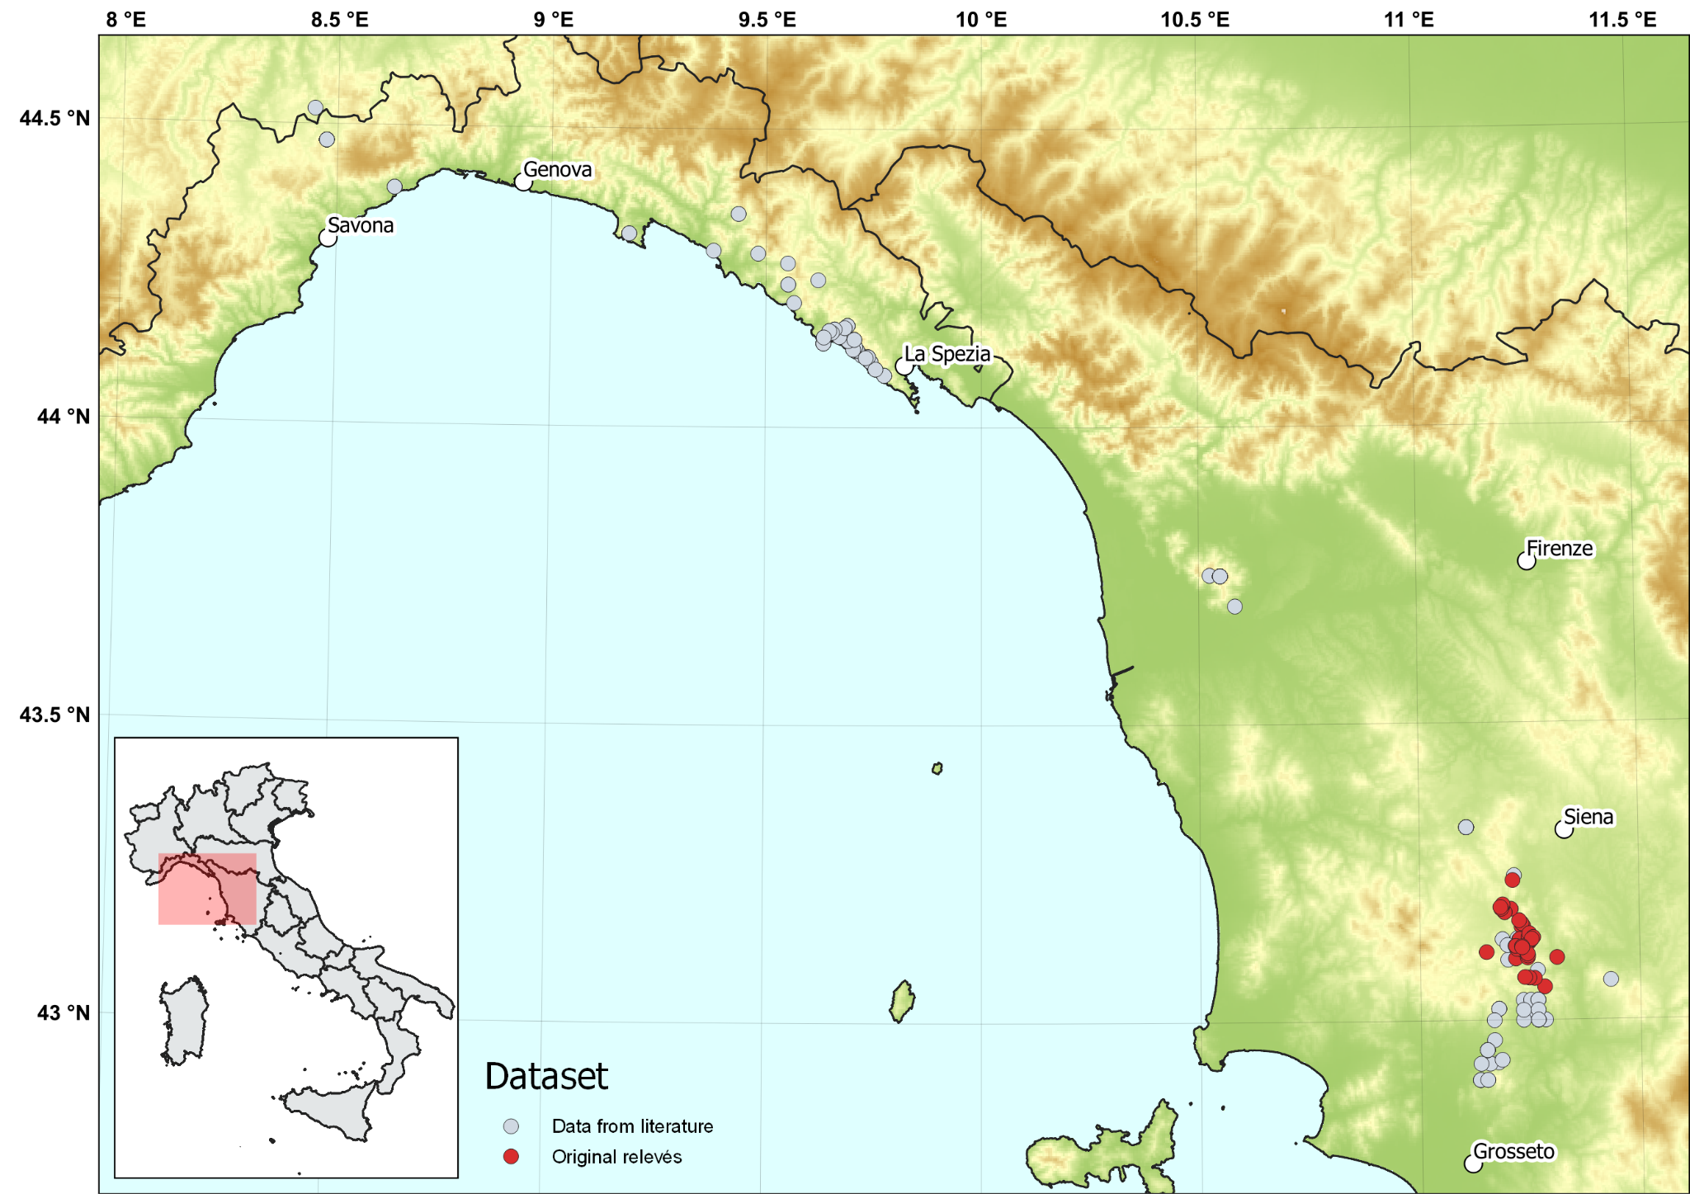

Fig. S1.1. Map showing the distribution of the surveyed relevés (in red) and the ones retrieved from CircumMed Forest Database (in grey).

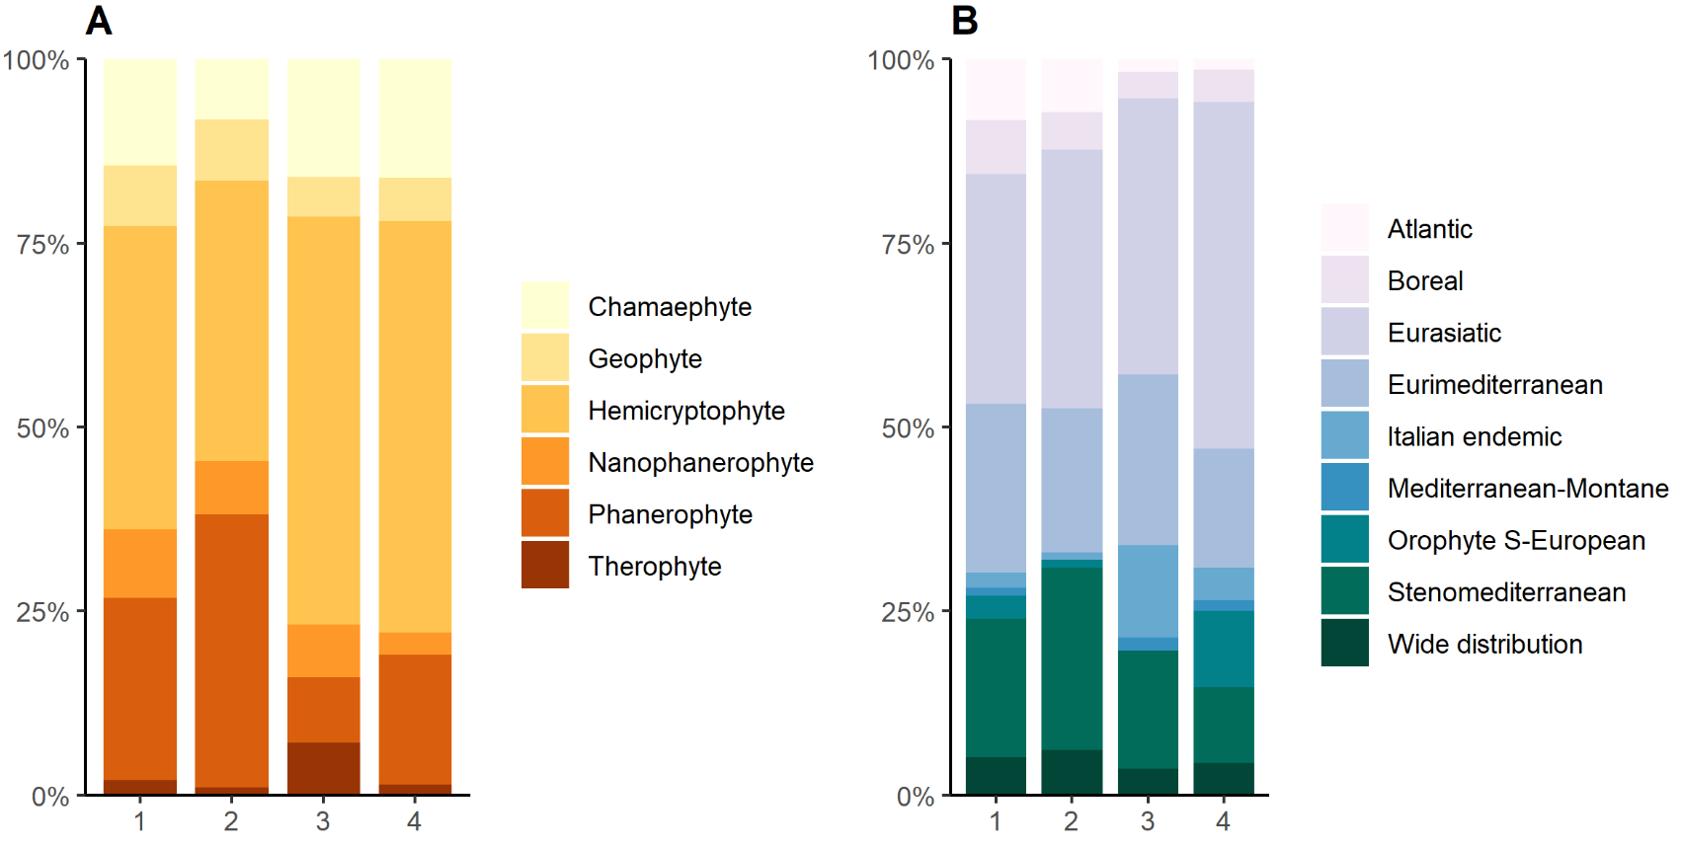
Fig. S1.2. A) Life-form spectrum (weighted on cover data) of the four floristic-ecological clusters derived from TWINSPAN analysis. B) Chorotype spectrum of the four clusters derived from our analysis. Cluster 1 - Eastern Liguria; Cluster 2 - Central-Southern Tuscany and marginally Western Liguria; Cluster 3 - Southern Tuscany; Cluster 4 - Eastern and Western Liguria. One alien species (Robinia pseudoacacia) marginally present is not included. Cluster 1 mostly includes hemicryptophytes (41%) and phanerophytes (25%). Eurasiatic (31%) and Eurimediterranean (23%) chorotypes are more represented in this cluster. Cluster 2 mostly reports phanerophytes (37%) and hemicryptophytes (38%). Here, Eurasiatic (35%) and Stenomediterranean (25%) chorotypes are the most represented. Cluster 3 shows dominance of hemicryptophytes (55%). Eurasiatic (38%) and a large proportion of endemics (12%) characterise the chorotype spectrum of this cluster. Cluster 4 exhibits a dominance of hemicryptophytes (56%) and Eurasiatic species (47%). Clusters 1 and 2 show a noteworthy prevalence of the Atlantic chorotype (8% and 7%, respectively), in contrast to clusters 3 and 4 (2% and 1%, respectively).

