Supplemental material 1
Additional results and study design information for field and greenhouse experiments.

Appendix S1. Variation in perennial recruitment by focal annual identity.
We screened for variation in perennial recruitment by identity of the focal annual sown in each plot to assure that patterns were parallel within each treatment, i.e., among species representing either native, naturalized, or invasive taxa. To do so, we ran a generalized linear model in SAS (PROC GLIMMIX, SAS Institute 2013) with perennial seedling counts from each of the two sampling years as the response fit with a negative binomial distribution. In both years, recruitment varied by focal annual identity (2017: F_{8,81}=6.4, P<0.001; 2018: F_{8,81}=7.5, P<0.001), but in each case, this result was driven by the decrement in seedling counts seen in plots seeded with invasives relative to those seeded with native or naturalized species (Fig. S1; see also Results). Post-hoc tests wherein P-values were adjusted for the number of comparisons via the Bonferroni method indicated that recruitment did not differ significantly among focal annual species representing each treatment in either year (t₈₁<2.2, P>0.9 in all cases). When we dropped invasive plots from the analysis, recruitment no longer varied significantly by focal annual identity (2017: F_{6,63}=1.3, P=0.28; 2018: F_{6,63}=1.2, P=0.34).
Table S1. Perennial plant species added to experimental field plots in 2016 and 2017. The number of seeds added per plot varied among seed size classes as shown.

Species | Growth form | Seed size | No. seeds
Achillea millefolium | Forb | Small | 200
Balsamorhiza sagittata | Forb | Large | 100
Festuca idahoensis | Grass | Medium | 150
Koeleria macrantha | Grass | Small | 200
Lupinus sericeus | Forb | Large | 100
Pseudoroegneria spicata | Grass | Medium | 150

Table S2. Summary statistics from generalized linear models evaluating cover per focal annual species as compared among experimental treatments representing native, naturalized or invasive annuals, and controls. Separate models were run for focal species seeded in the plot (unseeded controls were not included in this analysis; df = 2 and 87) vs. those colonizing from other plots (df = 3 and 96), as measured in each of three sampling years.

Year | Seeded |  |  | Colonized
 | F | P |  | F | P
2016 | 23.1 | <0.001 |  | 4.6 | 0.005
2017 | 2.9 | 0.059 |  | 12.9 | <0.001
2018 | 60.8 | <0.001 |  | 25.0 | <0.001

Table S3. Summary statistics from generalized linear models evaluating total cover of focal annual species and of litter cover, as compared among experimental treatments representing native, naturalized or invasive annuals, and controls (df = 3 and 96). Separate models were run for each response variable and sampling year. Note that litter cover was <1% in all plots in 2016 and hence was not analyzed.

Year | Focal annuals |  |  | Litter
 | F | P |  | F | P
2016 | 29.4 | <0.001 |  | − | −
2017 | 14.8 | <0.001 |  | 10.5 | <0.001
2018 | 3.9 | 0.011 |  | 27.5 | <0.001

Table S4. Summary statistics from generalized linear models evaluating additional soil properties measured in 2018, as compared among experimental treatments representing native, naturalized or invasive annuals, and controls (df = 3 and 96). Separate models were run for each response variable. Post-hoc comparisons of significant treatment effects (P < 0.05) are indicated as relevant (means that do not share letters are significantly different).
Variable | Mean (SE) |  |  |  |  | F | P
 | Native | Naturalized | Invasive | Control
SOM (LOI %) | 5.51 (0.11) | 5.46 (0.09) | 5.6 (0.13) | 5.62 (0.19) |  | 0.4 | 0.774
pH | 6.75 (0.03) | 6.76 (0.03) | 6.67 (0.04) | 6.63 (0.06) |  | 2.2 | 0.093
P _{Merlich} (ppm) | 26.67 (0.90) | 29.16 (0.85) | 30.16 (1.25) | 29.28 (1.72) |  | 2.2 | 0.098
K (ppm) | 271.2 (7.0)^{ab} | 281.4 (6.3)^{ab} | 300.7 (9.5)^{b} | 258.7 (11.6)ª |  | 3.3 | 0.025
S (ppm) | 5.06 (0.26) | 5.26 (0.23) | 5.86 (0.37) | 4.74 (0.42) |  | 1.7 | 0.177
Zn (ppm) | 6.54 (0.59) | 5.74 (0.45) | 5.88 (0.65) | 7.35 (1.16) |  | 0.9 | 0.472
Fe (ppm) | 54.54 (2.18) | 49.67 (1.89) | 49.54 (2.67) | 52.86 (3.78) |  | 1.2 | 0.321
Mn (ppm) | 13.59 (0.48) | 12.43 (0.42) | 11.92 (0.59) | 13.0 (0.83) |  | 1.9 | 0.134
Cu (ppm) | 2.06 (0.11) | 2.06 (0.09) | 1.72 (0.11) | 1.94 (0.17) |  | 2.1 | 0.101
Ca (ppm) | 1544.9 (22.0)^{ab} | 1583.4 (19.1)ª | 1496.0 (27.0)^{b} | 1659.0 (38.1)ª |  | 4.8 | 0.004
Mg (ppm) | 202.3 (3.8) | 206.8 (3.3) | 199.7 (4.7) | 204.4 (6.6) |  | 0.6 | 0.623
Na (ppm) | 7.01 (0.33) | 6.84 (0.28) | 6.1 (0.35) | 7.76 (0.63) |  | 2.2 | 0.090
CEC (meq/100 g) | 10.55 (0.26) | 10.6 (0.23) | 10.67 (0.32) | 11.86 (0.51) |  | 2.1 | 0.110

Table S5. Relationships between recruitment of native perennials and covariates representing biotic and abiotic conditions in experimental plots, as analyzed via generalized linear models. All variables were measured in 2018 except litter biomass, which was measured destructively in 2019. Separate models were constructed for 1) plots established with non-invasive annuals (native or naturalized taxa) or eventually colonized by these species (controls), and 2) invasive annual plots. In each case, all covariates were considered in the same multivariable model to isolate the independent influence of each covariate when remaining covariates were accounted for. To assess the relative contribution of covariates to each multivariable model, covariates were dropped one at a time to determine the associated change in AICc score.
Covariate | Non-invasive annuals and controls (full model AICc=782.5; df=1 and 71) |  |  |  |  | Invasive annuals (full model AICc=159.9; df=1 and 12)
Covariate | β | F | P | ΔAICc |  | β | F | P | ΔAICc
Focal annual cover | 0.001 | 0.5 | 0.466 | −2.0 |  | −0.005 | 6.4 | 0.026 | −0.2
Litter cover | 0.004 | 5.2 | 0.025 | 2.6 |  | 0.002 | 1.0 | 0.328 | −5.4
Litter biomass | −0.0003 | <0.1 | 0.911 | −2.5 |  | −0.003 | 28.1 | <0.001 | 14.0
Soil moisture | −0.060 | 1.1 | 0.303 | −1.4 |  | −0.021 | 0.2 | 0.662 | −6.8
NH₄⁺ | −0.032 | 0.8 | 0.387 | −1.7 |  | −0.131 | 41.9 | <0.001 | 18.7
NO₃⁻ | −0.151 | 2.0 | 0.158 | −0.5 |  | 0.165 | 7.3 | 0.019 | 1.2

Figure S1. Native perennial recruitment (mean + SE) as measured in both 2017 and 2018 and compared among plots established with native, naturalized, or invasive annuals. Results are broken out by identity of the annual species representing each treatment (native: COPA = Collinsia parviflora, CLPU = Clarkia pulchella, PLPA = Plantago patagonica); naturalized: ALAL = Alyssum alyssoides, ARSE = Arenaria serpyllifolia, FIAR = Filago arvensis, and VEVE = Veronica verna); invasive: BRJA = Bromus japonicus, BRTE = B. tectorum). See also Appendix S1.

Figure S2. Litter cover (mean + SE) in plots representing native, naturalized, or invasive annuals, and controls, 2019. The significant treatment effect (F_{3,96}=7.5, P<0.001) was evaluated with post-hoc comparisons, and means that do not share letters are significantly different.

Figure S3. Emergence and survival (+ 1 SE) of marked seeds of the native perennial grass, Pseudoroegneria spicata, planted into plots representing native, naturalized, or invasive annuals, and controls. For each variable, means that do not share either lower or uppercase letters are significantly different, as evaluated with post-hoc comparisons when the treatment effect was significant (P < 0.05). Photo shows marked seed, which was glued to a wooden toothpick and inserted in the soil, through thick litter generated by the invasive annual Bromus japonicus.

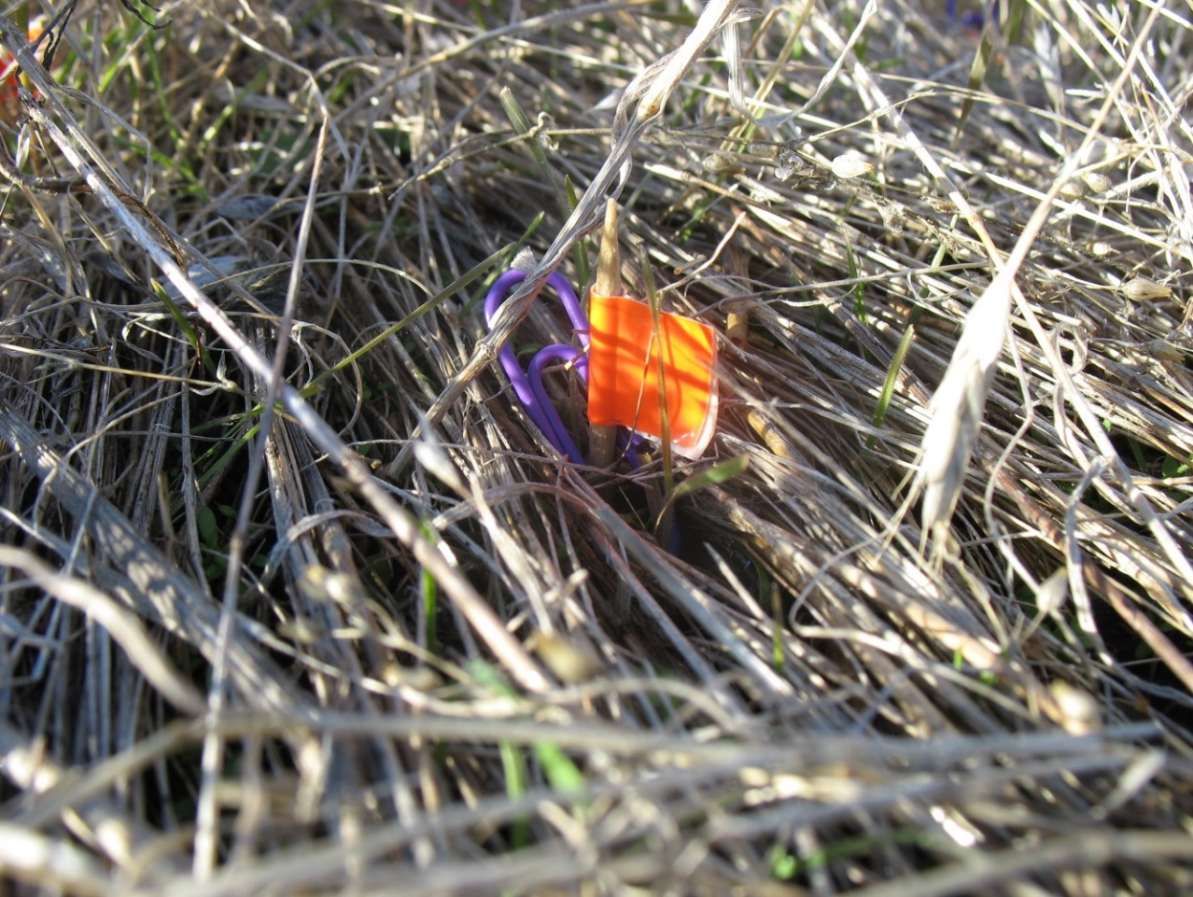

Figure S4. Results of greenhouse plant-soil feedback experiments. The first experiment a) compared focal annuals representing native, naturalized exotic, and invasive exotic taxa grown in untrained soil (round 1) and then in conspecific-trained soil (round 2); and the second experiment b) considered native perennials (ACMI = Achillea millefolium, BASA = Balsamorhiza sagittata, LUSE = Lupinus sericeus, FEID = Festuca idahoensis, KOMA = Koeleria macrantha, and PSSP = Pseudoroegneria spicata) grown in soil trained by the focal invasive annual, Bromus tectorum, or by non-Bromus annuals (focal native or naturalized taxa).

