Supplementary material 1: Informal records by anglers, with photograph evidence. Speciemens colleced with earthworm bait.

1) one specimen collected at 4 m depth, at Bermejo River, Salta Province. Collected Nov. 2016. Photo by Roberto Toval.
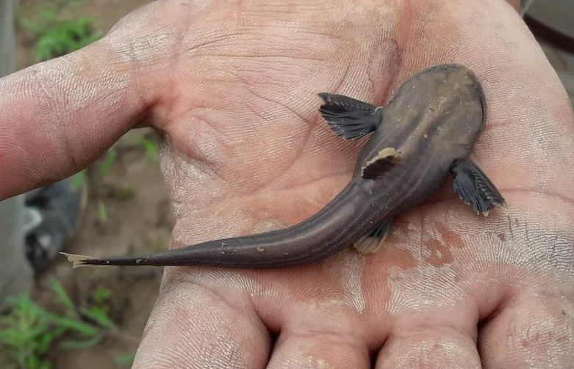

2) one specimen colleced at 8 m depht, at Misiones province. Collected Aug 2015. Photo by Julio Endler
