Supplementary Material 3: Annual maps of swamp eel occurrences across Florida from 1997–2006 (Figs. S4–S7).

Pintar, M.R., N.D. Strickland, J.L. Kline, M.I. Cook, and N.J. Dorn. Asian swamp eels (Synbranchidae: Monopterus) in Florida: distribution, spread, and range of hydrologic tolerance over twenty-seven years (1997–2023). Aquatic Invasions.

Individual full resolution maps are archived with the dataset:
Pintar, M.R., N.D. Strickland, J.L. Kline, M.I. Cook, and N.J. Dorn. 2024. Asian Swamp Eel (Synbranchidae: Monopterus) occurrence data in Florida 1997–2023. Figshare. https://doi.org/10.6084/m9.figshare.25521346.

Fig. S4. Annual maps of swamp eel occurrences across Florida from 1997–2006 with records from that year appearing as blue points and previous years’ records as red points. Years without new records are excluded.

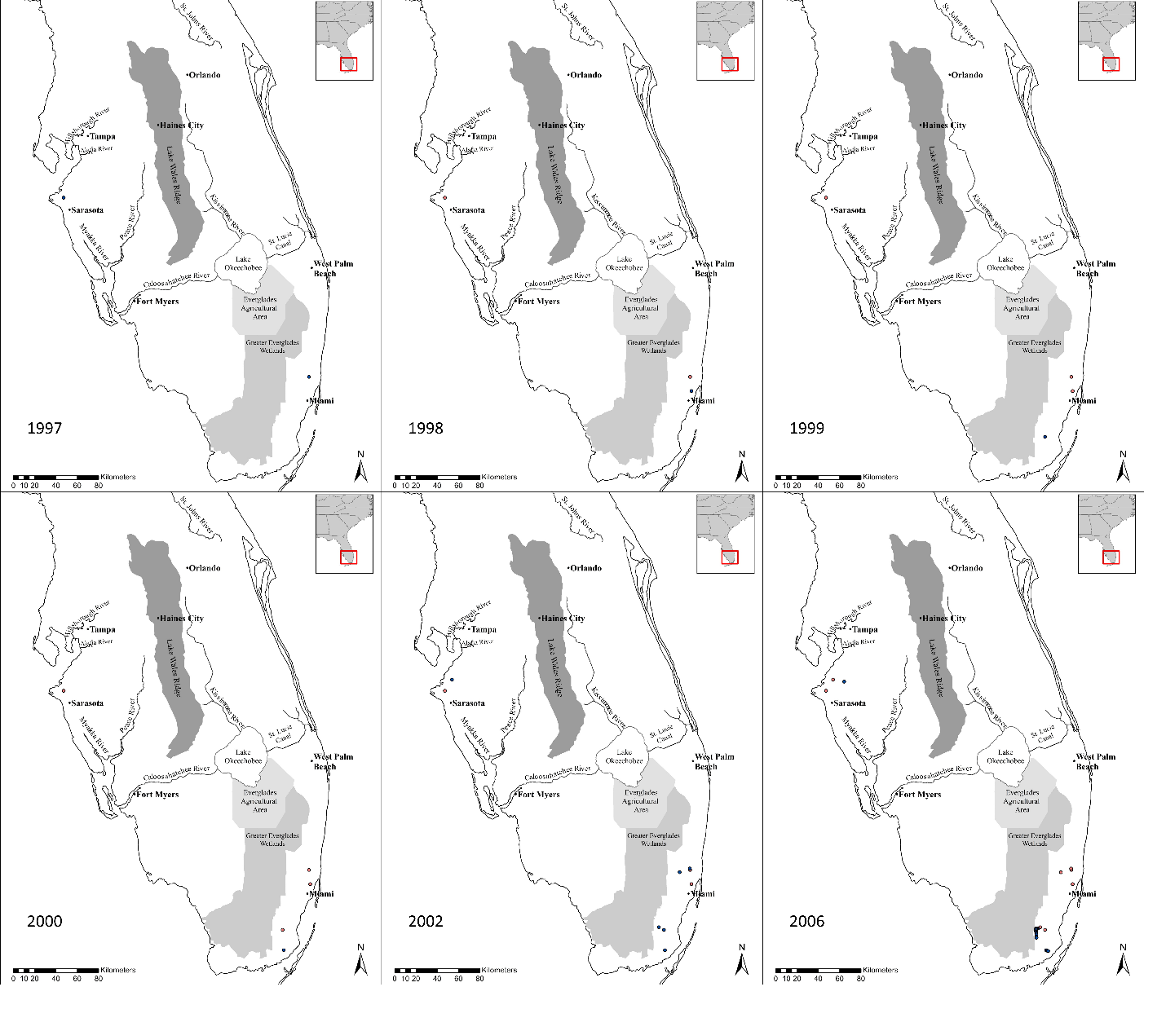
Fig. S5. Annual maps of swamp eel occurrences across Florida from 2007–2012 with records from that year appearing as blue points and previous years’ records as red points.

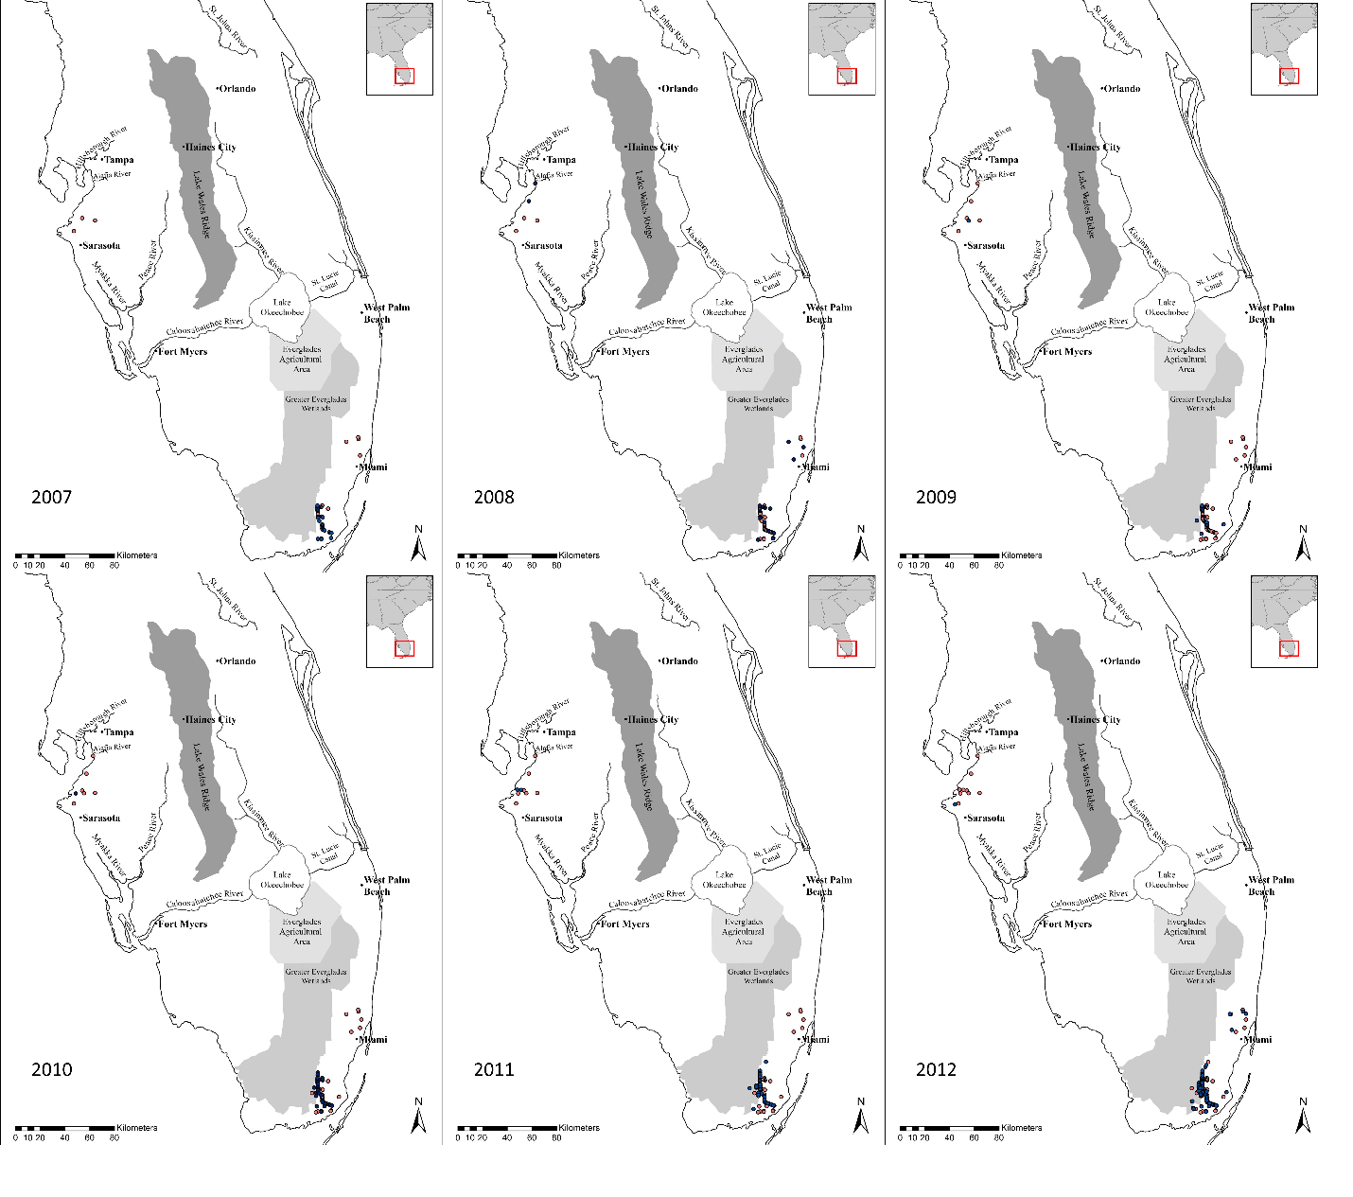
Fig. S6. Annual maps of swamp eel occurrences across Florida from 2013–2018 with records from that year appearing as blue points and previous years’ records as red points.

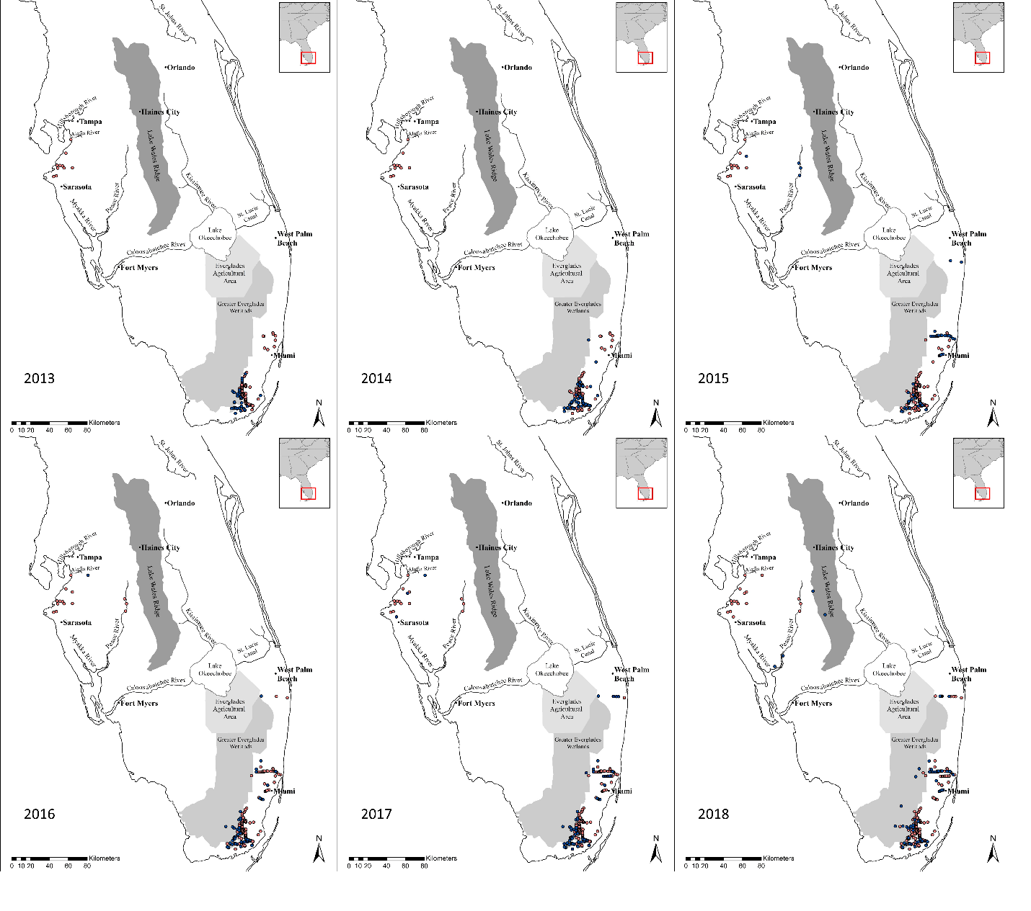
Fig. S7. Annual maps of swamp eel occurrences across Florida from 2019–2024 with records from that year appearing as blue points and previous years’ records as red points.
