Supplementary material 1
Article title: Root hemiparasites suppress invasive alien clonal plants: evidence from a cultivation experiment
Authors: Tamara Těšitelová, Kateřina Knotková, Adam Knotek, Hana Cempírková, Jakub Těšitel

Content:

Appendix S1: Location of source localities of hemiparasite seeds and invasive host plants
Appendix S2: Overview of the number of hemiparasite specimens and their biomass in the experimental treatments
Appendix S3: Overview of host shoot counts and host biomass in the experimental treatments
Appendix S4: Photographic documentation of all pots representing the experimental treatments.

Appendix S1: Location of source localities of hemiparasite seeds and invasive host plants

Study species | Source vegetation | GPS coordinates
Melampyrum arvense | Species rich grassland¹ | 48.7903161N, 16.6922181E
 | Monostand of S. gigantea | 48.7830451N, 16.6273936E
 | Monostand of S. lanceolatum | 48.7831110N, 16.6286695E
Rhinanthus alectorolophus | Species-rich grassland¹ | 48.8212272N, 16.6719728E
 | Monostand of S. gigantea | 48.7800203N, 16.8978881E
 | Monostand of S. lanceolatum | 48.7797161N, 16.8969383E
Solidago gigantea | Monostand of S. gigantea | 48.9279825N, 17.0757086E
Symphyotrichum lanceolatum | Monostand of S. lanceolatum | 48.8156733N, 16.8345633E

¹ source localities of the hemiparasite seeds used for the pilot cultivation trial and haustorial anatomy

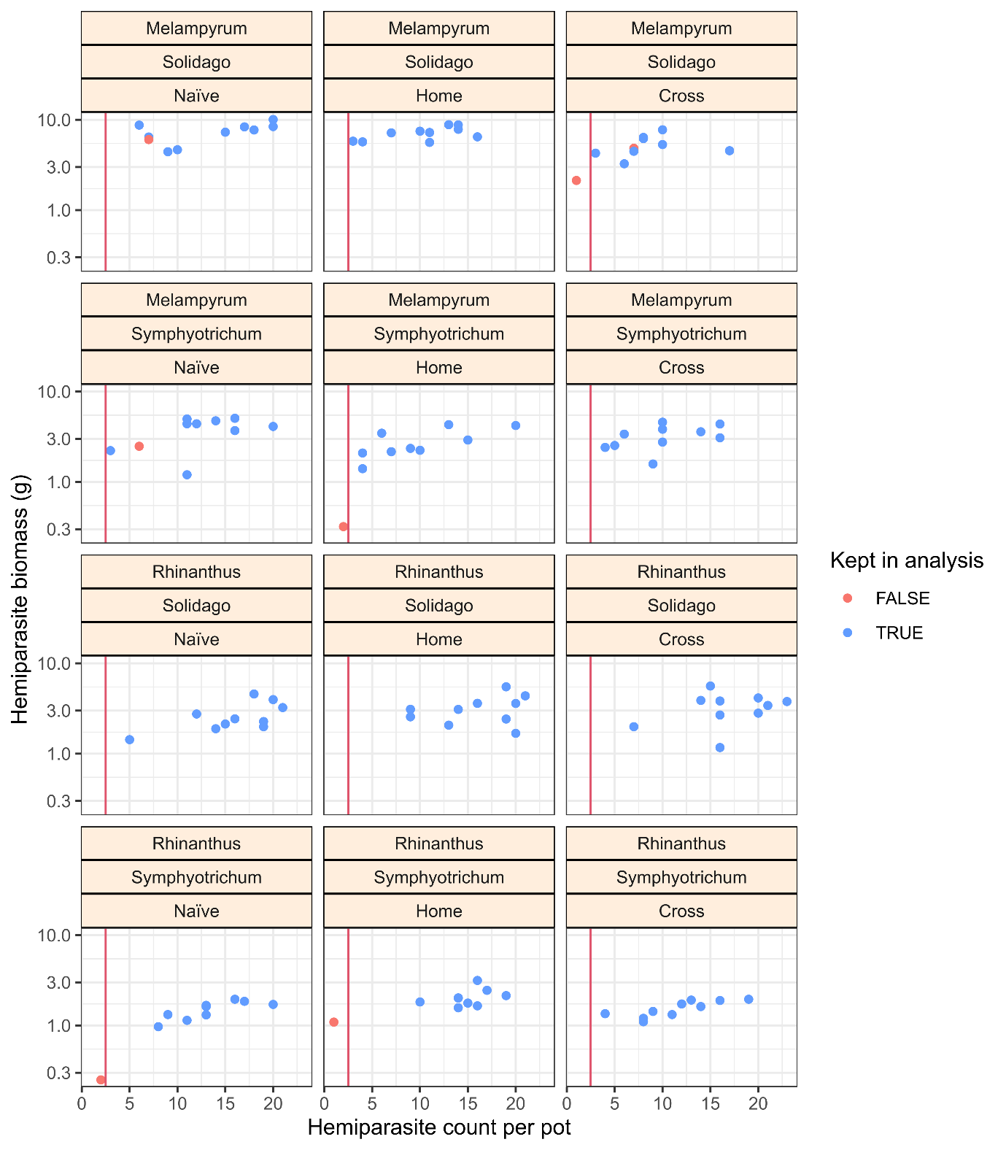
Appendix S2: Scatterplot displaying the relationship between counts of hemiparasites and their total biomass in individual pots categorized by hemiparasite and host identity and hemiparasite seed-source treatments. The vertical red line indicates the threshold for hemiparasites (number of hemiparasites per pot lower than 3). Red points indicate cases omitted from analysis due to too low hemiparasite establishment (to the left) or a low number of host shoots (to the right of the red line; see also Appendix S3).
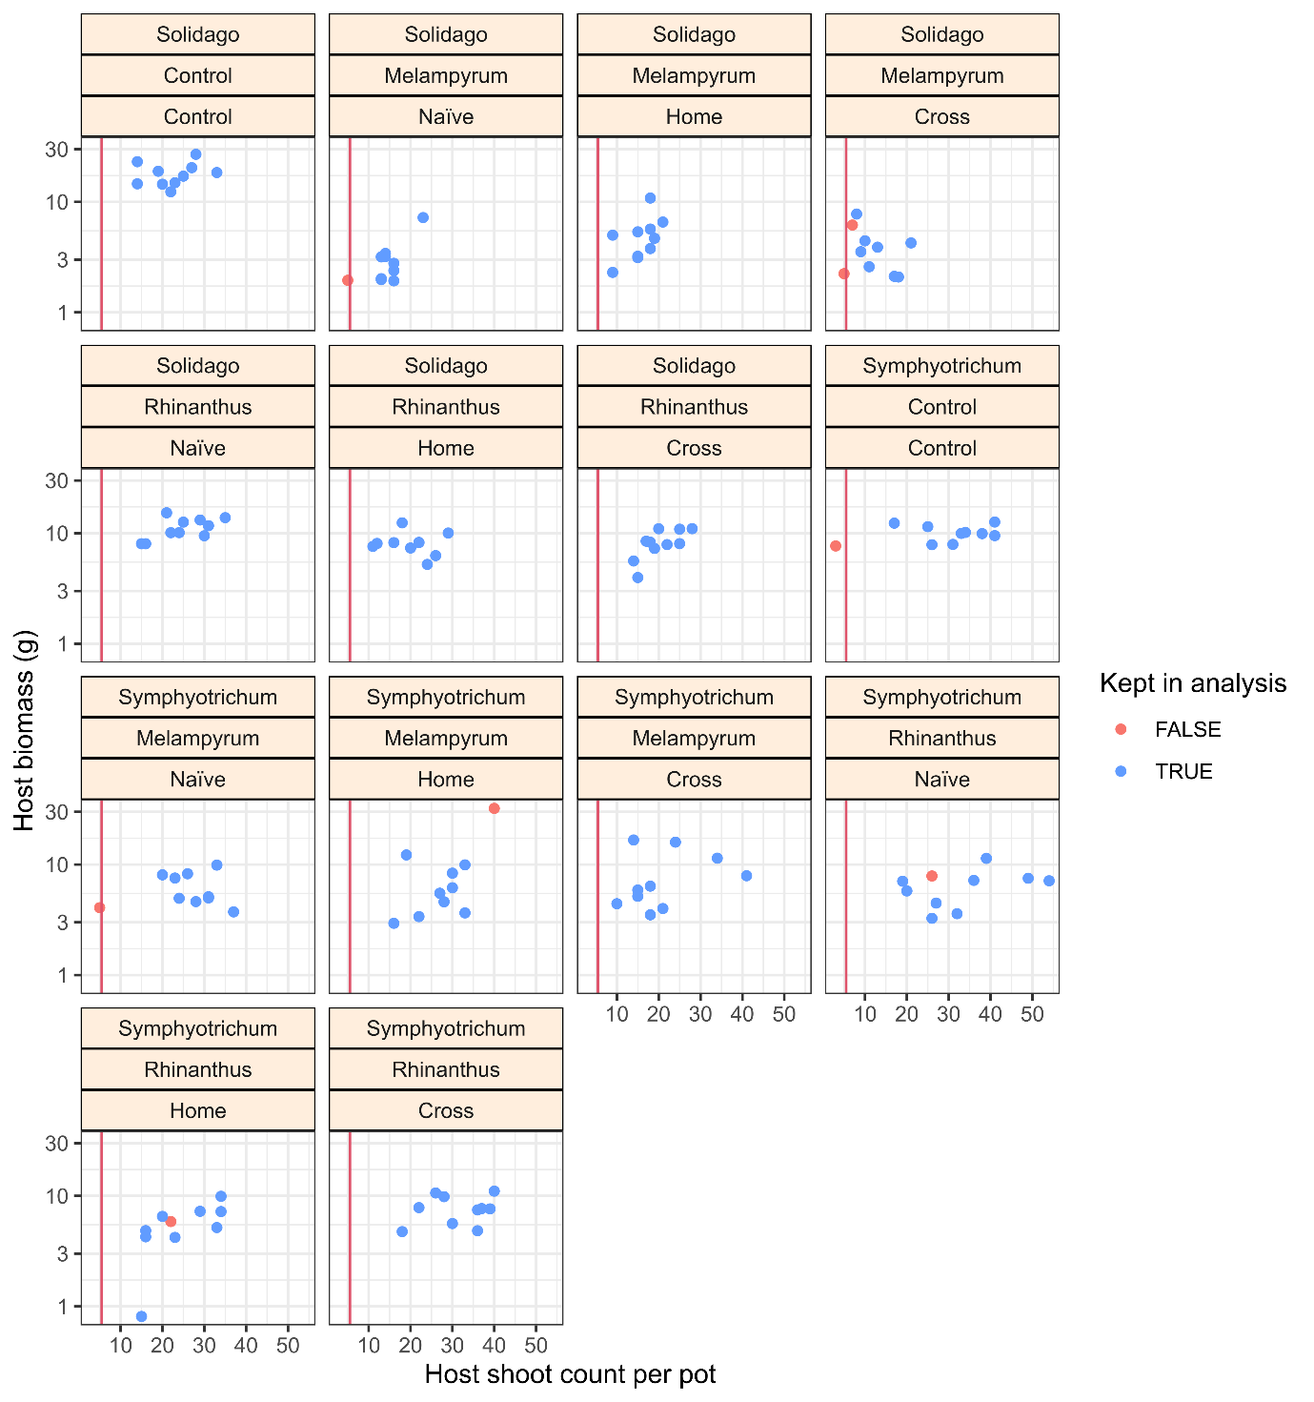
Appendix S3: Scatterplot displaying the relationship between counts of host shoots and their total biomass in individual pots categorized by host and hemiparasite identity and hemiparasite seed-source treatments. The vertical red line indicates the threshold for the host shoot count. Red dots indicate cases omitted from analyses due to low host shoot number (to the left) or low hemiparasite establishment (to the right of the red line; see also Appendix S2).

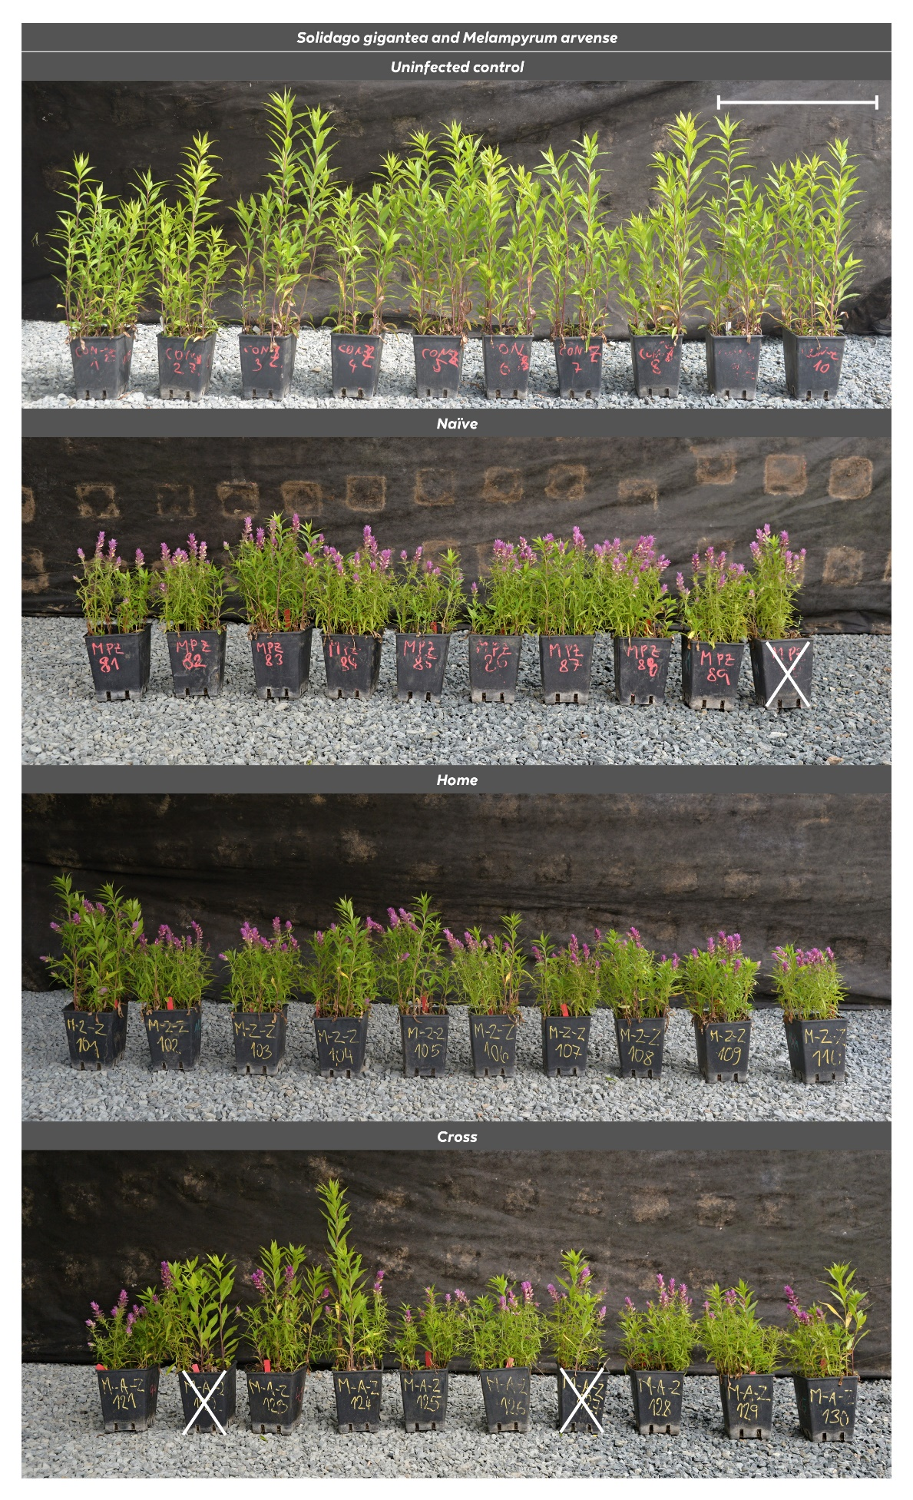
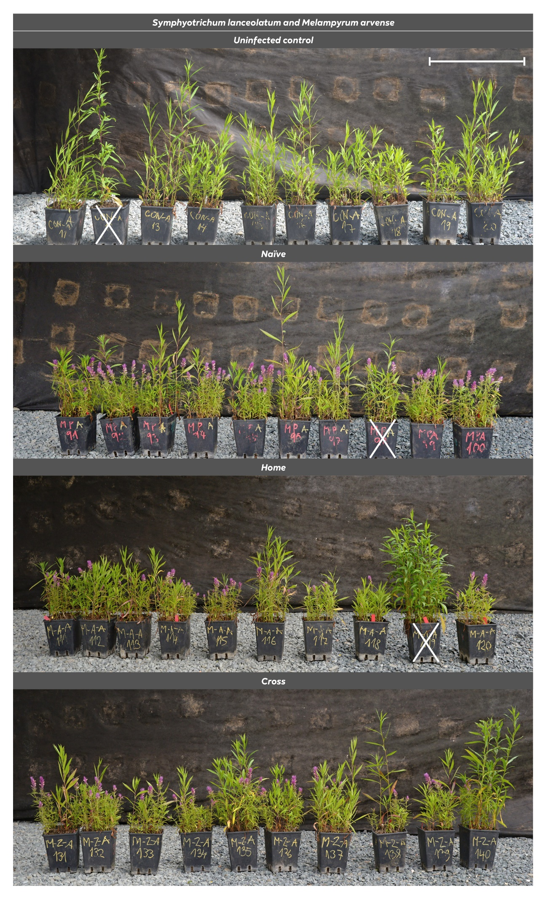
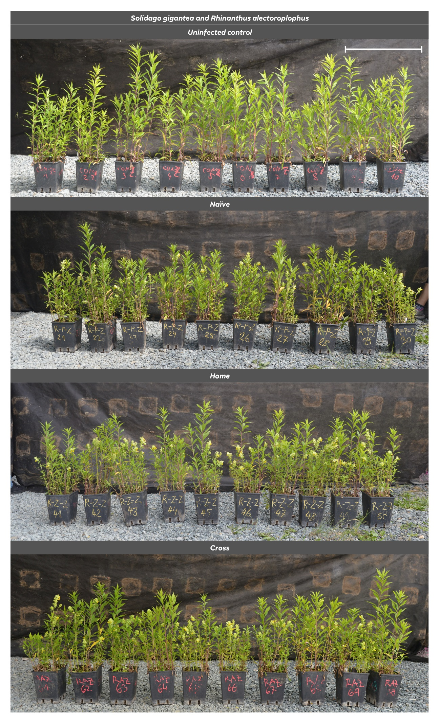
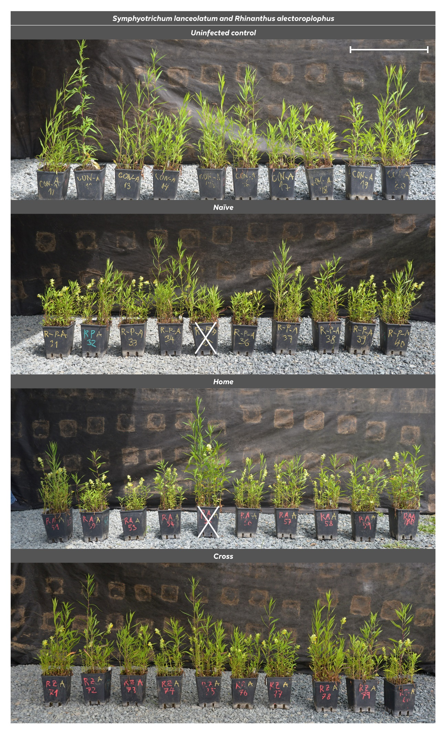
Appendix S4: Documentation of all pots representing hemiparasite seed-source treatments combined with the two invasive host species. The same photos of the control pots are replicated above each host-hemiparasite combination for a better comparison. White crossing denotes pots omitted from the statistical analyses due to a low number of established host shoots or hemiparasite individuals (see Appendices S2 and S3). Bar = 50 cm.

