SUPPLEMENTARY MATERIAL 2
A multi-taxa assessment of aquatic non-indigenous species introduced into Iberian freshwater and transitional waters
Jose M. Zamora-Marín^{1,2}, Ana Ruiz-Navarro^{1,3}, Francisco J. Oficialdegui^{1,4}, Pedro M. Anastácio⁵, Rafael Miranda⁶, Pablo García-Murillo⁷, Fernando Cobo⁸, Filipe Ribeiro⁹, Belinda Gallardo¹⁰, Emili García-Berthou¹¹, Dani Boix¹¹, Leopoldo Medina¹², Felipe Morcillo¹³, Javier Oscoz⁶, Antonio Guillén¹, Antonio A. Herrero-Reyes¹, Francisca C. Aguiar¹⁴, David Almeida¹⁵, Andrés Arias¹⁶, César Ayres¹⁷, Filipe Banha⁵, Sandra Barca⁸, Idoia Biurrun¹⁸, M. Pilar Cabezas¹⁹, Sara Calero²⁰, Juan A. Campos¹⁸, Laura Capdevila-Argüelles²¹, César Capinha^{22,23}, André Carapeto²⁴, Frederic Casals^{25,26}, Paula Chainho⁹, Santos Cirujano²⁷, Miguel Clavero²⁸, Jose A. Cuesta²⁹, Vicente Deltoro³⁰, João Encarnação³¹, Carlos Fernández-Delgado³², Javier Franco³³, Antonio J. García-Meseguer³⁴, Simone Guareschi²⁸, Adrián Guerrero-Gómez¹, Virgilio Hermoso⁷, Celia López-Cañizares¹, Joaquín López-Soriano³⁵, Annie Machordom³⁶, Joana Martelo⁹, Andrés Mellado-Díaz²⁰, Juan C. Moreno³⁷, Rosa Olivo del Amo¹, J. Carlos Otero⁸, Anabel Perdices³⁶, Quim Pou-Rovira³⁸, Sergio Quiñonero-Salgado³⁵, Argantonio Rodríguez-Merino⁷, Macarena Ros³⁹, Enrique Sánchez-Gullón³⁹, Marta I. Sánchez⁴¹, David Sánchez-Fernández³⁴, Jorge R. Sánchez-González⁴², Oscar Soriano³⁶, M. Alexandra Teodósio³¹, Mar Torralva¹, Rufino Vieira-Lanero⁸, Antonio Zamora-López¹, Francisco J. Oliva-Paterna¹

1 Department of Zoology and Physical Anthropology, Faculty of Biology, University of Murcia, CEIR Campus Mare Nostrum (CMN), Murcia, Spain
2 Department of Applied Biology, Centro de Investigación e Innovación Agroalimentaria (CIAGRO-UMH), Miguel Hernández University of Elche, Elche, Spain
3 Department of Didactics on Experimental Sciences, Faculty of Education, University of Murcia, Murcia, Spain
4 University of South Bohemia in České Budějovice, Faculty of Fisheries and Protection of Waters, South Bohemian Research Center of Aquaculture and Biodiversity of Hydrocenoses, Zátiší 728/II, 389 25 Vodňany, Czech Republic
5 MARE – Centro de Ciências do Mar e do Ambiente. Departamento de Paisagem, Ambiente e Ordenamento, Escola de Ciências e Tecnologia, Universidade de Évora, Évora, Portugal
6 Instituto de Biodiversidad y Medioambiente (BIOMA), Universidad de Navarra, Pamplona, Spain
7 Departamento de Biología Vegetal y Ecología, Facultad de Farmacia, Universidad de Sevilla, Sevilla, Spain
8 Departamento de Zooloxía, Xenética e Antropoloxía Física, Facultade de Bioloxía,
Universidade de Santiago de Compostela, A Coruña, Spain
9 MARE – Centro de Ciências do Mar e do Ambiente, Faculdade de Ciências da Universidade de Lisboa, Lisboa, Portugal
10 Instituto Pirenaico de Ecología (IPE), CSIC, Zaragoza, Spain
11 GRECO, Institute of Aquatic Ecology, University of Girona, Girona, Spain
12 Sistemática de Plantas Vasculares, Real Jardín Botánico (RJB-CSIC), Madrid, Spain
13 Departamento de Biodiversidad, Ecología y Evolución, Universidad Complutense de Madrid, Madrid, Spain
14 Centro de Estudos Florestais, Instituto Superior de Agronomia, Universidade de Lisboa, Lisboa, Portugal
15 Department of Basic Medical Sciences, School of Medicine, Universidad San Pablo-CEU, CEU Universities, Madrid, Spain
16 Departamento de Biología de Organismos y Sistemas, Universidad de Oviedo, Asturias, Spain
17 Asociación Herpetológica Española (A.H.E.), Museo Nacional de Ciencias Naturales (MNCN-CSIC), Madrid, Spain
18 Department of Plant Biology and Ecology, University of the Basque Country UPV/EHU, Bilbao, Spain
19 Department of Biogeographical Ecology and Evolution, Centro de Ciências do Mar (CCMAR), Universidade do Algarve, Faro, Portugal
20 Tragsatec, TSUP Planificación y Gestión Hídrica, Grupo Tragsa – SEPI, Madrid, Spain
21 GEIB - Grupo Especialista en Invasiones Biológicas, León, Spain
22 Centre of Geographical Studies, Institute of Geography and Spatial Planning, University of Lisbon, 1600-276 Lisboa, Portugal
23 Associated Laboratory Terra, Tapada da Ajuda, 1349-017 Lisboa, Portugal
24 Coordinador de Lista Vermelha da Flora de Portugal Continental, Sociedade Portuguesa de Botânica, Coimbra, Portugal
25 Departament de Ciència Animal, Universitat de Lleida, Lleida, Spain
26 Centre Tecnològic Forestal de Catalunya (CTFC), Solsona, Lleida, Spain
27 Ecología, conservación de macrófitos acuáticos y cambio global, Real Jardín Botánico (RJB-CSIC), Madrid, Spain
28 Departamento de Biología de la Conservación, Estación Biológica de Doñana (EBD-CSIC), Sevilla, Spain
29 Departamento de Ecología y Gestión Costera, Instituto de Ciencias Marinas de Andalucía (ICMAN-CSIC), Cádiz, Spain
30 Técnico Superior en Medio Ambiente, VAERSA-GVA, Generalitat Valenciana, Valencia, Spain
31 CCMAR - Centro de Ciências do Mar, Universidade do Algarve, Portugal
32 Departamento de Zoología, Universidad de Córdoba, Spain
33 AZTI, Investigación Marina, Gestión Ambiental de Mares y Costas, Pasaia, Guipúzkoa, Spain
34 Departamento de Ecología e Hidrología. Facultad de Biología. Universidad de Murcia, Murcia, Spain
35 Associació Catalana de Malacologia-Museu Blau. Barcelona, Spain
36 Departamento de Biodiversidad y Biología Evolutiva. Museo Nacional de Ciencias Naturales (MNCN-CSIC), Madrid, Spain
37 Departamento de Biología (Botánica), Facultad de Ciencias, Universidad Autónoma de Madrid, Madrid, Spain
38 Sorelló - Estudis al Medi Aquàtic, Girona, Spain
39 Departamento de Zoología, Facultad de Biología, Universidad de Sevilla, Sevilla, Spain
40 Consejería de Sostenibilidad, Medio Ambiente y Economía Azul, Junta de Andalucía, Huelva, Spain
41 Departamento de Ecología de Humedales, Estación Biológica de Doñana (EBD-CSIC), Sevilla, Spain
41 SIBIC, Departament de Ciència Animal, Universitat de Lleida, Lleida, Spain

Corresponding authors: Jose M. Zamora-Marín (josemanuel.zamora@um.es); Francisco J. Oliva-Paterna (fjoliva@um.es)

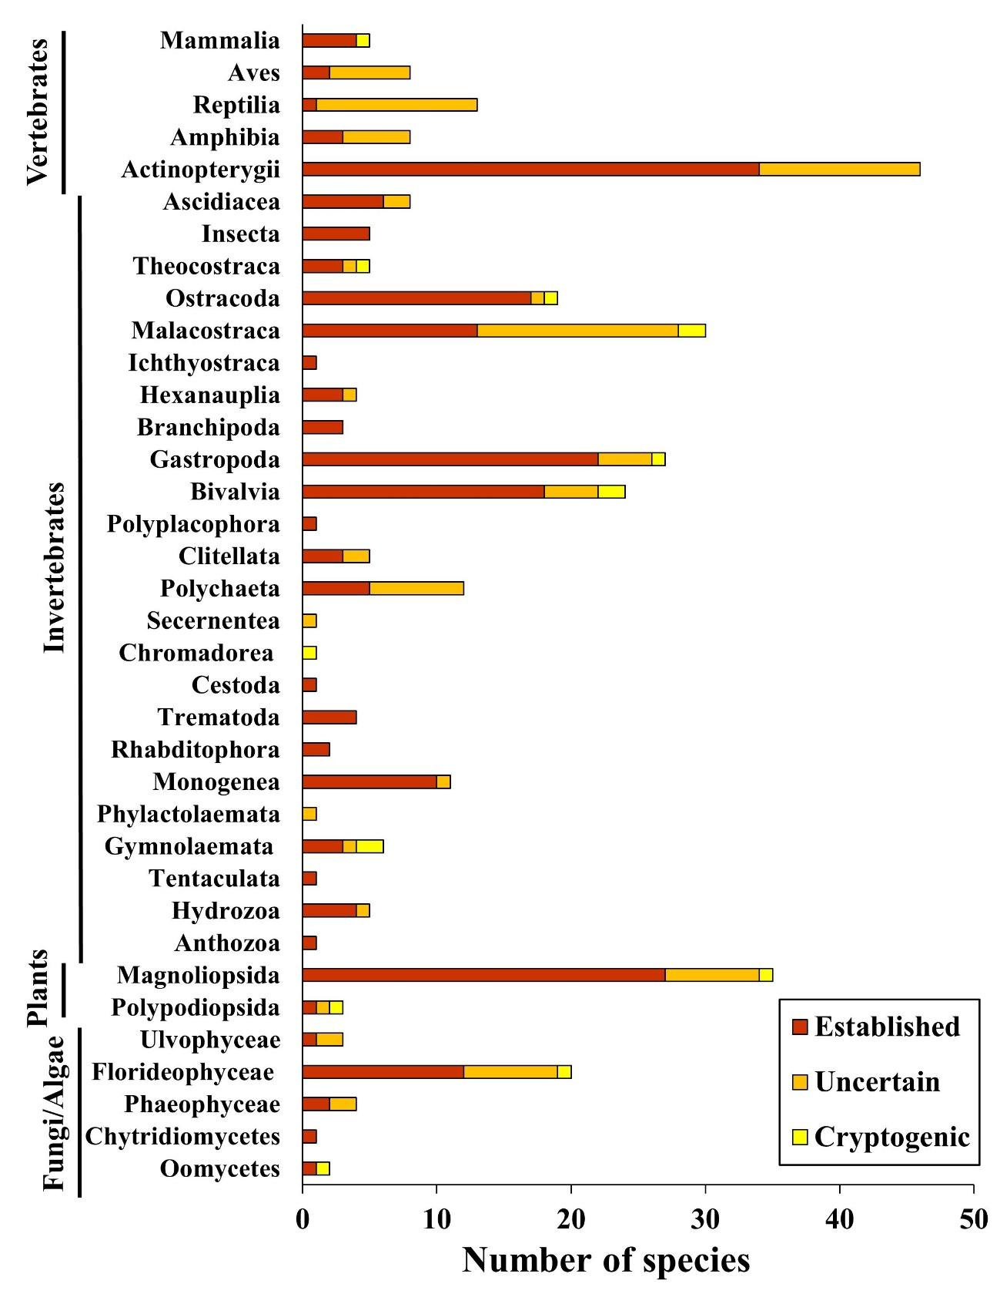
Figure S1. Number of aquatic non-indigenous species (NIS) recorded in Iberian inland waters (including freshwater and transitional waters) across taxonomic classes. From top to bottom, taxonomic classes are ranked by evolutionary order. Colours refer to the proportion of NIS belonging to each establishment stage (established, uncertain or cryptogenic).

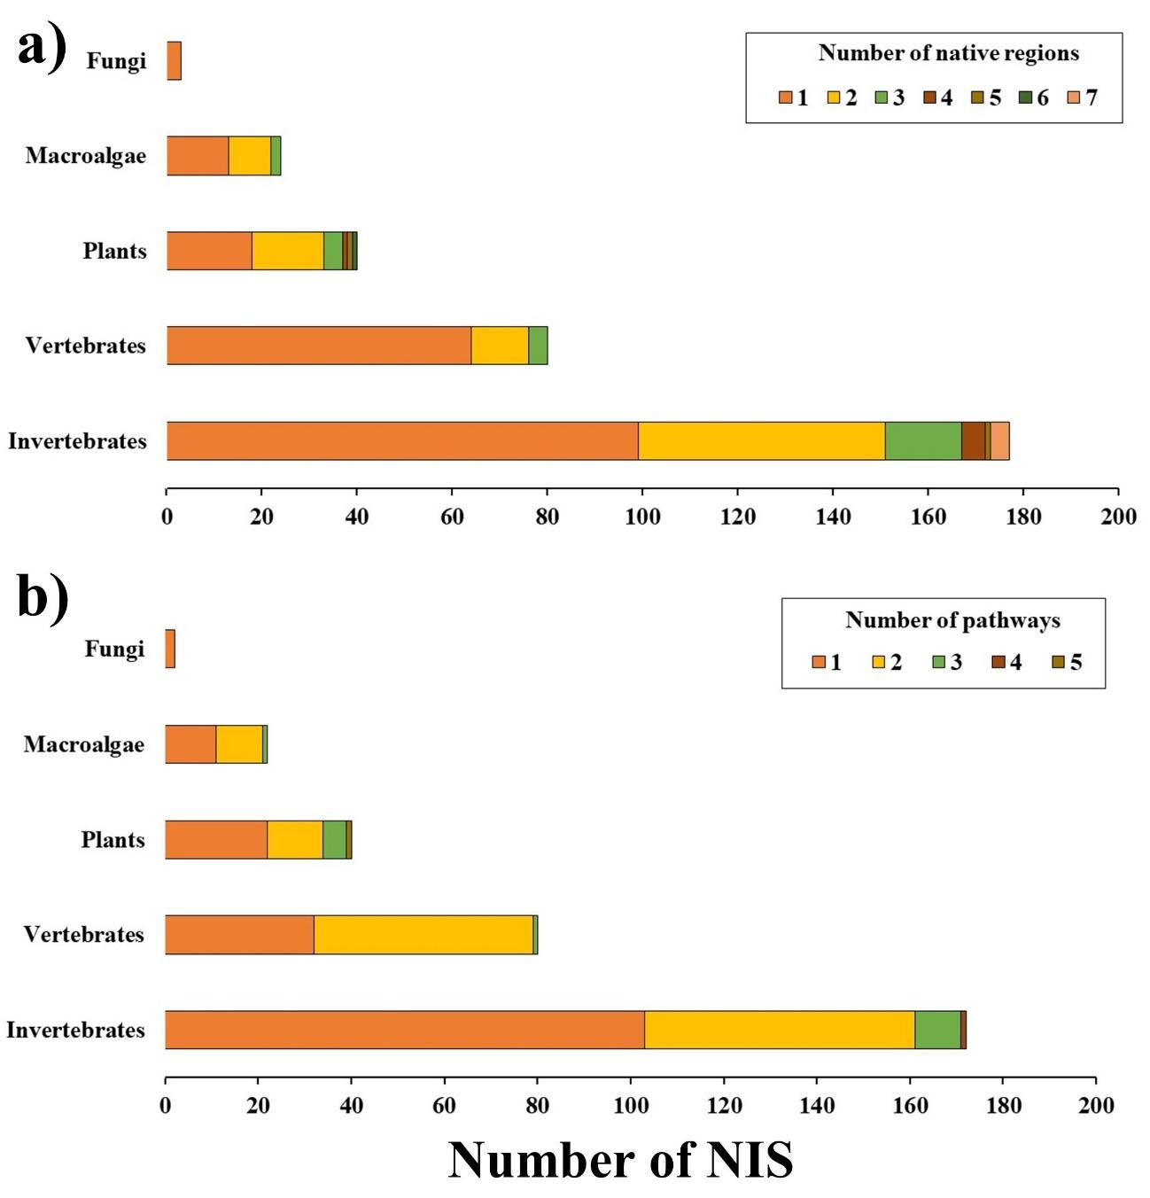
Figure S2. Number of native regions (a) and introduction pathways (b) associated to the five major biotic groups containing all aquatic non-indigenous species (NIS) introduced in Iberian inland waters (including freshwater and transitional waters). For instance, half of the inventoried non-indigenous invertebrate species presented a single native region and were introduced through a single pathway. From top to bottom, major biotic groups are ranked from the species-poorest to the species-richest. As several NIS presented two or more native regions or introduction pathways, data were down-weighted to avoid overrepresentation.

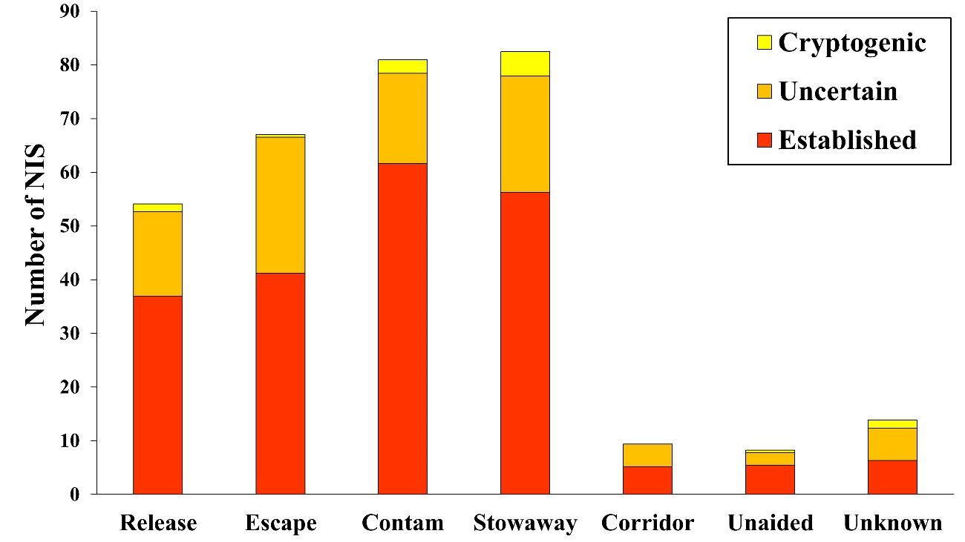

Figure S3. Contribution of the seven categories of introduction pathways to the arrival of aquatic non-indigenous species (NIS) to Iberian inland waters (both freshwater and transitional waters). As several NIS were introduced through two or more pathways, data were down-weighted to avoid overrepresentation of these categories. Colours refer to the proportion of NIS belonging to each establishment stage (established, uncertain or cryptogenic).

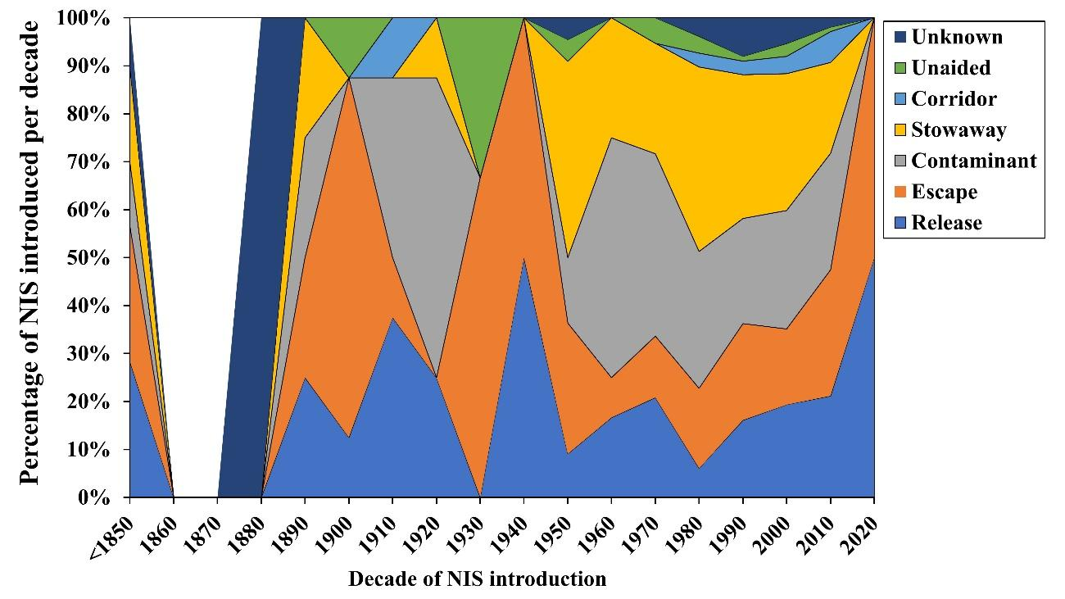
Figure S4. Temporal variation in the overall contribution of the seven introduction pathways to the arrival of aquatic non-indigenous species (NIS) to Iberian inland waters (including freshwater and transitional waters). As several NIS were introduced through two or more pathways, data were down-weighted to avoid overrepresentation of these categories.

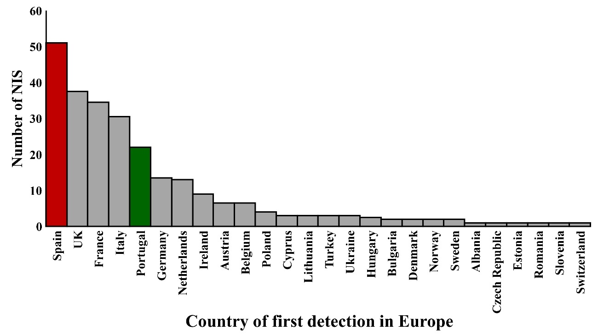
Figure S5. By-country distribution of first European records of aquatic non-indigenous species (NIS) introduced in Iberian inland waters (including freshwater and transitional waters). Information on countries of first detection in European inland waters was mostly retrieved from EASIN, but also from the screened literature. The two target Iberian countries (Spain and Portugal) are highlighted in red and green colour, respectively.

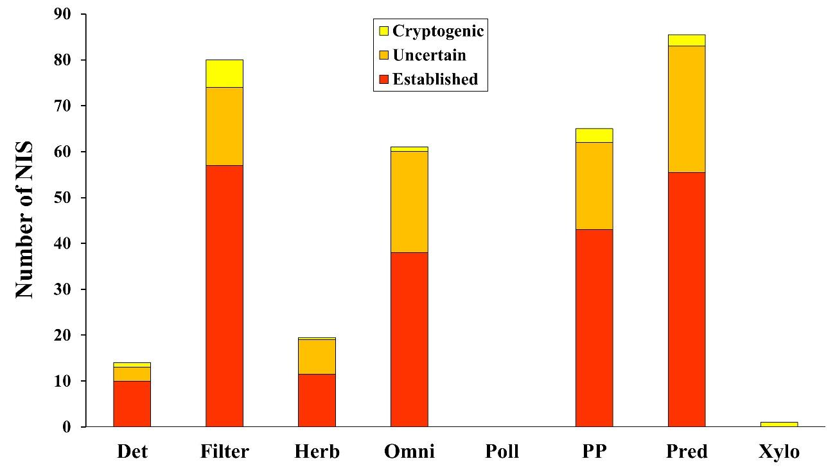
Figure S6. Distribution across functional groups (i.e. trophic groups) of aquatic non-indigenous species (NIS) recorded in Iberian inland waters (including freshwater and transitional waters). Colours refer to the proportion of NIS belonging to each establishment stage (established, uncertain or cryptogenic). Det: detritivores; Filter: filter-feeders; Herb: herbivores; Omni: omnivores; Poll: pollinator; PP: primary producers; Pred: predators; Xylo: xylophages.

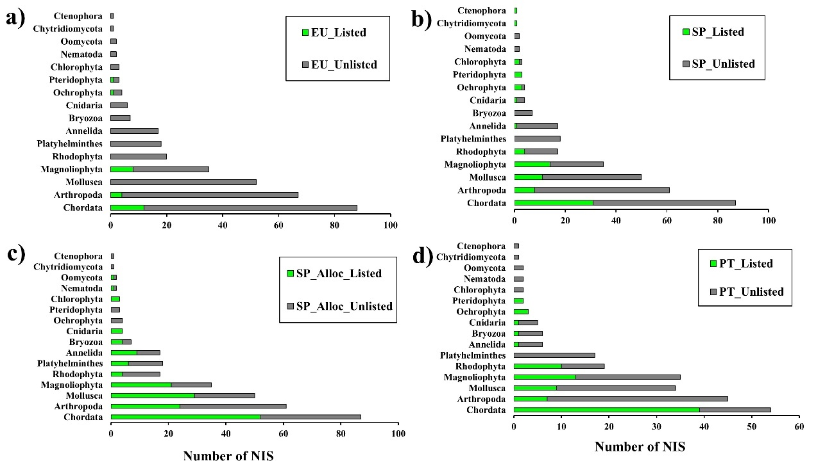
Figure S7. Legal coverage of official regulation lists for aquatic non-indigenous species (NIS) introduced in Iberian inland waters (including freshwater and transitional waters). These regulation lists include: (a) the EU Regulation 1143/2014 (EU_List); (b) the Spanish Catalogue of Invasive Alien Species (Real Decreto 630/2013) (SP_List); (c) the list of allochthonous species able to impact on Spanish native biodiversity (Royal Decree 570/2020) (SP_Alloc_List); and (d) the Decreto-lei 92/2019 (PT_List). For the EU_List (a), the number of unlisted taxa is calculated as the difference between all aquatic NIS recorded in Iberian inland waters and those taxa which are included in the EU_List. In the remaining histograms, the number of unlisted taxa is calculated as the difference between the pool of aquatic NIS recorded at country level (Spain or Portugal) and the subset of those listed in the corresponding regulation list.

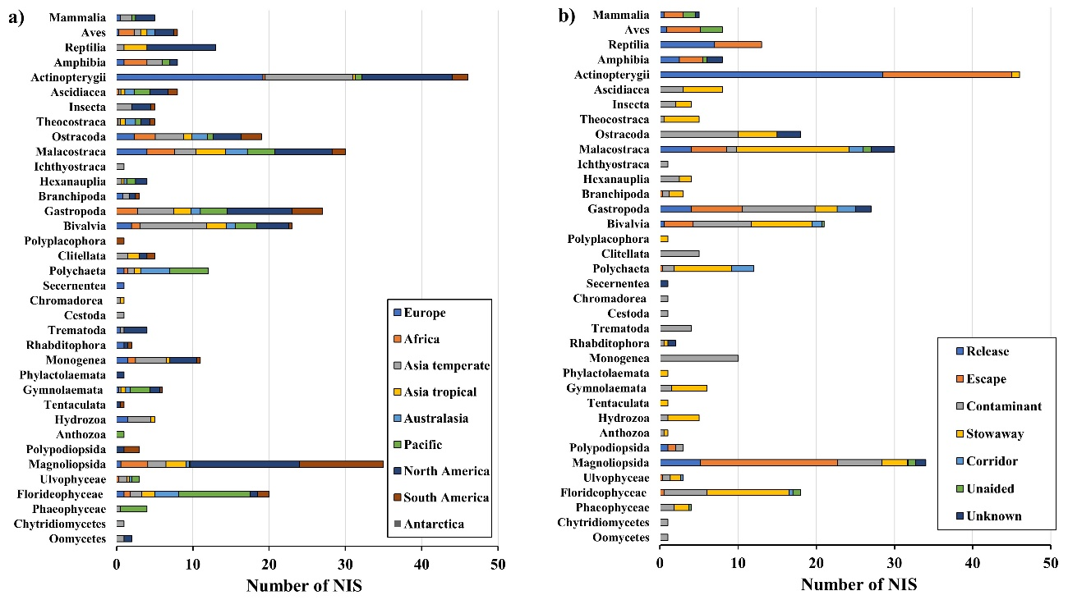

Figure S8. Distribution of native regions (a) and introduction pathways (b) across taxonomic classes containing all aquatic non-indigenous species (NIS) introduced in Iberian inland waters (including freshwater and transitional waters). From bottom to top, classes are ranked by evolutionary order. As several NIS presented two or more native regions or introduction pathways, data were down-weighted to avoid overrepresentation.

