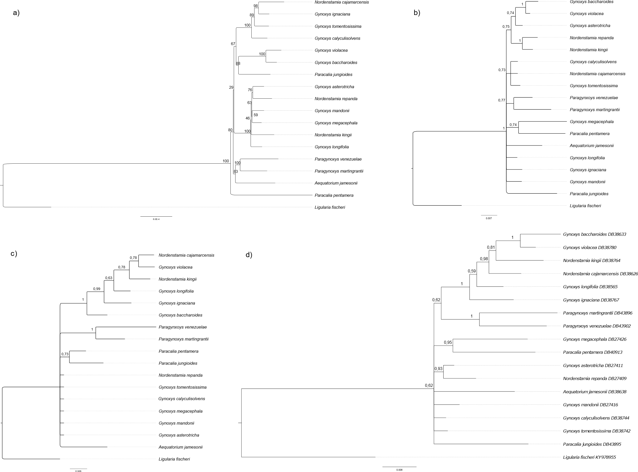
Appendix 2: Majority consensus tree on a) Plastid genome (Escobari et al 2021), b) ITS, c) ETS, d) ETS-ITS concatenated under Bayesian inference topology. Posterior probability values are given.

