Supplementary Data

Table S1. P-values for PWRST posthoc contrasts of allopatric G. pennsylvanicus populations by region (See Fig. 3). P-values marked with *** lost significance after correction.

Male Pronotum (Fig. 3A)
 | CTR | NE | NW | SE | SO | SW
NE | 0.545 | NA | NA | NA | NA | NA
NW | 0.071 | 0.006 | NA | NA | NA | NA
SE | 0.586 | 0.002 | 1.40E-04 | NA | NA | NA
SO | 0.545 | 0.020 | 6.52E-04 | 0.453 | NA | NA
SW | 0.186 | 5.52E-06 | 4.49E-06 | 0.077 | 0.515 | NA
WNC | 0.127 | 0.023 | 0.183 | 9.04E-06 | 0.001 | 3.89E-08
Female Pronotum (Fig. 3B)
 | CTR | NE | NW | SE | SO | SW
NE | 0.068 | NA | NA | NA | NA | NA
NW | 0.009 | 0.027 | NA | NA | NA | NA
SE | 0.874 | 2.81E-06 | 2.04E-08 | NA | NA | NA
SO | 0.933 | 0.024 | 0.003 | 0.664 | NA | NA
SW | 0.544 | 3.34E-06 | 2.89E-07 | 0.114 | 0.605 | NA
WNC | 0.080 | 0.756 | 0.070 | 6.79E-06 | 0.031 | 6.56E-06
Relative ovipositor (Fig. 3C)
 | CTR | NE | NW | SE | SO | SW
NE | 0.001 | NA | NA | NA | NA | NA
NW | 0.005 | 0.003 | NA | NA | NA | NA
SE | 2.73E-05 | 0.519 | 0.006 | NA | NA | NA
SO | 0.570 | 0.004 | 0.130 | 0.003 | NA | NA
SW | 0.003 | 0.005 | 0.324 | **0.039 | 0.031 | NA
WNC | 0.015 | 0.002 | 0.677 | 0.021 | 0.114 | 0.879
Ovipositor length (Fig. S2B)
 | CTR | NE | NW | SE | SO | SW
NE | 0.001 | NA | NA | NA | NA | NA
NW | 0.002 | 1.9E-05 | NA | NA | NA | NA
SE | 0.003 | 3.8E-15 | 0.102 | NA | NA | NA
SO | 0.461 | 2.8E-05 | 0.006 | 0.009 | NA | NA
SW | 0.013 | 2.45E-16 | 3.11E-05 | 0.001 | 0.166 | NA
WNC | 0.007 | 3.7E-09 | 0.974 | 0.069 | 0.011 | 9.72E-05

Table S2. P-values for PWRST posthoc contrasts of allopatric G. firmus populations by region (See Fig. 3). P-values marked with *** lost significance after correction.

Male Pronotum (Fig. 3A)
 | NE | SE
SE | 0.002 | NA
SO | 0.253 | 0.092
Female Pronotum (Fig. 3B)
 | NE | SE
SE | 0.006 | NA
SO | ***0.049 | 0.449
Relative ovipositor (Fig. 3C)
 | NE | SE
SE | 7.5E-05 | NA
SO | 1.1E-11 | 8.7E-4
Ovipositor length (Fig. S2B)
 | NE | SE
SE | 0.1 | NA
SO | 2.0E-16 | 2.0E-10

Table S3. P-values for PWRST posthoc contrasts of G. thinos populations and G. firmus populations in the Northeast, Florida, and Texas. See Fig. 4.

Male G. firmus/thinos Femur By Region (Fig. 4A) | NE G. firmus | FL G. firmus | TX G. firmus
FL firmus | 2.6E-06 | NA | NA
TX firmus | 0.809 | 2.2E-05 | NA
TX thinos | 0.004 | 6.1E-06 | 0.009
Female G. firmus/thinos Femur By Region (Fig. 4B) | NE G. firmus | FL G. firmus | TX G. firmus
FL firmus | 5.8E-06 | NA | NA
TX firmus | 0.301 | 7.20E-06 | NA
TX thinos | 0.416 | 3.36E-04 | 0.836
Female G. firmus/thinos Ovi/Femur Ratio By Region (Fig. 4C) | NE G. firmus | FL G. firmus | TX G. firmus
FL firmus | 3.6E-07 | NA | NA
TX firmus | 2.0E-16 | 3.24E-04 | NA
TX thinos | 6.6E-06 | 9.83E-06 | 1.29E-05
Female G. firmus/thinos Ovipositor Length By Region (Fig. S2) | NE G. firmus | FL G. firmus | TX G. firmus
FL firmus | 0.030 | NA | NA
TX firmus | 2.0E-16 | 9.9E-07 | NA
TX thinos | 1.7E-06 | 9.8E-06 | 0.006

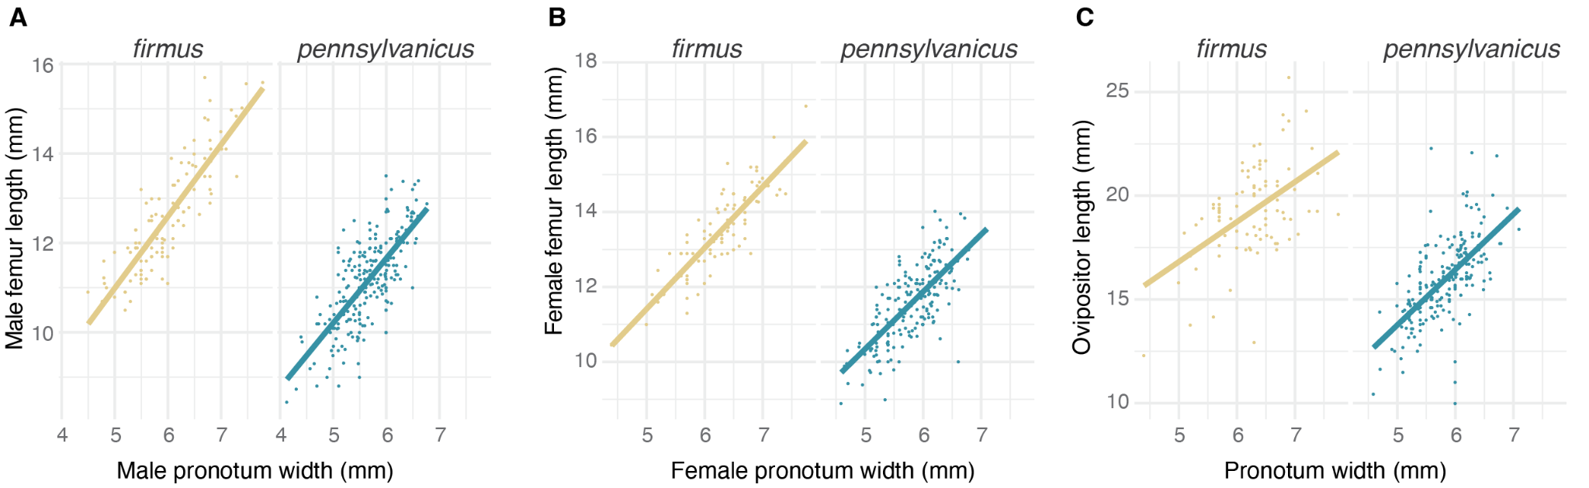

Figure S1: Relationship among phenotypic characteristics for allopatric populations. (a) Male Gryllus firmus (yellow) and G. pennsylvanicus (teal) linear models show positive relationships in femur length and pronotum width (G. firmus: R² = 0.76, F_{1,117} = 363.1, p-value < 2.2e-16; G. pennsylvanicus: R² = 0.53, F_{1,233} = 265.0, p-value < 2.2e-16). Female linear models show positive relationships in both (b) femur length and pronotum width (G. firmus: R² = 0.74, F_{1,89} = 254.7,p-value < 2.2e-16; G. pennsylvanicus: R² = 0.53, F_{1,192} = 217.0, p-value < 2.2e-16) and (c) ovipositor length and pronotum width (G. firmus: R² = 0.26, F_{1,87} = 30.48, p-value = 3.44e-07; G. pennsylvanicus: R² = 0.44, F_{1,214} = 165.7, p-value < 2.2e-16).

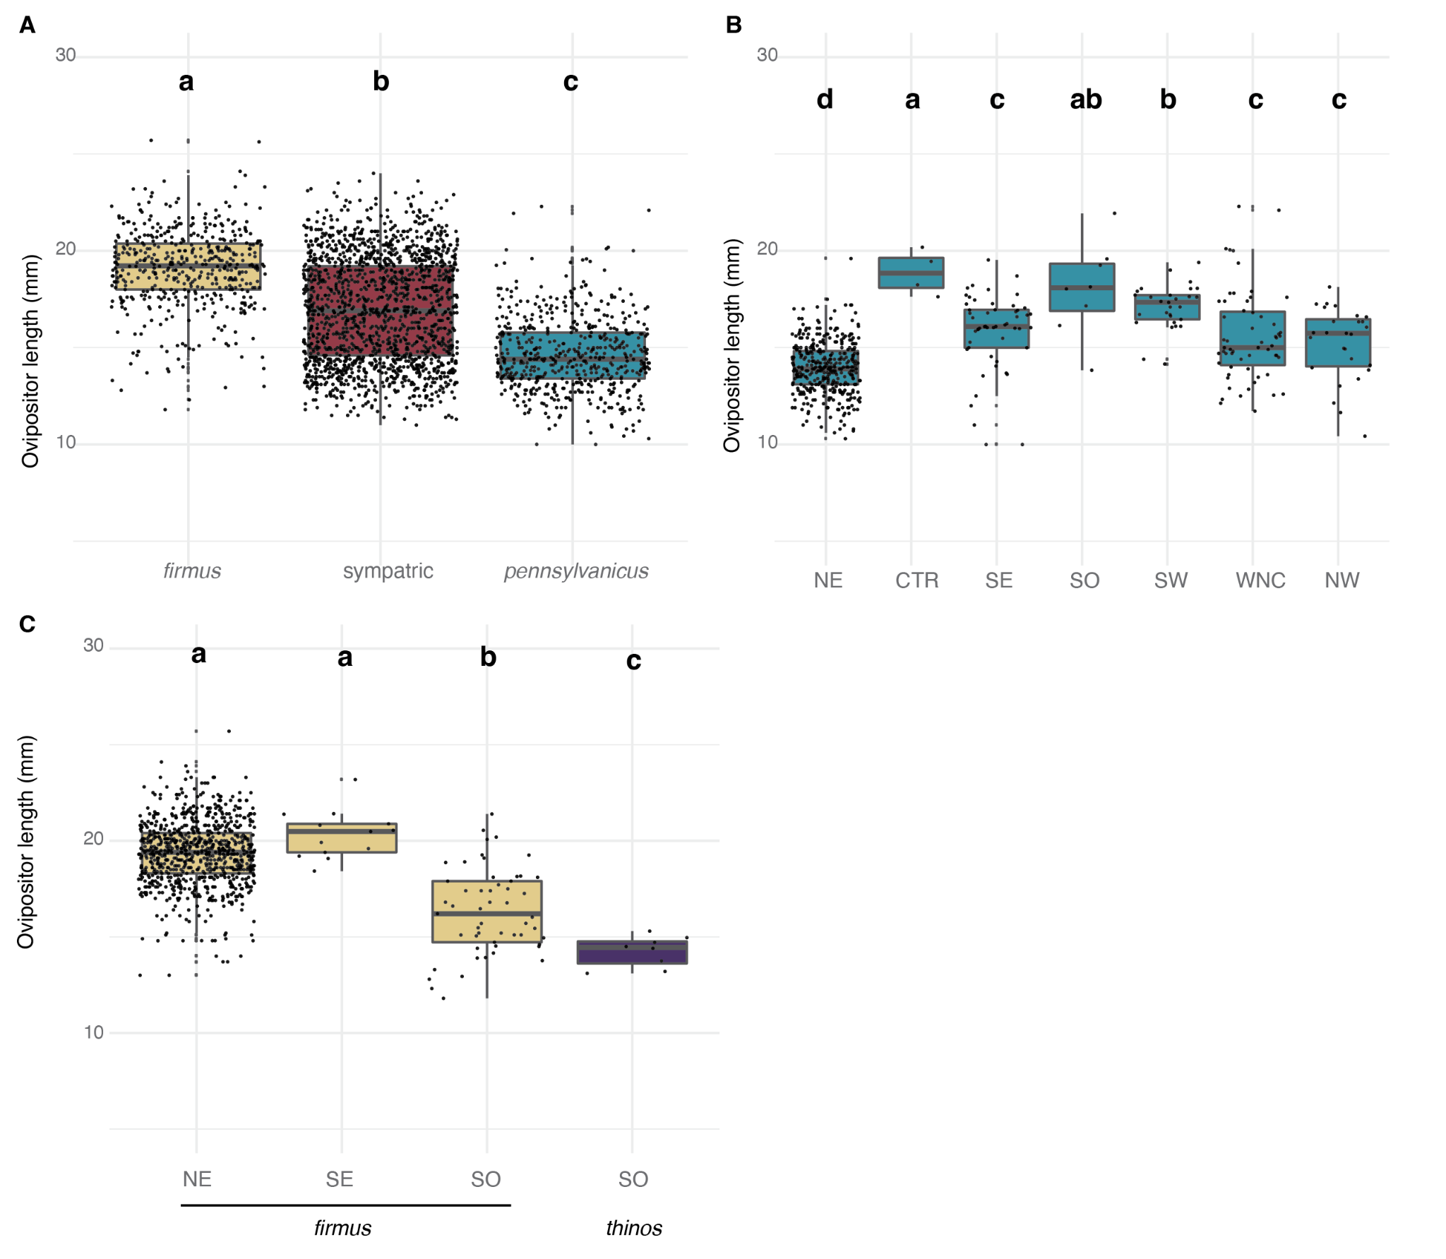
Figure S2: Ovipositor length differences between species and among populations of each species. A. Ovipositor length differences between G. firmus, G. pennsylvanicus and sympatric populations (G. firmus vs G. pennsylvanicus p < 2.0E-16; G. firmus vs sympatric p <2.0E-16; G. pennsylvanicus vs sympatric p <2.0E-16). B. Ovipositor length differences among populations of G. pennsylvanicus. Posthoc p-values are presented in Table S1. C. Ovipositor length differences among populations of G. firmus and G. thinos. Posthoc p-values are presented in Table S3. Boxplots indicate the mean values of each trait, quartiles and the range of the data (whiskers). Individual data points are overlaid as scatterplots. Letters indicate the significant differences among groups (PWRST with corrected p-values < 0.05).

a.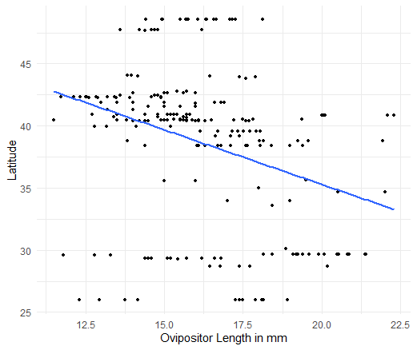 | b.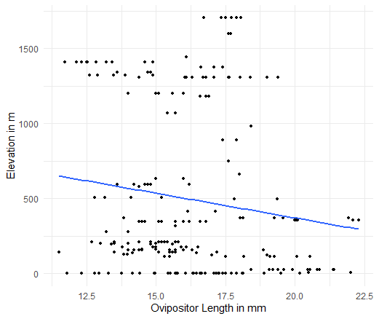 | c.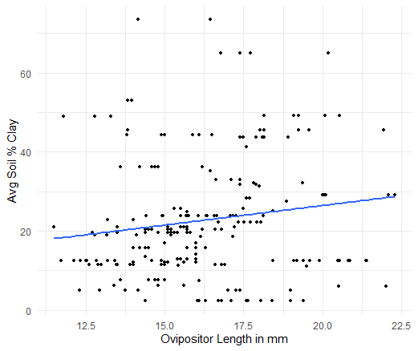
d.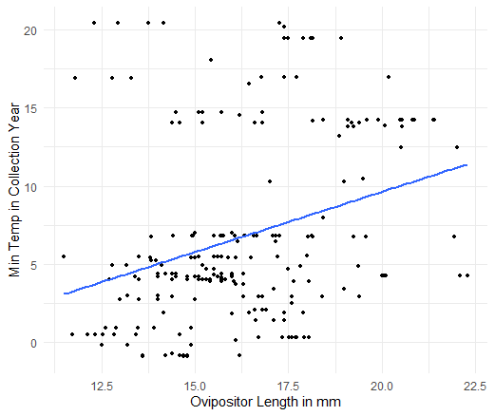 | e.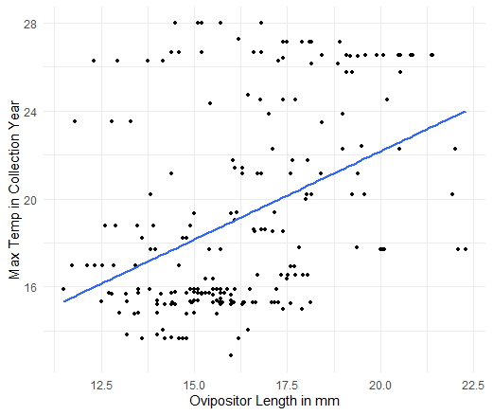 | f.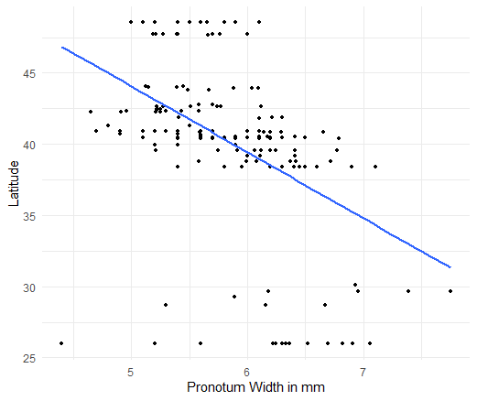
g.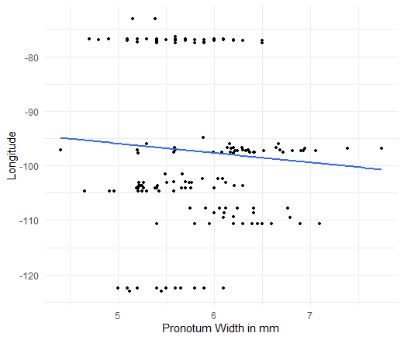 | h.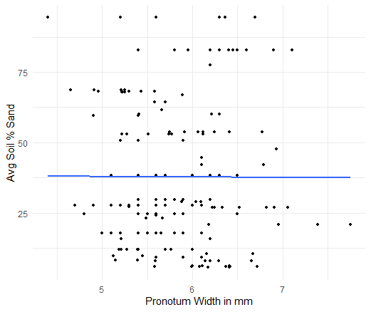 | i.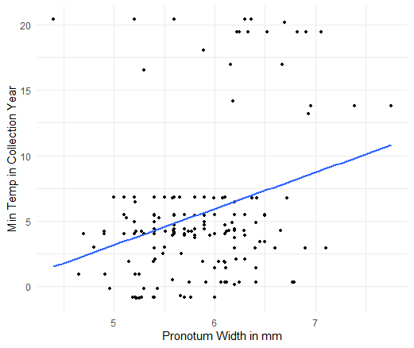
j.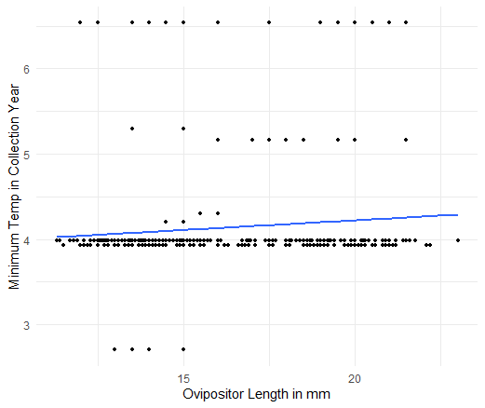 | k.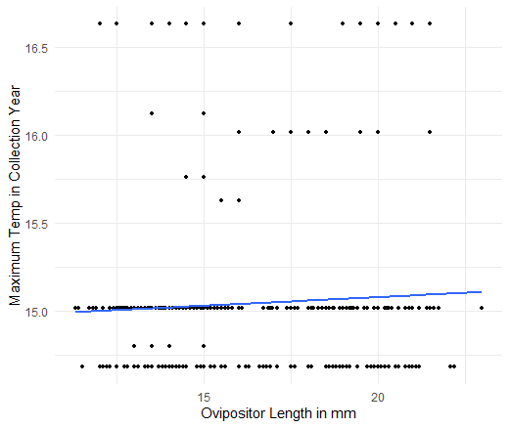 | l.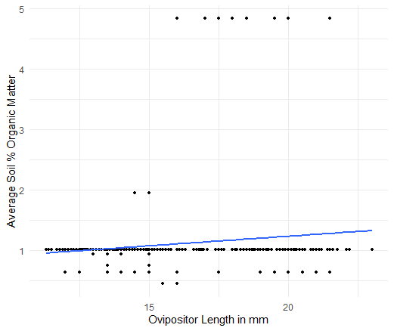
Figure S3: Scatterplots of significant AIC environmental variables. For all female allopatric populations: ovipositor length vs. latitude (a.), elevation (b.), average soil percent clay (c.), minimum temperature (d.), and maximum temperature (e.). For all female allopatric populations: pronotum width vs. latitude (f.), longitude (g.), average soil % sand (h.), and minimum temperature (i.). For female allopatric and sympatric Connecticut populations: ovipositor length vs. minimum temperature (j.), maximum temperature (k.), and average soil % organic matter (l.).

