Comparative analysis of the complete mitochondrial genomes of three Zeugodacus species (Insecta: Tephritidae: Dacinae) and their phylogenetic relationships with other congeners
Hoi-Sen Yong, Sze-Looi Song, Kah-Ooi Chua, Yvonne Jing Mei Liew, I. Wayan Suana, Phaik-Eem Lim, Kok-Gan Chan, Praphathip Eamsobhana

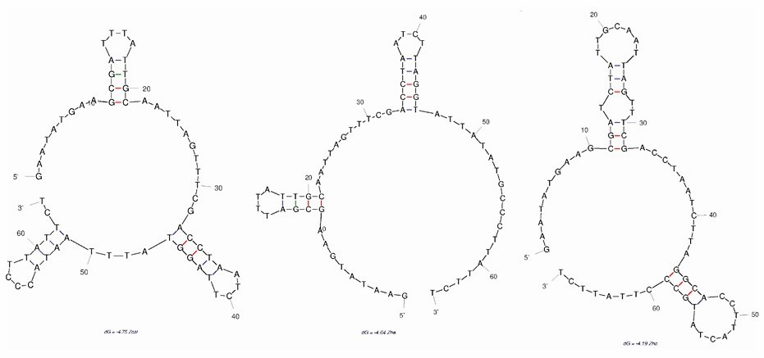
Figure S1. Stem-loop structure of spacing sequence between trnR and trnN genes in three Zeugodacus mitogenomes. Left, Z. calumniatus; centre, Z. heinrichi; right, Z. hochii.

