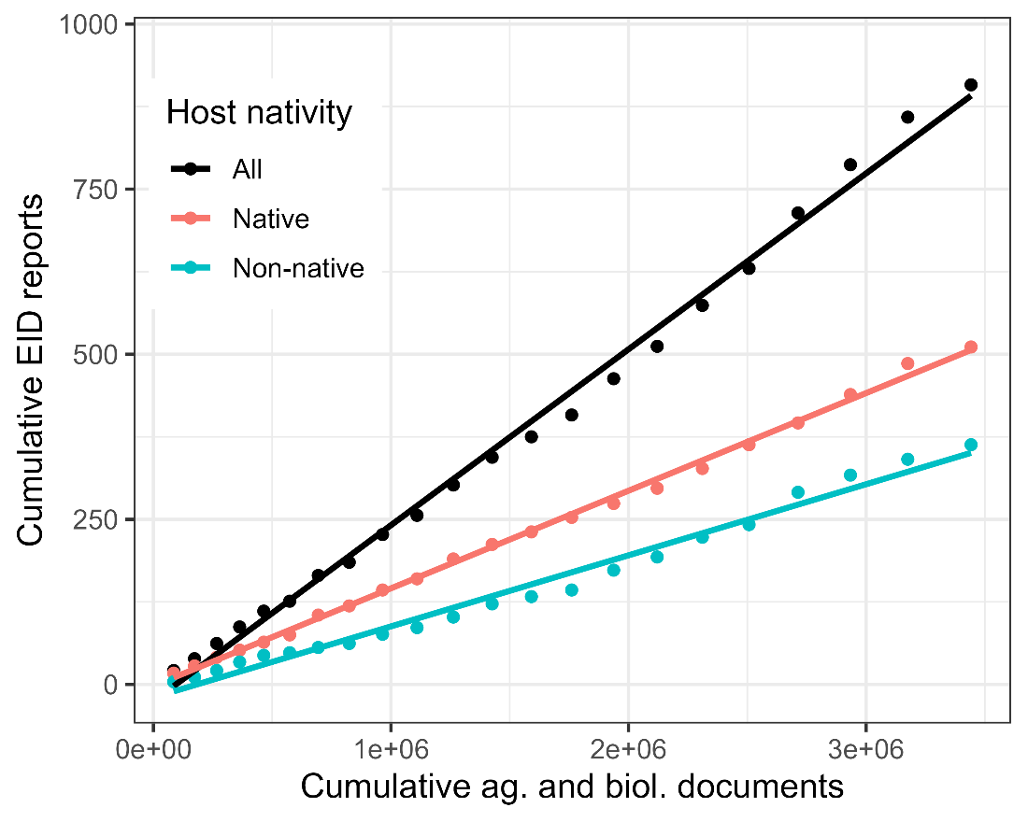
Supplemental Figure 1. Relationship between the cumulative number of all citable scientific documents in the agricultural (ag.) and biological (biol.) literature and the cumulative number of EID reports. The linear relationship implies EID accumulation is partially due to increased reporting and documentation in the scientific literature. Other factors, such as international trade and the movement of live plant material, have also increased over time, and likely also play a role in the accumulation of EID reports.

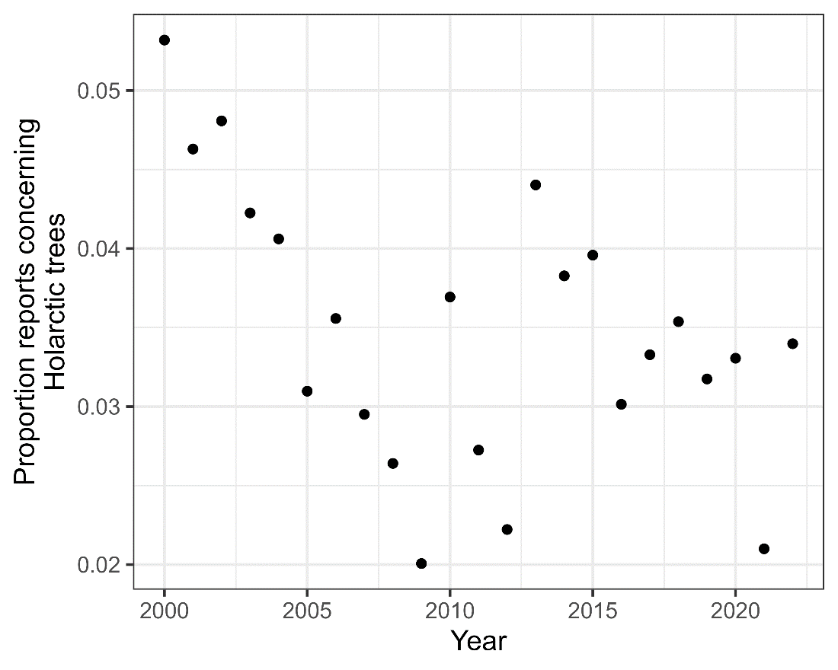
Supplemental Figure 2. Proportion of all EID reports published in Plant Disease represented by Holarctic trees, used in this study. Reports in Plant Disease were identified using the search terms described in the Methods (i.e., “first report”, “first record”, etc.). Plant Disease was chosen as this journal made up most of the First Reports in the dataset, and helped to ensure the reports are of pathogens (rather than e.g., insects or other organisms, that make up many other “First reports”). Note the proportion of reports concerning Holarctic trees is not increasing over time, and is not plotted cumulatively.

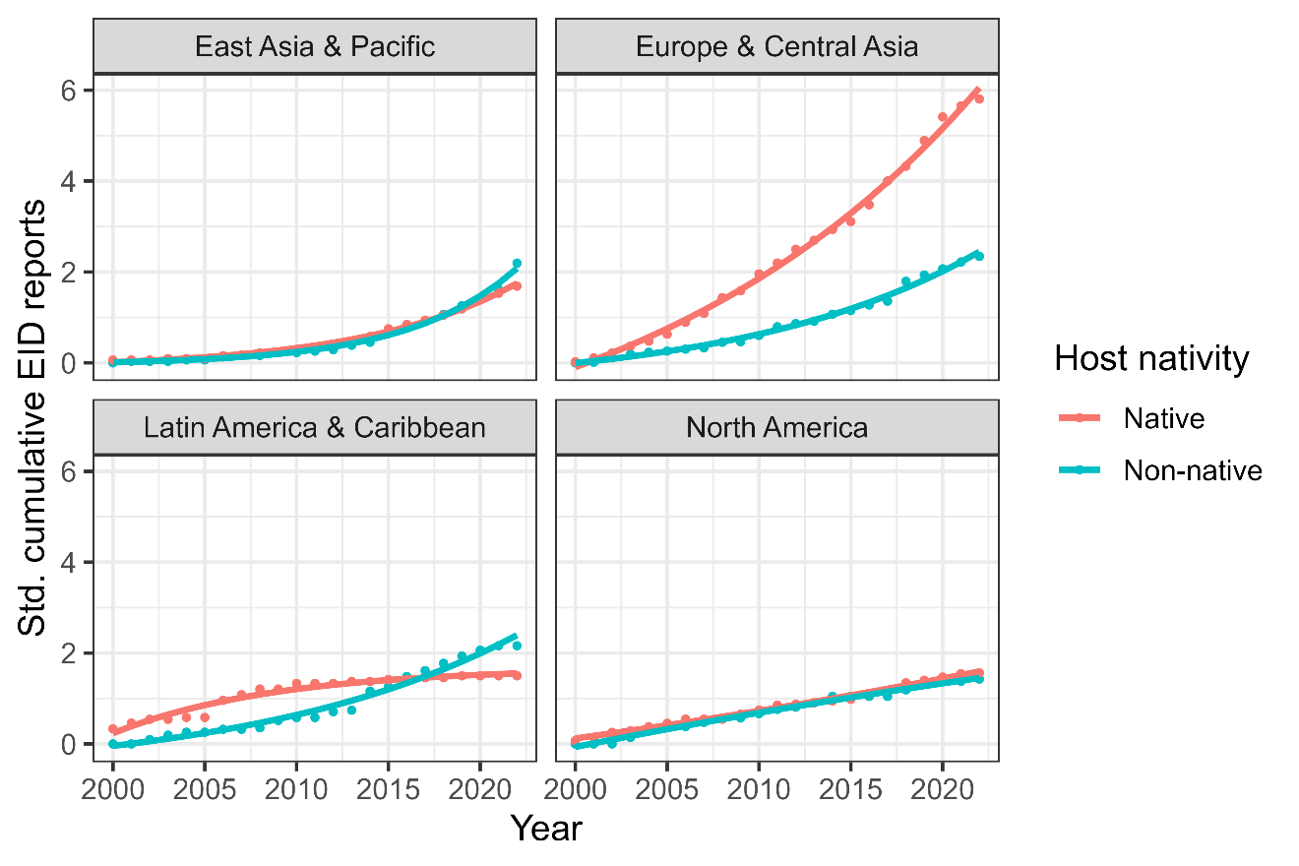
Supplemental Figure 3. Temporal accumulation of first reports of tree EIDs since 2000 for four geographic regions and 24 tree genera. Cumulative EID reports were standardized by the total number of native and non-native species considered in the countries of each region. Note the nativity classification corresponds to the nativity of particular host species. Models were fit as y ~ a × exp(b × x) + c, where y is the cumulative number of new reports, and x is the number of years elapsed since 2000 (the first year of data collection). To facilitate interpretation and visualization, x was back-transformed to year (by adding 2000). See also Fig. 2.

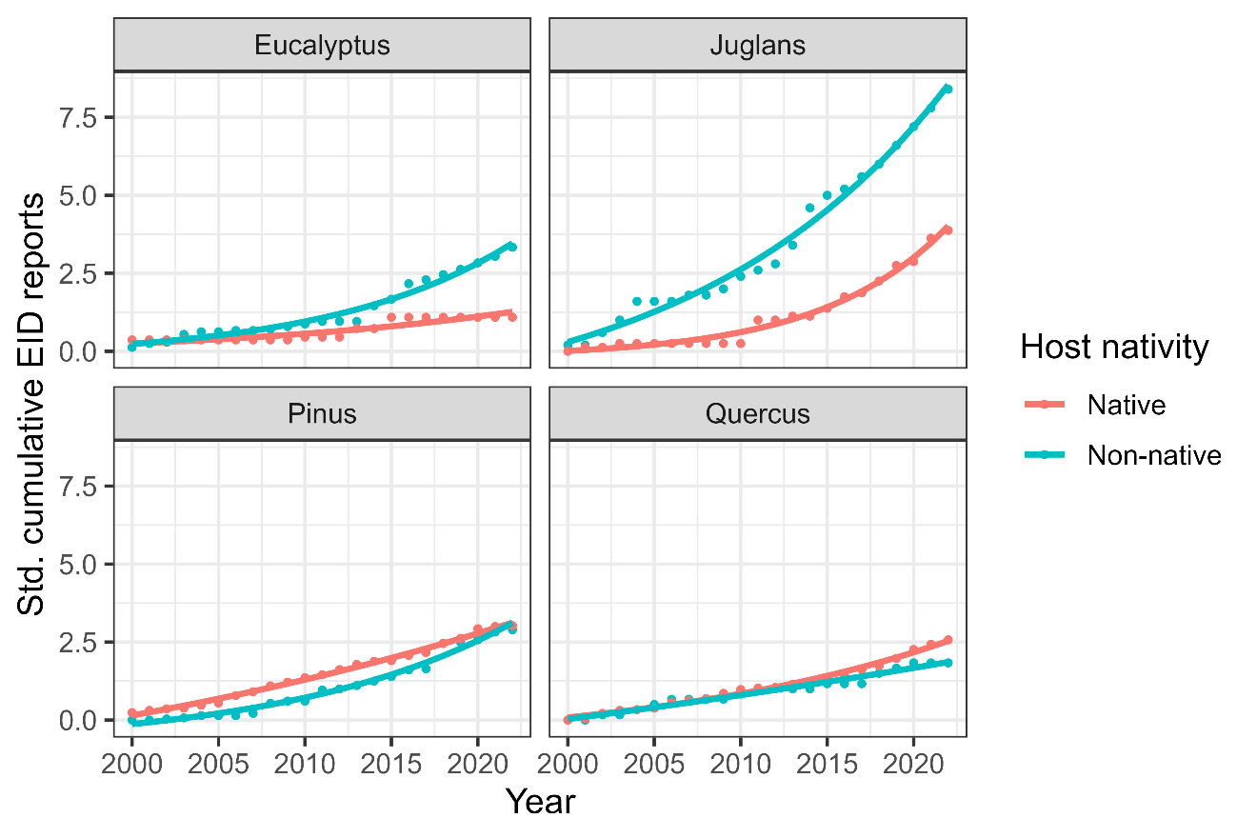
Supplemental Figure 4. Temporal accumulation of first reports of tree EIDs since 2000 for four host genera with the greatest total number of EID reports in the dataset. Cumulative EID reports were standardized by the total number of native and non-native species considered in each genus. Note the nativity classification corresponds to the nativity of particular host species, not the genus as a whole. Models were fit as y ~ a × exp(b × x) + c, where y is the cumulative number of new reports, and x is the number of years elapsed since 2000 (the first year of data collection). To facilitate interpretation and visualization, x was back-transformed to year (by adding 2000). See also Fig. 4.

