Supplementary Material 1
Photographs of Agelenidae – Atypidae family representatives

This file includes photos, which were the basis for the drawings and measurements referenced in the text. Some somatic measurements are included as well

Agelenidae
Pireneitega spasskyi (Charitonov, 1946)
KBS 160 (female, Bakuriani): epigyne, endogyne
KBS 193 (female, Lagodekhi): epigyne, endogyne

KBS 160 epigyne | KBS 193 epigyne
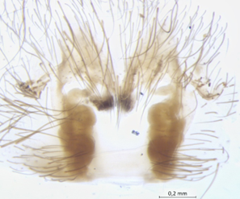 | 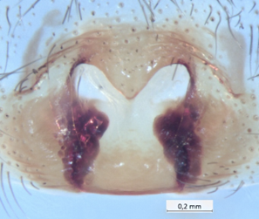
KBS 160 endogyne | KBS 193 endogyne
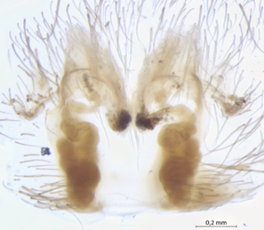 | 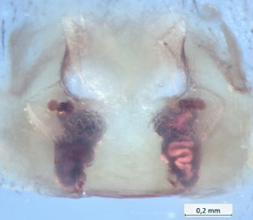

Pireneitega armeniaca (Brignoli, 1978)
KBS 334a (female, Kintrishi): epigyne, endogyne
KBS 334b (female, Kintrishi): epigyne, endogyne
KVS 507 (female, Kintrishi): epigyne, endogyne

KBS 334a epigyne | KBS 334b epigyne | KVS 507 epigyne
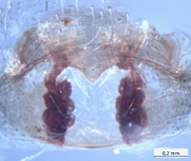 | 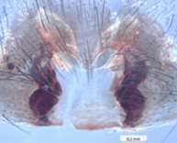 | 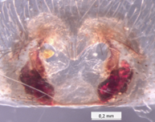
KBS 334a endogyne | KBS 334b endogyne | KVS 507 endogyne
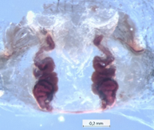 | 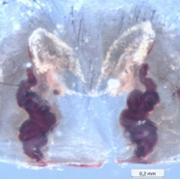 | 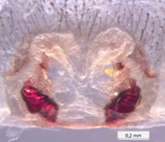

Pireneitega armeniaca (Brignoli, 1978)
KVS 509 (3 males, Kintrishi): palp prolateral, palp retrolateral, palp ventral
Drawing template link.
KVS 509a prolateral | KVS 509b prolateral | KVS 509c prolateral
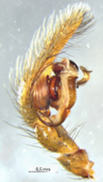 | 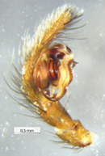 | 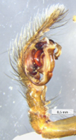
KVS 509a ventral | KVS 509b ventral | KVS 509c ventral
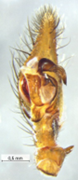 | 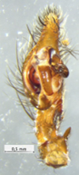 | 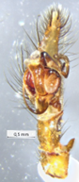
KVS 509a retrolateral | KVS 509b retrolateral | KVS 509c retrolateral
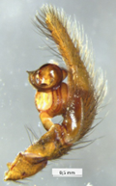 | 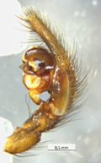 | 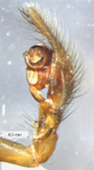

Tegenaria longimana Simon, 1898
Specimen KVS 473 from Kintrishi National Park: palp retrolateral, palp ventral.

Tegenaria chumachenkoi Kovblyuk & Ponomarev, 2008
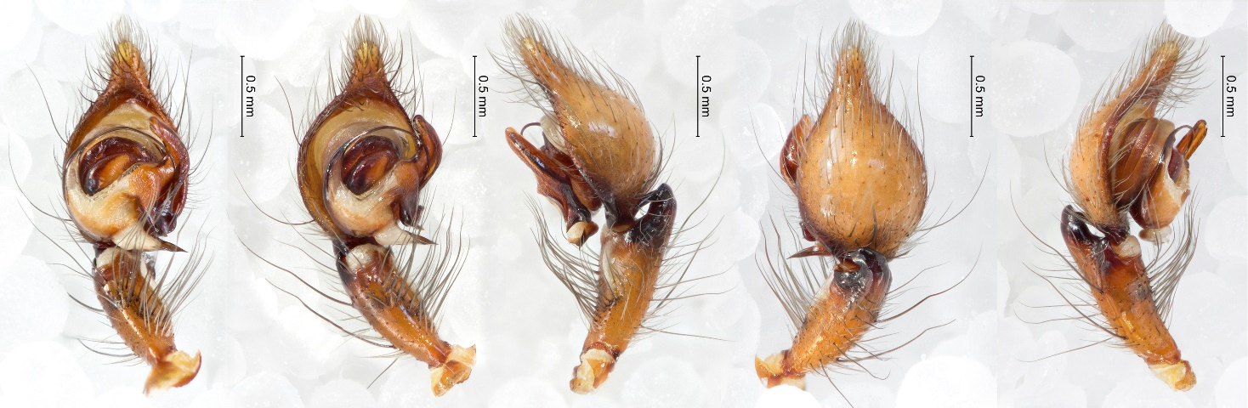Palpus of specimen (CaBOL-ID 1035510) from Gori palpus.

Amaurobiidae
Amaurobius similis (Blackwall, 1861)
Specimen KVS 310 from Kvelaantubani: prosoma, epigyne, Length: 7 .91 mm, prosoma length 3.76 mm, width 2.56 mm

Specimens KVS 390a and KVS 390b from Kojori:
KVS 390a: epigyne, vulva, habitus, habitus2, length 5.61 mm, prosoma length 2.37 mm, width 1.55 mm
KVS390b: epigyne (in situ), epigyne (prepared), vulva, length 5. 00 mm, prosoma length 2.04 mm, width 1.44 mm

Araneidae
Aculepeira talishia (Zawadsky, 1902): Specimen from Javakheti, CaBOL-ID 1004219, prosoma, epigyne (ventral), epigyne (caudal), vulva (frontal)
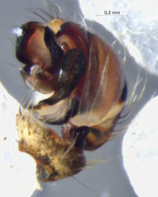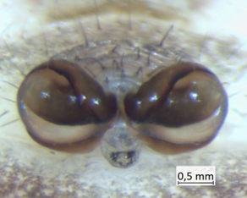
Gibbaranea gibbosa (Walckenaer, 1802), specimens from Kiketi, male: CaBOL-ID 1035487 (palpus), female: 1035488 (epigyne)

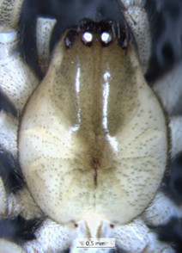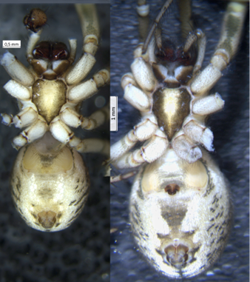
Leviellus caspicus (Simon, 1889), specimens from Gori: male (CaBOL-ID 1009760): Epigyne (ventral, caudal, dorsal, caudo-dorsal) prosoma length 2.78 mm, abdomen 3,13 (overlap probably ca. 0.2 mm), first leg: femur 3.46 mm, patella 1.28 mm, tibia 3.69 mm. Ventral habitus of CaBOL-IDs 1009760 and 1010360

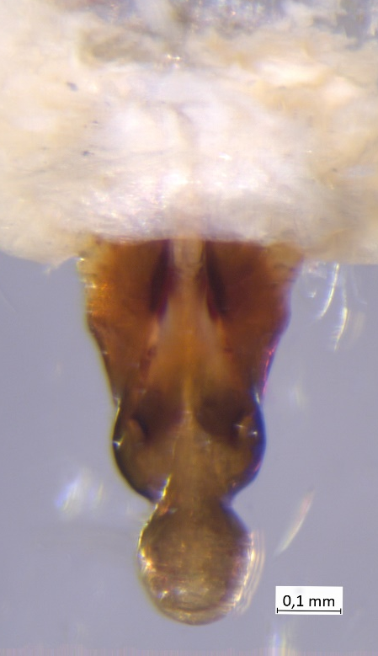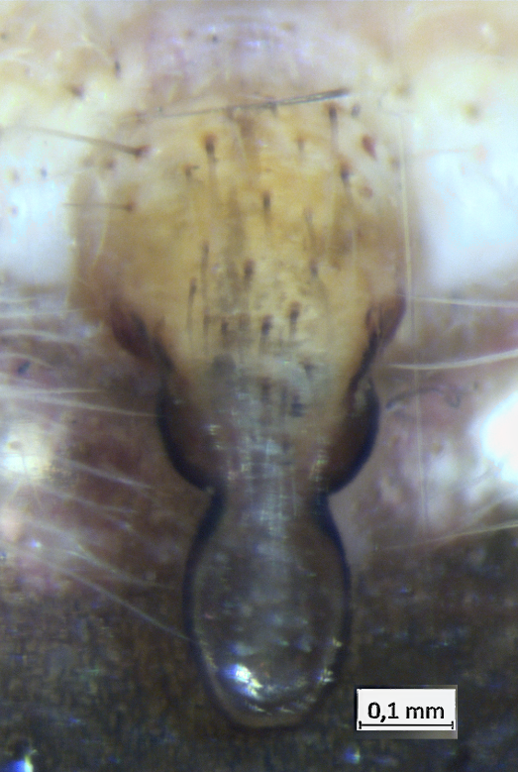
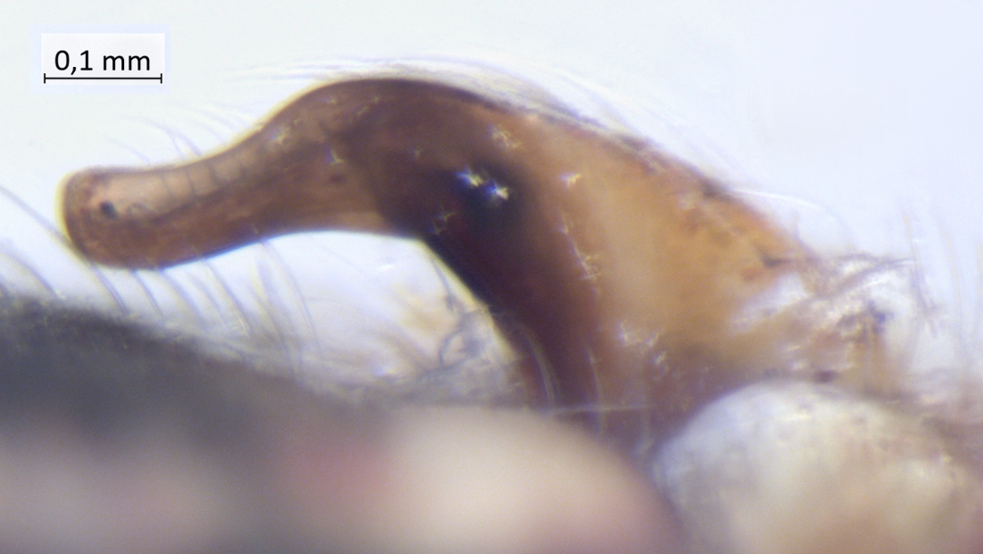
Neoscona spasskyi (Brignoli, 1983) specimen from Tbilisi, CaBOL-ID 1012457: epigyne (dorsal, ventral, lateral view)

Singa semiatra L. Koch, 1867
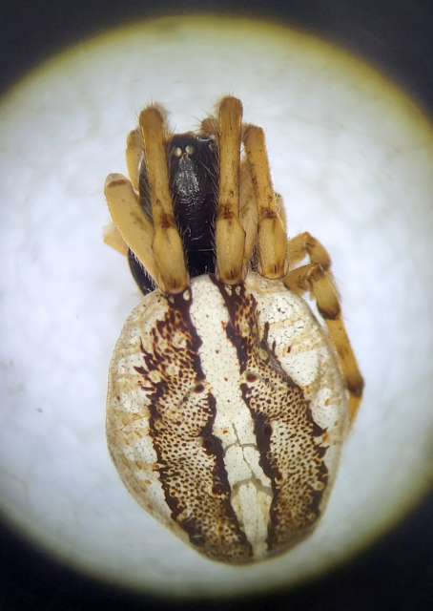
Female from Dalis Mta Reservoir, ZFMK-TIS-8015353. Photo by H.-J. Krammer.

