Supplementary material 1. Supplemental tables and figures.

Table S1. 34 environmental variables considered during the development of species distribution models for five lepidopteran grapevine pests. Environmental predictors were downloaded from WorldClim 2.1 (https://www.worldclim.org/data/worldclim21.html) and ENVIREM (https://envirem.github.io/) at 5 min spatial resolution.

Environmental variable
WorldClim 2.1
BIO1: Annual mean temperature (ºC)
BIO2: Mean diurnal range (ºC)
BIO3: Isothermality (ºC)
BIO4: Temperature seasonality (ºC)
BIO5: Max temperature of warmest month (ºC)
BIO6: Min temperature of coldest month (ºC)
BIO7: Temperature annual range (ºC)
BIO8: Mean temperature of wettest quarter (ºC)
BIO9: Mean temperature of driest quarter (ºC)
BIO10: Mean temperature of warmest quarter (ºC)
BIO11: Mean temperature of coldest quarter (ºC)
BIO12: Annual precipitation (mm)
BIO13: Precipitation of wettest month (mm)
BIO14: Precipitation of driest month (mm)
BIO15: Precipitation seasonality (mm)
BIO16: Precipitation of wettest quarter (mm)
BIO17: Precipitation of driest quarter (mm)
BIO18: Precipitation of warmest quarter (mm)
BIO19: Precipitation of coldest quarter (mm)
Elevation (m)
ENVIREM
annualPET: Annual potential evapotranspiration (mm)
climaticMoistureIndex: Index of relative wetness and aridity
continentality: Average temp. of warmest month - average temp. of coldest month (ºC)
embergerQ: Emberger's pluviothermic quotient
growingDegDays0: Sum of mean monthly temperature for months with mean temperature greater than 5℃ multiplied by number of days
growingDegDays5: Sum of mean monthly temperature for months with mean temperature greater than 0℃ multiplied by number of days
maxTempColdestMonth: Max temperature of coldest month (ºC)
minTempWarmestMonth: Min temperature of warmest month (ºC)
PETColdestQuarter: Mean monthly PET of coldest quarter (mm)
PETDriestQuarter: Mean monthly PET of driest quarter (mm)
PETseasonality: Monthly variability in potential evapotranspiration (mm)
PETWarmestQuarter: Mean monthly PET of warmest quarter (mm)
PETWettestQuarter: Mean monthly PET of wettest quarter (mm)
thermInd: Compensated thermicity index (ºC)

Table S2. Climatic suitability modeling methods as organized by the ODMAP framework (Zurell et al. 2020). Methods are divided into overview/conceptualization, data, model fitting, and prediction sections.
OVERVIEW
Authorship | • Authors: Hector Zumbado-Ulate, Tyler E. Schartel, Gregory S. Simmons, Matthew P. Daugherty.
Authorship | • Contact email: zumbadohector@gmail.com
Authorship | • Title: Assessing the risk of invasion by a vineyard moth pest guild.
Model objective | • Objective: Mapping, inference and explanation.
Model objective | • Target outputs: Response plots quantifying important predictor-suitability relationships, maps of continuous climatic suitability, assessing potential pest co-occurrence. For our dataset preparation and model construction, we followed step-by-step guidelines for calculating correlative ecological niche models (Sillero et al. 2021).
Taxon | European grapevine moth (EGVM; Lobesia botrana [Denis & Schiffermüller])  Grape tortrix moth (GTM; Argyrotaenia ljungiana [Thunberg]),  Grape berry moth (GBM; Paralobesia viteana [Clemens]),  European grape berry moth (EGBM; Eupoecilia ambiguella [Hübner]), Christmas berry webworm (CBW; Cryptoblabes gnidiella [Millière]).
Location | West Coast (California, Oregon, Washington), United States of America.
Scale of analysis | • Spatial extent:  -124.7628, -114.1295, 32.53088, 49.00359 (xmin, xmax, ymin, ymax).
Scale of analysis | • Spatial resolution: Climatic suitability models were developed and projected at 10 km² resolution.
Scale of analysis | • Temporal extent/time period: Moth species occurrences were downloaded from the Global Biodiversity Information Facility (GBIF; www.gbif.org) from 1960-2021. Additional data for EGVM monitoring (i.e., abundances) and trapping (i.e., presence) data were collected from 2010-2016 in Napa, California (Schartel et al. 2019).
Scale of analysis | • Type of extent boundary: Political (State boundaries).
Biodiversity data overview | • Observation type: Standardized monitoring data.
Biodiversity data overview | • Response/Data type: Presence-only datasets and background.
Type of predictors | climatic; elevation.
Conceptual model / Hypotheses | • Hypotheses about species-environment relationships: Climatic and environmental factors are hypothesized to influence climatic suitability for a vineyard moth pest complex.
Assumptions | We assumed that:  • Relevant ecological drivers (or proxies) of all study species distributions are included.  • Occurrence data represents sampling efforts that are adequate, representative, and free of observational biases.  • All detections of study species represent established populations  • Predictors are measured without error.  • Predictor relationships were fit under current conditions and predictions were accurately projected into the potential area of invasion.
SDM algorithms | • Algorithms: MaxEnt
SDM algorithms | • Model complexity: Climatic and environmental variables included in our climatic suitability modeling efforts were selected using recommended approaches to selecting predictors based on multicollinearity, improving model fit (i.e., AIC, sTSS), and addressing spatial autocorrelation among presence-only data. Model settings were chosen to accurately predict the potential distribution of study species.
SDM algorithms | • Model tuning: MaxEnt with species-specific tuning of model settings has been shown to have a robust performance and transferability (Shcheglovitova and Anderson 2013, Muscarella et al. 2014).
Workflow | Modeling workflow:  • Environmental variables included in climatic suitability models were selected because of their hypothesized roles in driving the distribution of moth pest complex and limited multicollinearity.  • Sixteen candidate models were generated for each study species using species-specific tuning of model settings.  • Prediction performance was assessed using the highest average of the area under the curve of the receiver-operating characteristic (‘AUC mean’), true skill statistic (TSS; Allouche et al. 2006) and the average of the 10-percentile training omission rate (10.or.pt mean; Radosavljevic and Anderson 2014).  • The relative importance of all climatic and environmental predictor variables was calculated, and response curves generated to compare the probability of each study species’ presence relative to each predictor.
Software | • Software: All climatic suitability modeling efforts were conducted in the R statistical language, V 4.1.2 (R Development Core Team 2021), using package ‘ENMeval’ 2.03 (Kass et al. 2021).
Software | • Code availability: R code is not shared but available upon request.
Software | • Data availability: Datasets are not shared but available upon request.
DATA
Biodiversity data | • Taxon names: EGVM (Lobesia botrana).  GTM (Argyrotaenia ljungiana).  GBM (Paralobesia viteana).  EGBM (Eupoecilia ambiguella).  CBW (Cryptoblabes gnidiella).
Biodiversity data | • Ecological level: species; populations.
Biodiversity data | • Data source: occurrence data for all five pest species in their native and other invaded ranges from 1960 to the present date GBIF: https://doi.org/10.15468/dl.3fp4k7 for EGBM, https://doi.org/10.15468/dl.8yqmf3 for EGVM, https://doi.org/10.15468/dl.yncefw for GBM, https://doi.org/10.15468/dl.d8r9y8 for GTM, and https://doi.org/10.15468/dl.j4wmzw for CBW.  For EGVM occurrences we also included records from its invasion into Napa County (Schartel et al. 2019).
Biodiversity data | • Sampling: The R package ‘rgbif’ 3.7.2 (Chamberlain et al. 2022) was used to download occurrence data.
Biodiversity data | Background: A collection of background points to specific areas was generated by buffering known occurrences in pest native and non-native ranges with a 50 km radius buffer (i.e., calibration areas). The final number of background points differed among species because of the different sizes of the calibration areas and corrections for sampling bias.
Biodiversity data | • Sample size Final presence-only datasets consisted of 467 occurrence records for EGBM, 459 for EGVM, 54 for GBM, 644 for GTM, and 121 for CBW. Final background datasets consisted of 12331 background points for EGBM, 6741 for EGVM, 3125 for GBM, 14991 for GTM, and 1784 for CBW.
Biodiversity data | • Data cleaning/filtering: Initial occurrence datasets were cleaned by checking for typos, removing unreferenced records, cross-checking geographic coordinates, and removing coordinates with a geographic inaccuracy > 10000 m using the r packages ‘scrubr’ 0.4 (Chamberlain 2022) (Chamberlain 2022) and ‘CoordinateCleaner’ 2.0–20 (Zizka et al. 2019).
Biodiversity data | Spatial autocorrelation: To reduce the effect of spatial autocorrelation in both occurrence and background datasets, we used the r package ‘humboldt’ 1.0 (Brown and Carnaval 2019) to filter and exclude points that were separated by a distance < 1 km.
Biodiversity data | • Errors and biases: All climatic suitability modeling efforts assume implicitly that occurrence data of all study species represent established populations.
Data partitioning  and validation | We used the block partition with the ‘lan_lon’ parameter to find the latitude and/or longitude lines that divide the occurrence localities into four groups of equal numbers (Muscarella et al. 2014). The number of background localities in each group depends on the distribution of occurrence localities across the study area. Data was validated using a block cross-validation method.
Predictor variables | Predictor variables:  • Climate: All 19 BIOCLIM variables (Booth et al. 2014), and 14 ENVIREM variables (Title and Bemmels 2018). We excluded the ‘aridityIndexThornthwaite’ and ‘monthCountByTemp10’ predictors from the ENVIREM dataset, following Title & Bemmels (2017)  • Environmental: Elevation.
Predictor variables | Data sources:  • BIOCLIM variables and elevation were obtained from the WorldClim 2.1 database (Fick and Hijmans 2017; https://www.worldclim.org/), which includes climatic data from 1970-2000. ENVIREM layers were downloaded from the ENVIREM website (https://envirem.github.io/).
Predictor variables | • Spatial extent:  -124.7628, -114.1295, 32.53088, 49.00359 (xmin, xmax, ymin, ymax).
Predictor variables | • Spatial resolution: Raster layers were obtained at 5 min resolution.
Predictor variables | • Coordinate reference system: Predictor variable rasters were obtained in WGS1984 projections (EPSG 4326).
Predictor variables | • Dimension reduction: Environmental data for each location of moth species occurrence and background locations was extracted with the R package ‘raster’ 3.5-29 (Hijmans et al. 2015). Multicollinearity among predictors at moth occurrence and background locations was assessed, and correlated variables with a corresponding higher variance inflation factor (> 0.7) were removed, using the R package ‘usdm’ 1.1–18 (Naimi 2015). Finally, we used the R package ‘fuzzySim’ 4.3 (Barbosa 2015) to create a data frame of all occurrences and background data as well as the corresponding values of the abiotic predictors in the grid of our spatial resolution.
MODEL
Variable  pre-selection | Climatic and environmental variables were considered based on their hypothesized roles in influencing potential climatic suitability for all study species.
Multicollinearity | Climatic and elevation predictor variables were inspected for multicollinearity (see DATA; Predictor variables; Dimension reduction).
Model settings | Model settings: Algorithm = maxent.jar; partition method = block; regularization of multiplier values = 1-4 with increments of 1; feature classes = L, H, Q, LQH; where L = Linear, H = Hinge, Q = Quadratic, Clamping = True. The block method extrapolates efficiently model predictions to other regions or periods. ‘Clamping’ restricts the values of predictors to stay within the bounds of the input occurrence and background data, therefore avoiding extreme extrapolations when making model predictions to environmental conditions outside the range of the occurrence and background data used to train the model (Kass et al. 2021).
Model selection | Model selection: For each species, a total of 16 candidate models were generated using combinations of regularization multiplier values and feature classes (see MODEL; Model settings, Model settings). A preferred model was selected using the AUC mean, TSS and 10.or.pt mean were used to select one model for each species.
Model estimates | For selected models, we estimated the percent contribution of each selected abiotic predictor and generated response curves by comparing the probability of each pest species’ presence relative to each abiotic predictor (Elith et al. 2006, Syfert et al. 2013). The percent contribution is a metric that quantifies how environmental variables are contributing to fitting the model (Phillips et al. 2006). Second, we calculated the percent of permutation importance of each selected abiotic predictor, a metric that shows the drop in the AUC training when the model is reevaluated on permuted data. A large decrease shows that the model depends heavily on that variable.
Threshold selection | To generate binary predictions, we used the 10-percentile lowest omission rate logistic threshold (10.or.pt; Radosavljevic & Anderson, 2014), which excludes those occurrence points with suitability in the lowest 10 percentile, and the maximum training sensitivity plus specificity logistic threshold (maxSS), which performs an overall true occurrence prediction (Liu et al. 2005). This approach allowed us to quantify the extent of climatically suitable habitat (ESH) across the study region under two scenarios with different degrees of conservativeness: 1) removing only the 10 percent of the localities having the lowest predicted values of suitability, or 2) maximizing the true positive prediction, resulting in a more restricted definition of climatic suitability.
ASSESSMENT

Performance statistics | To evaluate how much model predictions differed from the random distribution of the observed presences across the prediction gradients, we estimated the Boyce index (Boyce et al. 2002) with the R package ‘ecospat’ 3.3 (Di Cola et al. 2017). The Boyce index varies between -1 and 1 and is an appropriate metric for models built with presence-only datasets (Hirzel et al., 2006). Positive values show a model where predictions are consistent with the distribution of presences in the evaluation dataset, values close to zero indicate that the model is not different from a random model, and negative values show poor predictive ability in areas where presences are more frequent. To evaluate the extrapolation of our predictions outside the training data we estimated the slope of the regression of the response variable on the logit of predicted probabilities according to Miller’s calibration statistics (Miller et al. 1991) with the R package ‘ModEvA’ 3.5 (Barbosa et al., 2013). Predictions perfectly calibrated will have a slope equal to 1. Although Miller calibration statistics perform better in models built from presence-absence datasets, such as generalized linear models, it still provides a reliable approach to visualizing the transference of our predictions from the native and invaded range to a new geographic space.
PREDICTION
Prediction output | Continuous and binary predictions of climatic suitability for all five study species were estimated using the MaxEnt algorithm. To generate binary predictions, we used the 10.or.pt and the maxSS (see MODEL; Model settings, Threshold selection)
Uncertainty quantification | To evaluate how much model predictions differed from the random distribution of the observed presences across the prediction gradients, we estimated the Boyce index and the slope of the regression of the response variable on the logit of predicted probabilities according to Miller’s calibration statistics (see MODEL; Model settings, Performance statistics)

Table S3. Fit metrics for the most robust model of the extent of climatically suitable habitat for each of five individual moth species (EGBM = European grape berry moth, Eupoecilia ambiguella; EGVM = European grapevine moth, Lobesia botrana; GBM = Grape berry moth, Paralobesia viteana; GTM = Grape tortrix moth, Argyrotaenia ljungiana; CBM = Christmas berry webworm, Cryptoblabes gnidiella).

Parameter | EGBM | EGVM | GBM | GTM | CBW
Model settings (FC-RM)¹ | LHQ-1 | Q-1 | H-3 | L-1 | LHQ-1
Prevalence | 0.03 | 0.02 | 0.02 | 0.04 | 0.04
AUC² mean | 0.80 | 0.74 | 0.70 | 0.75 | 0.90
10.or.pt³ mean | 0.1 | 0.01 | 0.10 | 0.05 | 0.04
sTSS⁴ | 0.74 | 0.71 | 0.66 | 0.66 | 0.82
10.or.pt⁵ threshold | 0.21 | 0.2 | 0.52 | 0.33 | 0.09
maxSS⁶ threshold | 0.53 | 0.48 | 0.68 | 0.67 | 0.17
Boyce Index | 0.98 | 0.92 | 0.92 | 0.95 | 0.90
MCS⁷ slope | 0.65 | 0.60 | 1.04 | 0.70 | 0.94

¹RM = regularization multiplier values (1-4 with increments of 1); FC = features classes (L, H, Q, LHQ, where L = Linear, H = Hinge, Q = Quadratic)
²highest average of the area under the curve of the receiver-operating characteristic
³average of the 10-percentile training omission rate
⁴standardized true skill statistic
⁵10-percentile lowest omission rate threshold
⁶maximum training sensitivity plus specificity threshold (maxSS)
⁷Miller calibration statistics (slope)

Table S4. Estimates of the extent of climatically suitable habitat in km² (and percent of total viticultural regions) shared by pairs of five moth pest species across viticulture regions of the West Coast of the United States. The calculations were performed using two thresholds: 10-percentile lowest omission rate threshold (10.or.pt) and the maximum training sensitivity plus specificity threshold (maxSS). EGBM = European grape berry moth, Eupoecilia ambiguella; EGVM = European grapevine moth, Lobesia botrana; GBM = Grape berry moth, Paralobesia viteana; GTM = Grape tortrix moth, Argyrotaenia ljungiana; CBW= Christmas berry webworm, Cryptoblabes gnidiella.
Species | 10.or.pt
Species | EGBM | EGVM | GBM | GTM | CBW
EGBM | -
EGVM | 884.9 (0.5) | -
GBM | 4060.7 (2.3) | 33315.7 (18.6) | -
GTM | 459.8 (0.3) | 19356.9 (10.8) | 10613.9 (5.9) | -
CBW | 101.3 (0.1) | 1201.9 (0.7) | 1201.9 (0.7) | 1145.3 (0.6) | -
Species | maxSS
Species | EGBM | EGVM | GBM | GTM | CBW
EGBM | -
EGVM | 68.2 (0.0) | -
GBM | 0.0 (0.0) | 0.0 (0.0) | -
GTM | 0.0 (0.0) | 109.6 (0.1) | 0.0 (0.0) | -
CBW | 0.0 (0.0) | 121.9 (0.1) | 0.0 (0.0) | 81.8 (0.0) | -

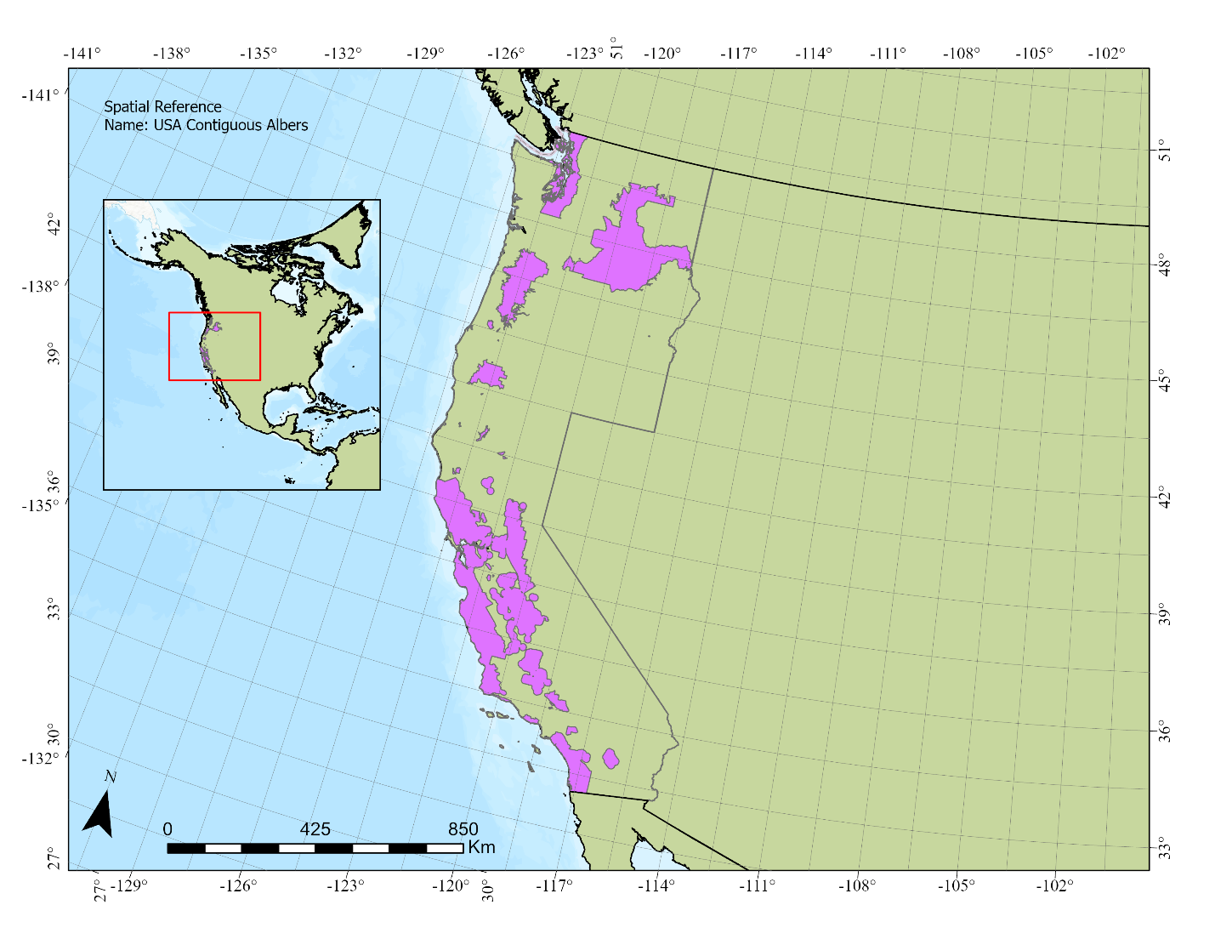

Figure S1. Study region with purple polygons denoting the location of viticulture regions within the West Coast of the United States, specifically in California, Oregon, and Washington.

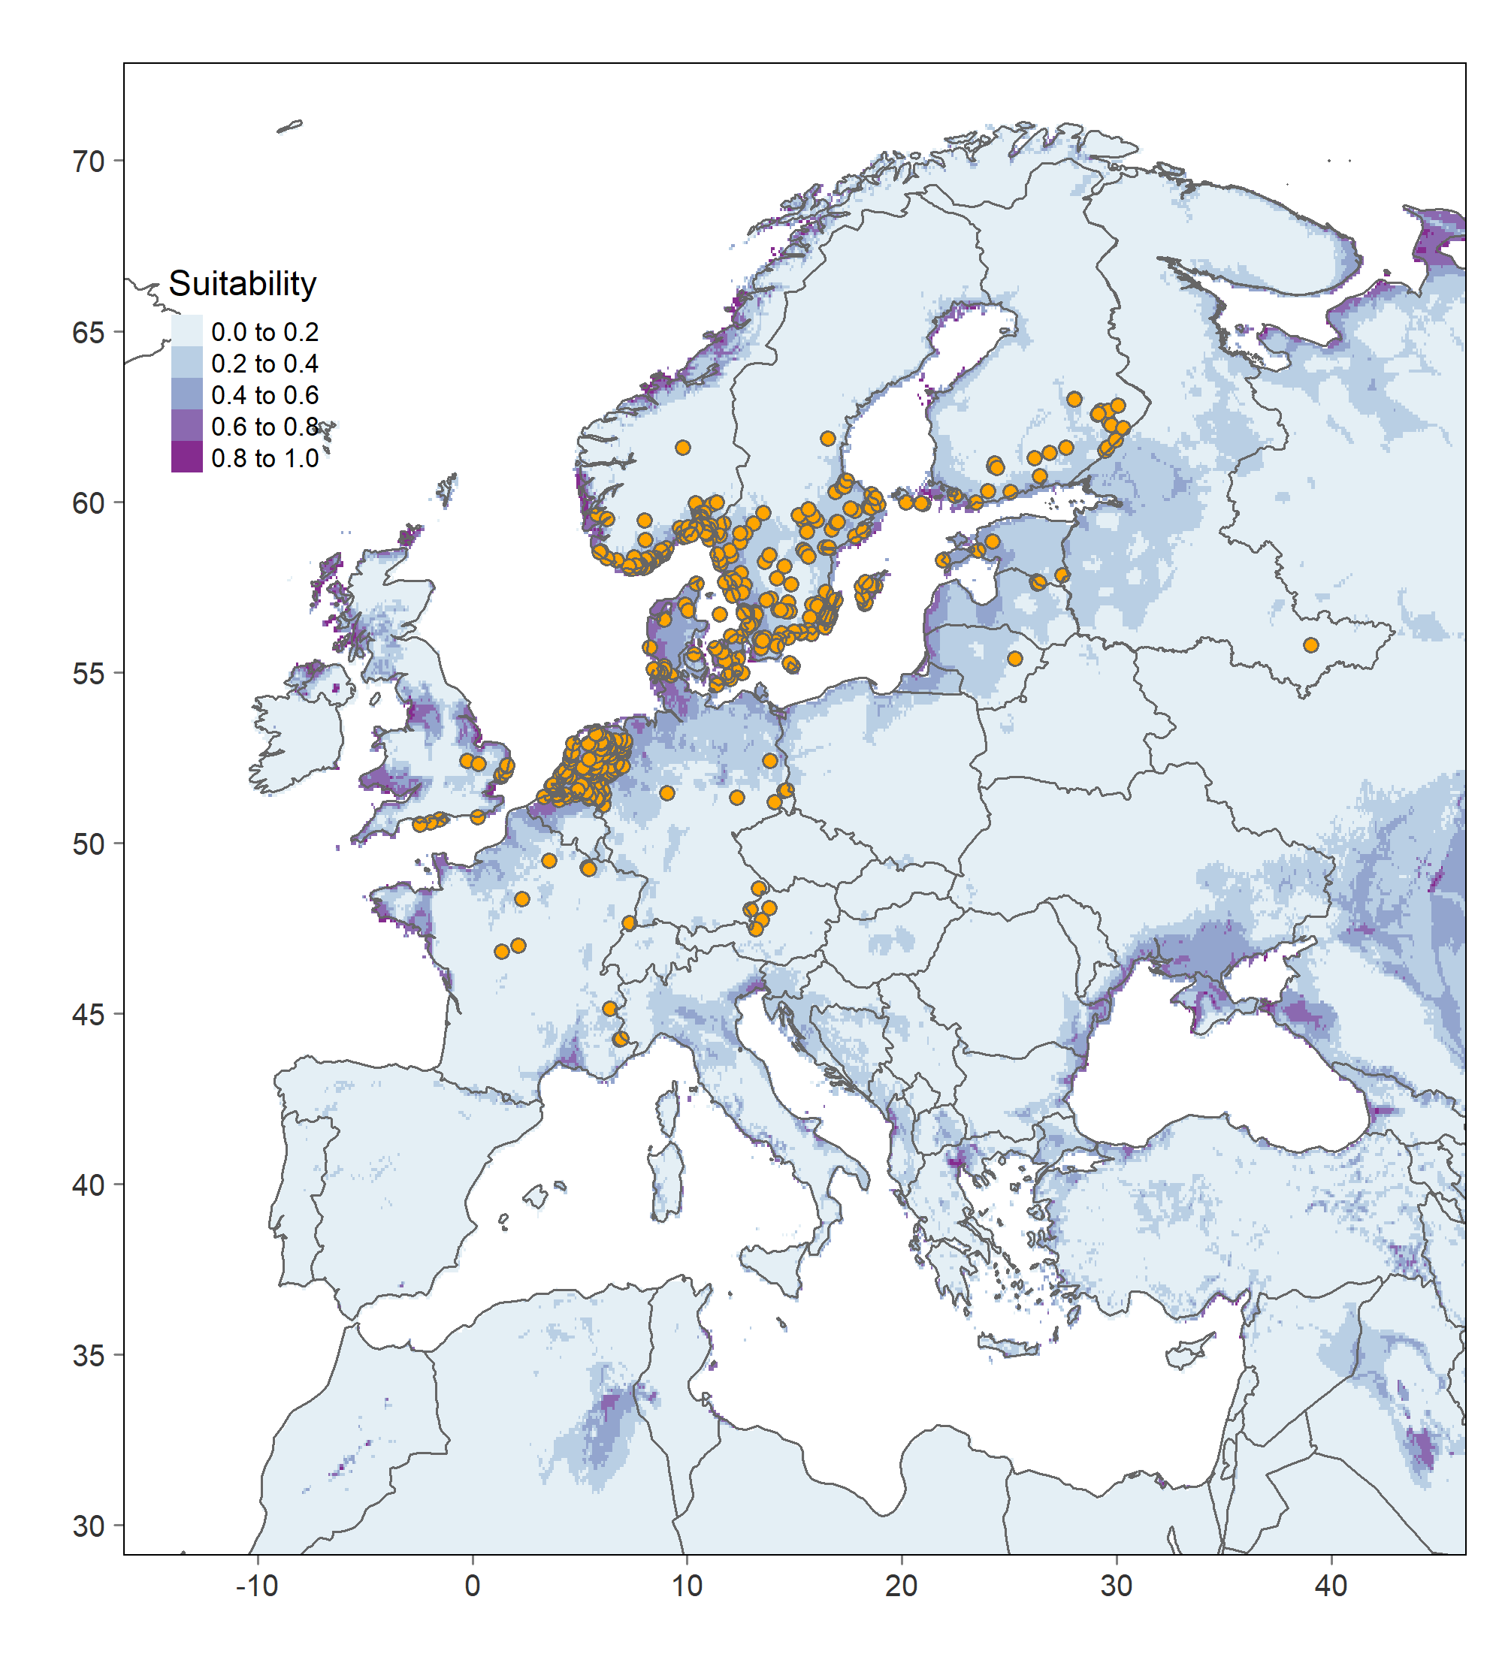

Figure S2. Known occurrences (orange dots) and climatic suitability estimates for the European grape berry moth, Eupoecilia ambiguella, across its native range in Europe.

.

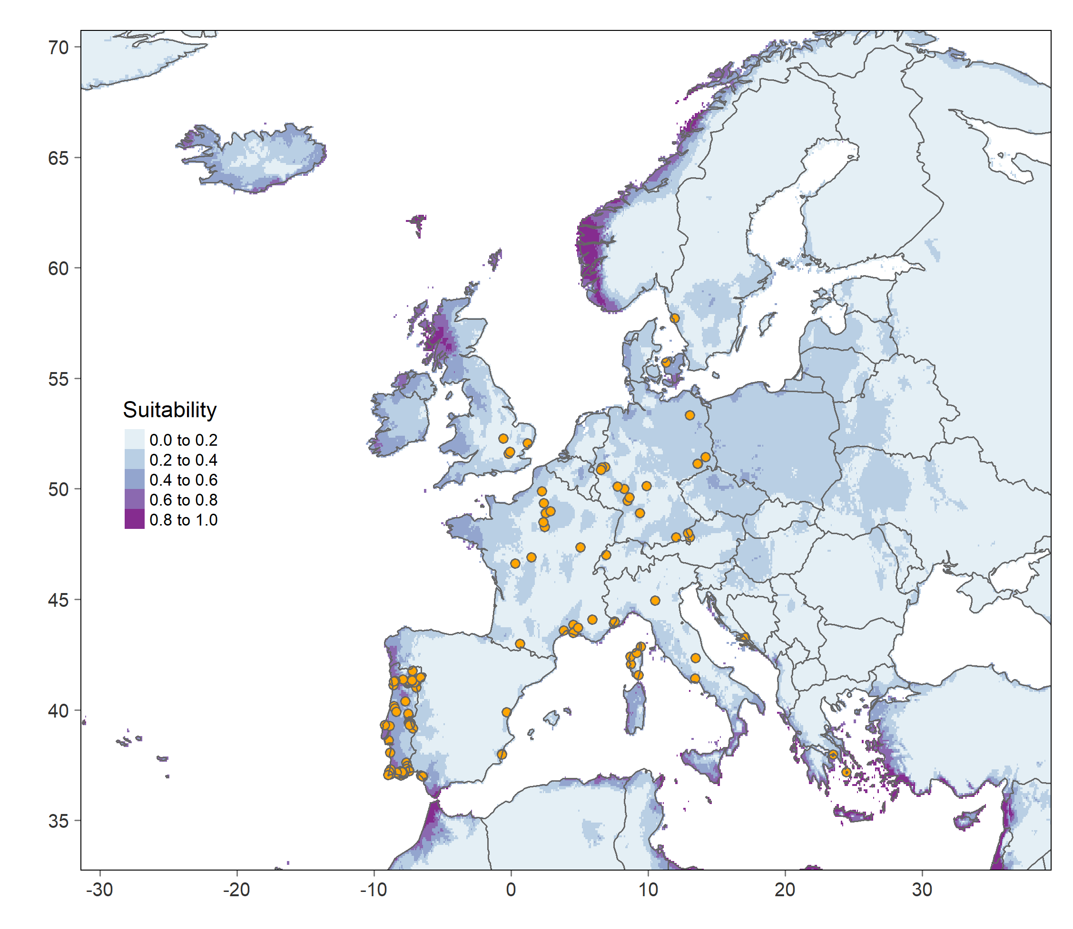

Figure S3. Known occurrences (orange dots) and climatic suitability estimates for the European grapevine moth, Lobesia botrana, across its native range in Europe.

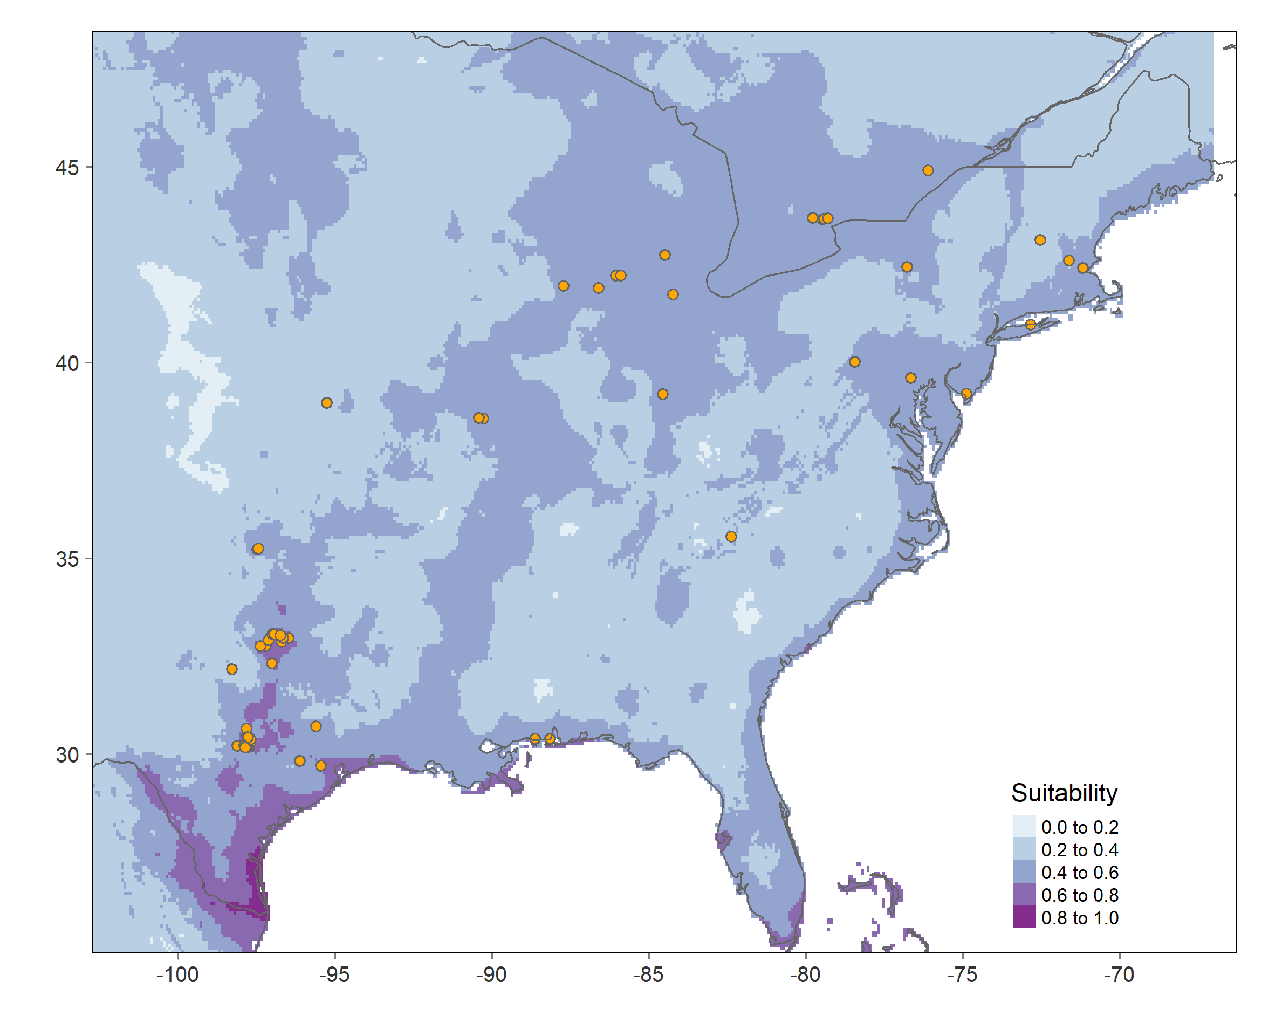
.

Figure S4. Known occurrences (orange dots) and climatic suitability estimates for the Grape berry moth, Paralobesia viteana, across its range in North America.

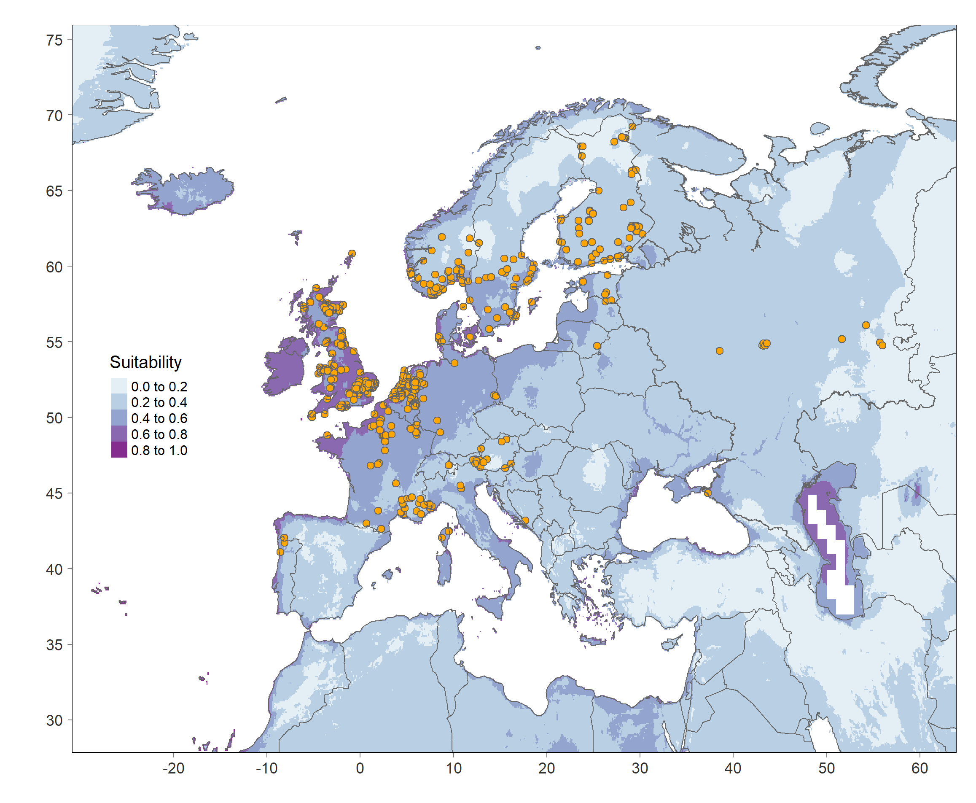

Figure S5. Known occurrences (orange dots) and climatic suitability estimates for the Grape tortrix moth, Argyrotaenia ljungiana, across its native and invaded range in Europe.

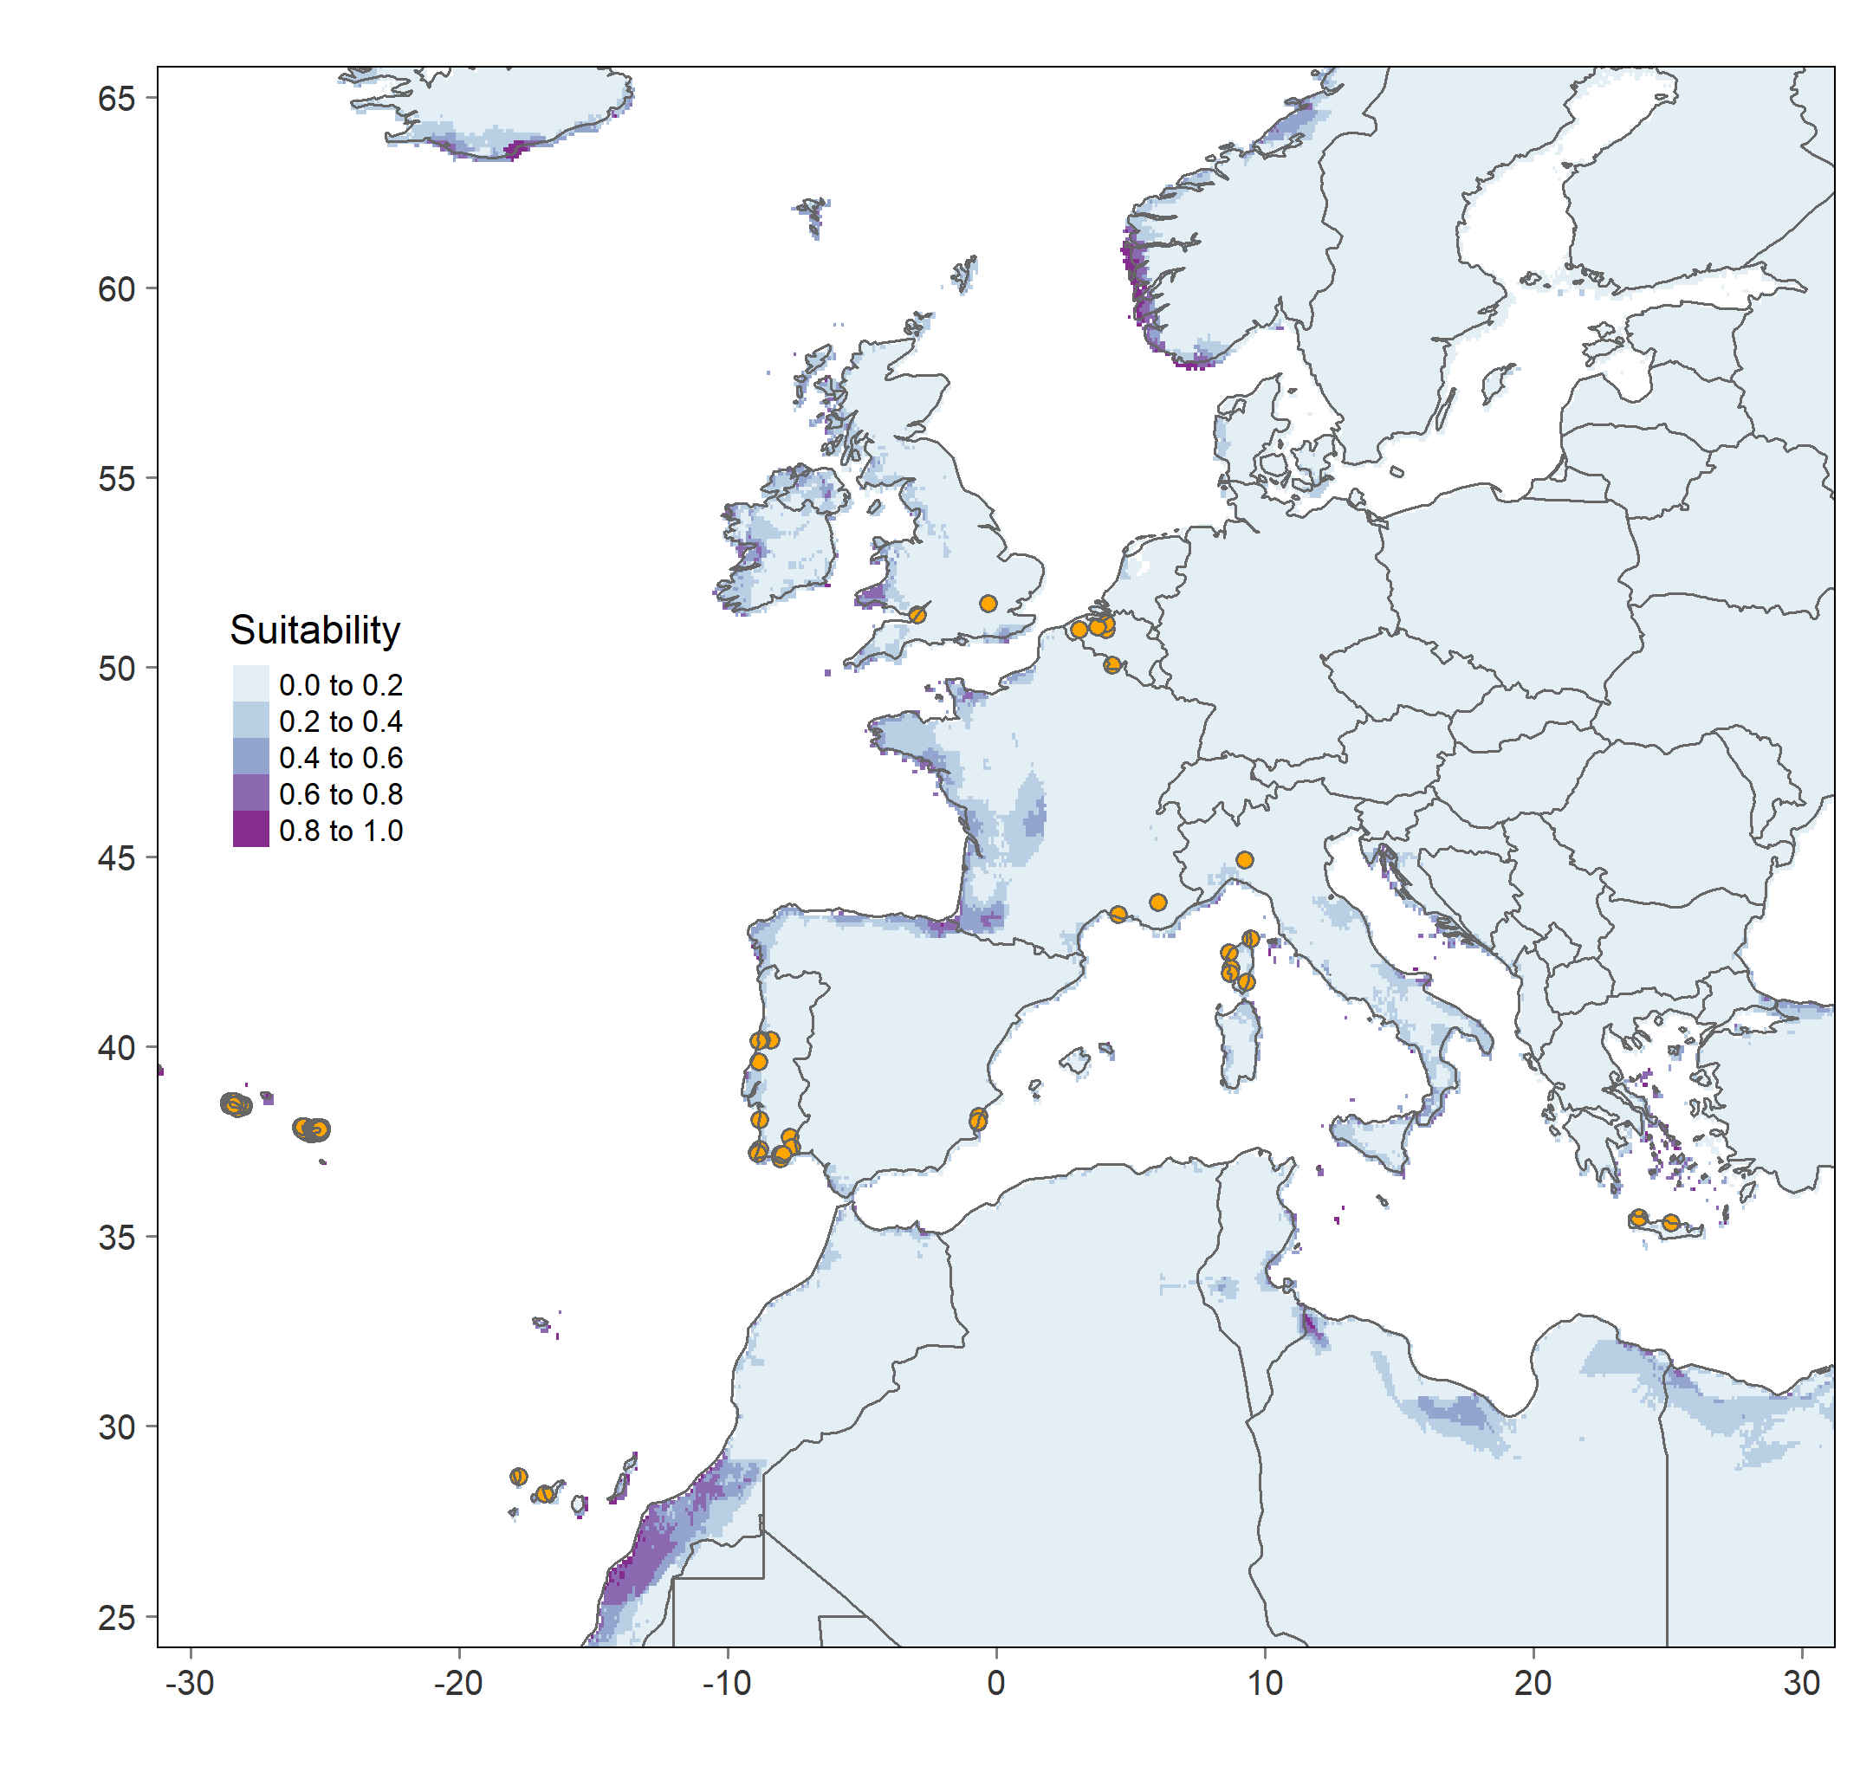

Figure S6. Known occurrences (orange dots) and climatic suitability estimates for the Christmas berry webworm, Cryptoblabes gnidiella, across its native range in Europe and Northern Africa.

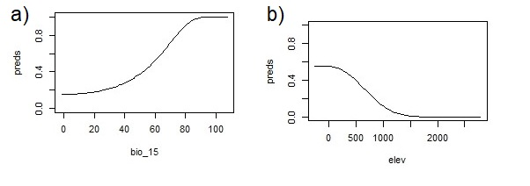

Figure S7. Response curves of the two environmental predictors with the highest contributions to the model predictions for the European grapevine moth, Lobesia botrana, across its native and invaded range. A) Seasonal precipitation (‘bio_15’) shows that climatic suitability increased in regions where monthly values range from 40% to approximately 100 %; B) Elevation (‘elev’) response indicates that climatic suitability was high at sea level and sharply decreased until approximately 1500 m.

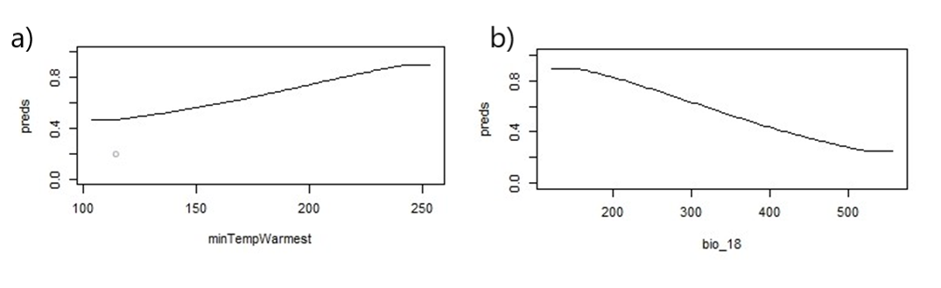
Figure S8. Response curves of the two environmental predictors with the highest contributions to the model predictions for the grape berry moth, Paralobesia viteana, across its native and invaded range. A) The minimum temperature of the warmest month (‘minTempWarmest’) response shows that climatic suitability gradually increased with temperature, reaching maximum suitability at approximately 25 °C; B) precipitation of the warmest quarter (‘bio_18’) response shows climatic suitability rapidly decreased as precipitation increased during the warmest quarter, with a maximum suitability between 0- and 200-mm precipitation.

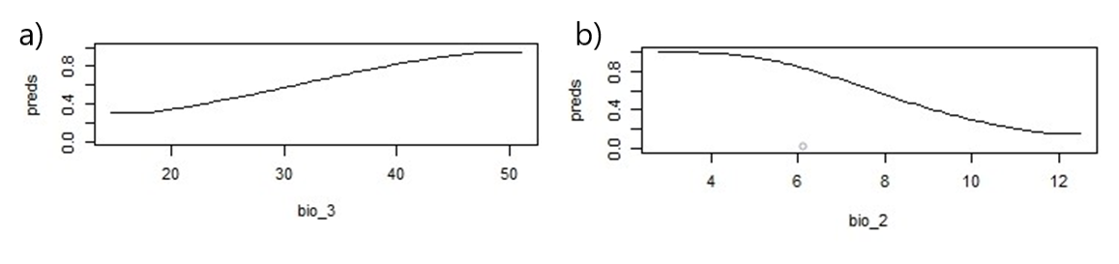
Figure S9. Response curves of the two environmental predictors with the highest contributions to the model predictions for the grape tortrix moth, Argyrotaenia ljungiana, across its native and invaded range. A) Isothermality (‘bio_3’) response suggests that climatic suitability increased as the ratio of diurnal variation to annual variation in temperatures increased, reaching a maximum suitability close to 50 °C; B) Mean diurnal range (‘bio_2’) showed that climatic suitability decreased when the mean differences between maximum and minimum temperatures were the greatest.

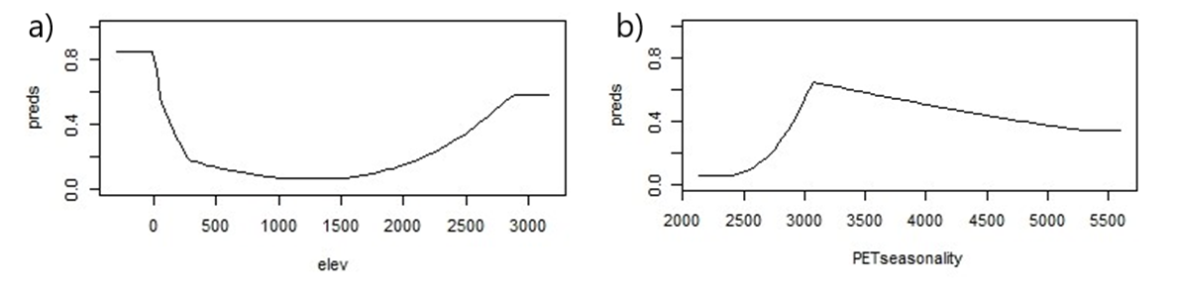

Figure S10. Response curves of the two environmental predictors with the highest contributions to the model predictions for the European grape berry moth, Eupoecilia ambiguella, across its native and invaded range. A) Elevation response (‘elev) shows that climatic suitability was high (80%) at sea level (zero meters elevation) and sharply decreased until approximately 1500 m where it started increasing again gradually until it reaches elevation close to 3000 m; B) Monthly variability in potential evapotranspiration response (‘PETseasonality’) shows increased climatic suitability from 2500 mm to approximately 3000 mm (70%) before gradually decreasing.
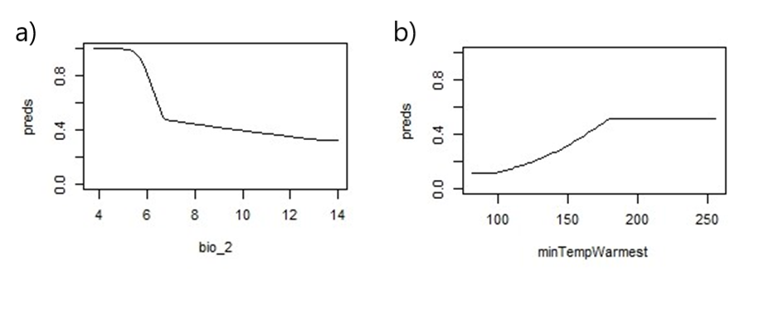
Figure S11. Response curves of the two environmental predictors with the highest contributions to the model predictions for the Christmas berry webworm, Cryptoblabes gnidiella, across its native and invaded range. A) Mean diurnal range (‘bio_2’) showed that climatic suitability decreased as the mean differences between maximum and minimum temperatures increased; B) The minimum temperature of the warmest month (‘minTempWarmest’) response shows that climatic suitability gradually increased with temperature, reaching maximum suitability (50%) at approximately 20 °C.

References

Allouche O, Tsoar A, Kadmon R (2006) Assessing the accuracy of species distribution models: prevalence, kappa and the true skill statistic (TSS). Journal of Applied Ecology 43: 1223–1232. https://doi.org/10.1111/j.1365-2664.2006.01214.x
Barbosa AM (2015) fuzzySim: applying fuzzy logic to binary similarity indices in ecology. Methods in Ecology and Evolution 6: 853–858. https://doi.org/10.1111/2041-210X.12372
Booth TH, Nix HA, Busby JR, Hutchinson MF (2014) BIOCLIM: the first species distribution modelling package, its early applications and relevance to most current MaxEnt studies. Diversity and Distributions 20: 1–9. https://doi.org/10.1111/ddi.12144
Boyce MS, Vernier PR, Nielsen SE, Schmiegelow FKA (2002) Evaluating resource selection functions. Ecological Modelling 157: 281–300. https://doi.org/10.1016/S0304-3800(02)00200-4
Brown JL, Carnaval AC (2019) A tale of two niches: methods, concepts, and evolution. Frontiers of Biogeography 11. https://doi.org/10.21425/F5FBG44158
Chamberlain S (2022) scrubr: Clean Biological Occurrence Records. Available from: https://github.com/ropensci/scrubr (devel) https://docs.ropensci.org/scrubr/ (docs) (May 19, 2022).
Chamberlain S, Oldoni D, Barve V, Desmet P, Geffert L, Mcglinn D, Ram K, rOpenSci (https://ropensci.org/), Waller [aut J, cre (2022) rgbif: Interface to the Global Biodiversity Information Facility API. Available from: https://CRAN.R-project.org/package=rgbif (May 5, 2022).
Di Cola V, Broennimann O, Petitpierre B, Breiner FT, D’Amen M, Randin C, Engler R, Pottier J, Pio D, Dubuis A, Pellissier L, Mateo RG, Hordijk W, Salamin N, Guisan A (2017) Ecospat: an R package to support spatial analyses and modeling of species niches and distributions. Ecography 40: 774–787. https://doi.org/10.1111/ecog.02671
Elith J, Graham C, Anderson R, Dudík M, Ferrier S, Guisan A, Hijmans RJ, Huettmann F, Leathwick JR, Lehmann A, Li J, Lohmann L, Loiselle B, Manion G, Moritz C, Nakamura M, Nakazawa Y, Overton JM, Peterson AT, Phillips SJ, Richardson K, Scachetti-Pereira R, Schapire RE, Soberón J, Williams S, Wisz MS, Zimmermann NE (2006) Novel methods improve prediction of species’ distributions from occurrence data. Ecography 29: 129–151. https://doi.org/10.1111/j.2006.0906-7590.04596.x
Fick SE, Hijmans RJ (2017) WorldClim 2: new 1-km spatial resolution climate surfaces for global land areas. International Journal of Climatology 37: 4302–4315. https://doi.org/10.1002/joc.5086
Hijmans RJ, Van Etten J, Cheng J, Mattiuzzi M, Sumner M, Greenberg JA, Lamigueiro OP, Bevan A, Racine EB, Shortridge A (2015) raster: Geographic Data Analysis and Modeling. Version 2.4-20. R package.
Hirzel AH, Le Lay G, Helfer V, Randin C, Guisan A (2006) Evaluating the ability of habitat suitability models to predict species presences. Predicting Species Distributions 199: 142–152. https://doi.org/10.1016/j.ecolmodel.2006.05.017
Kass JM, Muscarella R, Galante PJ, Bohl CL, Pinilla-Buitrago GE, Boria RA, Soley-Guardia M, Anderson RP (2021) ENMeval 2.0: Redesigned for customizable and reproducible modeling of species’ niches and distributions. Methods in Ecology and Evolution 12: 1602–1608. https://doi.org/10.1111/2041-210X.13628
Liu C, Berry PM, Dawson TP, Pearson RG (2005) Selecting thresholds of occurrence in the prediction of species distributions. Ecography 28: 385–393. https://doi.org/10.1111/j.0906-7590.2005.03957.x
Márcia Barbosa A, Real R, Muñoz A-R, Brown JA (2013) New measures for assessing model equilibrium and prediction mismatch in species distribution models. Diversity and Distributions 19: 1333–1338. https://doi.org/10.1111/ddi.12100
Miller ME, Hui SL, Tierney WM (1991) Validation techniques for logistic regression models. Statistics in Medicine 10: 1213–1226. https://doi.org/10.1002/sim.4780100805
Muscarella R, Galante PJ, Soley-Guardia M, Boria RA, Kass JM, Uriarte M, Anderson RP (2014) ENMeval: An R package for conducting spatially independent evaluations and estimating optimal model complexity for Maxent ecological niche models. Methods in Ecology and Evolution 5: 1198–1205. https://doi.org/10.1111/2041-210X.12261
Naimi B (2015) usdm: uncertainty analysis for species distribution models. R package version 1.1-15.
Phillips SJ, Anderson RP, Schapire RE (2006) Maximum entropy modeling of species geographic distributions. Ecological Modelling 190: 231–259. https://doi.org/10.1016/j.ecolmodel.2005.03.026
R Development Core Team (2021) R: A language and environment for statistical computing. R Foundation for Statistical Computing. R Foundation for Statistical Computing, Vienna, Austria. Available from: https://www.R-project.org (May 5, 2022).
Radosavljevic A, Anderson RP (2014) Making better MAXENT models of species distributions: Complexity, overfitting and evaluation. Journal of Biogeography 41: 629–643. https://doi.org/10.1111/jbi.12227
Schartel TE, Bayles BR, Cooper ML, Simmons GS, Thomas SM, Varela LG, Daugherty MP (2019) Reconstructing the European Grapevine Moth (Lepidoptera: Tortricidae), Invasion in California: Insights From a Successful Eradication. Annals of the Entomological Society of America 112: 107–117. https://doi.org/10.1093/aesa/say056
Shcheglovitova M, Anderson RP (2013) Estimating optimal complexity for ecological niche models: A jackknife approach for species with small sample sizes. Ecological Modelling 269: 9–17. https://doi.org/10.1016/j.ecolmodel.2013.08.011
Sillero N, Arenas-Castro S, Enriquez‐Urzelai U, Vale CG, Sousa-Guedes D, Martínez-Freiría F, Real R, Barbosa AM (2021) Want to model a species niche? A step-by-step guideline on correlative ecological niche modelling. Ecological Modelling 456: 109671. https://doi.org/10.1016/j.ecolmodel.2021.109671
Syfert MM, Smith MJ, Coomes DA (2013) The effects of sampling bias and model complexity on the predictive performance of MaxEnt species distribution models. PLOS ONE 8: e55158. https://doi.org/10.1371/journal.pone.0055158
Title PO, Bemmels JB (2018) ENVIREM: an expanded set of bioclimatic and topographic variables increases flexibility and improves performance of ecological niche modeling. Ecography 41: 291–307. https://doi.org/10.1111/ecog.02880
Zizka A, Silvestro D, Andermann T, Azevedo J, Duarte Ritter C, Edler D, Farooq H, Herdean A, Ariza M, Scharn R, Svantesson S, Wengström N, Zizka V, Antonelli A (2019) CoordinateCleaner: Standardized cleaning of occurrence records from biological collection databases. Methods in Ecology and Evolution 10: 744–751. https://doi.org/10.1111/2041-210X.13152
Zurell D, Franklin J, König C, Bouchet PJ, Dormann CF, Elith J, Fandos G, Feng X, Guillera-Arroita G, Guisan A, Lahoz-Monfort JJ, Leitão PJ, Park DS, Peterson AT, Rapacciuolo G, Schmatz DR, Schröder B, Serra-Diaz JM, Thuiller W, Yates KL, Zimmermann NE, Merow C (2020) A standard protocol for reporting species distribution models. Ecography 43: 1261–1277. https://doi.org/10.1111/ecog.04960

