Supplementary Material

Three new species of the sea fan genus Muricea (Cnidaria, Octocorallia, Plexauridae) from the northwest region of Mexico

Osvaldo Hernández ^{1,3}, Jaime Gómez-Gutiérrez¹, Carolina Galván-Tirado^{2,3}, Carlos Sánchez³

1 Departamento de Plancton y Ecología Marina, Centro Interdisciplinario de Ciencias Marinas, Instituto Politécnico Nacional, Av. IPN, s/n, CP 23096, La Paz, Baja California Sur, Mexico 2 Consejo Nacional de Ciencia y Tecnología, Av. Insurgentes Sur 1582, Col. Crédito Constructor, Alcaldía Benito Juárez, C.P. 03940, Ciudad de Mexico, Mexico 3 Departamento de Ciencias Marinas y Costeras, Universidad Autónoma de Baja California Sur, Carretera al sur km 5.5, CP 23080, La Paz, Baja California Sur, Mexico

Corresponding author: Carlos Sánchez (csanchez@uabcs.mx)

Running head: Three new species of Muricea from the Mexican Pacific

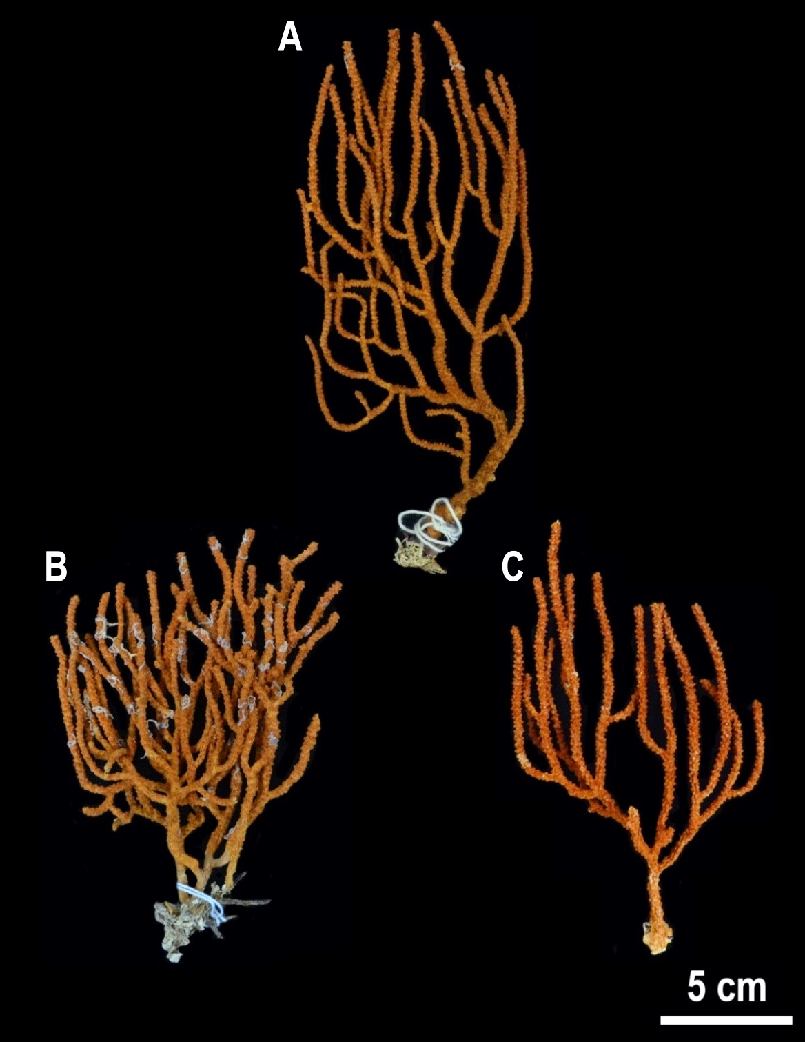
Figure S1. Muricea ambarae sp. nov. paratypes collected in the northwest region of Mexico to show intraspecific colony morphology variability A USNM 1606630: San Esteban Island (Punta Noroeste), Sonora, Mexico B USNM 1606631: Bahía de Las Ánimas (Los Choros), Baja California, Mexico C USNM 1606632: Punta Abreojos, Pacific coast of Baja California Sur, Mexico.
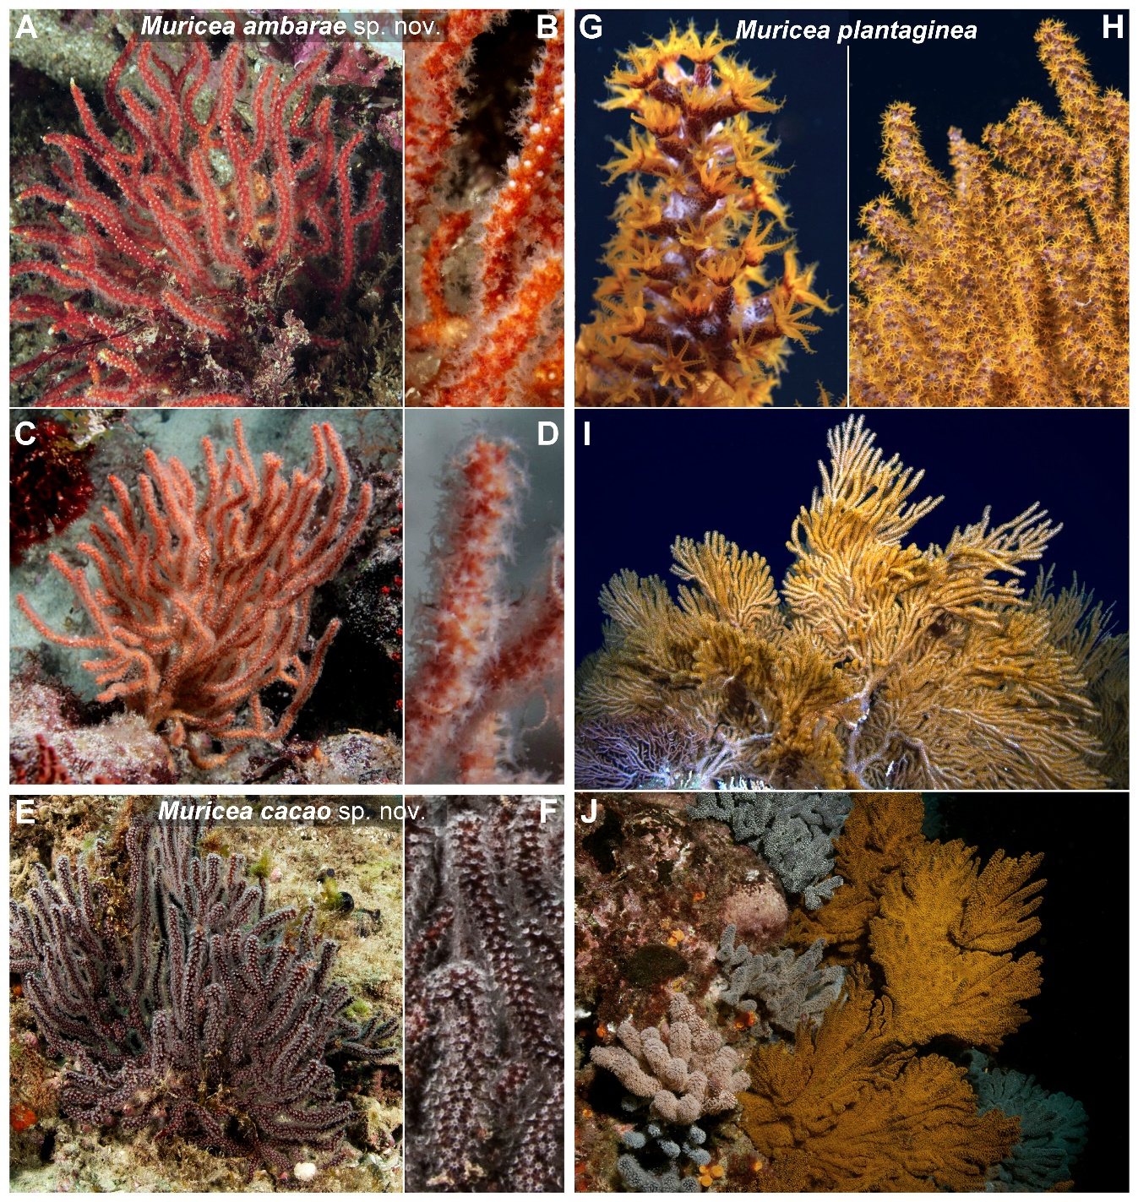
Figure S2. Comparison of the sea fans colonies in situ, underwater images of A-D Muricea ambarae sp. nov. E-F Muricea cacao sp. nov. G-I Muricea plantaginea. Photographs A-I Carlos Sánchez J Image from Breedy and Guzman (2016).

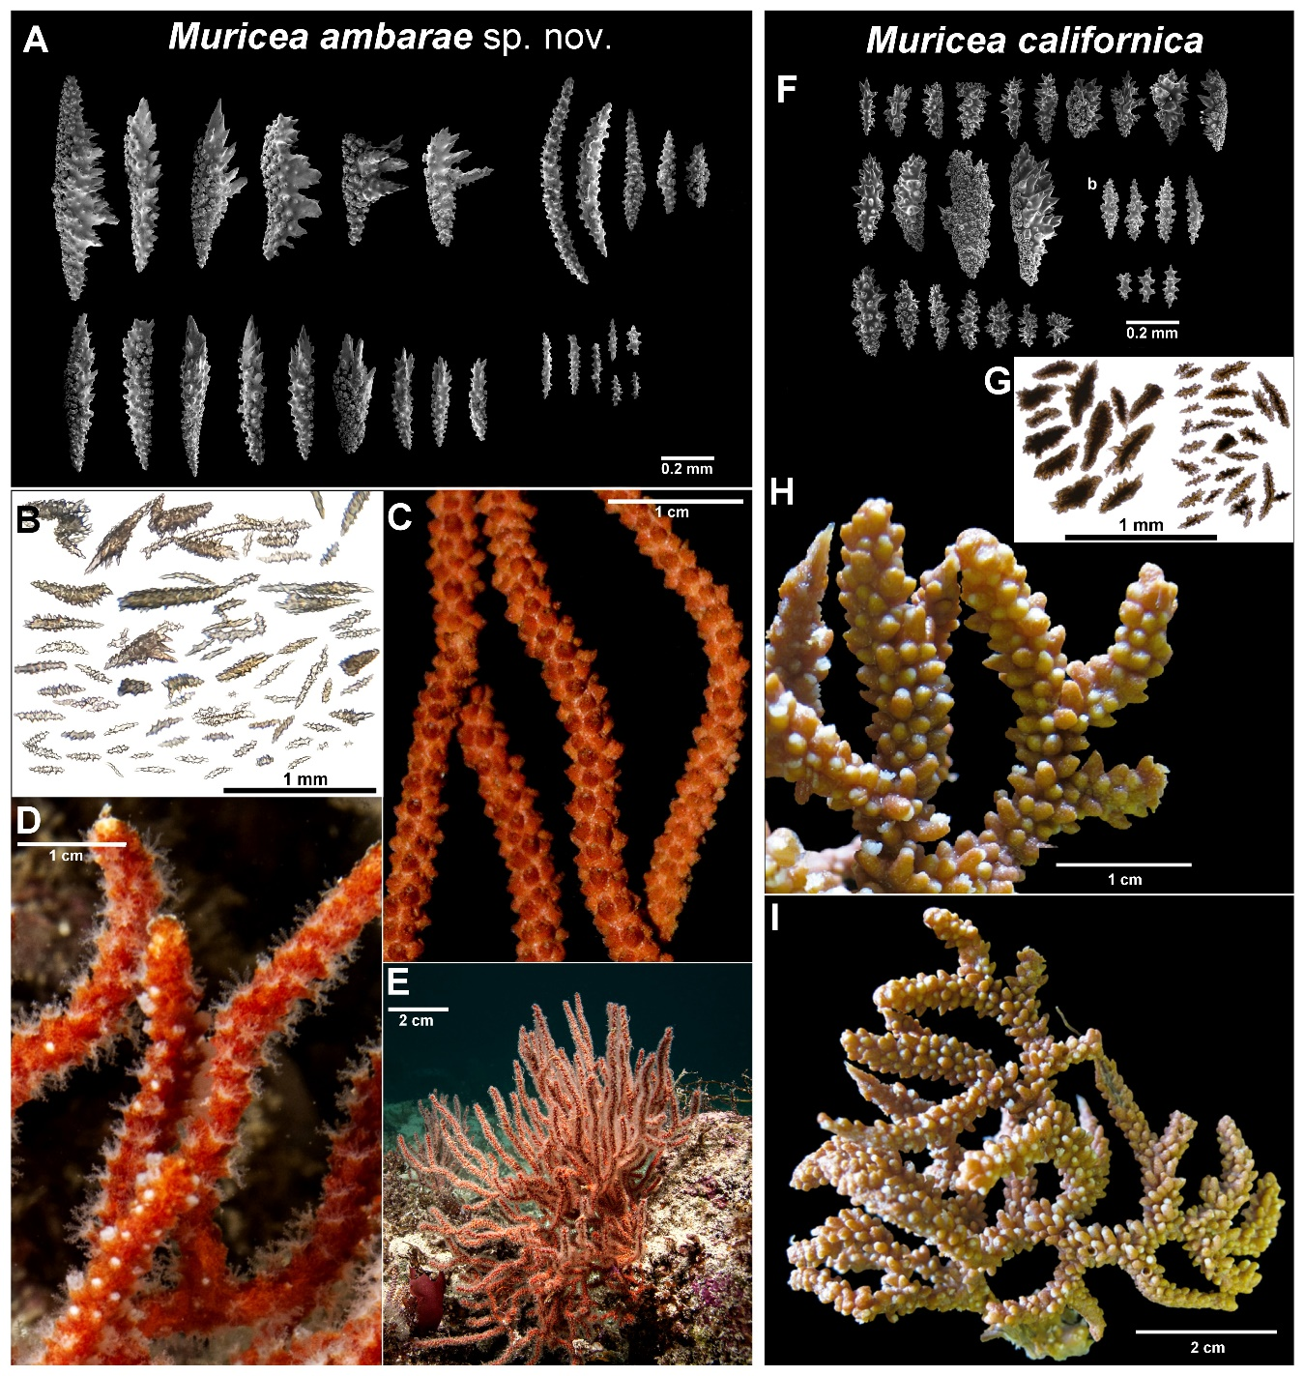
Figure S3. Comparison of the sea fans colonies, sclerites types, dry material branches and colony and in situ, underwater images of A-E Muricea ambarae sp. nov. with F-I Muricea californica. Photographs A-C present study D-E by Carlos Sánchez F-I Images modified from Breedy and Guzman (2016).

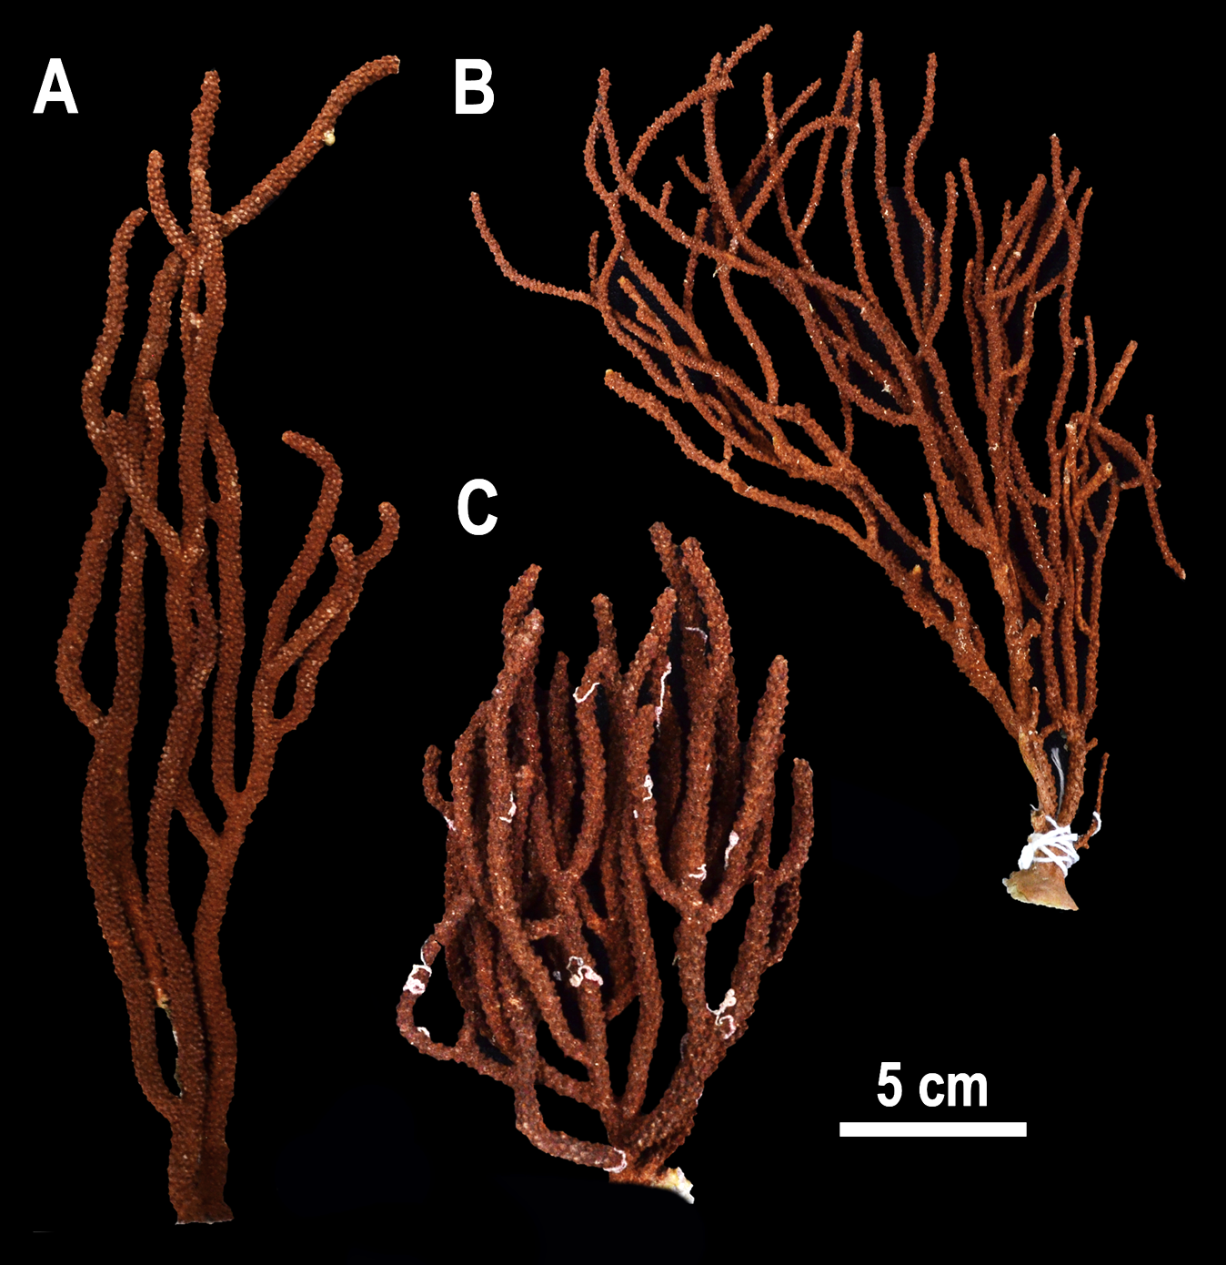
Figure S4. Muricea cacao sp. nov. paratypes collected in the northwest region of Mexico to show intraspecific colony morphology variability A USNM 1606635: Salsipuedes Island (Caleta Falsa Norte), Baja California, Mexico B USNM 1606636: Bahía de los Ángeles (Punta Pescador), Baja California, Mexico C USNM 1606634: San Marcos Island (El Faro-Lobera), Baja California Sur, Mexico.

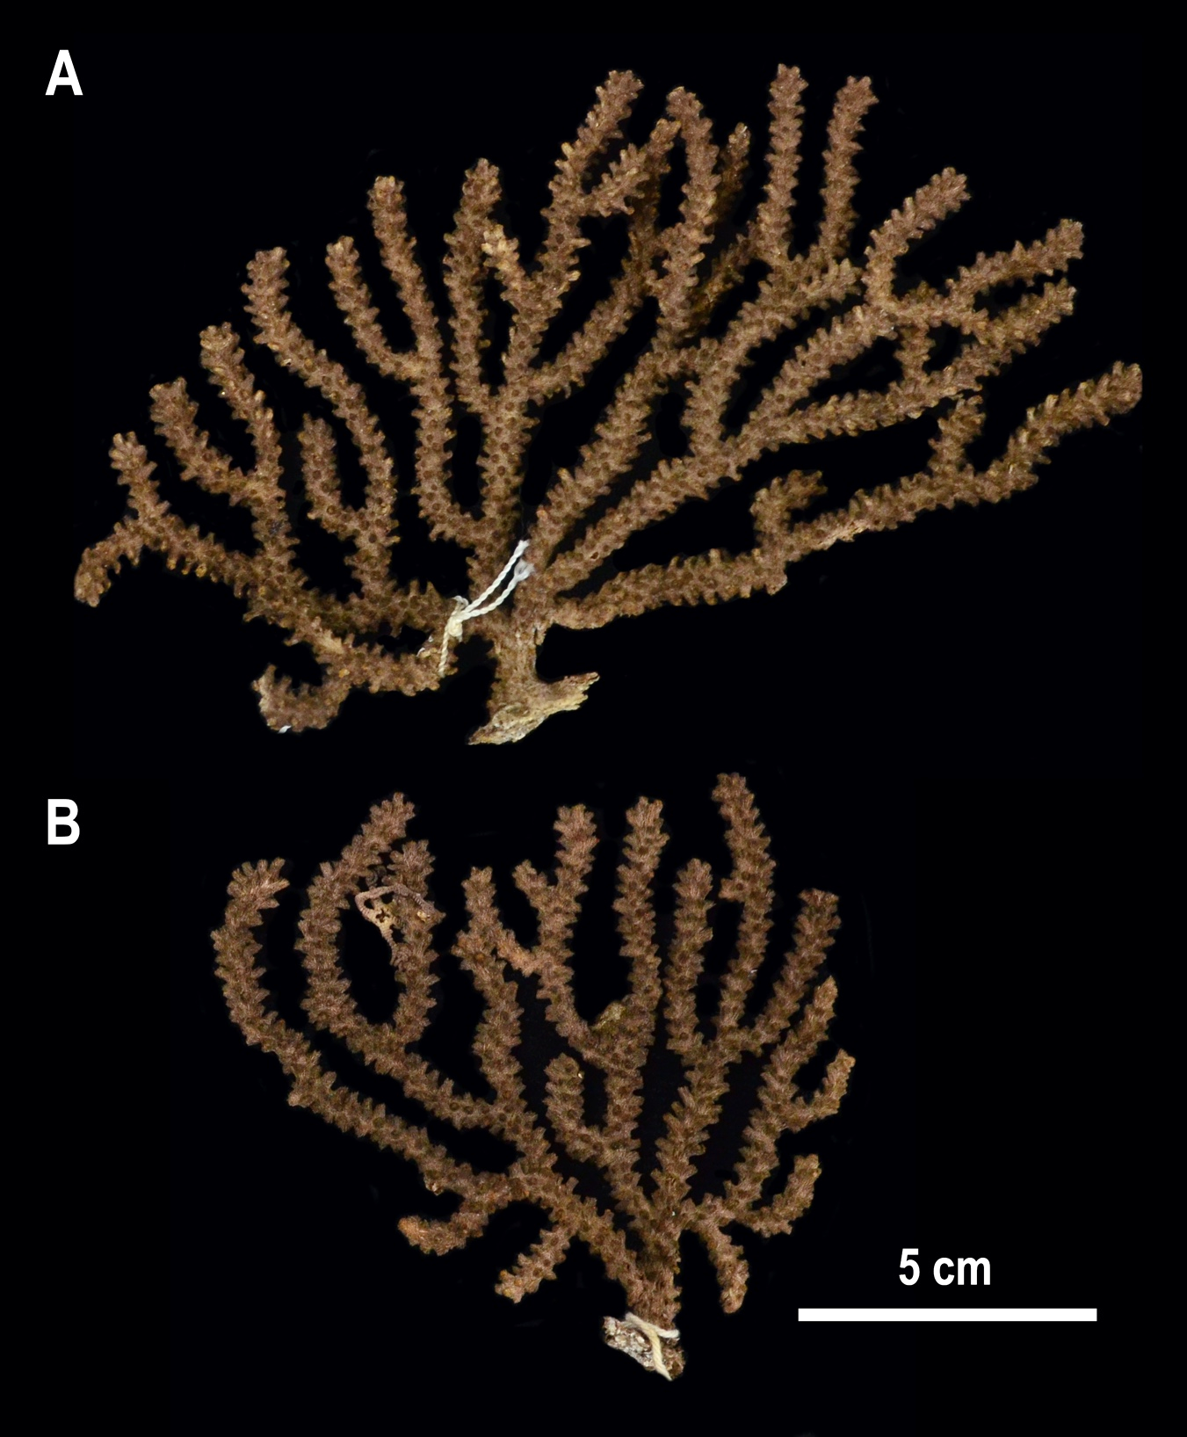
Figure S5. Muricea molinai sp. nov. paratypes collected in the northwest region of Mexico to show intraspecific colony morphology variability A USNM 1606638: Todos Santos, Punta Lobos (Bajo Fondo del Medio), Pacific coast of Baja California Sur, Mexico B USNM 1606639: Bahía Santa María, Cabo San Lázaro (Roca del Cabito), Pacific coast of Baja California Sur, Mexico.
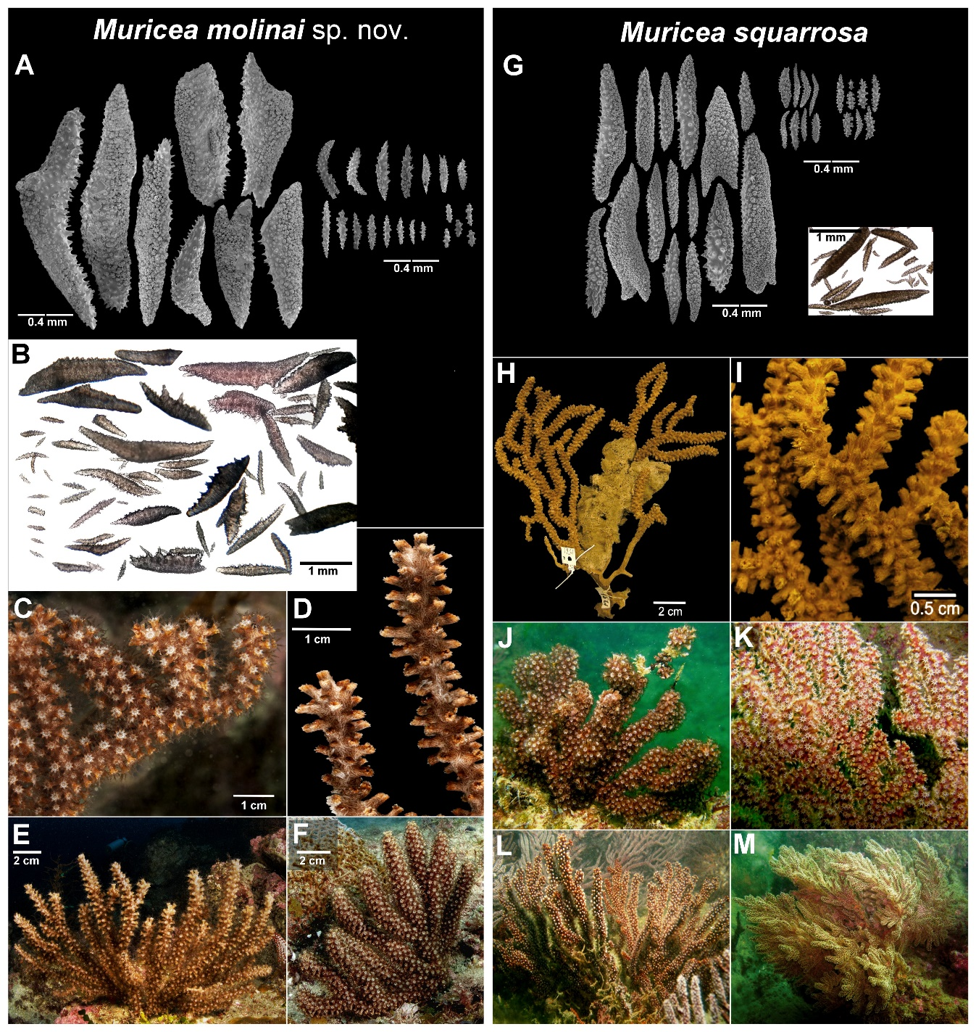
Figure S6. Comparison of the sea fans colonies, sclerites types, dry material branches and colony and in situ, underwater images of A-F Muricea molinai sp. nov. with G-M Muricea squarrosa. Photographs A-B present study C-F by Carlos Sánchez G-M Images modified from Breedy and Guzman (2015).

Data S1. Details of the molecular analyses.

The genomic DNA was extracted from ten sea fan colonies collected in the Mexican Pacific using the Qiagen DNeasy Blood & Tissue kit (Qiagen, Valencia, CA) following the manufacturer’s protocol. A pair of primers were designed to amplify a fragment of ~931 bp from the mitochondrial MutS gene (mtMutS): MutS 1-F CCGAATCTGCTATTGGTTTAG and MutS 1-R AATTTTTGTTAAACCACTCTG with Primer 3Web (http://primer3.ut.ee; Untergasser et al. 2012). The reactions of the polymerase chain reaction (PCR) were carried out in 30 µl total volume containing final concentrations of 50-100 ng/µl DNA template, 0.3 mM dNTPs, 2 mM MgCl₂, 0.8 mg/ml Bovine Serum Albumin (BSA), 1 U Taq DNA polymerase (Invitrogen, Inc., Carlsbad, CA), 0.3 µM each primer, and 1X of reaction buffer. The PCR profile was carried out as follows: one cycle of 95 °C for 5 min, 35 cycles of 95 °C for 1 min, 50 °C for 1 min, 72 °C for 1 min and a final extension of 72 °C for 10 min. Each PCR product was sequenced by Macrogen Co. in both DNA strands. Sequence edition, strands assembling, and alignments were performed in Geneious Prime software 2022.2 (Kearse et al. 2012). The Tamura 3-parameter substitution model was used as the best-fit model for the dataset by jModeltest 2.1.6 for the tree reconstruction (Darriba et al. 2012). The phylogenetic tree was performed with maximum likelihood (ML) using Mega7 (Kumar et al. 2016) with 1000 bootstrap replicates. Plexaura kuna (OL616260 Genbank accession) (Muthye et al. 2022), a sister taxon of Muricea, was used as outgroup. Thus, a total of 23 mtMutS sequences were analyzed in the phylogenetic tree (Fig. 10).

Table S1. Muricea species included in the molecular analyses, and their corresponding internal catalog number and GenBank accession numbers. Data from the outgroup is included.

Species | Catalog number | Sampling location | Genbank ID | Reference
Muricea austera Verrill, 1869 | IM10_21 | Islote, San Juanico Island, Islas Marías Archipelago, Nayarit, Mexico | OQ268203 | Present study
Muricea austera Verrill, 1869 | IM10_17 | Islote, San Juanico Island, Islas Marías Archipelago, Nayarit, Mexico | OQ268204 | Present study
Muricea californica Aurivillius, 1931 | ECU005 | NA | OK391167 | Vergara-Florez, unpublished
Muricea crassa Verrill, 1869 | NA | Coiba National Park, Panama | LT174652 | Poliseno et al. (2017)
Muricea echinata Verrill, 1866 | ECU083 | NA | OK391166 | Vergara-Florez, unpublished
Muricea fruticosa Verrill, 1869 | TV_11 | Bahía Magdalena, Baja California Sur, Mexico | OQ268206 | Present study
Muricea fruticosa Verrill, 1869 | HMG94 | Coiba Island, Panama | HG917017 | Vargas et al. (2014)
Muricea hebes Verrill, 1864 | UABCS-PFA-CN-276 | Rio de La Plata shipwreck, Acapulco, Guerrero, Mexico | OQ268207 | Present study
Muricea plantaginea (Valenciennes, 1846) | ECU004 | NA | OK391169 | Vergara-Florez, unpublished
Muricea purpurea Verrill, 1868 | NA | Coiba National Park, Panama | LT174653 | Poliseno et al. (2017)
Muricea purpurea Verrill, 1868 | USNM 1016584 | Panama Bay, Panama | GQ293304 | Herrera et al. (2010)
Muricea purpurea Verrill, 1868 | ECU021 | NA | OK391165 | Vergara-Florez, unpublished
Muricea squarrosa Verrill, 1869 | ECU044 | NA | OK391155 | Vergara-Florez, unpublished
Muricea sp. | CAS-1007376 | Rocas Alijos, Mexico | AY683067 | Wirshing et al. (2005)
Muricea sp. | HMG81 | Coiba Island, Panama | HG917015 | Vargas et al. (2014)
Muricea sp. | MZUCR-OCT 0023 | Costa Rica | LT221095 | Ament-Velásquez et al. (2016)
Muricea cacao sp. nov. holotype | USNM 1606633 | San Marcos Island (El Faro-Lobera), Baja California Sur, Mexico | OQ268208 | Present study
Muricea cacao sp. nov. paratype | USNM 1606635 | Salsipuedes Island (Caleta Falsa Norte), Baja California, Mexico | OQ268209 | Present study
Muricea ambarae sp. nov. paratype | USNM 1606630 | San Esteban Island (Punta Noroeste), Sonora, Mexico | OQ268210 | Present study
Muricea ambarae sp. nov. holotype | USNM 1606629 | San Esteban Island (Punta Sureste), Sonora, Mexico | OQ268211 | Present study
Muricea molinai sp. nov. paratype | USNM 1606639 | Bahía Santa María, Cabo San Lázaro (Roca del Cabito), Baja California Sur, Mexico | OQ268212 | Present study
Muricea molinai sp. nov. | UABCS-PFA-CN-164 | Bajo El Golfito, Cabo San Lucas, Baja California Sur, Mexico | OQ268213 | Present study
Plexaura kuna Lasker, Kim, Coffroth, 1996 (outgroup) | NA | Bocas del Toro, Panama | OL616260 | Muthye et al. (2022)

References of Supplementary Material

Ament-Velásquez SL, Breedy O, Cortés J, Guzman HM, Wörheide G, Vargas S (2016) Homoplasious colony morphology and mito-nuclear phylogenetic discordance among Eastern Pacific octocorals. Molecular Phylogenetics and Evolution 98: 373–381. https://doi.org/10.1016/j.ympev.2016.02.023
Breedy O, Guzman HM (2015) A revision of the genus Muricea Lamouroux, 1821 (Anthozoa, Octocorallia) in the eastern Pacific. Part I: Eumuricea Verrill, 1869 revisited. Zookeys 537: 1–32. https://doi.org/10.3897/zookeys.537.6025
Breedy O, Guzman HM (2016) A revision of the genus Muricea Lamouroux, 1821 (Anthozoa, Octocorallia) in the eastern Pacific. Part II. ZooKeys 581: 1–69. https://doi.org/10.3897/zookeys.581.7910
Darriba D, Taboada GL, Doallo R, Posada D (2012) jModelTest 2: more models, new heuristics and parallel computing. Nature Methods 9: 772. https://doi.org/10.1038/nmeth.2109
Herrera S, Baco A, Sánchez JA (2010) Molecular systematics of the bubblegum coral genera (Paragorgiidae, Octocorallia) and description of a new deep-sea species. Molecular Phylogenetics and Evolution 55:123–135. https://doi.org/10.1016/j.ympev.2009.12.007
Kearse M, Moir R, Wilson A, Stones-Havas S, Cheung M, Sturrock S, Buxton S, Cooper A, Markowitz S, Duran C, Thierer T, Ashton B, Meintjes P, Drummond A (2012) Geneious Basic: an integrated and extendable desktop software platform for the organization and analysis of sequence data. Bioinformatics 28:1647–1649 https://doi.org/10.1093/bioinformatics/bts199
Kumar S, Stecher G, Tamura K (2016) MEGA7: Molecular Evolutionary Genetics Analysis Version 7.0 for Bigger Datasets. Molecular Biology and Evolution 33: 1870–1874. https://doi.org/10.1093/molbev/msw054
Muthye V, Mackereth CD, Stewart JB, and Lavrov D.V (2022). Large dataset of octocoral mitochondrial genomes provides new insights into mt-mutS evolution and function. DNA Repair 110:103273. https://doi.org/10.1016/j.dnarep.2022.103273
Poliseno A, Breedy O, Eitel M, Wöerheide G, Guzman HM, Krebs S, Blum H, Vargas S. (2017) Complete mitochondrial genome of Muricea crassa and Muricea purpurea (Anthozoa: Octocorallia) from the eastern tropical Pacific. bioRXiv. https://doi.org/10.1101/042945
Untergasser A, Cutcutache I, Koressaar T, Ye J, Faircloth BC, Remm M, Rozen SG (2012) Primer3—new capabilities and interfaces. Nucleic Acids Research, 40(15): e115. https://doi.org/10.1093/nar/gks596
Vargas S, Guzman HM, Breedy O, Wörheide G (2014) Molecular phylogeny and DNA barcoding of tropical eastern Pacific shallow-water gorgonian octocorals. Marine Biology 161: 1027–1038. https://doi.org/10.1007/s00227-014-2396-8
Wirshing HH, Messing CG, Douady CJ, Reed J, Stanhope MJ, Shivji MS (2005) Molecular evidence for multiple lineages in the gorgonian family Plexauridae (Anthozoa: Octocorallia). Marine Biology 147: 497–508. https://doi.org/10.1007/s00227-005-1592-y

