Supplementary File
For: Characterization of the complete mitochondrial genome of the longhorn beetle, Batocera horsfieldi (Coleoptera, Cerambycidae), and its phylogenetic analysis with suitable longhorn beetles

1. Adult image
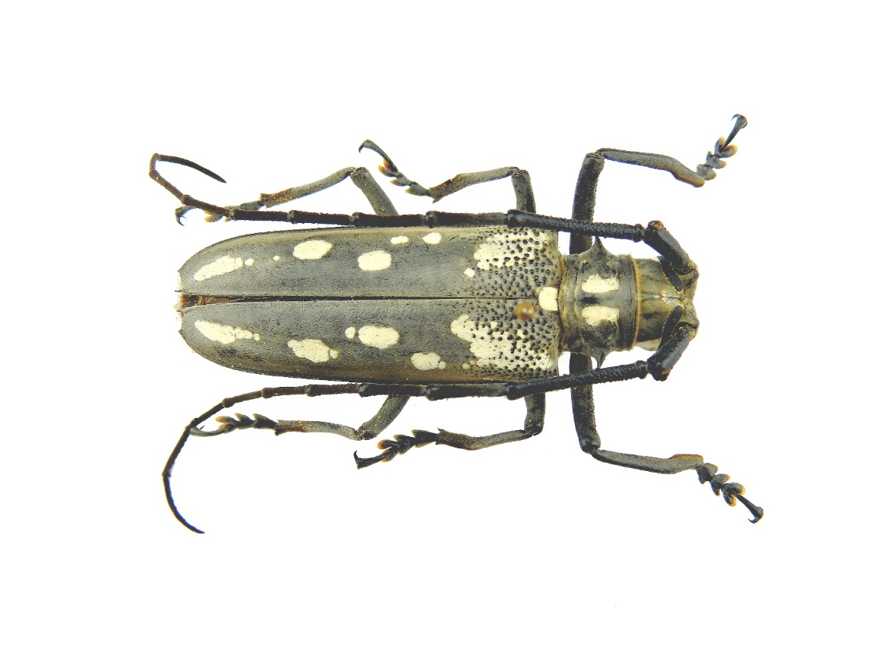
Batocera horsfieldi (Male, adult)

2. Insect identification materials
1) Hua LZ,Nara Hajime,G.A.Saemulson,S.W.Lingafelter(2009) Iconography of Chinense Longicorn Beetles (1406 Species) in Color. Sun Yat - sen University Press, Guangzhou,69-70pp
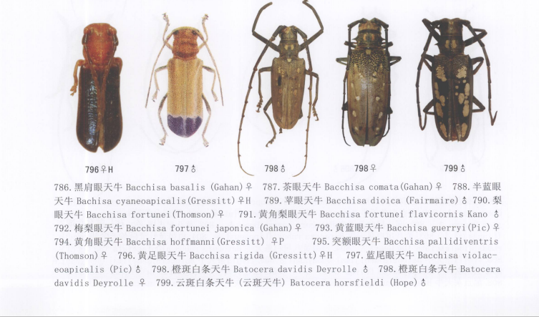
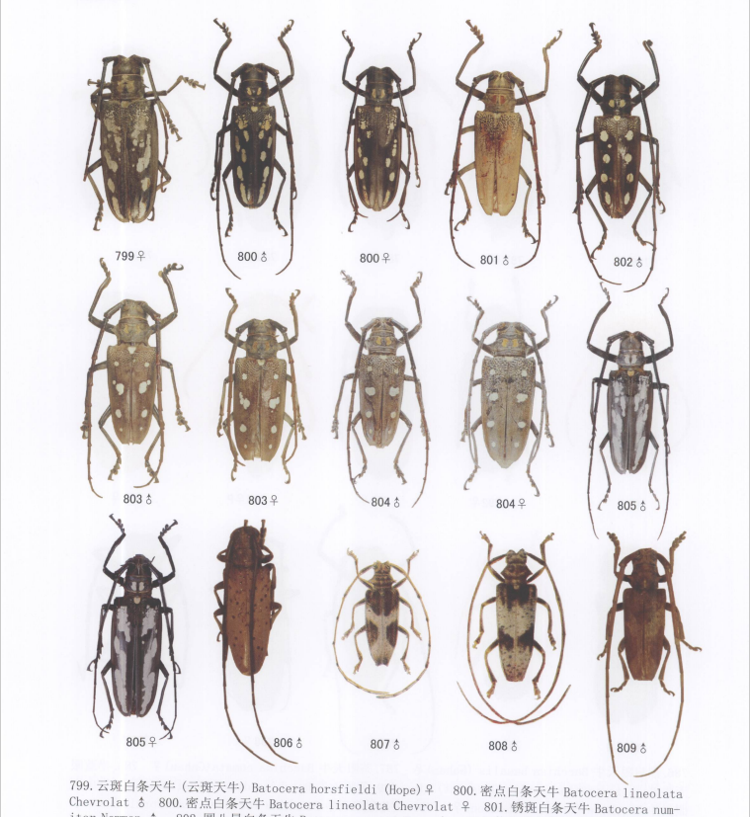

2) Liu Y, Xiong S, Ren JQ, Zhang XX, Chen L. (2012) Comparative morphological study on genus Batocera (Coleoptera, Cerambycidae, Lamiinae, Batocerini). Acta Zootaxonomica Sinica, 37(04): 701-711.
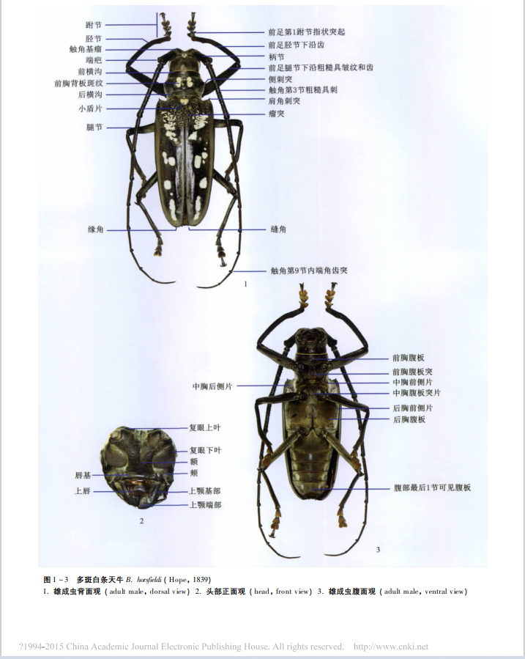

3. Data availability
For B. horsfieldi: https://doi.org/10.6084/m9.figshare.22666192.v1.
For 22 species: https://doi.org/10.6084/m9.figshare.22673647.v1 .

Table S1 GenBank accession numbers of species used in this study.
Family | Genus | Species | GenBank  Accession  number
Cerambycidae | Monochamus | Monochamus sparsutus | NC053906.1
Cerambycidae | Monochamus | Monochamus alternatus | NC050066.1
Cerambycidae | Monochamus | Monochamus sartor urussovii | OP856519.1
Cerambycidae | Monochamus | Monochamus saltuarius | OP169419.1
Cerambycidae | Agapanthia | Agapanthia amurensis | MW617354.1
Cerambycidae | Agapanthia | Agapanthia daurica | MN473114.1
Cerambycidae | Anoplophora | Anoplophora glabripennis | NC008221.1
Cerambycidae | Anoplophora | Anoplophora horsfieldi | MW364565.1
Cerambycidae | Anoplophora | Anoplophora chinensis | NC029230.1
Cerambycidae | Batocera | Batocera lineolata | MW629558.1
Cerambycidae | Batocera | Batocera rubus | OM161963.1
Cerambycidae | Batocera | Batocera horsfieldi | OQ785650
Cerambycidae | Xylotrechus | Xylotrechus grayii | NC030782.1
Cerambycidae | Turanoclytus | Turanoclytus namaganensis | NC060874.1
Cerambycidae | Demonax | Demonax pseudonotabilis | OP096419.1
Cerambycidae | Allotraeus | Allotraeus orientalis | NC061181.1
Cerambycidae | Arhopalus | Arhopalus unicolor | NC053904.1
Cerambycidae | Aromia | Aromia bungii | NC053714.1
Cerambycidae | Cephalallus | Cephalallus oberthueri | NC062854.1
Cerambycidae | Vesperus | Vesperus sanzi | MN473093.1
Vesperidae | Spiniphilus | Spiniphilus spinicornis | NC029515.1
Out groups | Dryops | Dryops ernesti | KX035147.1
Out groups | Heterocerus | Heterocerus parallelus | KX087297.1

