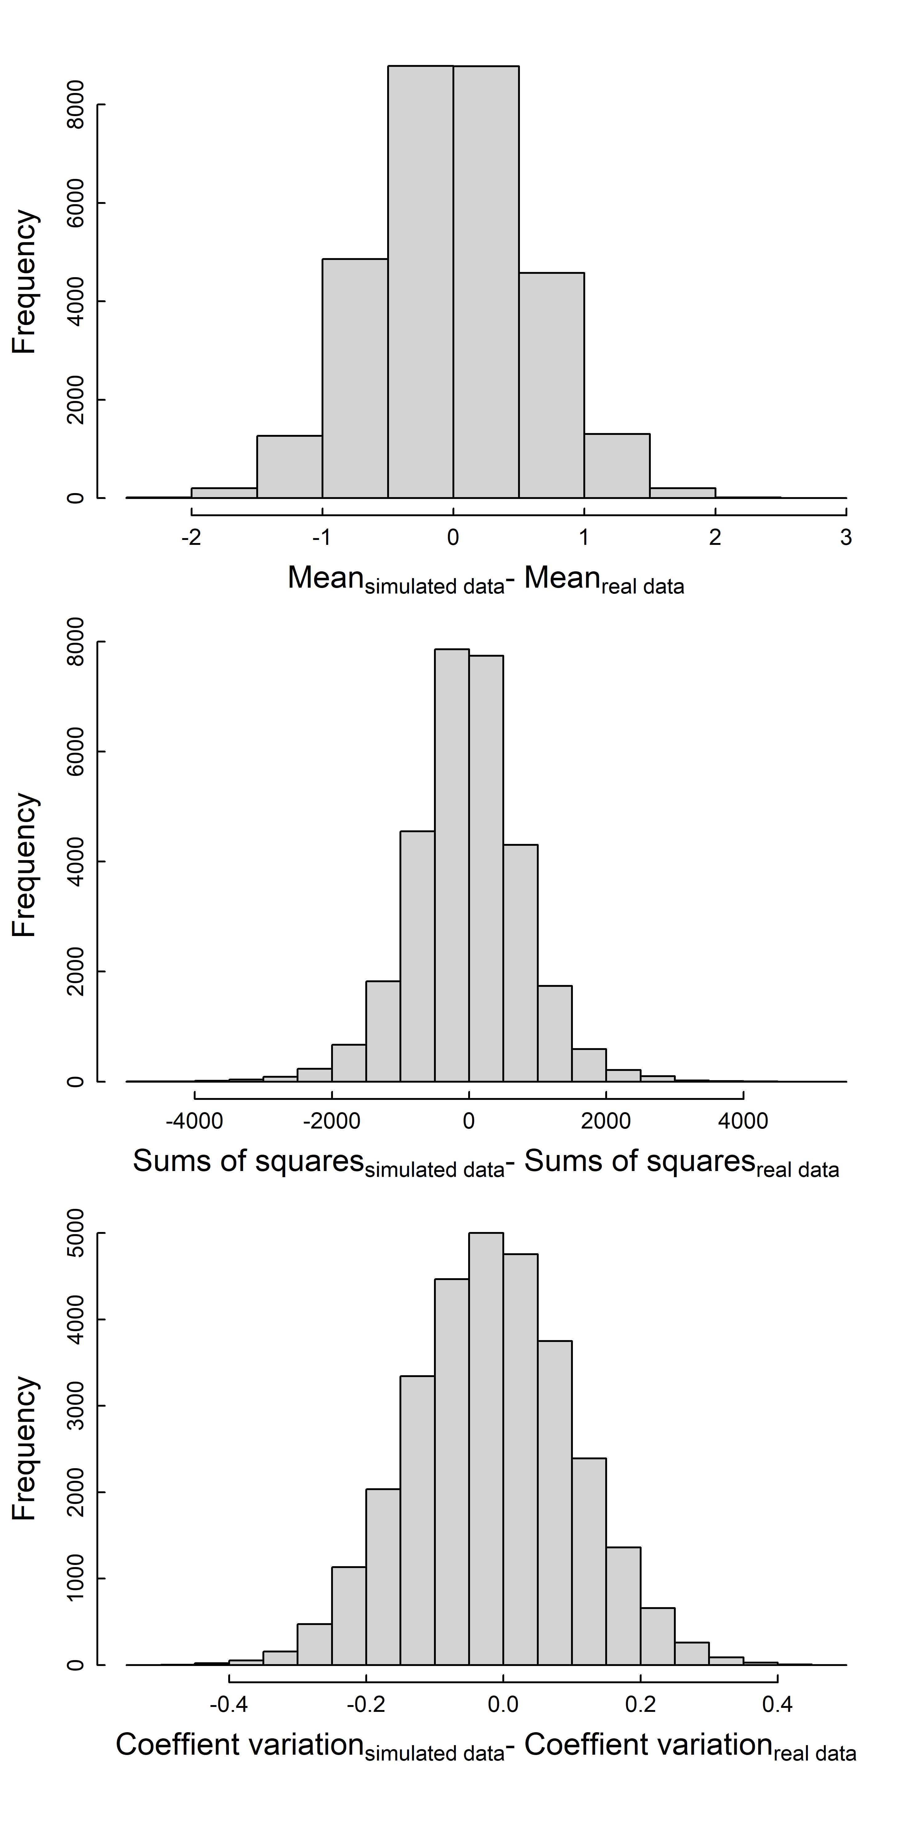
Figure S5. Zero-centred histogram of the residuals between simulated data and predictions of the model with the total sycamore maple basal area in a radius of 50 km from the sampler as a predictor of the number of Cryptostroma corticale spores detected in aerobiological samples.

