An initial molecular resolution of the mantellid frogs of the Guibemantis liber complex reveals three new species from northern Madagascar

Thore Koppetsch, Maciej Pabijan, Carl R. Hutter, Jörn Köhler, Philip-Sebastian Gehring, Andolalao Rakotoarison, Fanomezana M. Ratsoavina, Mark D. Scherz, David R. Vieites, Frank Glaw, Miguel Vences

Supplementary Materials

Table S1. Primers and thermal cycling profiles used for the amplification of DNA fragments used in this study (see Materials and Methods). Fragment length refers to the alignment length in the concatenated supermatrix; nuclear-encoded genes have been further trimmed for calculation of haplotype networks. Thermal cycling schemes start with temperature (in °C) of each step, followed by the time in seconds between parentheses; cycling repetitions are indicated within brackets.

Marker | Primer name | Primer sequences | PCR conditions | Reference
12S (648 bp) | 12SAL | AAACTGGGATTAGATACCCCACTAT | 94(90), [94(45), 52(45), 72(90) x 33], 72(300) | Kocher et al. (1989) / Hrbek and  Larson (1999)
 | 16SR3 | TTTCATCTTTCCCTTGCGGTAC
16S (551 bp) | 16Sra-L | CGCCTGTTTATCAAAAACAT | 94(90), [94(45), 52(45), 72(90) x 33], 72(300) | Vences et al. (2003)
 | 16Srb-H | CCGGTCTGAACTCAGATCACGT |  | Vences et al. (2003)
16S (6381 bp) | 16SL3 | AGCAAAGAHYWWACCTCGTACCTTTTGCAT | 94(90), [94(45), 52(45), 72(90) x 33], 72(300) | Vences et al. (2003)
 | 16SAH | ATGTTTTTGATAAACAGGCG |  | Vences et al. (2003)
COB (520 bp) | Cytb-a | CCATGAGGACAAATATCATTYTGRGG | 94(90), [94(30), 53(45), 72(90) x 35], 72(600) | Bossuyt and Milinkovitch (2000)
 | Cytb-c | CTACTGGTTGTCCTCCGATTCATGT |  | Bossuyt and Milinkovitch (2000)
COX1 (622 bp) | LCO1490 | GGTCAACAAATCATAAAGATATTGG | 94(90), [94(30), 49(45), 72(90) x 35] | Folmer et al. (1994)
 | HCO2198 | TAAACTTCAGGGTGACCAAAAAATCA |  | Folmer et al. (1994)
RAG1 (699 bp) | Rag1-Mart Fl1 | AGCTGGAGYCARTAYCAYAARATG | 94(240), [94(45), 45(40), 72(120) x 45], 72(600) | modified from Martin (1999)
 | Rag-1Mart R6 | GTGTAGAGCCARTGRTGYTT |  | modified from Martin (1999)
 | Rag-1AmpF2 | ACNGGNMGICARATCTTYCARCC |  | Chiari et al. (2004)
 | Rag1-UC-R | TTGGACTGCCTGGCATTCAT |  | provided by D.R. Vieites
BDNF (577 bp) | BDNF DRV F1 | ACCATCCTTTTCCTKACTATGG | 94(120), [94(20), 57(45), 72(120) x 39], 72(600) | Vieites et al. (2007) / Crottini et al. (2012)
 | BDNF DRV R1 | CTATCTTCCCCTTTTAATGGTC |  | Vieites et al. (2007) / Crottini et al. (2012)
TYR (548 bp) | Tyr-1a | AGGTCCTCTTRAGCAAGGAATG | 94(120), [94(60), 61(90), 72(120) x 40], 72(600) | Bossuyt and Milinkovitch (2000)
 | Tyr-1b | AGGTCCTCYTRAGGAAGGAATG
 | Tyr-1d | TCCTCCGTGGGCACCCARTTCCC
 | Tyr-1e | GAGAAGAAAGAWGCTGGGCTGAG
 | Tyr-1g | TGCTGGCRTCTCTCCARTCCCA
POMC (577 bp) | POMC DRVF1 | ATATGTCATGASCCAYTTYCGCTGGAA | 95(120), [95(45), 62(50) -1°/cycle, 72(80) x 9], [95(45), 52(50), 72(80) x 30], 72(600) | Vieites et al. (2007)
 | POMC DRVR1 | GGCRTTYTTGAAWAGAGTCATTAGWGG |  | Vieites et al. (2007)

References for Table S1:

Bossuyt F, Milinkovitch MC (2000) Convergent adaptive radiations in Madagascan and Asian ranid frogs reveal covariation between larval and adult traits. Proceedings of the National Academy of Sciences of the United States of America 97: 6585–6590.
Chiari Y, Vences M, Vieites DR, Rabemananjara F, Bora P, Ramilijaona Ravoahangimalala O, Meyer A (2004) New evidence for parallel evolution of colour patterns in Malagasy poison frogs (Mantella). Molecular Ecology 13: 3763–3774.
Crottini, A, Madsen O, Poux C, Strauß A, Vieites DR, Vences M (2012) Vertebrate time-tree elucidates the biogeographic pattern of a major biotic change around the K–T boundary in Madagascar. – Proceedings of the National Academy of Sciences of the United States of America 109: 5358–5363.
Folmer O, Black M, Hoeh W, Lutz R, Vrijenhoek R (1994) DNA primers for amplification of mitochondrial cytochrome c oxidase subunit I from diverse metazoan invertebrates. Molecular Marine Biotechnology 3: 294–299.
Hrbek T, Larson A (1999) The evolution of diapause in the killifish family Rivulidae (Atherinomorpha, Cyprinodontiformes): a molecular phylogenetic and biogeographic perspective. Evolution 53: 1200–1216.
Kocher TD, Thomas WK, Meyer A, Edwards SV, Pääbo S, Villablanca FX, Wilson AC (1989) Dynamics of mitochondrial DNA evolution in animals: Amplification and sequencing with conserved primers. Proceedings of the National Academy of Sciences of the United States of America 86: 6196–6200.
Martin AP (1999) Substitution rates of organelle and nuclear genes in sharks: implicating metabolic rate (again). Molecular Biology and Evolution 16: 996–1002.
Vences M, Kosuch J, Glaw F, Böhme W, Veith M (2003) Molecular phylogeny of hyperoliid treefrogs: biogeographic origin of Malagasy and Seychellean taxa and re-analysis of familial paraphyly. Journal of Zoological Systematics and Evolutionary Research 41: 205–215.
Vieites DR, Min MS, Wake DB (2007) Rapid diversification and dispersal during periods of global warming by plethodontid salamanders. Proceedings of the National Academy of Sciences of the United States of America 104: 19903–19907.

Table S2. Substitution models and partitions applied for the multigene BI phylogenetic reconstruction.

Subset | Best Model | # sites | Character sets included in subset
1 | GTR+I+G | 1105 | rag2_3rdpos, rag1_3rdpos, cytb_1stpos, 16SAL
2 | HKY+I | 381 | cytb_2ndpos, co1_2ndpos
3 | GTR+G | 380 | co1_3rdpos, cytb_3rdpos
4 | SYM+I+G | 1523 | bdnf_3rdpos, rag2_2ndpos, co1_1stpos, rag1_1stpos, rag1_2ndpos, tyrosinase_2ndpos, tyrosinase_1stpos, rag2_1stpos
5 | F81+G | 770 | bdnf_1stpos, bdnf_2ndpos, pomc_1stpos, pomc_2ndpos
6 | GTR+G | 375 | pomc_3rdpos, tyrosinase_3rdpos
7 | GTR+I+G | 1286 | 16SL3, 12SAL

Table S3. Minimum and maximum pairwise uncorrected distance for a fragment of the mitochondrial cytochrome b gene among the nine main mitochondrial lineages of the G. liber complex.

 | NCC | NCE1 | NCE2 | NCENTR | NE1 | NE2 | NOR | SCE | SOE
NCC | 0‒0.003876
NCE1 | 0.08721‒0.1066 | 0‒0.02713
NCE2 | 0.1318‒0.1453 | 0.1298‒0.155 | 0‒0.02519
NCENTR | 0.1182‒0.1318 | 0.1085‒0.1247 | 0.07558‒0.09302 | 0‒0.0155
NE1 | 0.1609‒0.1822 | 0.155‒0.1744 | 0.1434‒0.1738 | 0.1337‒0.1554 | 0‒0.04845
NE2 | 0.1686‒0.1764 | 0.155‒0.1667 | 0.1376‒0.1531 | 0.1337‒0.1415 | 0.06977‒0.08915 | 0‒0.00969
NOR | 0.1357‒0.1473 | 0.1124‒0.1279 | 0.0814‒0.0969 | 0.05321‒0.07171 | 0.1376‒0.155 | 0.1395‒0.1473 | 0‒0.01744
SCE | 0.1008‒0.1163 | 0.0969‒0.1186 | 0.126‒0.1493 | 0.1105‒0.1337 | 0.1357‒0.1595 | 0.1337‒0.1473 | 0.1202‒0.1434 | 0‒0.02713
SOE | 0.09302‒0.1027 | 0.09496‒0.1085 | 0.1298‒0.1453 | 0.1202‒0.1298 | 0.1376‒0.1554 | 0.1415‒0.1473 | 0.1182‒0.1298 | 0.07752‒0.0969 | 0‒0.01163

Table S4. Minimum and maximum pairwise uncorrected distance for a fragment of the 5’-end of the mitochondrial 16S rRNA gene among the nine main mitochondrial lineages of the G. liber complex.
 | NCC | NCE1 | NCE2 | NCENTR | NE1 | NE2 | NOR | SCE | SOE
NCC | ‒
NCE1 | 0.01829‒0.02626 | 0‒0.006623
NCE2 | 0.04294‒0.06579 | 0.03878‒0.06127 | 0.002033‒0.02553
NCENTR | 0.03259‒0.03347 | 0.02439‒0.03282 | 0.02851‒0.05022 | 0‒0
NE1 | 0.05894‒0.07098 | 0.06314‒0.07923 | 0.06314‒0.09847 | 0.06098‒0.07098 | 0‒0.02292
NE2 | 0.07531‒0.07536 | 0.07128‒0.08352 | 0.06762‒0.1009 | 0.06509‒0.07113 | 0.02846‒0.03862 | 0.004167‒0.004167
NOR | 0.04684‒0.04684 | 0.03862‒0.04701 | 0.03462‒0.05544 | 0.0142‒0.01426 | 0.07114‒0.07755 | 0.07771‒0.07943 | ‒
SCE | 0.03061‒0.03956 | 0.02851‒0.03854 | 0.03788‒0.0617 | 0.03049‒0.03939 | 0.05295‒0.06424 | 0.06126‒0.07033 | 0.03955‒0.04915 | 0‒0.006397
SOE | 0.04832‒0.05263 | 0.04555‒0.05365 | 0.04331‒0.06383 | 0.04931‒0.05677 | 0.06917‒0.08043 | 0.07525‒0.08772 | 0.05521‒0.0597 | 0.0406‒0.04681 | 0.002119‒0.006356

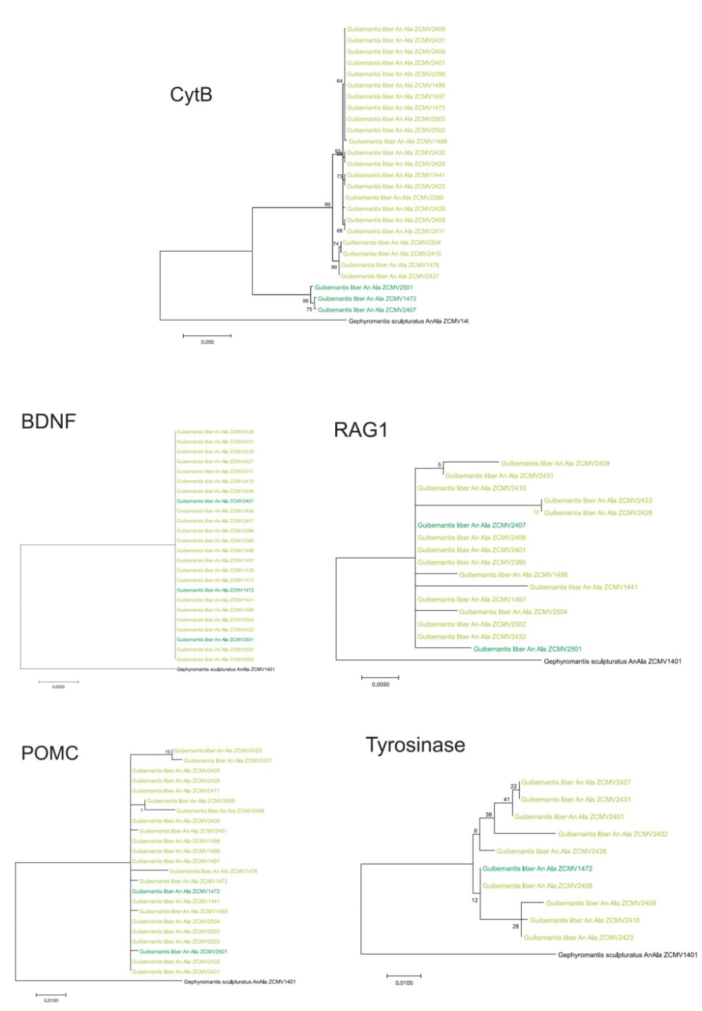

Figure S1. Maximum likelihood trees calculated from DNA sequences of fragments of the mitochondrial gene for cytochrome b, and from the phased allele sequences for four nuclear-encoded genes, for samples from An’Ala where mitochondrial haplotypes corresponding to the genetic lineages NCE1 and NCE2 occur in syntopy (as obvious from the cytochrome b tree). The four nuclear genes do not show any evidence of concordant differentiation of these two lineages at this site.

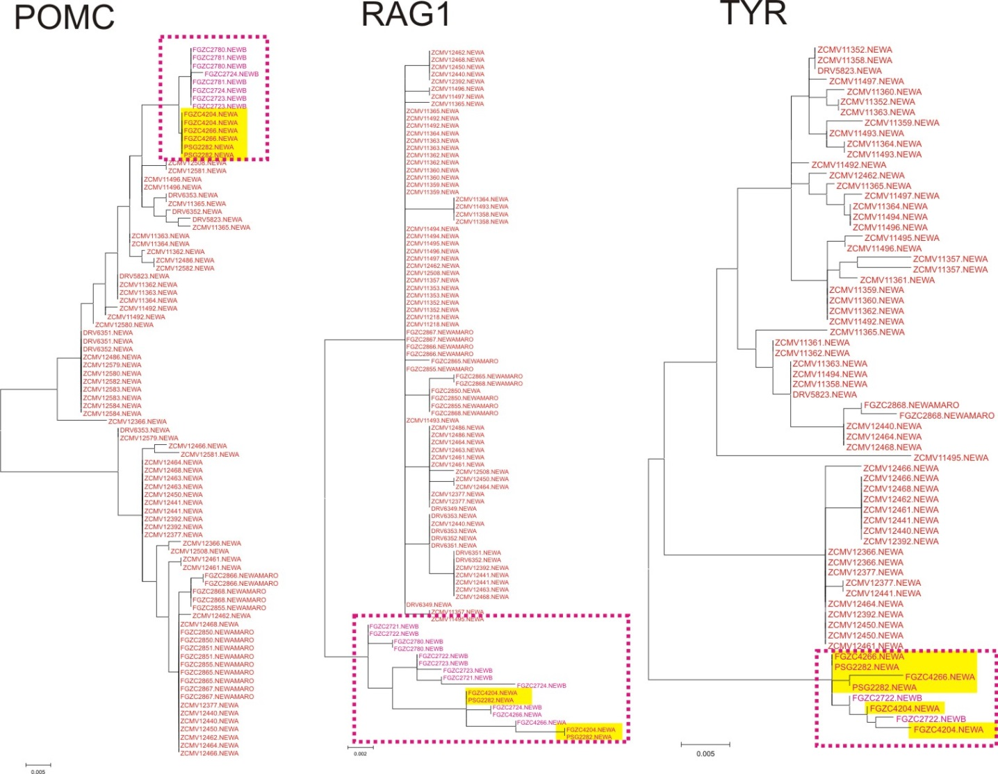

Figure S2. Maximum likelihood trees calculated from DNA sequences of fragments of three nuclear-encoded genes, for lineages NE1 (red) and NE2 (magenta; within box delimited by dotted line). The trees illustrates that samples from Ambodivoangy (highlighted yellow) are assigned to NE2 by the nuclear-encoded markers, suggesting they probably belong to this lineage (= G. fotsitenda), in agreement with their occurrence at low elevation, but possess an introgressed mitochondrial genome from NE1 and therefore cluster within NE1 in the mitochondrial tree (Fig. 1).

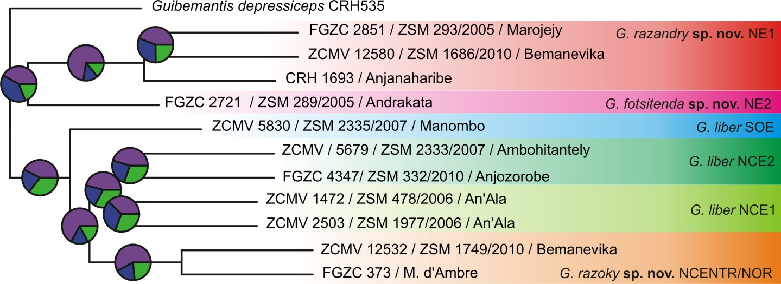

Figure S3. Species tree obtained with ASTRAL from gene trees of 12,951 nuclear-encoded markers. Pie charts represent the quartet score frequency i.e., the proportion of gene trees that support the different topologies. The biggest slice is the current topology and indicates how many gene trees support that topology compared to the others.

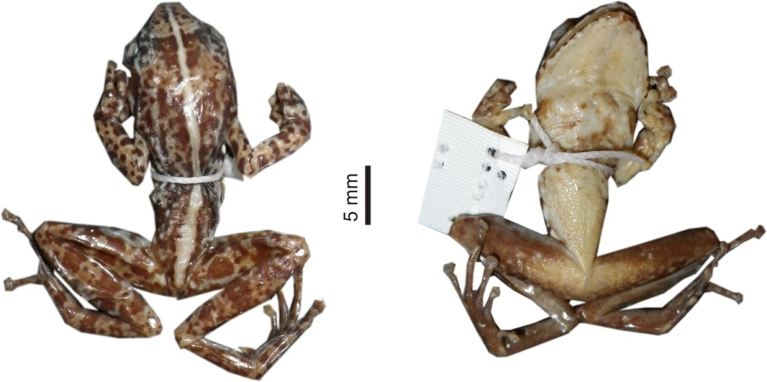

Figure S4. Dorsal (left) and ventral (right) views of the designated lectotype of Gephyromantis variabilis Millot and Guibe, 1951 (MNHN 1953.117) from Itremo.

