Supplementary File 2
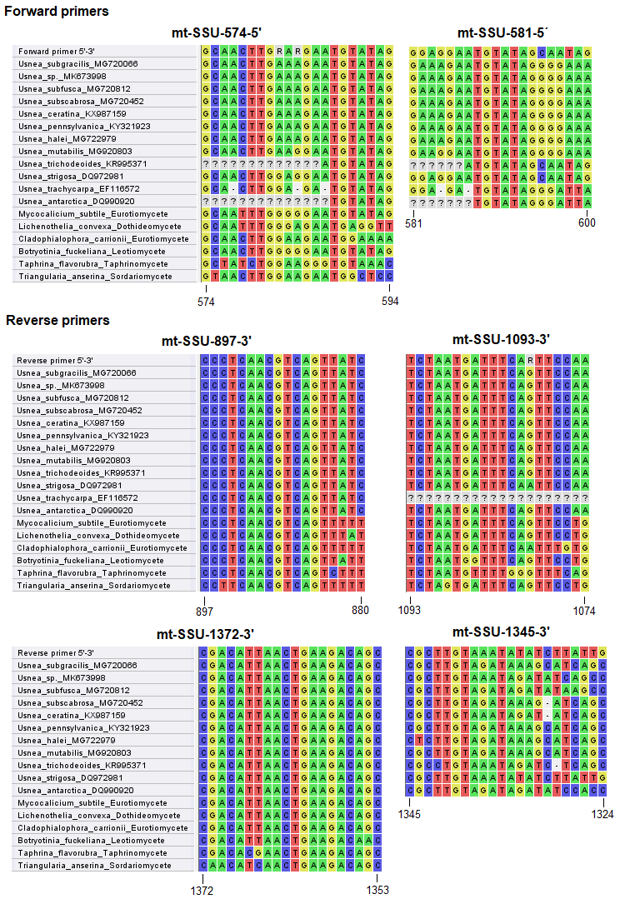

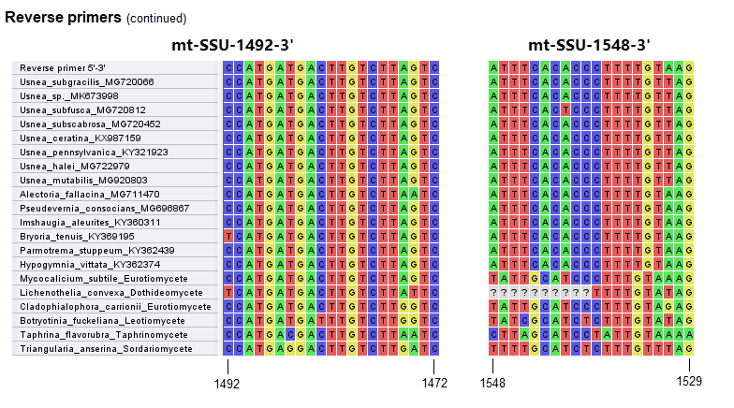Fig. S1. Sequence alignments at the priming sites for alternative primers. From the alignments, we show that our newly designed primer pair, mt-SSU-581-5’and mt-SSU-1345-3’, cannot reliably prime to the Usnea mycobiont sequences, especially at the 3’end, and we have to design alternatives primers to cope with PCR amplification. Supplementary File 3 should be consulted while selecting the reverse primers.

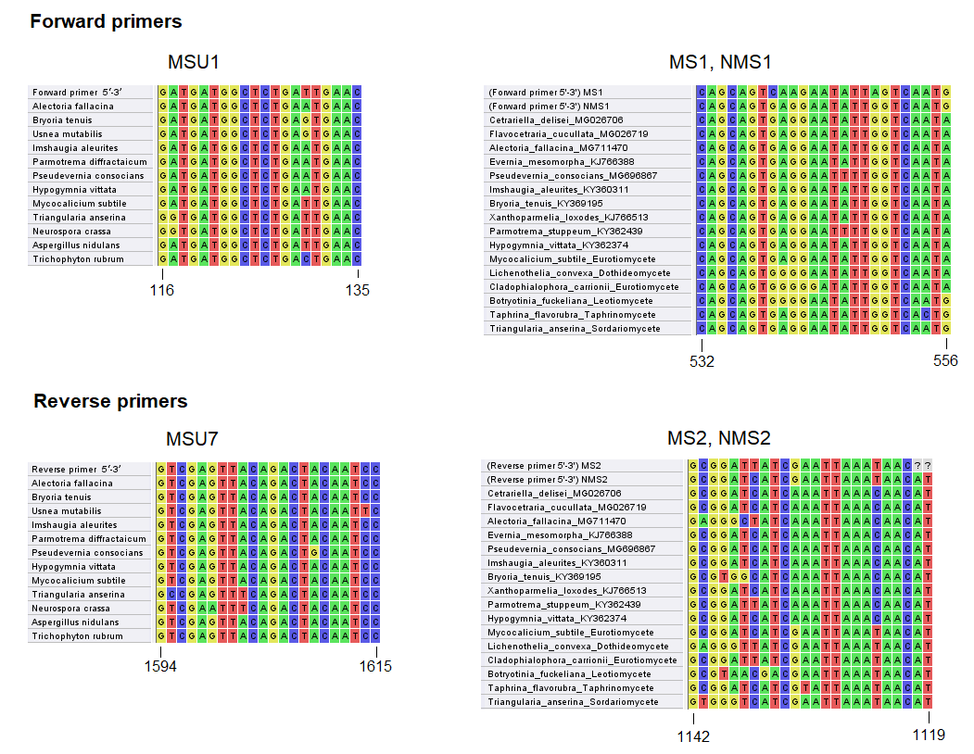
Fig. S2. Other published mtSSU primers and their alignments at primer binding sites.

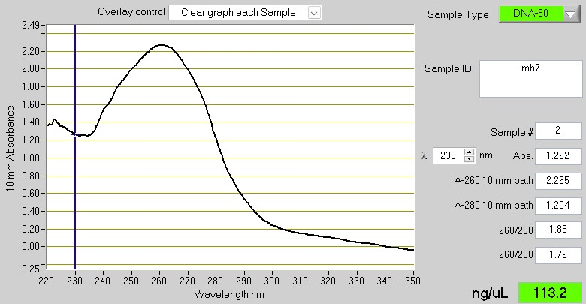
Fig. S3. Nanodrop results of the DNA extract from one Melanelia specimen which failed in obtaining PCR products. The low value of 260/230 = 1.79 indicates presence of contaminants which absorb at 230 nm. The value of 260/230 should be around 2.0 to 2.2 to be regarded as “pure”.
Table S1. Number of in silico PCR amplicons in each fungal family using the primer pair mrSSU1&mrSSU3R.
Family | Number | Family | Number | Family | Number
Nectriaceae | 589 | Hericiaceae | 5 | Ceratocystidaceae | 1
Aspergillaceae | 201 | Hymenochaetaceae | 5 | Cerrenaceae | 1
Trichocomaceae | 156 | Pertusariaceae | 5 | Chrysotrichaceae | 1
Graphidaceae | 79 | Pneumocystidaceae | 5 | Coccocarpiaceae | 1
Ophiocordycipitaceae | 69 | Pyriculariaceae | 5 | Coniothyriaceae | 1
Ophiostomataceae | 63 | Diaporthaceae | 4 | Corynesporascaceae | 1
Cordycipitaceae | 59 | Hypoxylaceae | 4 | Cryphonectriaceae | 1
Lecanoraceae | 48 | Ploettnerulaceae | 4 | Dothioraceae | 1
Hypocreaceae | 33 | Podosporaceae | 4 | Drepanopezizaceae | 1
Parmeliaceae | 33 | Vuilleminiaceae | 4 | Gnomoniaceae | 1
Polyporaceae | 29 | Agaricaceae | 3 | Gomphidiaceae | 1
Teloschistaceae | 27 | Boletaceae | 3 | Herpotrichiellaceae | 1
Cladoniaceae | 20 | Chaetomiaceae | 3 | Hygrophoraceae | 1
Clavicipitaceae | 19 | Cladosporiaceae | 3 | Hyphodiscaceae | 1
Glomerellaceae | 19 | Collemataceae | 3 | Massalongiaceae | 1
Erysiphaceae | 17 | Didymellaceae | 3 | Melanommataceae | 1
Lyophyllaceae | 17 | Icmadophilaceae | 3 | Microascaceae | 1
Omphalotaceae | 13 | Lichenotheliaceae | 3 | Mollisiaceae | 1
Botryosphaeriaceae | 12 | Pannariaceae | 3 | Monoblastiaceae | 1
Marasmiaceae | 11 | Phlyctidaceae | 3 | Morchellaceae | 1
Sclerotiniaceae | 10 | Pluteaceae | 3 | Mycocaliciaceae | 1
Tremellaceae | 10 | Taphrinaceae | 3 | Nephromataceae | 1
unknown | 10 | Tricholomataceae | 3 | Peltulaceae | 1
Arthrodermataceae | 9 | Tuberaceae | 3 | Peniophoraceae | 1
Lobariaceae | 9 | Bulleribasidiaceae | 2 | Phaeosphaeriaceae | 1
Orbiliaceae | 9 | Helotiaceae | 2 | Placynthiaceae | 1
Umbilicariaceae | 9 | Leptosphaeriaceae | 2 | Psoraceae | 1
Acarosporaceae | 8 | Opegraphaceae | 2 | Pyrenulaceae | 1
Sordariaceae | 8 | Pisolithaceae | 2 | Pyronemataceae | 1
Mycosphaerellaceae | 7 | Pseudeurotiaceae | 2 | Saccotheciaceae | 1
Peltigeraceae | 7 | Rhizopogonaceae | 2 | Sarocladiaceae | 1
Physciaceae | 7 | Roccellaceae | 2 | Schizoporaceae | 1
Plectosphaerellaceae | 7 | Sphaerophoraceae | 2 | Shiraiaceae | 1
Pleosporaceae | 7 | Stereocaulaceae | 2 | Sporocadaceae | 1
Ramalinaceae | 7 | Trypetheliaceae | 2 | Stictidaceae | 1
Russulaceae | 7 | Verrucariaceae | 2 | Suillaceae | 1
Trichosporonaceae | 7 | Apiosporaceae | 1 | Thelebolaceae | 1
Arthoniaceae | 6 | Astrosphaeriellaceae | 1 | Triblidiaceae | 1
Ajellomycetaceae | 5 | Auriculariaceae | 1 | Trichomeriaceae | 1
Amanitaceae | 5 | Boletinellaceae | 1 | Xylariaceae | 1
Bionectriaceae | 5 | Bondarzewiaceae | 1

