SUPPORTING INFORMATION
SI – I. Map of each variable that was used for the final model
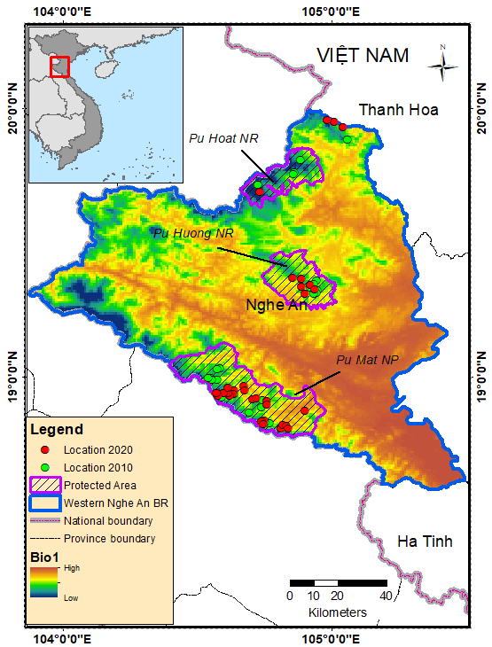 | 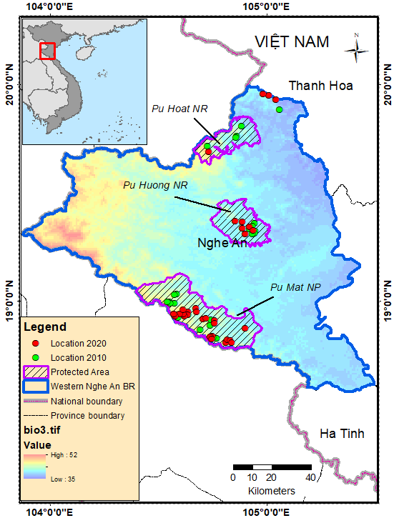
BIO1 = Annual Mean Temperature | BIO3 = Isothermality (BIO2/BIO7) (×100)
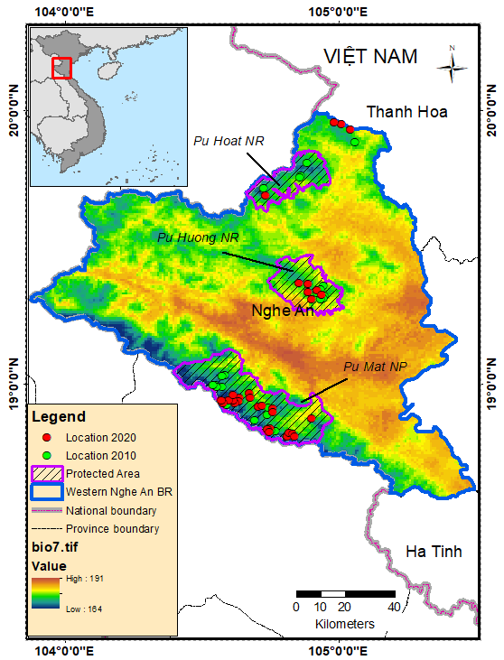 | 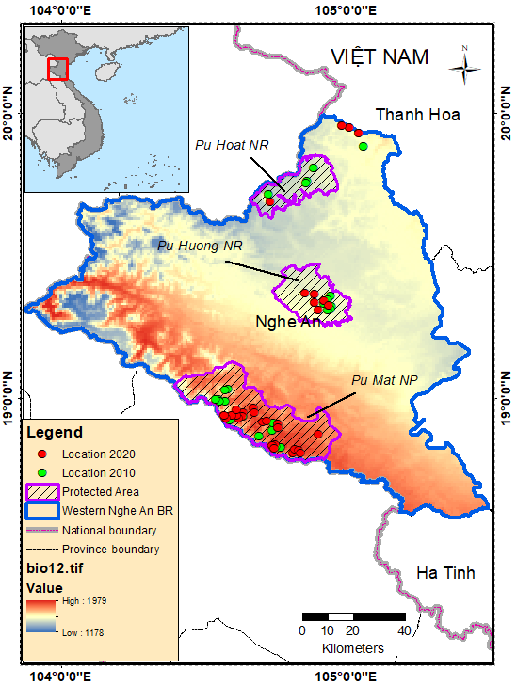
BIO7 = Temperature Annual Range | BIO12 = Annual Precipitation
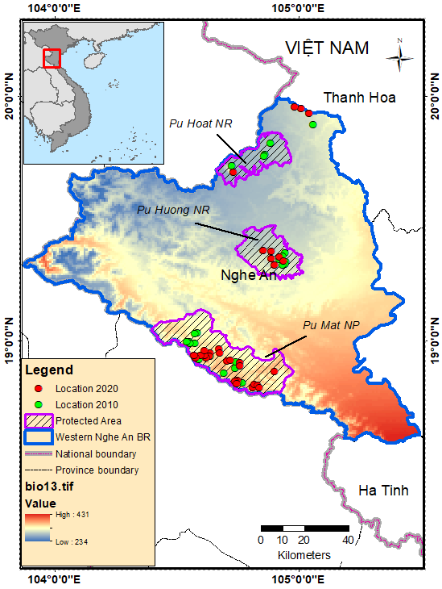 | 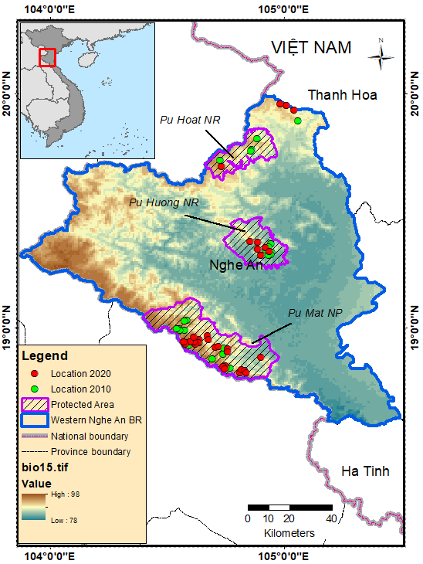
BIO13 = Precipitation of Wettest Month | BIO15 = Precipitation Seasonality (Coefficient of Variation)
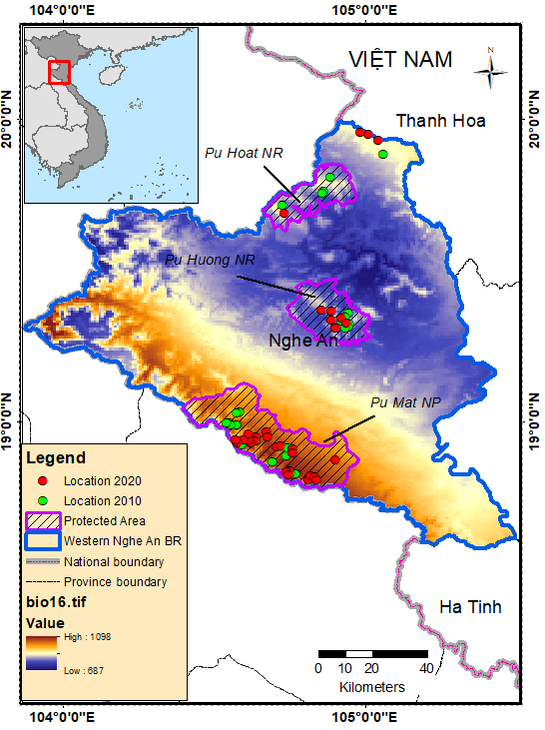 | 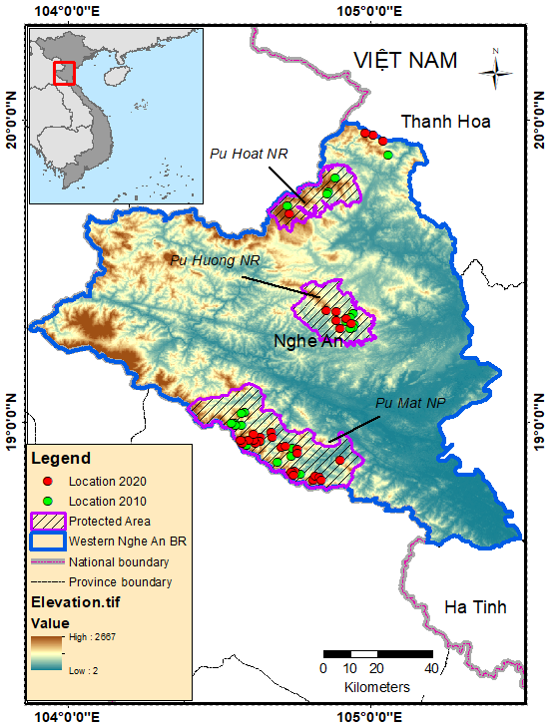
BIO16 = Precipitation of Wettest Quarter | Elevation
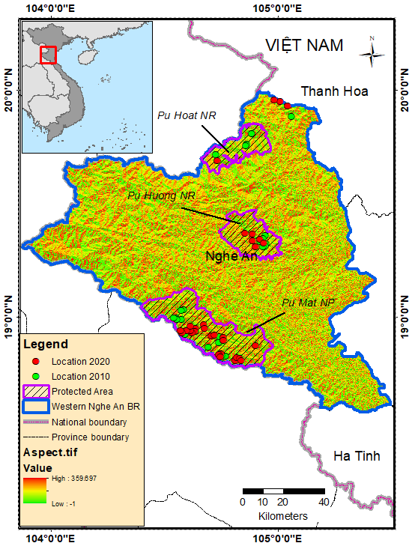 | 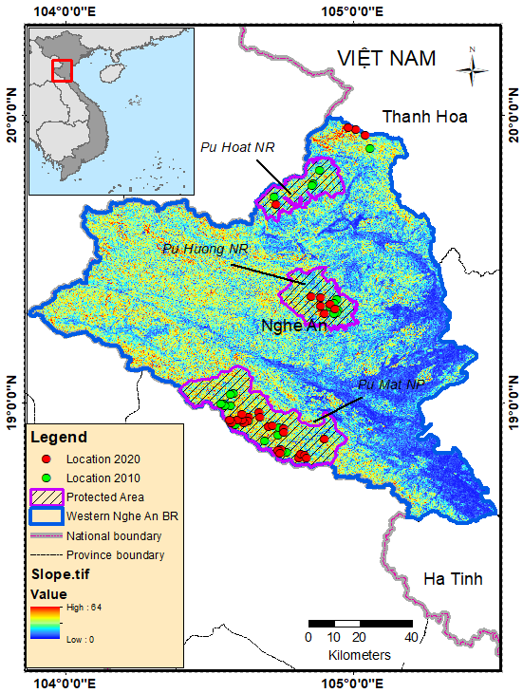
Aspect | Slope
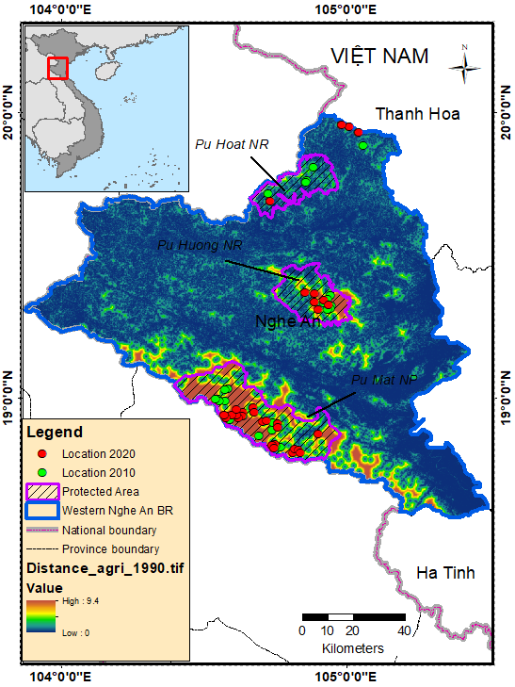 | 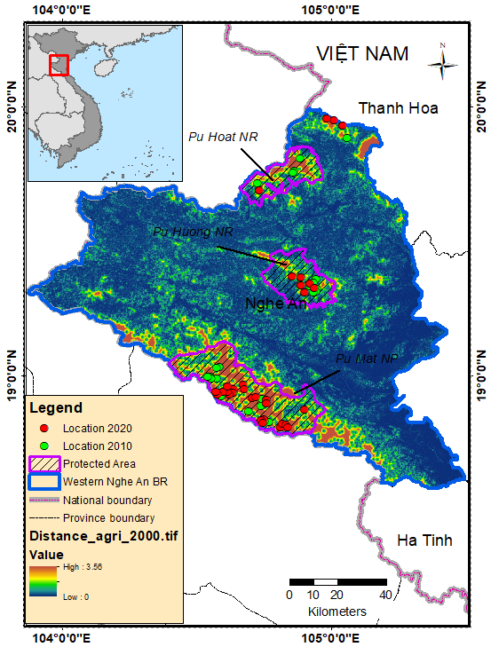
Distance to agricultural land in 1990 | Distance to agricultural land in 2000
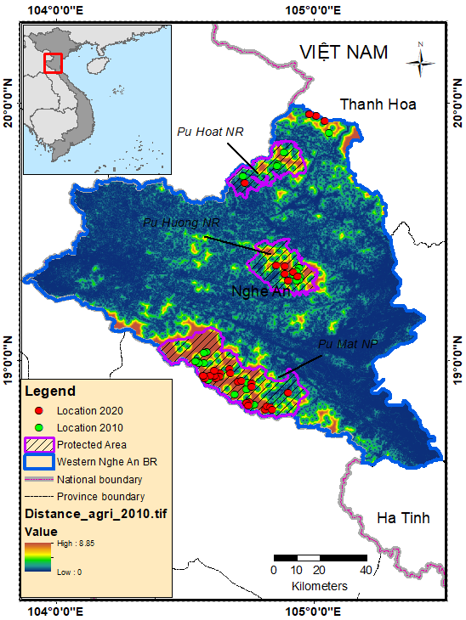 | 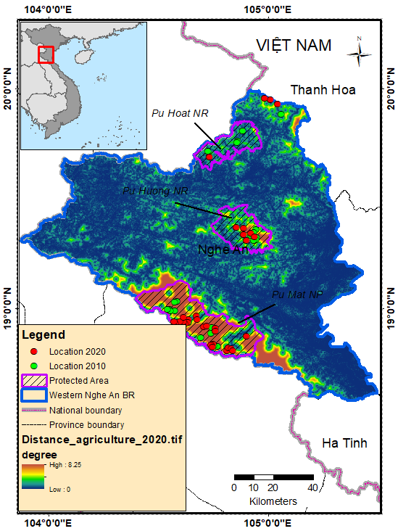
Distance to agricultural land in 2010 | Distance to agricultural land in 2020
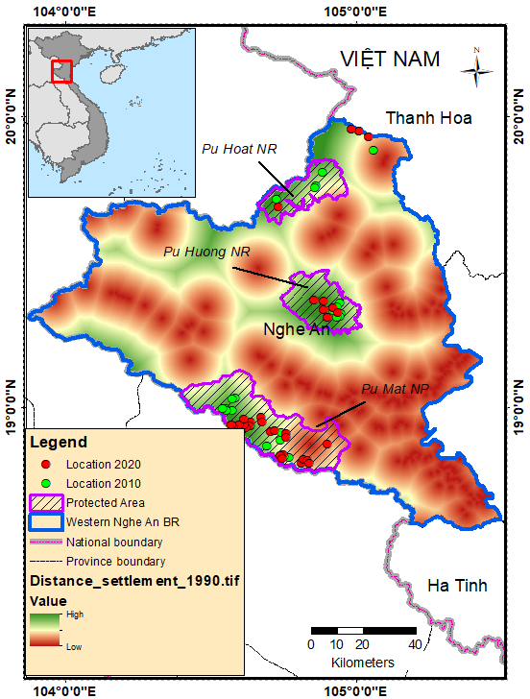 | 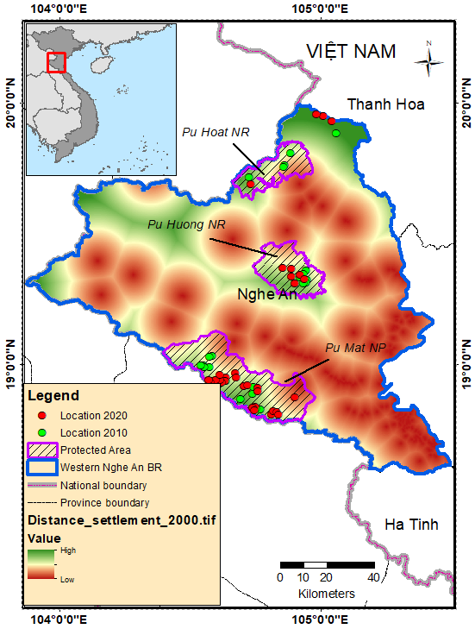
Distance to settlement in 1990 | Distance to settlement in 2000
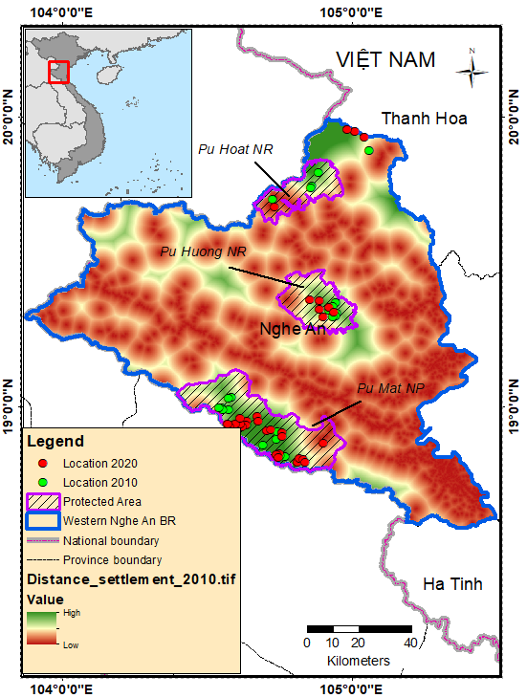 | 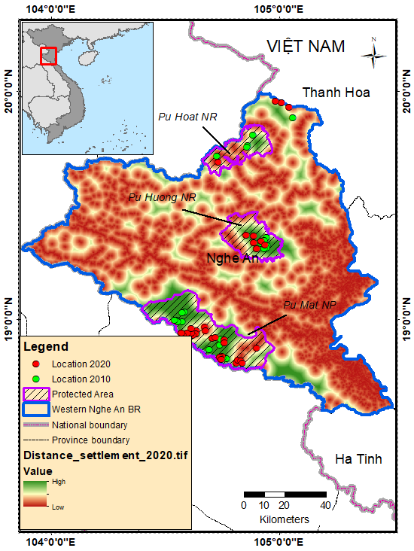
Distance to settlement in 2010 | Distance to settlement in 2020

SI-II. The percent contribution of environmental variables
No | Model 2010 |  | Model 2020
No | Variables | Percent contribution | Variables | Percent contribution
1 | Distance_agri | 55.4 | Distance_agri | 39.7
2 | Distance_settlement | 29.3 | Bio7 | 23.5
3 | elevation | 6.6 | Bio16 | 23.3
4 | landcover | 3.4 | Bio15 | 3.8
5 | bio1 | 2.2 | Bio3 | 3.4
6 | bio7 | 1.5 | Bio13 | 2.4
7 | aspect | 0.5 | Landcover | 1.5
8 | Bio15 | 0.3 | Distance_settlement | 1.1
9 | Slope | 0.3 | Elevation | 0.8
10 | Bio16 | 0.2 | Aspect | 0.3
11 | Bio13 | 0.2 | Bio12 | 0.2
12 | Bio3 | 0.1 | Bio1 | 0.1
13 | Bio12 | 0 | Slope | 0.1

SI-III. The suitable habitat of N. leucogenys were predicted from occurrence localities in 2020
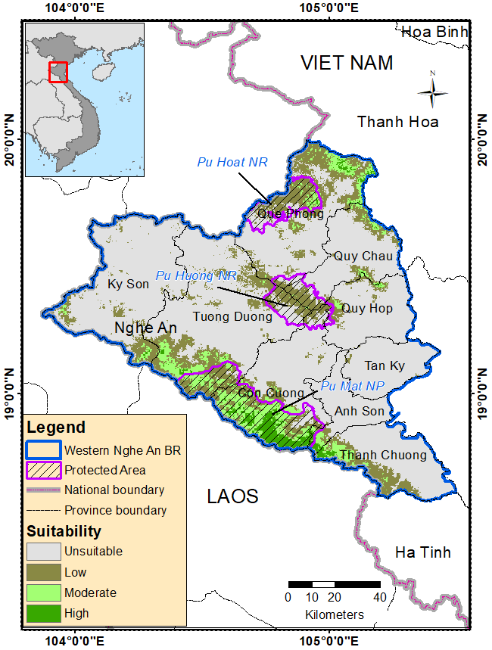  1990 | 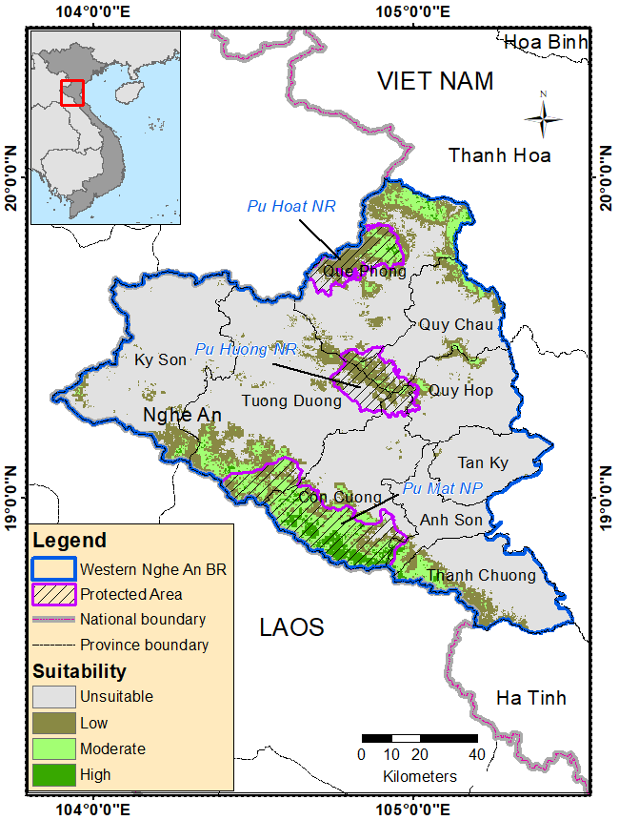  2000
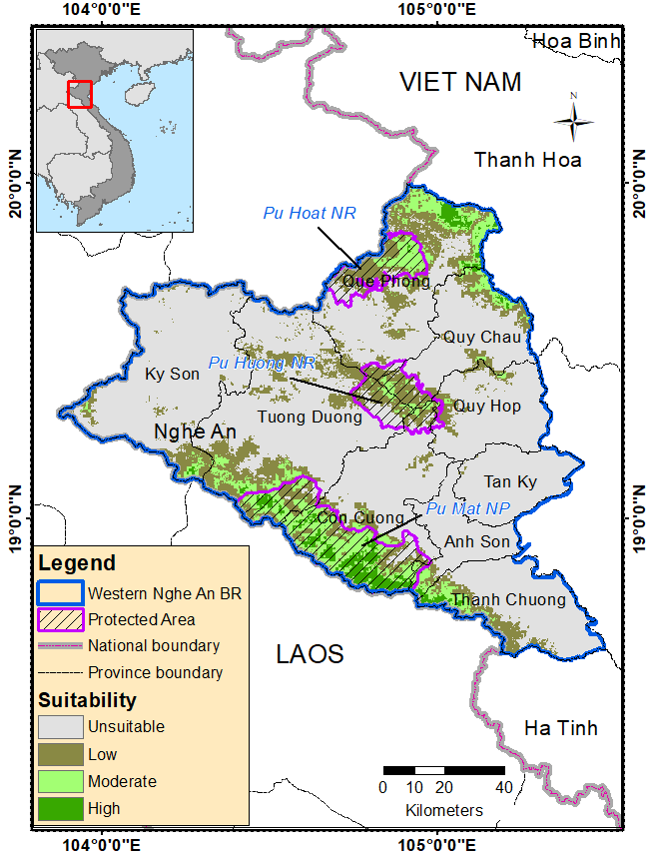  2010 | 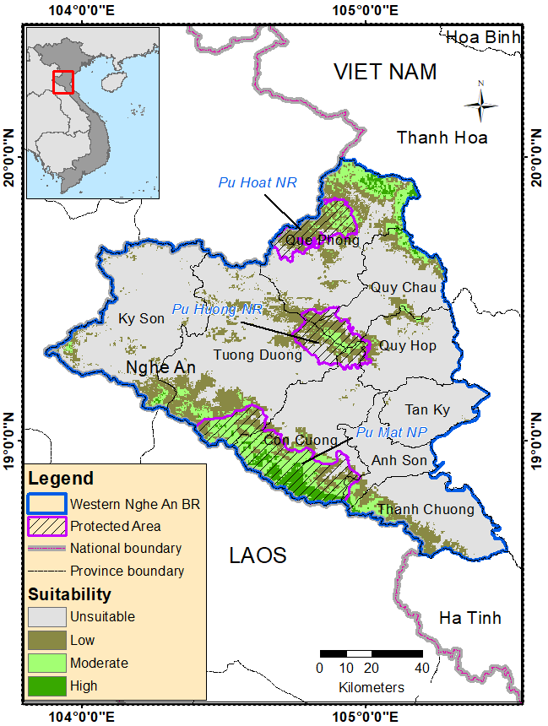  2020

SI-IV. Area of suitable habitat of N. leucogenys projected by MaxEnt model in 1990, 2000, 2010, 2020 from the model of 2020 (unit: km²)
Habitat suitability | Year
Habitat suitability | 1990 | 2000 | 2010 | 2020
Low | 2521.17 | 2132.61 | 2431.49 | 2488.18
Moderate | 941.28 | 1147.61 | 1194.10 | 1173.40
High | 327.40 | 263.83 | 381.79 | 360.84
Total | 3789.85 | 3544.05 | 4007.38 | 4022.42

