Supplementary Material

Genetic analyses reveal a complex introduction history of the globally invasive tree Acacia longifolia

Running title: Invasion genetics of Acacia longifolia

Sara Vicente^{1,2,3*} (0000-0002-8538-3586), Helena Trindade² (0000-0002-1209-2622), Cristina Máguas² (0000-0002-4396-7073), Johannes J. Le Roux³ (0000-0001-7911-9810)

¹Centro de Estudos do Ambiente e do Mar (CESAM), Faculdade de Ciências da Universidade de Lisboa, Campo Grande 1749-016, Lisboa, Portugal
²Centre for Ecology, Evolution and Environmental Changes (cE3c) & CHANGE - Global Change and Sustainability Institute, Faculdade de Ciências da Universidade de Lisboa, Campo Grande 1749-016, Lisboa, Portugal
³School of Natural Sciences, Macquarie University, North Ryde, NSW, Australia

Email addresses: sarafvicente@gmail.com (SV; *corresponding author); htrindade@fc.ul.pt (HT); cmhanson@fc.ul.pt (CM); jaco.leroux@mq.edu.au (JLR).

Figures

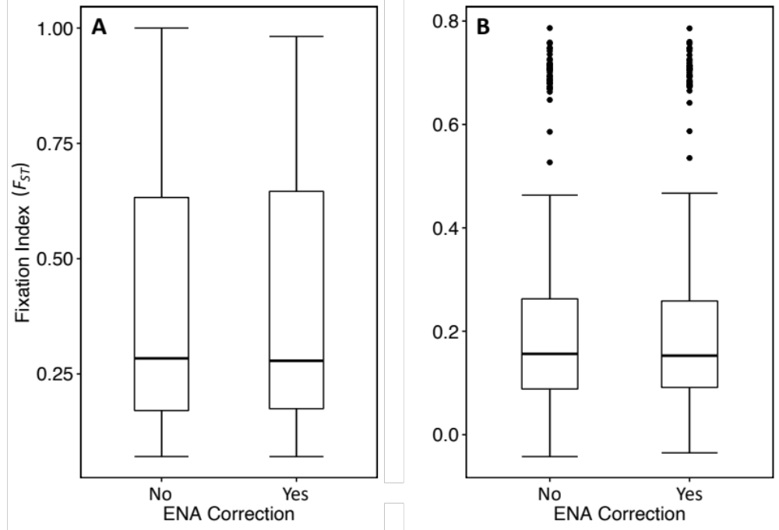
Figure S1. Comparison of the A) global fixation indexes over all loci and populations of Acacia longifolia, and B) pairwise fixation indexes, with and without the ENA correction (Chapuis and Estoup 2007). Mann-Whitney U test p > 0.05 for all comparisons.
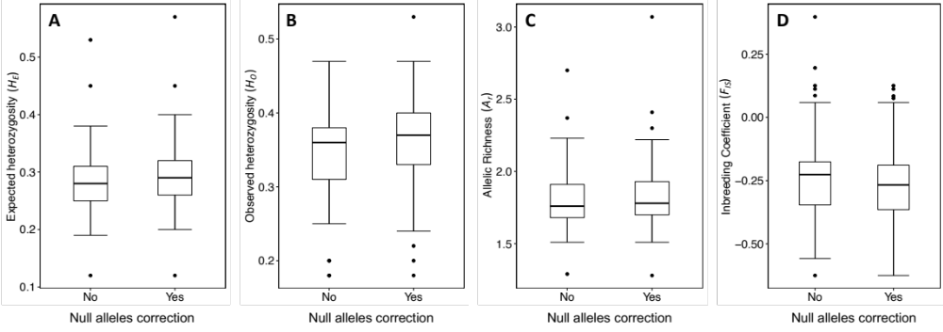
Figure S2. Comparisons of A) expected heterozygosity, B) observed heterozygosity, C) allelic richness, and D) inbreeding coefficent, using uncorrected and null allele-corrected datasets (Micro-Checker v2.2; Van Oosterhout et al. 2004). Mann-Whitney U test p > 0.05 for all comparisons.
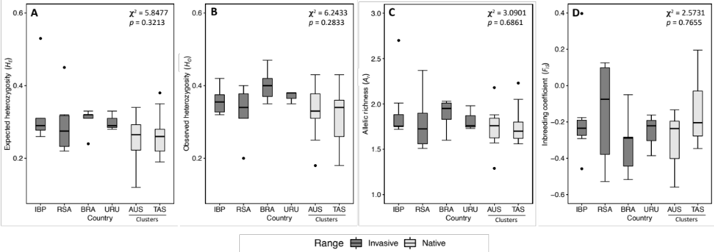

Figure S3. Box plots showing comparisons of expected heterozygosity (A), observed heterozygosity (B), allelic richness (C) and inbreeding coefficient (D) among Acacia longifolia populations from invaded countries (with populations from Portugal and Spain combined as Iberian Peninsula, IBP) and the two native range clusters identified by STRUCTURE analysis. Kruskal-Wallis test results are shown on the upper right corner, with 5 degrees of freedom.
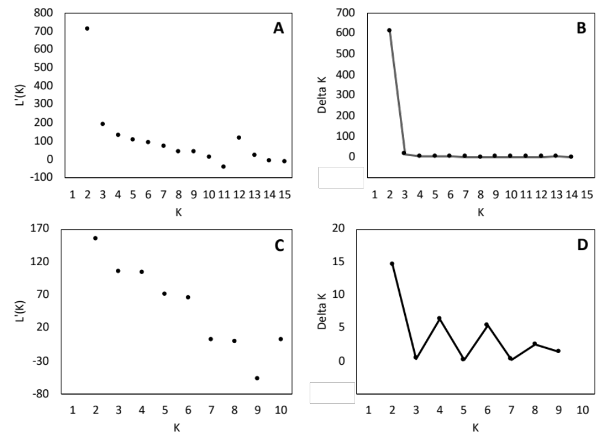

Figure S4. Likelihood distribution [LnP(K)] and Delta K plots (Evanno method; Evanno et al. 2005) from STRUCTURE HARVESTER analysis for A-B) the complete dataset, and C-D) further analysis of the largest cluster (indicated in blue in Fig. 6A in the main text) identified in the analysis of the complete dataset (hierarchical analysis), respectively.

Figure S5. STRUCTURE bar plots for K = 3 - 6 from the hierarchical analysis of the largest cluster from analysis of the complete dataset (indicated in blue in Fig. 6A in the main text).
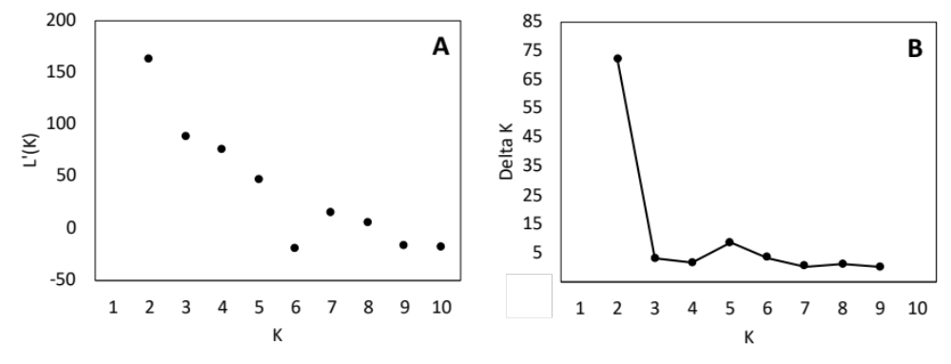
Figure S6. Results from the STRUCTURE HARVESTER analysis of the native range dataset. A) Likelihood distribution [LnP(K)] plot, and B) Delta K plot (Evanno method; Evanno et al. 2005).
Figure S7. STRUCTURE bar plots for K = 3 – 6 from the analysis of the native range data only.
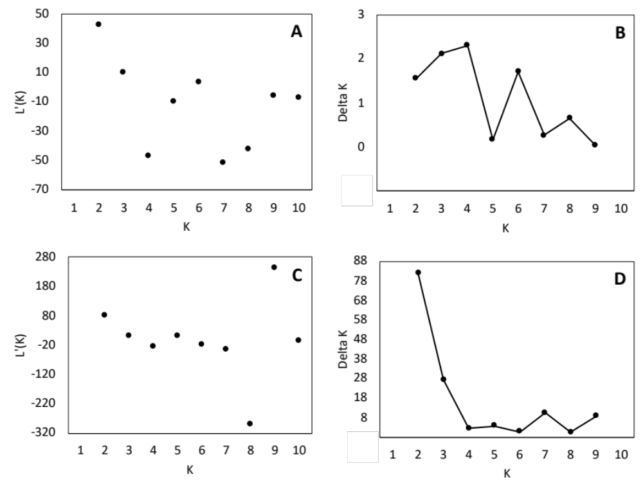
Figure S8. Likelihood distribution [LnP(K)] and Delta K plots (Evanno method; Evanno et al. 2005) from STRUCTURE HARVESTER analysis for A-B) mainland Australia data, and C-D) Tasmania data, respectively.
Figure S9. STRUCTURE bar plots for K = 2 – 6 (except K = 4) from the analysis of the mainland Australia data only.
Figure S10. STRUCTURE bar plots for K = 3 – 6 from the analysis of the Tasmania data only.
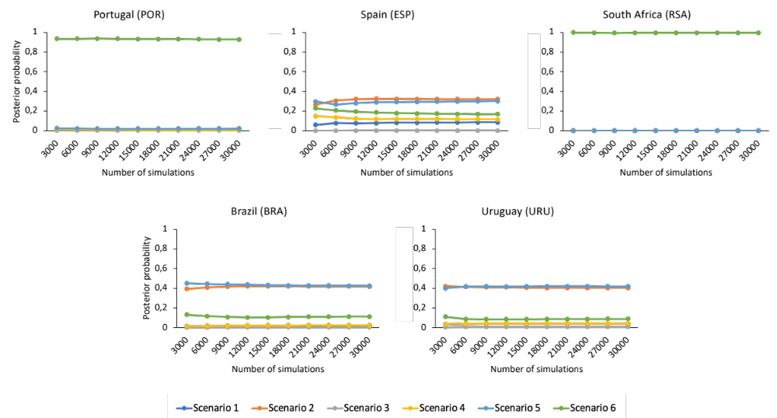

Figure S11. Posterior probabilities of the six tested scenarios by invaded country.
Tables

Table S1. Details of microsatellite primers tested for cross-amplification in Acacia longifolia.
Locus | Primer sequence (5'-3') | References
Chloroplast microsatellites (cpSSRS)
ccmp1 | Fw: CAGGTAAACTTCTCAACGGA | Weising & Gardner (1999)
ccmp1 | Rv: CCGAAGTCAAAAGAGCGATT | Weising & Gardner (1999)
ccmp2 | Fw: GATCCCGGACGTAATCCTG | Weising & Gardner (1999)
ccmp2 | Rv: ATCGTACCGAGGGTTCGAAT | Weising & Gardner (1999)
ccmp3* | Fw: CAGACCAAAAGCTGACATAG | Weising & Gardner (1999)
ccmp3* | Rv: GTTTCATTCGGCTCCTTTAT | Weising & Gardner (1999)
ccmp4* | Fw: AATGCTGAATCGAYGACCTA | Weising & Gardner (1999)
ccmp4* | Rv: CCAAAATATTBGGAGGACTCT | Weising & Gardner (1999)
ccmp5* | Fw: TGTTCCAATATCTTCTTGTCATTT | Weising & Gardner (1999)
ccmp5* | Rv: AGGTTCCATCGGAACAATTAT | Weising & Gardner (1999)
ccmp6 | Fw: CGATGCATATGTAGAAAGCC | Weising & Gardner (1999)
ccmp6 | Rv: CATTACGTGCGACTATCTCC | Weising & Gardner (1999)
ccmp7* | Fw: CAACATATACCACTGTCAAG | Weising & Gardner (1999)
ccmp7* | Rv: ACATCATTATTGTATACTCTTTC | Weising & Gardner (1999)
ccmp8 | Fw: TTGGCTACTCTAACCTTCCC | Weising & Gardner (1999)
ccmp8 | Rv: TTCTTTCTTATTTCGCAGDGAA | Weising & Gardner (1999)
ccmp9 | Fw: GGATTTGTACATATAGGACA | Weising & Gardner (1999)
ccmp9 | Rv: CTCAACTCTAAGAAATACTTG | Weising & Gardner (1999)
ccmp10 | Fw: TTTTTTTTTAGTGAACGTGTCA | Weising & Gardner (1999)
ccmp10 | Rv: TTCGTCGDCGTAGTAAATAG | Weising & Gardner (1999)
Nuclear microsatellites (SSRs)
DCLOC† | Fw: CAACTTGTGATTAAAGTCCACGG | Roberts et al. (2013)
DCLOC† | Rv: TGTGTTGAGACTTTGTGCTG | Roberts et al. (2013)
C51M0* | Fw: CTGCAAATCGTTTCTTCAAGCC | Forrest et al. (2015)
C51M0* | Rv: ACAGAAATGAGCATGACCCC | Forrest et al. (2015)
Am030* | Fw: GAGGTAATATTTTGAATTCCTTGAAC | Butcher et al. (2000)
Am030* | Rv: GGTGTATACCTCTTTCCTGTGG | Butcher et al. (2000)
Am502* | Fw: CAAATGGCCAAGTTACGACTG | Butcher et al. (2000)
Am502* | Rv: TTCTGGTAATCCAAACTTATGTGG | Butcher et al. (2000)
Am352 | Fw: CCTCATGTCCTTGAATGTCAC | Butcher et al. (2000)
Am352 | Rv: GACTAACCCACAAGGAAGAGTTAC | Butcher et al. (2000)
Am387 | Fw: TGATACAAGGGAAGACAGAGTGG | Butcher et al. (2000)
Am387 | Rv: CCAACTCAAAACCTGACAACG | Butcher et al. (2000)
Am429 | Fw: CCTTCTTCTCTCATCTACCAAACC | Butcher et al. (2000)
Am429 | Rv: CCCACATCATCACTCACAACT | Butcher et al. (2000)
Plop4 | Fw: AAACCAAGGTCTTCTCTGCTTC | Brown & Gardner (2011)
Plop4 | Rv: ACTCCCTCTCTTTCCATCTCT | Brown & Gardner (2011)
Plo18 | Fw: ATTGAAGCTGCCCTCACATT | Brown & Gardner (2011)
Plo18 | Rv: TGTTCGGCCTCTTCTTTCTC | Brown & Gardner (2011)
Ad-33 | Fw: GAGAAGAGAAAGGGGATGGG | Guillemaud et al. (2015)
Ad-33 | Rv: CCATCATTATTGTTTGTCCCG | Guillemaud et al. (2015)
Saucerful/Secrets | Fw: GTAGTTGAGCTGGTTTCCGC | Unpublished data
Saucerful/Secrets | Rv: TGCTGATGCCTTCTTTCAGC | Unpublished data
Atomheart/Mother | Fw: CCCTCCAGCTGATAGTTCCC | Unpublished data
Atomheart/Mother | Rv: GCTATCGTGACGGCATGTG | Unpublished data
Division/Bell* | Fw: ATCACTTCTACACGCCCTCC | Unpublished data
Division/Bell* | Rv: CCACCACATGCTACACCAAC | Unpublished data
Umma/Gumma | Fw: TGGCGATCGATGAGCTTCTG | Unpublished data
Umma/Gumma | Rv: GCTGTTGTTGCTGTAGGACG | Unpublished data
The/Wall* | Fw: TGACATACCACGACCAGTCC | Unpublished data
The/Wall* | Rv: AGATCGGCCAGTACACTTCG | Unpublished data
Locus | Primer sequence (5'-3') | References
Keep/Talking | Fw: CGAACTGATCAAGGCGATGG | Unpublished data
Keep/Talking | Rv: ATCGTTTTTGGCGTCGTAGC | Unpublished data
Darkside/Moon | Fw: GCCTTGGCTTCTTTCAGACC | Unpublished data
Darkside/Moon | Rv: TGGTACCCCATCACCTTCAC | Unpublished data
Animals/Meddle | Fw: ACGTTCACTTTCTTGTCGCC | Unpublished data
Animals/Meddle | Rv: CGAACTGATCAAGGCGATGG | Unpublished data
Obscured/Clouds | Fw: GAACATGATGAACGCCGAGG | Unpublished data
Obscured/Clouds | Rv: GTAGTTGAGCTGGTTTCCGC | Unpublished data
Astronomy/Domine | Fw: ATGTCGAGCAGGTCGGTG | Unpublished data
Astronomy/Domine | Rv: CTGCGGTTTTACCTTCGGTG | Unpublished data
Pulse/Echoes | Fw: CTGCTTCGTTGAGTTGGTCG | Unpublished data
Pulse/Echoes | Rv: ACGTAGAGATCGCCTGGAAC | Unpublished data
Arnold/Layne | Fw: TCTACCAGCGAATCCACCAG | Unpublished data
Arnold/Layne | Rv: GTGGTCGAACTGATCAAGGC | Unpublished data
AH2-1 | Fw: GACAGAGGGAGCATTTTGTA | Aggarwal et al. (2011), Bairu et al. (2020)
AH2-1 | Rv: CAGACAAGACCAGAGAATGAC | Aggarwal et al. (2011), Bairu et al. (2020)
AH2-13 | Fw: GAAGAAGCAGGAGGAGGTAG | Aggarwal et al. (2011), Bairu et al. (2020)
AH2-13 | Rv: TGTTTTCCACTTCTCACACA | Aggarwal et al. (2011), Bairu et al. (2020)
AH3-1* | Fw: CTAAGGCACTTGGATCATTC | Aggarwal et al. (2011), Bairu et al. (2020)
AH3-1* | Rv: AGAGAGAGAGAGGCACACTG | Aggarwal et al. (2011), Bairu et al. (2020)
AH3-10* | Fw: AGGGATATCGGATGCTTACT | Aggarwal et al. (2011), Bairu et al. (2020)
AH3-10* | Rv: AAAGATGCAGCAGACCTATC | Aggarwal et al. (2011), Bairu et al. (2020)
AH3-18 | Fw: TGAGACAATTAATGGTGGTG | Aggarwal et al. (2011), Bairu et al. (2020)
AH3-18 | Rv: TTTACAAGGGAAAAGCTGAG | Aggarwal et al. (2011), Bairu et al. (2020)
Ak15* | Fw: CACCCCCACGTTATCTTACA | Adamski et al. (2013), Bairu et al. (2020)
Ak15* | Rv: GACTGGCGAAAGAGTCGAA | Adamski et al. (2013), Bairu et al. (2020)
Ak89* | Fw: AGGGGAAGGACGAAAGTTGT | Adamski et al. (2013), Bairu et al. (2020)
Ak89* | Rv: GCAAGAGGAGCTTCAAGTGG | Adamski et al. (2013), Bairu et al. (2020)
AH01 | Fw: TTGAGGTTGAGGGTGATGAA | Ng et al. (2005), Bairu et al. (2020)
AH01 | Rv: GGCAAGCCTCTCTCTCTCT | Ng et al. (2005), Bairu et al. (2020)
AH16* | Fw: GAGGGTAATGCTTCAAGTAGAC | Ng et al. (2005), Bairu et al. (2020)
AH16* | Rv: TGCGTGTCTCCCCACTACTC | Ng et al. (2005), Bairu et al. (2020)
AH56 | Fw: GATAGCTCATAGAAACACCATACC | Ng et al. (2005), Bairu et al. (2020)
AH56 | Rv: GGCGAAGCTCTCTCTCTCTCTCTCTCT | Ng et al. (2005), Bairu et al. (2020)
Am465* | Fw: TGGGTATCACTTCCACCATT | Butcher et al. (2000), Bairu et al. (2020)
Am465* | Rv: AGGCTGCTTCTTTGTGCAGG | Butcher et al. (2000), Bairu et al. (2020)
*Markers selected for analysis with A. longifolia
†Previously tested and selected for analysis with A. longifolia in (Vicente et al. 2018).

Table S2. Primers selected for cpSSRs and SSRs analyses and their corresponding repeat motifs, identified alleles, fluorescent dye labels used, PCR conditions (annealing temperature and concentration of magnesium chloride).
Locus | Primer | Sequence (5'-3') | Repeat Motif | Alleles | Dye | T_{annealing} (°C) | [MgCl₂] (mM) | Reference
Chloroplast microsatellites (cpSSRS)
ccmp3 | Fw | CAGACCAAAAGCTGACATAG | (T)₁₁ | 93, 94 | 6FAM | 52 | 2.5 | Weising & Gardner (1999)
ccmp3 | Rv | GTTTCATTCGGCTCCTTTAT
ccmp4 | Fw | AATGCTGAATCGAYGACCTA | (T)₁₃ | 107, 110 | HEX | 52 | 2.5 | Weising & Gardner (1999)
ccmp4 | Rv | CCAAAATATTBGGAGGACTCT
ccmp5 | Fw | TGTTCCAATATCTTCTTGTCATTT | (C)₇(T)₁₀, (T)₅C(A)₁₁ | 118, 119, 120 | 6FAM | 52 | 2.5 | Weising & Gardner (1999)
ccmp5 | Rv | AGGTTCCATCGGAACAATTAT
ccmp7 | Fw | CAACATATACCACTGTCAAG | (A)₁₃ | 147, 148, 154 | HEX | 52 | 2.5 | Weising & Gardner (1999)
ccmp7 | Rv | ACATCATTATTGTATACTCTTTC
Nuclear microsatellites (SSRs)
DCLOC | Fw | CAACTTGTGATTAAAGTCCACGG | (CT)₁₁ | 98, 102, 108, 112, 114, 116 | HEX | 59 | 2 | Roberts et al. (2013); Vicente et al. (2018)
DCLOC | Rv | TGTGTTGAGACTTTGTGCTG
Am502 | Fw | CAAATGGCCAAGTTACGACTG | (TTC)₃-(GGA)₈, AGA(GGA)₂ | 99, 117, 126, 129, 132, 135, 138, 144 | ATTO-550 | 60 | 1.5 | Butcher et al. (2000)
Am502 | Rv | TTCTGGTAATCCAAACTTATGTGG
Division/Bell | Fw | ATCACTTCTACACGCCCTCC | (TCC)₅ | 136, 142,151, 154 | HEX | 55 | 1.5 | Unpublished data
Division/Bell | Rv | CCACCACATGCTACACCAAC
The/Wall | Fw | TGACATACCACGACCAGTCC | (GGT)₅ | 142, 193 | 6FAM | 52 | 1.5 | Unpublished data
The/Wall | Rv | AGATCGGCCAGTACACTTCG
C51M0 | Fw | CTGCAAATCGTTTCTTCAAGCC | (CTTT)₆ | 131, 135, 143 | HEX | 60 | 1.5 | Forrest et al. (2015)
C51M0 | Rv | ACAGAAATGAGCATGACCCC
Am030 | Fw | GAGGTAATATTTTGAATTCCTTGAAC | (AT)₉(GT)₁₅ | 81, 87 | 6FAM | 60 | 1.5 | Butcher et al. (2000)
Am030 | Rv | GGTGTATACCTCTTTCCTGTGG
Locus | Primer | Sequence (5'-3') | Repeat Motif | Alleles | Dye | T_{annealing} (°C) | [MgCl₂] (mM) | Reference
Ak89 | Fw | AGGGGAAGGACGAAAGTTGT | (AC)₇ | 156, 158, 160, 162, 164, 166, 176 | 6FAM | 60 | 2.5 | Adamski et al. (2013), Bairu et al. (2020)
Ak89 | Rv | GCAAGAGGAGCTTCAAGTGG
Ak15 | Fw | CACCCCCACGTTATCTTACA | (TAT)₅  (Behaves as dinucleotide) | 292, 300, 310, 312, 314, 316, 318, 326, 328 | 6FAM | 60 | 2.5 | Adamski et al. (2013), Bairu et al. (2020)
Ak15 | Rv | GACTGGCGAAAGAGTCGAA
AH16 | Fw | GAGGGTAATGCTTCAAGTAGAC | (GA)₁₆ | 82, 84, 86 | HEX | 60 | 2.5 | Ng et al. (2005), Bairu et al. (2020)
AH16 | Rv | TGCGTGTCTCCCCACTACTC
Am465 | Fw | TGGGTATCACTTCCACCATT | (AC)₂₃ | 104, 106, 136, 144, 146, 152, 154, 156, 162 | HEX | 60 | 2.5 | Butcher et al. (2000)
Am465 | Rv | AGGCTGCTTCTTTGTGCAGG
AH3-10 | Fw | AGGGATATCGGATGCTTACT | (GAT)₇ | 178, 181, 187, 190, 202, 232 | HEX | 60 | 2.5 | Aggarwal et al. (2011), Bairu et al. (2020)
AH3-10 | Rv | AAAGATGCAGCAGACCTATC
AH3-1 | Fw | CTAAGGCACTTGGATCATTC | (TCT)₅ | 217, 220 | 6FAM | 60 | 2.5 | Aggarwal et al. (2011), Bairu et al. (2020)
AH3-1 | Rv | AGAGAGAGAGAGGCACACTG

Table S3. Descriptions of parameters included in the ABC analyses.

Parameter | Description
Effective population sizes
N_{Ancestral} | Native ancestral population (unsampled)
N_{AUS} | Mainland Australia population
N_{TAS} | Tasmanian population
N_{Ghost1}, N_{Ghost2} | Two unsampled “ghost” populations (scenarios 4 & 5)
N_{INV} | Invasive population
Time of events (generations)
t_{NAT} | Split of the mainland Australia and Tasmanian populations from the ancestral population
t_{AUS} | Split of the mainland Australia population from the ancestral population (scenario 6)
t_{TAS} | Split of the Tasmanian population from the ancestral population (scenario 6)
t_{Ghost1}, t_{Ghost2} | Introduction of the two unsampled “ghost” populations to non-native range (scenarios 4 & 5)
t_{Inv} | Introduction of the invasive population to non-native range
Admixture rate
ra | Rate of admixture (scenarios 3, 4 & 5)
Mutation rates
Âμmic | Microsatellite mean mutation rate
pmic | Microsatellite mean coefficient P
snimic | Microsatellite mean SNI rate

Table S4. Prior and posterior values of parameters for Scenario 6 of ABC analyses, selected as the best scenario for Portugal (POR) and South Africa (RSA).

 |  |  | Portugal (POR) |  |  |  |  | South Africa (RSA)
Scenario 6 |  |  | Posterior |  |  |  |  | Posterior
Parameter | Distribution | Prior (min-max) | Mean | Q_{0.025} | Q_{0.975} | RMedAD | MedRB | Mean | Q_{0.025} | Q_{0.975} | RMedAD | MedRB
Effective population sizes
N_{Ancestral} | Uniform | 10 – 10 000 | 7280 | 3380 | 9830 | 0.227 | -0.078 | 7650 | 3760 | 9880 | 0.222 | -0.133
N_{AUS} | Uniform | 10 – 10 000 | 6660 | 2540 | 9790 | 0.262 | -0.009 | 5760 | 1810 | 9600 | 0.290 | 0.041
N_{TAS} | Uniform | 10 – 10 000 | 3740 | 620 | 9170 | 0.506 | 0.368 | 4090 | 888 | 9100 | 0.449 | 0.134
N_{INV} | Uniform | 10 – 10 000 | 6690 | 1170 | 9910 | 0.432 | -0.245 | 4350 | 375 | 9700 | 0.623 | 0.361
Time of events (generations)
t_{AUS} | Uniform | 10 – 10 000 | 1120 | 178 | 4580 | 0.453 | 0.372 | 1740 | 269 | 6170 | 0.424 | 0.239
t_{TAS} | Uniform | 10 – 10 000 | 534 | 94 | 1450 | 0.559 | 0.042 | 1470 | 284 | 3610 | 0.427 | -0.050
t_{Inv} | Uniform | 10 – * | 34.1 | 11 | 59.5 | 0.408 | 0.066 | 53.4 | 12.2 | 93.8 | 0.431 | -0.044
Mutation rates
Âμmic | Log-uniform | 10⁻⁶ - 10⁻³ | 3.43 x 10⁻⁵ | 1.14 x 10⁻⁵ | 8.60 x 10⁻⁵ | 0.388 | 0.288 | 4.98 x 10⁻⁵ | 1.60 x 10⁻⁵ | 1.24 x 10⁻⁴ | 0.363 | 0.210
pmic | Uniform | 0.1 - 0.3 | 0.278 | 0.187 | 0.300 | 0.222 | -0.215 | 0.279 | 0.199 | 0.300 | 0.181 | -0.185
snimic | Gamma | 10⁻⁷ - 10⁻³ | 2.60 x 10⁻⁶ | 1.00 x 10⁻⁷ | 1.30 x 10⁻⁵ | 0.727 | 0.083 | 1.19 x 10⁻⁶ | 1.00 x 10⁻⁷ | 6.06 x 10⁻⁶ | 0.725 | 0.812
Prior rules
t_{AUS} ≥ t_{TAS}, t_{AUS} > t_{Inv}, t_{TAS} > t_{Inv}
*POR = 61; RSA = 96

Table S5. Prior and posterior values of parameters for A) Scenario 2 and B) Scenario 5 of ABC analyses, selected as the best scenarios for Brazil (BRA) and Uruguay (URU).

S5A |  |  | Brazil (BRA) |  |  |  |  | Uruguay (URU)
Scenario 2 |  |  | Posterior |  |  |  |  | Posterior
Parameter | Distribution | Prior (min-max) | Mean | Q_{0.025} | Q_{0.975} | RMedAD | MedRB | Mean | Q_{0.025} | Q_{0.975} | RMedAD | MedRB
Effective population sizes
N_{Ancestral} | Uniform | 10 – 10 000 | 4300 | 456 | 9390 | 0.584 | 0.255 | 3790 | 340 | 9290 | 0.666 | 0.470
N_{AUS} | Uniform | 10 – 10 000 | 5870 | 1460 | 9710 | 0.361 | 0.143 | 4970 | 971 | 9540 | 0.446 | 0.310
N_{TAS} | Uniform | 10 – 10 000 | 3340 | 440 | 8680 | 0.627 | 0,583 | 2740 | 316 | 8380 | 0.908 | 1.049
N_{INV} | Uniform | 10 – 10 000 | 682 | 24.4 | 4940 | 2.248 | 6.258 | 7040 | 24.7 | 4990 | 2.280 | 5.320
Time of events (generations)
t_{NAT} | Uniform | 10 – 10 000 | 642 | 47.8 | 285 | 0.656 | 0.858 | 415 | 13.7 | 1870 | 0.729 | 1.251
t_{Inv} | Uniform | 10 – * | 16.3 | 10 | 20 | 0.173 | -0.063 | 29.6 | 36.9 | 37 | 0.260 | -0.178
Mutation rates
Âμmic | Log-uniform | 10⁻⁶ - 10⁻³ | 5.07 x 10⁻⁵ | 1.21 x 10⁻⁵ | 1.55 x 10⁻⁴ | 0,518 | 0.046 | 6.77 x 10⁻⁵ | 1.76 x 10⁻⁵ | 2.02 x 10⁻⁴ | 0.539 | -0.144
pmic | Uniform | 0.1 - 0.3 | 0.270 | 0.175 | 0.3 | 0.219 | -0.208 | 0.264 | 0.163 | 0.300 | 0.223 | -0.178
snimic | Gamma | 10⁻⁷ - 10⁻³ | 3.00 x 10⁻⁶ | 1.00 x 10⁻⁷ | 1.65 x 10⁻⁵ | 0.769 | 0.455 | 2.19 x 10⁻⁶ | 1.00 x 10⁻⁷ | 1.20 x 10⁻⁵ | 0.788 | 0.673
Prior rules
t_{NAT} > t_{Inv}
*BRA = 20; URU = 37

S5B |  |  | Brazil (BRA) |  |  |  |  | Uruguay (URU)
Scenario 5 |  |  | Posterior |  |  |  |  | Posterior
Parameter | Distribution | Prior (min-max) | Mean | Q_{0.025} | Q_{0.975} | RMedAD | MedRB | Mean | Q_{0.025} | Q_{0.975} | RMedAD | MedRB
Effective population sizes
N_{Ancestral} | Uniform | 10 – 10 000 | 5300 | 752 | 9700 | 0.468 | 0.080 | 5730 | 951 | 9750 | 0.433 | -0.066
N_{AUS} | Uniform | 10 – 10 000 | 5560 | 1310 | 9680 | 0.388 | 0.123 | 5230 | 1140 | 9590 | 0.401 | 0.209
N_{TAS} | Uniform | 10 – 10 000 | 3000 | 347 | 8630 | 0.732 | 0.864 | 3060 | 403 | 8620 | 0.699 | 0.714
N_{Ghost1} | Uniform | 10 – 10 000 | 5040 | 112 | 9760 | 0.549 | -0.033 | 4450 | 84.6 | 9720 | 0,641 | 0.028
N_{Ghost2} | Uniform | 10 – 10 000 | 5480 | 254 | 9830 | 0.515 | -0.136 | 5760 | 252 | 9860 | 0.537 | -0.235
N_{INV} | Uniform | 10 – 10 000 | 1110 | 31.3 | 7290 | 2.653 | 6.088 | 891 | 22.6 | 6590 | 4.720 | 10.412
Time of events (generations)
t_{NAT} | Uniform | 10 – 10 000 | 412 | 30.1 | 1920 | 0.628 | 0.871 | 516 | 43.7 | 2520 | 0.608 | 0.772
t_{Ghost1} | Uniform | 10 – * | 17.9 | 12.9 | 20.0 | 0.096 | -0.061 | 31.4 | 19.5 | 37 | 0.120 | -0.060
t_{Ghost2} | Uniform | 10 – * | 15.3 | 10.9 | 19.3 | 0.141 | -0.044 | 25.7 | 13.6 | 35.6 | 0.216 | -0.065
t_{Inv} | Uniform | 10 – * | 13.8 | 10 | 18.8 | 0.166 | -0.027 | 18.6 | 10 | 31.9 | 0.288 | 0.026
Admixture rate
ra | Uniform | 0.001 – 0.999 | 0.521 | 0.0276 | 0.976 | 0.488 | -0.055 | 0.563 | 0.0416 | 0.980 | 0.465 | -0.177
Mutation rates
Âμmic | Log-uniform | 10⁻⁶ - 10⁻³ | 5.27 x 10⁻⁵ | 1.26 x 10⁻⁵ | 1.66 x 10⁻⁴ | 0.489 | 0.152 | 5.62 x 10⁻⁵ | 1.33 x 10⁻⁵ | 1.67 x 10⁻⁴ | 0.475 | 0.260
pmic | Uniform | 0.1 - 0.3 | 0.267 | 0.161 | 0.300 | 0.224 | -0.203 | 0.261 | 0.157 | 0.300 | 0.211 | -0.183
snimic | Gamma | 10⁻⁷ - 10⁻³ | 2.22 x 10⁻⁶ | 1.00 x 10⁻⁷ | 1.18 x 10⁻⁵ | 0.762 | 0.582 | 1.83 x 10⁻⁶ | 1.00 x 10⁻⁷ | 9.93 x 10⁻⁶ | 0.776 | 0.989
Prior rules
t_{NAT} > t_{Inv}, t_{NAT} > t_{Ghost1}, t_{NAT} > t_{Ghost2}, t_{Ghost1} ≥ t_{Ghost2}, t_{Ghost1} ≥ t_{Inv}, t_{Ghost2} ≥ t_{Inv}
*BRA = 20; URU = 37

Table S6. Type I and Type II errors for the chosen scenarios of each invaded country in ABC analyses.

Country (Scenario) | Type I errors | Type II errors
Portugal (Scenario 6) | 0.07 | 0.02
South Africa (Scenario 6) | 0.12 | 0.03
Brazil (Scenario 2) | 0.51 | 0.54
Brazil (Scenario 5) | 0.54 | 0.54
Uruguay (Scenario 2) | 0.42 | 0.60
Uruguay (Scenario 5) | 0.54 | 0.45

Table S7. Results of the “model checking” analysis for the best scenarios selected by country in ABC analyses. NAL, N2P = Mean number of alleles; HET, H2P = Mean genetic diversity; VAR, V2P = Mean allelic size variance; DM2 = Mean genetic distance.

 | Portugal (POR)  Scenario 6 |  | South Africa (RSA)  Scenario 6 |  | Brazil (BRA)  Scenario 2 |  | Brazil (BRA)  Scenario 5 |  | Uruguay (URU)  Scenario 2 |  | Uruguay (URU)  Scenario 5
Summary statistics | Observed | Proportion (simulated<observed) | Observed | Proportion (simulated<observed) | Observed | Proportion (simulated<observed) | Observed | Proportion (simulated<observed) | Observed | Proportion (simulated<observed) | Observed | Proportion (simulated<observed)
NAL_{AUS} | 4.0000 | 0.6870 | 4.0000 | 0.5145 | 4.0000 | 0.7835 | 4.0000 | 0.6650 | 4.0000 | 0.7150 | 4.0000 | 0.6310
NAL_{TAS} | 3.3333 | 0.5745 | 3.3333 | 0.4125 | 3.3333 | 0.6940 | 3.3333 | 0.5750 | 3.3333 | 0.6435 | 3.3333 | 0.4860
NAL_{INV} | 4.0833 | 0.8350 | 4.2500 | 0.7515 | 2.6667 | 0.7080 | 2.6667 | 0.5000 | 2.5000 | 0.6815 | 2.5000 | 0.4810
HET_{AUS} | 0.3328 | 0.2660 | 0.3328 | 0.1375 | 0.3328 | 0.4980 | 0.3328 | 0.3310 | 0.3328 | 0.4575 | 0.3328 | 0.2575
HET_{TAS} | 0.3481 | 0.3920 | 0.3481 | 0.2275 | 0.3481 | 0.5830 | 0.3481 | 0.4405 | 0.3481 | 0.5485 | 0.3481 | 0.3510
HET_{NV} | 0.3832 | 0.4520 | 0.5382 | 0.8260 | 0.3675 | 0.7225 | 0.3675 | 0.5390 | 0.3324 | 0.6145 | 0.3324 | 0.4080
VAR_{AUS} | 7.9140 | 0.9820* | 7.9140 | 0.9560* | 7.9140 | 0.9900** | 7.9140 | 0.9800* | 7.9140 | 0.9840* | 7.9140 | 0.9810*
VAR_{TAS} | 7.5102 | 0.9830* | 7.5102 | 0.9540* | 7.5102 | 0.9880* | 7.5102 | 0.9780* | 7.5102 | 0.9830* | 7.5102 | 0.9830*
VAR_{INV} | 9.4490 | 0.9890* | 20.3009 | 0.9960** | 8.0159 | 0.9880* | 8.0159 | 0.9850* | 8.0636 | 0.9860* | 8.0636 | 0.9800*
N2P_{AUS&TAS} | 4.7500 | 0.7125 | 4.7500 | 0.4525 | 4.7500 | 0.8240 | 4.7500 | 0.7415 | 4.7500 | 0.7835 | 4.7500 | 0.7270
N2P_{AUS&INV} | 5.5833 | 0.8925 | 5.8333 | 0.7855 | 4.5000 | 0.8445 | 4.5000 | 0.7450 | 4.4167 | 0.7870 | 4.4167 | 0.7190
N2P_{TAS&INV} | 4.7500 | 0.8345 | 5.3333 | 0.7695 | 3.5833 | 0.7715 | 3.5833 | 0.6300 | 3.5000 | 0.6900 | 3.5000 | 0.5305
H2P_{AUS&TAS} | 0.3579 | 0.3205 | 0.3579 | 0.1225 | 0.3579 | 0.5660 | 0.3579 | 0.4150 | 0.3579 | 0.5215 | 0.3579 | 0.3110
H2P_{AUS&INV} | 0.3543 | 0.2995 | 0.4210 | 0.2865 | 0.3470 | 0.5275 | 0.3470 | 0.3695 | 0.3364 | 0.4755 | 0.3364 | 0.2555
H2P_{TAS&INV} | 0.3745 | 0.4355 | 0.4328 | 0.4070 | 0.3624 | 0.6445 | 0.3624 | 0.4795 | 0.3547 | 0.5665 | 0.3547 | 0.3730
V2P_{AUS&TAS} | 7.8540 | 0.9810* | 7.8540 | 0.9430 | 7.8540 | 0.9880* | 7.8540 | 0.9820* | 7.8540 | 0.9840* | 7.8540 | 0.9830*
V2P_{AUS&INV} | 8.4072 | 0.9840* | 12.3769 | 0.9830* | 7.9271 | 0.9880* | 7.9271 | 0.9810* | 7.9033 | 0.9850* | 7.9033 | 0.9820*
V2P_{TAS&INV} | 8.2176 | 0.9810* | 12.5342 | 0.9830* | 7.6842 | 0.9880* | 7.6842 | 0.9820* | 7.6963 | 0.9840* | 7.6963 | 0.9840*
DM2_{AUS&TAS} | 0.6459 | 0.8650 | 0.6459 | 0.5560 | 0.6459 | 0.9470 | 0.6459 | 0.9425 | 0.6459 | 0.9550* | 0.6459 | 0.9225
DM2_{AUS&INV} | 0.1540 | 0.5285 | 4.1463 | 0.9560* | 0.1528 | 0.5815 | 0.1528 | 0.5730 | 0.0905 | 0.3660 | 0.0905 | 0.2465
DM2_{TAS&INV} | 0.3822 | 0.8435 | 5.1588 | 0.9850* | 0.4382 | 0.9490 | 0.4382 | 0.9455 | 1.0147 | 0.9720* | 1.0147 | 0.9660*
*tail-area probability < 0.05; ** tail-area probability < 0.01; *** tail-area probability < 0.001
Bridgehead Scenarios: South Africa (RSA) – Portugal (POR)

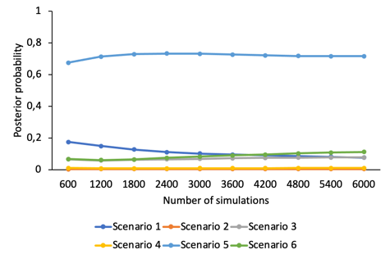

Figure S12. Posterior probabilities of the six bridgehead tested scenarios between RSA and POR (600 000 simulations in total).

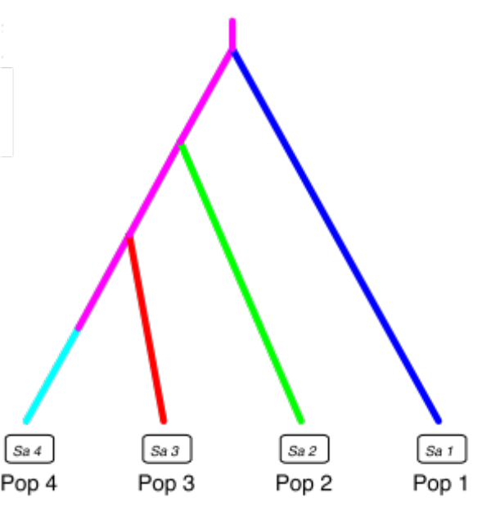

Figure S13. DIYABC drawing of scenario 5, which had the higher posterior probability of the six bridgehead tested scenarios between RSA and POR (p = 0.7161, 95% CI = 0.6165-0.8157). Pop 1 = AUS; Pop 2 = TAS; Pop 3 = RSA; Pop 4 = POR.
Table S8. Results of the “model checking” analysis for the best bridgehead scenarios selected (scenario 5) in ABC analyses. NAL, N2P = Mean number of alleles; HET, H2P = Mean genetic diversity; VAR, V2P = Mean allelic size variance; DM2 = Mean genetic distance.

 | Scenario 5
Summary statistics | Observed | Proportion (simulated<observed)
NAL_{AUS} | 4.0000 | 0.0170*
NAL_{TAS} | 3.3333 | 0.0115*
NAL_{RSA} | 4.2500 | 0.7210
NAL_{POR} | 4.0833 | 0.0135*
HET_{AUS} | 0.3328 | 0.0000***
HET_{TAS} | 0.3481 | 0.0000***
HET_{RSA} | 0.5344 | 0.6040
HET_{POR} | 0.3832 | 0.0000***
VAR_{AUS} | 7.9140 | 0.8530
VAR_{TAS} | 7.5102 | 0.8510
VAR_{RSA} | 20.2430 | 0.9930**
VAR_{POR} | 9.4490 | 0.9000
N2P_{AUS&TAS} | 4.7500 | 0.0180*
N2P_{AUS&RSA} | 5.8333 | 0.1925
N2P_{AUS&POR} | 5.5833 | 0.0640
N2P_{TAS&RSA} | 5.3333 | 0.2610
N2P_{TAS&POR} | 4.7500 | 0.0235*
N2P_{RSA&POR} | 5.5000 | 0.1750
H2P_{AUS&TAS} | 0.3579 | 0.0000***
H2P_{AUS&RSA} | 0.4205 | 0.0030**
H2P_{AUS&POR} | 0.3543 | 0.0000***
H2P_{TAS&RSA} | 0.4324 | 0.0070**
H2P_{TAS&POR} | 0.3745 | 0.0000***
H2P_{RSA&POR} | 0.4786 | 0.0420*
V2P_{AUS&TAS} | 7.8540 | 0.8430
V2P_{AUS&RSA} | 12.3647 | 0.9520*
V2P_{AUS&POR} | 8.4072 | 0.8675
V2P_{TAS&RSA} | 12.5276 | 0.9590*
V2P_{TAS&POR} | 8.2176 | 0.8705
V2P_{RSA&POR} | 15.5085 | 0.9800*
DM2_{AUS&TAS} | 0.6459 | 0.5255
DM2_{AUS&RSA} | 4.0303 | 0.8700
DM2_{AUS&POR} | 0.1540 | 0.1620
DM2_{TAS&RSA} | 5.0685 | 0.9080
DM2_{TAS&POR} | 0.3822 | 0.3820
DM2_{RSA&POR} | 4.1941 | 0.9080
*tail-area probability < 0.05; ** tail-area probability < 0.01; *** tail-area probability < 0.001
References

Adamski DJ, Dudley NS, Morden CW, Borthakur D (2013) Cross-amplification of nonnative Acacia species in the Hawaiian Islands using microsatellite markers from Acacia koa. Plant Biosystems - An International Journal Dealing with all Aspects of Plant Biology 147: 1088–1091. https://doi.org/10.1080/11263504.2012.749958
Aggarwal RK, Allainguillaume J, Bajay MM, Barthwal S, Bertolino P, Chauhan P, Consuegra S, Croxford A, Dalton DL, Belder ED, Díaz‐Ferguson E, Douglas MR, Drees M, Elderson J, Esselink GD, Fernández‐Manjarrés JF, Frascaria‐Lacoste N, Gäbler‐Schwarz S, Leaniz CGD, Ginwal HS, Goodisman M a. D, Guo B, Hamilton MB, Hayes PK, Hong Y, Kajita T, Kalinowski ST, Keller L, Koop BF, Kotzé A, Lalremruata A, Leese F, Li C, Liew WY, Martinelli S, Matthews EA, Medlin LK, Messmer AM, Meyer EI, Monteiro M, Moyer GR, Nelson RJ, Nguyen TTT, Omoto C, Ono J, Pavinato V a. C, Pearcy M, Pinheiro JB, Power LD, Rawat A, Reusch TBH, Sanderson D, Sannier J, Sathe S, Sheridan CK, Smulders MJM, Sukganah A, Takayama K, Tamura M, Tateishi Y, Vanhaecke D, Vu NV, Wickneswari R, Williams AS, Wimp GM, Witte V, Zucchi MI (2011) Permanent Genetic Resources added to Molecular Ecology Resources Database 1 August 2010 – 30 September 2010. Molecular Ecology Resources 11: 219–222. https://doi.org/10.1111/j.1755-0998.2010.02944.x
Bairu M, Coetzer W, Assefa A (2020) Development of an SSR-based DNA fingerprinting method for black wattle (Acacia mearnsii De Wild). New Zealand Journal of Forestry Science 50. https://doi.org/10.33494/nzjfs502020x56x
Brown G, Gardner MG (2011) Isolation, characterisation and transferability of microsatellites for Paraserianthes lophantha, Cape Wattle (Leguminosae: Mimosoideae): A significant weed worldwide. Muelleria 29: 87–92. https://biostor.org/reference/253957
Butcher PA, Decroocq S, Gray Y, Moran GF (2000) Development, inheritance and cross-species amplification of microsatellite markers from Acacia mangium. Theoretical and Applied Genetics 101: 1282–1290. https://doi.org/10.1007/s001220051608
Chapuis M-P, Estoup A (2007) Microsatellite null alleles and estimation of population differentiation. Molecular Biology and Evolution 24: 621–631. https://doi.org/10.1093/molbev/msl191
Evanno G, Regnaut S, Goudet J (2005) Detecting the number of clusters of individuals using the software structure: a simulation study. Molecular Ecology 14: 2611–2620. https://doi.org/10.1111/j.1365-294X.2005.02553.x
Forrest CN, Roberts DG, Denham AJ, Ayre DJ (2015) Microsatellite primers for vulnerable and thriving Acacia (Fabaceae) species from Australia’s arid zone. Applications in Plant Sciences 3: 1400121. https://doi.org/10.3732/apps.1400121
Guillemaud T, Broadhurst L, Legoff I, Henery M, Blin A, Ducatillion C, Ferrando N, Malausa T (2015) Development of 23 polymorphic microsatellite loci in invasive silver wattle, Acacia dealbata (Fabaceae). Applications in Plant Sciences 3: 1500018. https://doi.org/10.3732/apps.1500018
Ng CH, Koh SC, Lee SL, Ng KKS, Mark A, Norwati M, Wickneswari R (2005) Isolation of 15 polymorphic microsatellite loci in Acacia hybrid (Acacia mangium×Acacia auriculiformis). Molecular Ecology Notes 5: 572–575. https://doi.org/10.1111/j.1471-8286.2005.00994.x
Roberts DG, Forrest CN, Denham AJ, Ayre DJ (2013) Microsatellite markers for vulnerable Australian aridzone Acacias. Conservation Genetics Resources 5: 199–201. https://doi.org/10.1007/s12686-012-9767-6
Van Oosterhout C, Hutchinson W, Wills D, Shipley P (2004) MICRO-CHECKER: Software for identifying and correcting genotyping errors in microsatellite data. Molecular Ecology Notes 4: 535–538. https://doi.org/10.1111/j.1471-8286.2004.00684.x
Vicente S, Máguas C, Trindade H (2018) Genetic diversity and differentiation of invasive Acacia longifolia in Portugal. Web Ecology 18: 91–103. https://doi.org/10.5194/we-18-91-2018
Weising K, Gardner RC (1999) A set of conserved PCR primers for the analysis of simple sequence repeat polymorphisms in chloroplast genomes of dicotyledonous angiosperms. Genome 42: 9–19. https://doi.org/10.1139/g98-104

