Supplementary Information 1:

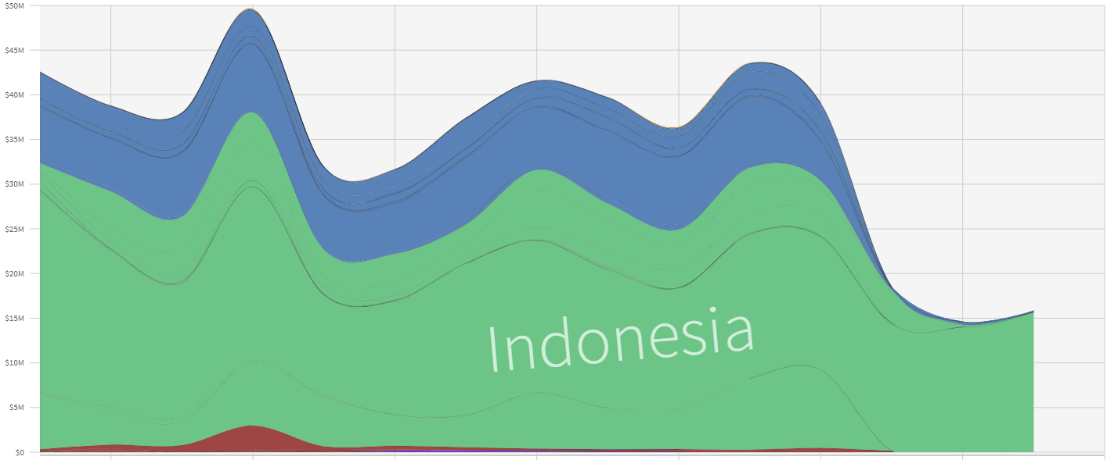
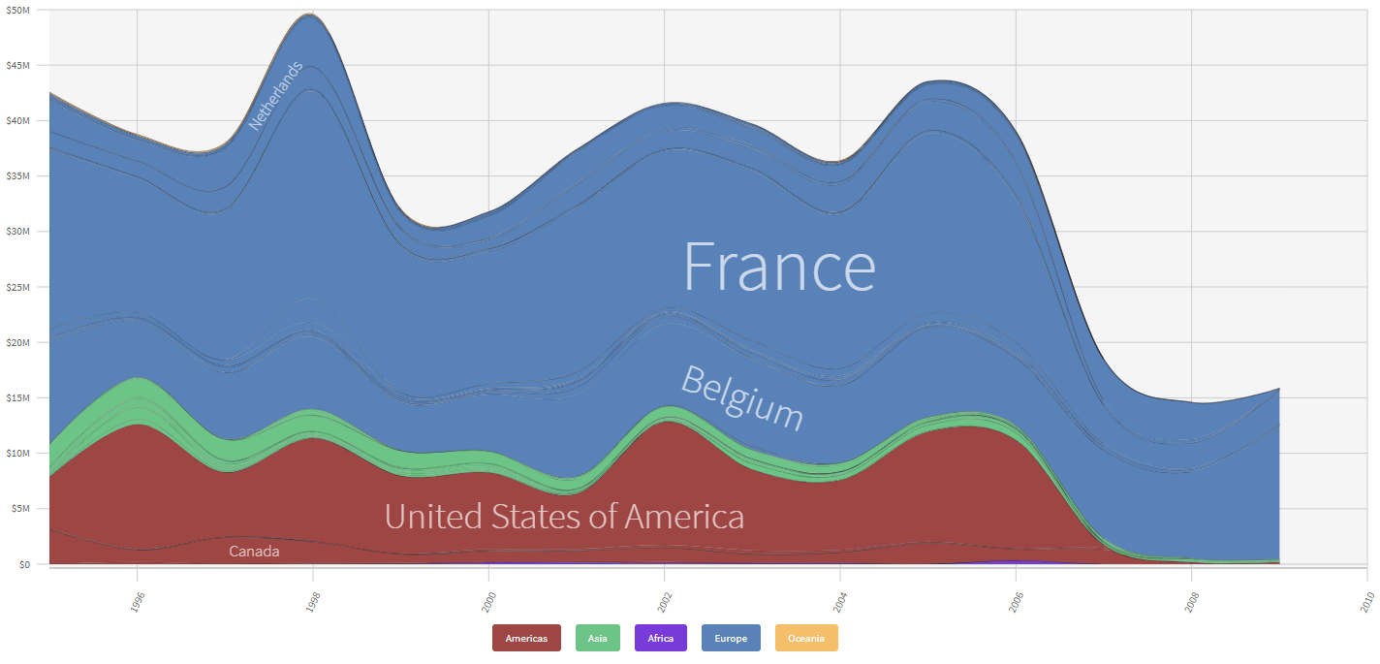
Figure 1. Export (above) and import (below) data of frogs’ legs by country/regions from 1996-2009. Source: Atlas of Economic Complexity (2023)

Figure 2. Richness of frog species in trade for consumption based on IUCN species ranges (see Methods).
Figure 3. Richness of frog species traded internationally for consumption based on IUCN species ranges (see Methods); blue: 1, yellow: 2, and red: 3.

Figure 4. Number of species native to each country in international trade for consumption based on IUCN species ranges (see Methods).

