Supplementary material 3: additional tables and figures

Table S1. Borrowed specimens. An approximate number of examined specimens of the different morphotypes are given together with country.
Institution | Location (City, Country) | H. f. fuscipes | H. f. rottenbergii | H. f. subrotundus | H. arcticus
Bavarian State Collection of Zoology (ZSM) | Munich, Germany | 3 Germany | 5 Germany | 1 Germany
Finnish Museum of Natural History (HELS) | Helsinki, Finland | 5 Finland | 9 Finland | 6 Finland | 7 Finland
Natural History Museum (UiO) | Oslo, Norway | 3 Norway | 7 Norway |  | 5 Norway
Natural History Museum (NHM) | London, UK | 1 China , 1 Israel, 1 Portugal, 1 Spain, 1 Turkey | 1 China, 1 Egypt, 6 France, 2 Hungary, 1 Spain, 1 Turkey, 4 UK | 6 UK
Natural History Museum of Denmark (COPEN) | Copenhagen, Denmark | 2 Denmark, 2 Greece, 1 Poland, 2 USA |  | 2 Denmark
Norwegian Institute for Nature Research (NINA) | Trondheim, Norway | 3 Norway |  | 3 Norway | 3 Norway
Senckenberg German Entomological Institute (SDEI) | Müncheberg, Germany |  | 2 Poland, 2 Germany | 2 Bulgaria
Tromsø University Museum (UiT) | Tromsø, Norway |  |  |  | 1 Norway
University Museum of Bergen (UiB) | Bergen, Norway |  | 2 Norway | 2 Norway | 6 Norway

Table S2. Partition schemes and substitution models with the lowest Bayesian Information Criterion in PartitionFinder. Used in MrBayes and BEAST analyses. Abbreviations: G=gamma distribution, I = proportion of invariant sites, JC = Jukes Cantor (Jukes and Cantor 1969), SYM = Symmetrical model (Zharkikh 1994), F81 = Felsenstein 1981 (Felsenstein 1981), HKY = Hasegawa-Kishino-Yano (Hasegawa et al. 1985), K80 = Kimura 2-parameter (Kimura 1980), TrN = Tamura Nei (Tamura and Nei 1993), TrNef = TrN with equal base frequencies. Pos. = codon position.
Analyses used (software) | Gene segment | Subset Partitions | Best substitution model
MrBayes with outgroup | COI | Pos. 1 | SYM+G
MrBayes with outgroup | COI | Pos. 2 | F81
MrBayes with outgroup | COI | Pos. 3 | HKY+G
MrBayes with outgroup | H3 | Pos. 1 and pos. 2 | JC+I
MrBayes with outgroup | H3 | Pos. 3 | K80+I
MrBayes with outgroup | ITS2 | - | HKY+G
MrBayes with outgroup | Concatenated | COI pos. 1 and H3 pos. 1 | SYM+G
MrBayes with outgroup | Concatenated | COI pos. 2 | F81
MrBayes with outgroup | Concatenated | COI pos. 3 | HKY+G
MrBayes with outgroup | Concatenated | H3 pos. 2 | JC
MrBayes with outgroup | Concatenated | H3 pos. 3 | K80
MrBayes with outgroup | Concatenated | ITS2 | HKY+I
BEAST without outgroup (strict clock) | COI | Pos. 1 | TrNef+I
BEAST without outgroup (strict clock) | COI | Pos. 2 | HKY
BEAST without outgroup (strict clock) | COI | Pos. 3 | TrN+G
BEAST without outgroup (strict clock) | H3 | Pos. 1 and pos. 2 | JC+I
BEAST without outgroup (strict clock) | H3 | Pos. 3 | K80
BEAST without outgroup (strict clock) | ITS2 | - | HKY

Table S3. Posterior probabilities of Clade I and Clade II as separate species under different prior combinations. Analyses conducted in BPP v3.0. Posterior probability values are the mean of multiple runs with different starting trees and algorithms (0 vs 1). Theta (Θ) = ancestral population size, tau (τ₀) = age of root.
A priori assignment of Clade VII specimens | Parameter priors (Θ , τ₀)
A priori assignment of Clade VII specimens | G(1, 50), G(1, 20) | G(1, 50), G(1, 200) | G(1, 500), G(1, 20) | G(1, 500), G(1, 200)
As H. arcticus | 0.566 | 0.622 | 0.544 | 0.597
As H. f. rottenbergii | 0.597 | 0.623 | 0.541 | 0.610
As separate species | 0.590 | 0.616 | 0.545 | 0.602

Table S4. Posterior probabilities (PP) of species models from BPP v2.2. Based on multi-locus data (COI, H3 and ITS2) from 111 Hydrobius specimens. PP range from four prior-combinations. Models with PP < 0.05 are not reported. Species scenarios from Fig. S6.
A priori assignment of Clade VII specimens | Species model | Posterior probability
A priori assignment of Clade VII specimens | Species model | Scenario 1 | Scenario 2 | Scenario 3 | Scenario 4 | Scenario 5
As H. arcticus/H. f. rottenbergii | 10 species, split between Clade I and Clade II | 0.40–0.45 | 0.39–0.45 | - | - | -
As H. arcticus/H. f. rottenbergii | 11 species | 0.55–0.60 | 0.55–0.61 | - | - | -
As separate species | 11 species, split between Clade I and Clade II | - | - | 0.40–0.46 | 0.39–0.44 | 0.39–0.46
As separate species | 12 species | - | - | 0.54–0.60 | 0.55–0.60 | 0.54–0.61

Table S5. Effect of priors on split probabilities of (Clade I, Clade II) nodes in BPP v2.2. Theta (Θ) = ancestral population size, tau (τ₀) = age of root. Species scenarios from Fig. S6.
Species scenario | Parameter priors (Θ , τ₀)
Species scenario | G(1, 50),  G(1, 20) | G(1, 50),  G(1, 200) | G(1, 500),  G(1, 20) | G(1, 500),  G(1, 200)
1 | 0.57 | 0.60 | 0.55 | 0.59
2 | 0.55 | 0.61 | 0.55 | 0.60
3 | 0.56 | 0.60 | 0.54 | 0.60
4 | 0.56 | 0.60 | 0.56 | 0.59
5 | 0.57 | 0.59 | 0.54 | 0.61

Table S6. Mean ± SE and number of observations (n) of male genitalia characters of Hydrobius morphotypes. See material and methods for details on character measurements.
Character (unit) | Mean ± SE (n)
Character (unit) | H. arcticus | H. f. rottenbergii | H. f. fuscipes | H. f. subrotundus
Width of parameres, dorsal view (ln(µm)) | 3.98 ± 0.0157 (15) | 3.90 ± 0.0153 (15) | 3.74 ± 0.00754 (15) | 3.81 ± 0.00767 (16)
Robustness of parameres | 9.43 ± 0.154 (15) | 9.90 ± 0.242 (15) | 12.8 ± 0.180 (15) | 12.2 ± 0.158 (15)
Ratio paramere length / penis length | 1.47 ± 0.0180 (15) | 1.45 ± 0.0218 (15) | 1.58 ± 0.0139 (15) | 1.62 ± 0.0166 (15)
Width of parameres, lateral view (ln(µm)) | 3.79 ± 0.0343 (14) | 3.64 ± 0.0228 (15) | 3.71 ± 0.0166 (14) | 3.84 ± 0.0207 (16)
Curvature of paramere tip (µm) | 58.8 ± 2.13 (15) | 54.4 ± 1.33 (15) | 59.7 ± 1.83 (14) | 73.0 ± 1.61 (16)

Table S7. Post hoc comparison of means of male genital characters in morphotypes of Hydrobius. Number of observations is approximately 15 of each morphotype (Table S6). t-value and corresponding adjusted p-value are used to see if differences between morphotypes are significantly different from 0. Adjusted p-values were calculated with Tukey’s HSD test. p-values lower than 0.05 in bold. See material and methods for details on character measurements.
Character (unit, degrees of freedom) | Morphotype | Morphotype | Difference between morphotypes ± SE | t-value | Adjusted p-value
Width of parameres, dorsal view (ln(µm), df = 58) | H. arcticus | H. f. rottenbergii | 0.0889 ± 0.0172 | 5.17 | < 0.001
Width of parameres, dorsal view (ln(µm), df = 58) | H. arcticus | H. f. fuscipes | 0.248 ± 0.0169 | 14.6 | < 0.001
Width of parameres, dorsal view (ln(µm), df = 58) | H. arcticus | H. f. subrotundus | 0.172 ± 0.0169 | 10.2 | < 0.001
Width of parameres, dorsal view (ln(µm), df = 58) | H. f. fuscipes | H. f. rottenbergii | 0.159 ± 0.0169 | 9.39 | < 0.001
Width of parameres, dorsal view (ln(µm), df = 58) | H. f. subrotundus | H. f. rottenbergii | 0.0830 ± 0.0169 | 4.90 | < 0.001
Width of parameres, dorsal view (ln(µm), df = 58) | H. f. fuscipes | H. f. subrotundus | 0.0760 ± 0.0167 | 4.56 | < 0.001
Robustness of parameres (df = 56) | H. arcticus | H. f. rottenbergii | 0.470 ± 0.265 | 1.78 | 0.294
Robustness of parameres (df = 56) | H. arcticus | H. f. fuscipes | 3.36 ± 0.265 | 12.7 | < 0.001
Robustness of parameres (df = 56) | H. arcticus | H. f. subrotundus | 2.81 ± 0.265 | 10.6 | < 0.001
Robustness of parameres (df = 56) | H. f. fuscipes | H. f. rottenbergii | 2.89 ± 0.265 | 10.9 | < 0.001
Robustness of parameres (df = 56) | H. f. subrotundus | H. f. rottenbergii | 2.34 ± 0.265 | 8.86 | < 0.001
Robustness of parameres (df = 56) | H. f. fuscipes | H. f. subrotundus | 0.542 ± 0.265 | 2.05 | 0.183
Ratio paramere length / penis length (df = 56) | H. arcticus | H. f. rottenbergii | 0.0117 ± 0.0251 | 0.466 | 0.966
Ratio paramere length / penis length (df = 56) | H. arcticus | H. f. fuscipes | 0.113 ± 0.0251 | 4.48 | < 0.001
Ratio paramere length / penis length (df = 56) | H. arcticus | H. f. subrotundus | 0.151 ± 0.0251 | 6.02 | < 0.001
Ratio paramere length / penis length (df = 56) | H. f. fuscipes | H. f. rottenbergii | 0.124 ± 0.0251 | 4.95 | < 0.001
Ratio paramere length / penis length (df = 56) | H. f. subrotundus | H. f. rottenbergii | 0.163 ± 0.0251 | 6.49 | < 0.001
Ratio paramere length / penis length (df = 56) | H. f. fuscipes | H. f. subrotundus | 0.0387 ± 0.0251 | 1.54 | 0.420
Width of parameres, lateral view (ln(µm), df = 55) | H. arcticus | H. f. rottenbergii | 0.160 ± 0.0365 | 4.38 | < 0.001
Width of parameres, lateral view (ln(µm), df = 55) | H. arcticus | H. f. fuscipes | 0.0843 ± 0.0371 | 2.27 | 0.118
Width of parameres, lateral view (ln(µm), df = 55) | H. arcticus | H. f. subrotundus | 0.0414 ± 0.0360 | 1.15 | 0.660
Width of parameres, lateral view (ln(µm), df = 55) | H. f. fuscipes | H. f. rottenbergii | 0.0755 ± 0.0365 | 2.07 | 0.177
Width of parameres, lateral view (ln(µm), df = 55) | H. f. subrotundus | H. f. rottenbergii | 0.201 ± 0.0353 | 5.70 | < 0.001
Width of parameres, lateral view (ln(µm), df = 55) | H. f. fuscipes | H. f. subrotundus | 0.126 ± 0.0360 | 3.49 | 0.00516
Curvature of paramere tip (µm, df = 56) | H. arcticus | H. f. rottenbergii | 4.47 ± 2.47 | 1.81 | 0.278
Curvature of paramere tip (µm, df = 56) | H. arcticus | H. f. fuscipes | 0.854 ± 2.51 | 0.340 | 0.986
Curvature of paramere tip (µm, df = 56) | H. arcticus | H. f. subrotundus | 14.2 ± 2.43 | 5.83 | < 0.001
Curvature of paramere tip (µm, df = 56) | H. f. fuscipes | H. f. rottenbergii | 5.32 ± 2.51 | 2.12 | 0.159
Curvature of paramere tip (µm, df = 56) | H. f. subrotundus | H. f. rottenbergii | 18.6 ± 2.43 | 7.67 | < 0.001
Curvature of paramere tip (µm, df = 56) | H. f. fuscipes | H. f. subrotundus | 13.3 ± 2.47 | 5.38 | < 0.001

Table S8. Intercept ± SE and number of observations (n) of morphological characters of Hydrobius morphotypes. Intercepts from linear regression models where the character was plotted against body size. See material and methods for details on character measurements.
Character (unit) | Intercept ± SE (n)
Character (unit) | H. arcticus | H. f. rottenbergii | H. f. fuscipes | H. f. subrotundus
Length of parameres (ln(µm)) | 5.71 ± 0.229 (15) | 5.65 ± 0.238 (15) | 5.73 ± 0.248 (15) | 5.77 ± 0.244 (15)
Elytral Index | 1.005 ± 0.0606 (21) | 1.076 ± 0.0649 (26) | 1.060 ± 0.0709 (33) | 1.003 ± 0.0678 (33)

Table S9. Post hoc comparison of intercepts for length of parameres affected by body size. Length of parameres was plotted against body size in natural log-log scale for different morphotypes of Hydrobius. Number of observations: 15 of each morphotype. T-value and corresponding adjusted p-value are used to see if differences between morphotypes are significantly different from 0. Degrees of freedom = 55. Adjusted p-values were calculated with Tukey’s HSD test. p-values < 0.05 in bold.
Morphotype | Morphotype | Difference between morphotypes ± SE | t-value | Adjusted p-value
H. arcticus | H. f. rottenbergii | 0.061 ± 0.020 | 3.08 | 0.0158
H. arcticus | H. f. fuscipes | 0.017 ± 0.026 | 0.635 | 0.918
H. arcticus | H. f. subrotundus | 0.058 ± 0.023 | 2.49 | 0.0710
H. f. fuscipes | H. f. rottenbergii | 0.078 ± 0.021 | 3.72 | 0.00250
H. f. subrotundus | H. f. rottenbergii | 0.12 ± 0.019 | 6.23 | < 0.001
H. f. fuscipes | H. f. subrotundus | 0.041 ± 0.019 | 2.23 | 0.125

Table S10. Post hoc comparison of intercepts from a regression with Elytral Index affected by body size. Elytral Index was plotted against body size for different morphotypes of Hydrobius. Number of observations: 21 H. arcticus, 26 H. f. rottenbergii, 33 H. f. fuscipes and 33 H. f. subrotundus. T-value and corresponding adjusted p-value are used to see if differences between morphotypes are significantly different from 0. Degrees of freedom = 108. The adjusted p-values were calculated with Tukey’s HSD test. p-values < 0.05 in bold. See material and methods for details on character measurements.
Morphotype | Morphotype | Difference between morphotypes ± SE | t-value | Adjusted p-value
H. arcticus | H. f. rottenbergii | 0.070 ± 0.013 | 5.519 | < 0.001
H. arcticus | H. f. fuscipes | 0.055 ± 0.016 | 3.544 | 0.00314
H. arcticus | H. f. subrotundus | 0.0017 ± 0.014 | 0.124 | 0.999
H. f. fuscipes | H. f. rottenbergii | 0.015 ± 0.012 | 1.236 | 0.598
H. f. subrotundus | H. f. rottenbergii | 0.072 ± 0.011 | 6.485 | < 0.001
H. f. fuscipes | H. f. subrotundus | 0.057 ± 0.011 | 5.387 | < 0.001

References

Felsenstein J (1981) Evolutionary trees from DNA sequences: a maximum likelihood approach. Journal of Molecular Evolution 17: 368-376. doi:10.1007/bf01734359
Hasegawa M, Kishino H, Yano T-a (1985) Dating of the human-ape splitting by a molecular clock of mitochondrial DNA. Journal of Molecular Evolution 22: 160-174. doi:10.1007/bf02101694
Jukes TH, Cantor CR (1969) Evolution of Protein Molecules. Mammalian Protein Metabolism: 21-132. doi:10.1016/b978-1-4832-3211-9.50009-7
Kimura M (1980) A simple method for estimating evolutionary rates of base substitutions through comparative studies of nucleotide sequences. Journal of Molecular Evolution 16: 111-120. doi:10.1007/bf01731581
Tamura K, Nei M (1993) Estimation of the number of nucleotide substitutions in the control region of mitochondrial DNA in humans and chimpanzees. Molecular Biology and Evolution 10: 512-526. DOI:
Zharkikh A (1994) Estimation of evolutionary distances between nucleotide sequences. Journal of Molecular Evolution 39: 315-329. doi:10.1007/bf00160155

Figure legends
Figure S1. Majority-rule consensus tree from Bayesian analysis of COI sequences. Branch support values are posterior probabilities. Samples are labeled with ID-numbers, identified morphotypes and country of origin. Specimens collected in sympatry are also labeled with locality name (Rinnleiret, Motzen or Oland). Samples from BOLD labeled with Sequence ID from BOLD. Scale bar indicates expected number of nucleotide substitutions per site. Abbreviations of morphotypes: arc=arcticus, fus=fuscipes, rot=rottenbergii, sub=subrotundus.
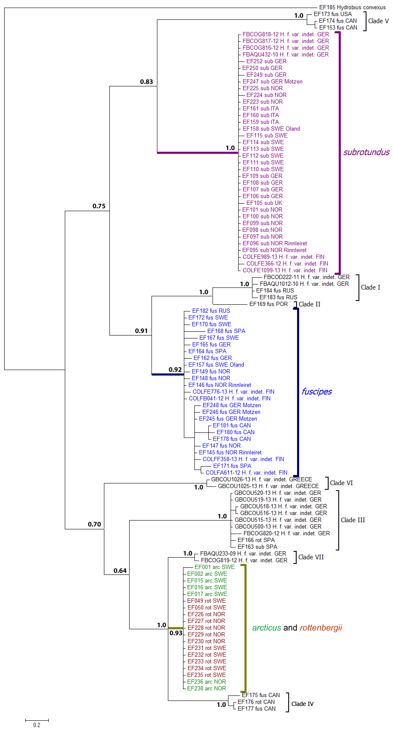

Figure S2. Majority-rule consensus tree from Bayesian analysis of H3 sequences. Branch support values are posterior probabilities. Terminal names and abbreviations as in Fig. S1. Scale bar indicates expected number of nucleotide substitutions per site. Branches with “//” have been manually cut.
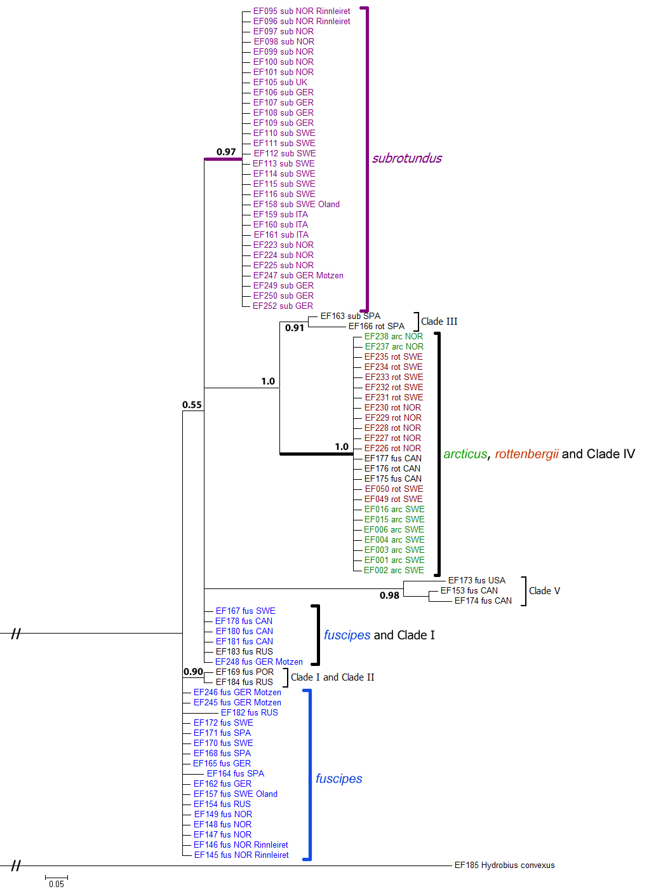

Figure S3. Majority-rule consensus tree from Bayesian analysis of ITS2 sequences. Branch support values are posterior probabilities. Terminal names and abbreviations as in Fig. S1. Scale bar indicates expected number of nucleotide substitutions per site.
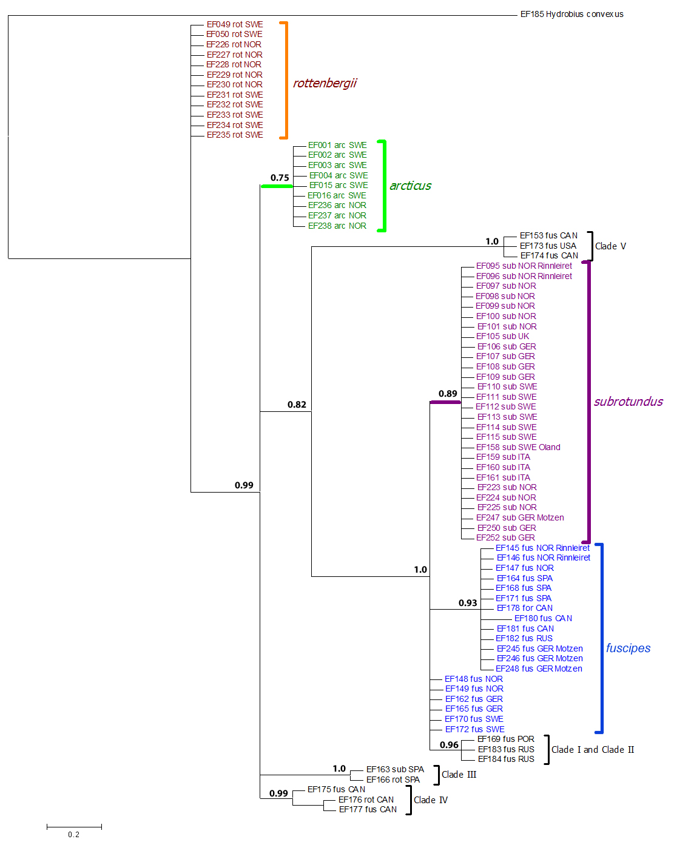

Figure S4. Ultrametric (strict clock) maximum clade credibility (MCC) tree used in GMYC analysis of H3. Terminal names and abbreviations as in Fig. S1. Values next to branches show Bayesian posterior probability support (node values with PP < 0.5 not shown). Scale bar represents an artificial time scale with the root at time 1.
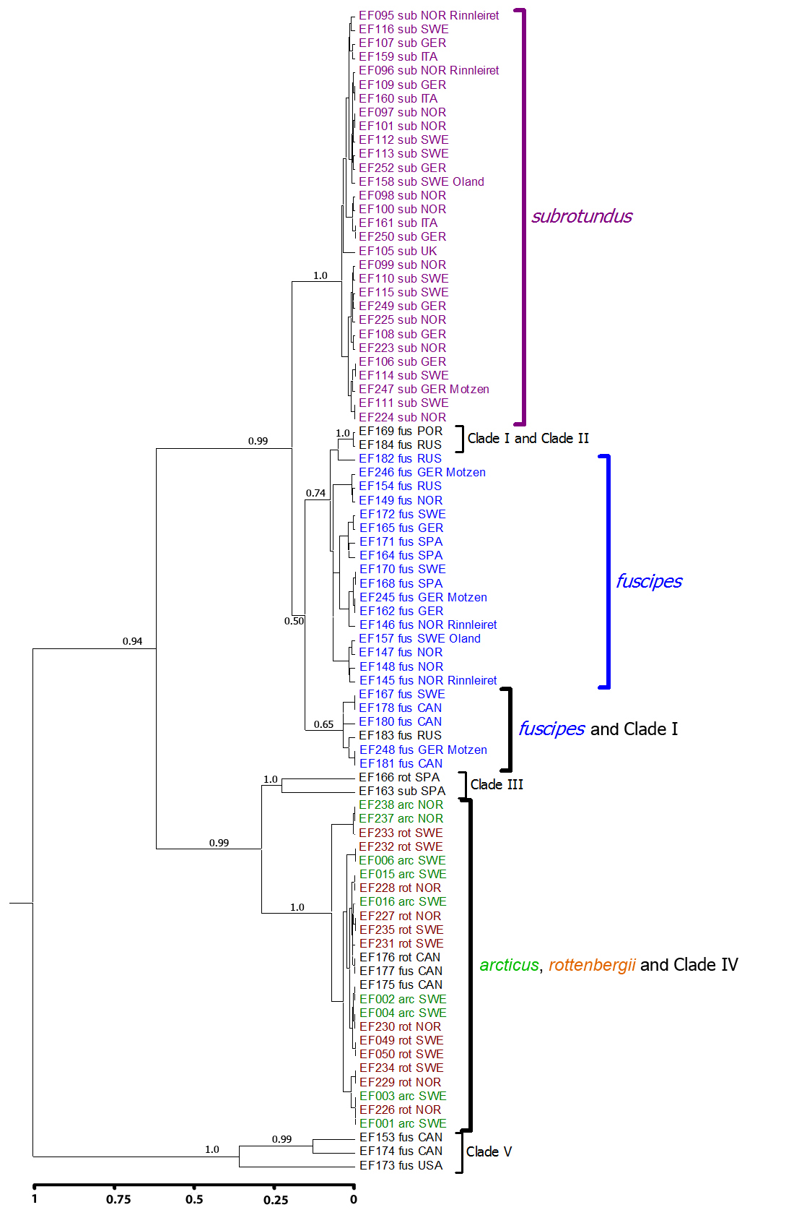

Figure S5. Species trees with highest posterior probability from BPP v3.0 analyses conducted on 111 Hydrobius specimens. Multi-locus data (COI, H3 and ITS2) used with H. convexus included as outgroup. a) Species tree with largest posterior probability (PP). b) Species tree with second largest PP. c-d) Subtrees from node marked “X” in a and b. c) Tree with 12 species delimited (including outgroup). d) Tree with 11 species delimited, Clade I and Clade II considered the same species. * Clade VII only delimited when specimens from Clade VII were a priori assigned as a potential species separate from H. arcticus and H. f. rottenbergii.
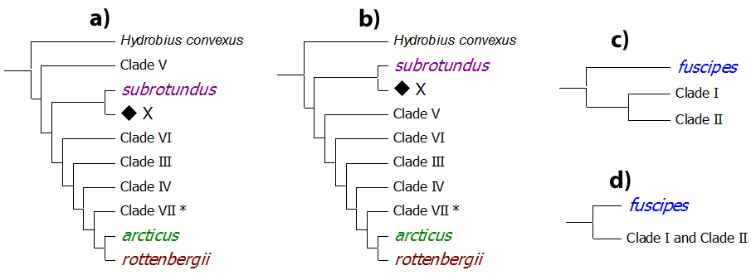
Figure S6. Results of BPP v2.2 analyses conducted on 111 Hydrobius specimens. Multi-locus data (COI, H3 and ITS2) used with H. convexus as outgroup. A) Guide tree. B-E) subtrees from node marked “X” in A, used in 5 different species scenarios. B) Topology of species scenario 1 and 2. Specimens of Clade VII a priori assigned as H. arcticus in “species scenario 1” and as H. f. rottenbergii in “species scenario 2”. C) Topology of species scenario 3. D) Topology of species scenario 4. E) Topology of species scenario 5. Values next to branches indicate range of split posterior probabilities, i.e. the probability for the node representing a speciation event, from four different prior-combinations that were used in each of the species scenarios. Values in red have split probabilities < 0.9. Samples were assigned to potential species groups based on genetically divergent clades in Table 5, taxonomic knowledge and GMYC-delimited species.
