Supplementary Information
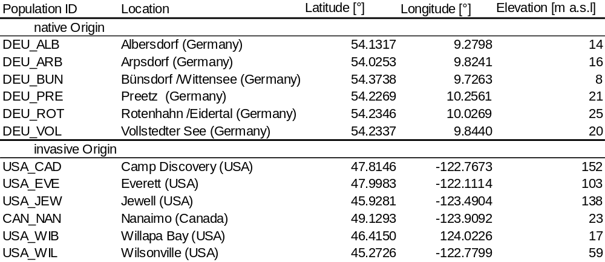
Fig. S1: Population information.
Location of populations included in this study for the native (top left) and invasive (top right) range. Native population locations also served as experimental sites for the field experiment. Detailed information about the location of the populations on the bottom. Map was created using QGIS (QGIS Development Team 2020). Map data © OpenStreetMap contributors and available from https://www.openstreetmap.org
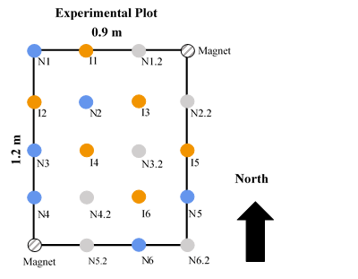
Fig. S2: Schematic overview of one experimental plot with planting scheme.
Each plot contained one individual from each of the six invasive population origins (orange dots, I 1-6). Furthermore, one individual had been planted from each of the six native population origins (blue dots, N 1-6) that also served as the experimental sites. Each plot also included a replicate set of native individuals (gray dots, N 1.2-6.2) that were planted to determine performance in a following growing season. These plants of the replicate set also served as replacement plants if necessary. Magnets were buried to make the experimental plots easier to find. Each plant was clearly labelled using a zip-tie and tape with the plant’s ID written down. If a plant had died before the end of the experiment, the grid-pattern allowed removal of the entire sod at the planting position to assure that there would be no future re-growth of the plant.

Table S1: Transformations of variables 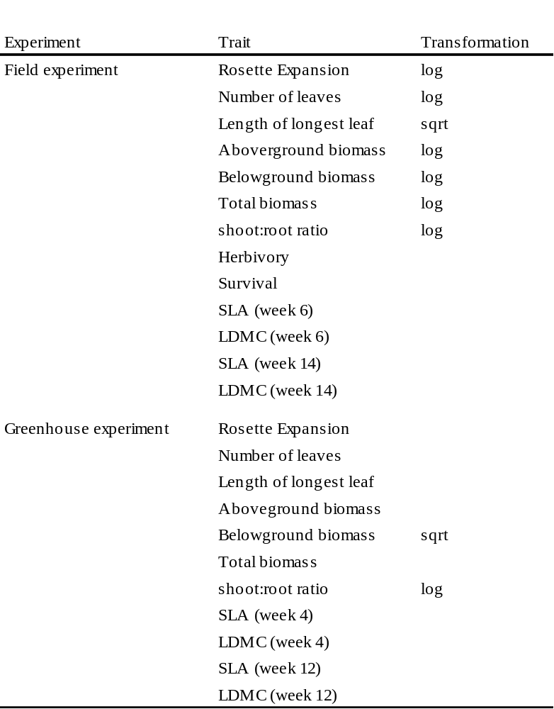
For Herbivory and Survival, a glmer with family = “binomial” and for Number of leaves (greenhouse experiment) a glmer with family = “poisson” was fitted.

Table S2: Mean values for performance traits (field experiment).
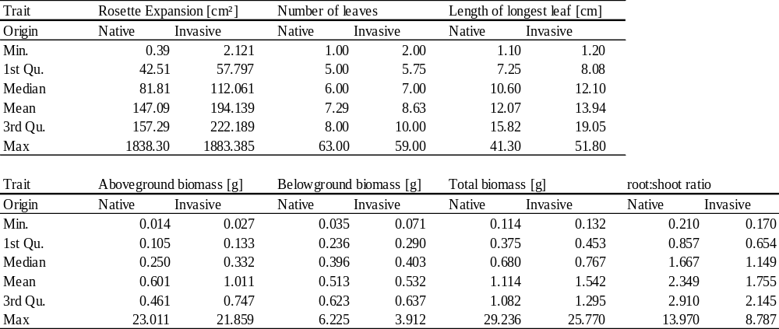
Distribution of measure values for performance traits in the field experiment.

Table S3: Mean values for functional leaf traits (field experiment).
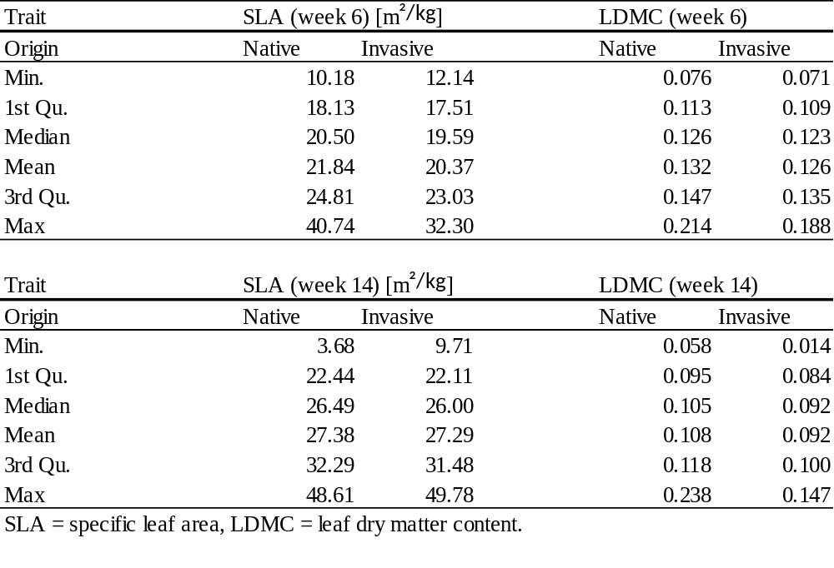
Distribution of measured values for functional leaf traits in the field experiment.

Table S4: Mean values for performance traits (greenhouse experiment).
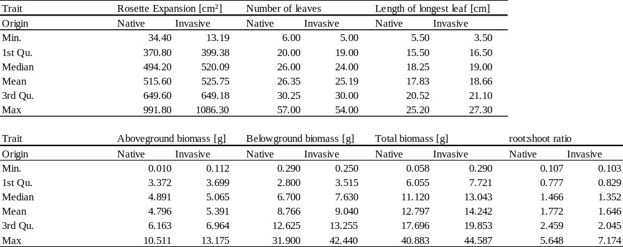
Distribution of measured values for performance traits in the greenhouse experiment.

Table S5: Mean values for functional leaf traits (greenhouse experiment).
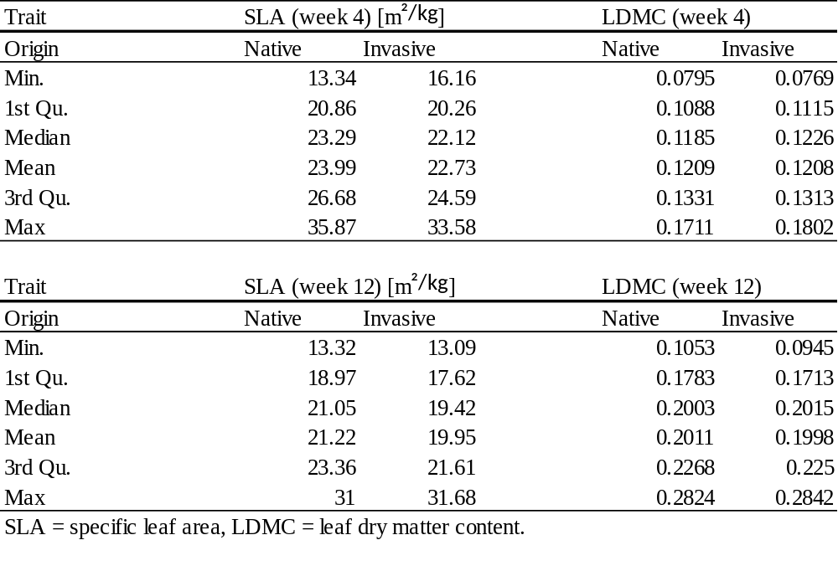
Distribution of measured values for functional leaf traits in the greenhouse experiment.

Fig. S3: Origin effects (field experiment)
Response of performance (a-c) traits in relation to origin of the seeds for each individual. Native individuals (left, blue) originated from the field sites where the experimental plots were located. Invasive individuals (right, orange) originate from the Pacific Northwest. Herbivory was assessed as a binary trait (presence/absence) only. N=319 (a-c) and n = 322 (d).

Fig. S4: Origin effects x covariate (field experiment)
Effects of origin in interaction with α-diversity (a, c) and maximum vegetation height of surrounding vegetation within the experimental plot (b). O = origin, α-Div =α-diversity, mvh = maximum vegetation height (of surrounding vegetation), SLA = specific leaf area, LDMC = leaf dry matter content. Week 6 and Week 14 indicates that the leaves for analysis were harvested after 6 weeks of experimental runtime or at the final harvest of the plants after the entire experimental runtime, respectively. N = 193 (a), 311 (b), 319 (c). SLA after 6 weeks was only taken for plants that had a sufficient number of healthy leaves and therefore constitutes a reduced subset.

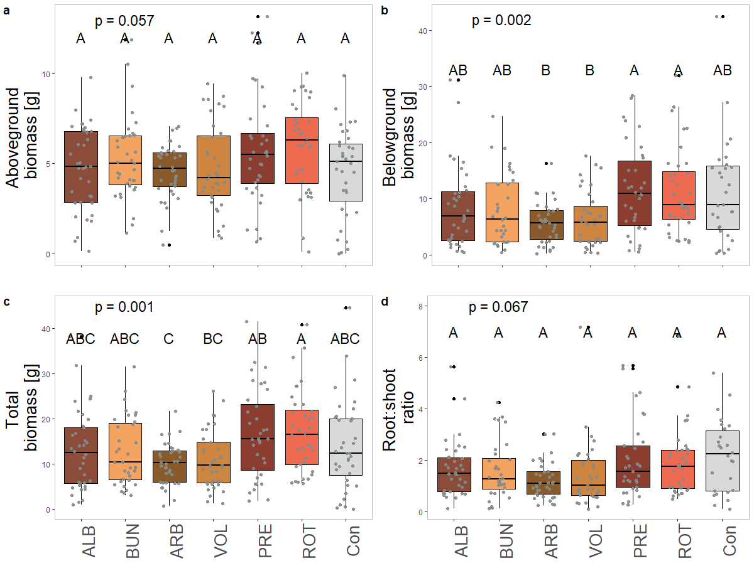
Fig. S5: Treatment effects on performance traits (greenhouse experiment)
Effects of soil provenance in the greenhouse experiment. Different colors represent different soil origins (only soil from native sites were included in this experiment). Different letter combinations in the panels indicate significant differences according to the Tukey post-hoc test. ALB = Albersdorf, ARB = Arpsdorf, BUN = Bünsdorf/Wittensee, Con = Control (no soil added from any field site), PRE = Preetz, ROT = Rotenhahn/Eidertal, VOL = Vollstedter See. For location information see Supplementary Fig. S1. N(a) = 250, n(b) = 238, n(c) = 251, n(d) = 230.
Fig. S6: Treatment effects on functional traits (greenhouse experiment)
Effects of soil provenance in the greenhouse experiment. Different colors represent different soil origins (only soil from native sites were included in this experiment). Different letter combinations in the panels indicate significant differences according to the Tukey post-hoc test. ALB = Albersdorf, ARB = Arpsdorf, BUN = Bünsdorf/Wittensee, Con = Control (no soil added from any field site), PRE = Preetz, ROT = Rotenhahn/Eidertal, VOL = Vollstedter See. For location information see Supplementary Fig. S1. N(a) = 215, n(b) = 248 , n(c) = 251, n(d) = 249.

