Supplementary material 1

Figure S1. Phylogenetic tree based on maximum likelihood (ML) analysis of a combined DNA data set of ACT sequences for Calonectria spp. Bootstrap values ≥70% for ML analyses and posterior probabilities values ≥0.90 obtained from Bayesian inference (BI) are indicated at the nodes as ML/BI. Bootstrap values <70% or probabilities values <0.90 are marked with “*”, and nodes lacking the support values are marked with “−”. Isolates representing ex-type material are marked with “T”. Curvicladiella cignea (isolate CBS 109167 and CBS 109168) represents the outgroup.
Figure S2. Phylogenetic tree based on maximum likelihood (ML) analysis of a combined DNA data set of CMDA sequences for Calonectria spp. Bootstrap values ≥70% for ML analyses and posterior probabilities values ≥0.90 obtained from Bayesian inference (BI) are indicated at the nodes as ML/BI. Bootstrap values <70% or probabilities values <0.90 are marked with “*”, and nodes lacking the support values are marked with “−”. Isolates representing ex-type material are marked with “T”. Curvicladiella cignea (isolate CBS 109167 and CBS 109168) represents the outgroup.
Figure S3. Phylogenetic tree based on maximum likelihood (ML) analysis of a combined DNA data set of HIS3 sequences for Calonectria spp. Bootstrap values ≥70% for ML analyses and posterior probabilities values ≥0.90 obtained from Bayesian inference (BI) are indicated at the nodes as ML/BI. Bootstrap values <70% or probabilities values <0.90 are marked with “*”, and nodes lacking the support values are marked with “−”. Isolates representing ex-type material are marked with “T”. Curvicladiella cignea (isolate CBS 109167 and CBS 109168) represents the outgroup.
Figure S4. Phylogenetic tree based on maximum likelihood (ML) analysis of a combined DNA data set of TUB2 sequences for Calonectria spp. Bootstrap values ≥70% for ML analyses and posterior probabilities values ≥0.90 obtained from Bayesian inference (BI) are indicated at the nodes as ML/BI. Bootstrap values <70% or probabilities values <0.90 are marked with “*”, and nodes lacking the support values are marked with “−”. Isolates representing ex-type material are marked with “T”. Curvicladiella cignea (isolate CBS 109167 and CBS 109168) represents the outgroup.
Figure S5. Phylogenetic tree based on maximum likelihood (ML) analysis of a combined DNA data set of TEF1 sequences for Calonectria spp. Bootstrap values ≥70% for ML analyses and posterior probabilities values ≥0.90 obtained from Bayesian inference (BI) are indicated at the nodes as ML/BI. Bootstrap values <70% or probabilities values <0.90 are marked with “*”, and nodes lacking the support values are marked with “−”. Isolates representing ex-type material are marked with “T”. Curvicladiella cignea (isolate CBS 109167 and CBS 109168) represents the outgroup.
Figure S6. Phylogenetic tree based on maximum likelihood (ML) analysis of a combined DNA data set of RPB2 sequences for Calonectria spp. Bootstrap values ≥70% for ML analyses and posterior probabilities values ≥0.90 obtained from Bayesian inference (BI) are indicated at the nodes as ML/BI. Bootstrap values <70% or probabilities values <0.90 are marked with “*”, and nodes lacking the support values are marked with “−”. Isolates representing ex-type material are marked with “T”. Curvicladiella cignea (isolate CBS 109167 and CBS 109168) represents the outgroup.
Note:
Calonectria parvispora
Calonectria brachiatica
Calonectria pini
Calonectria exiguispora sp. nov.
Calonectria colombiana
Calonectria spathulata
Calonectria guahibo sp. nov.

Figure S1.
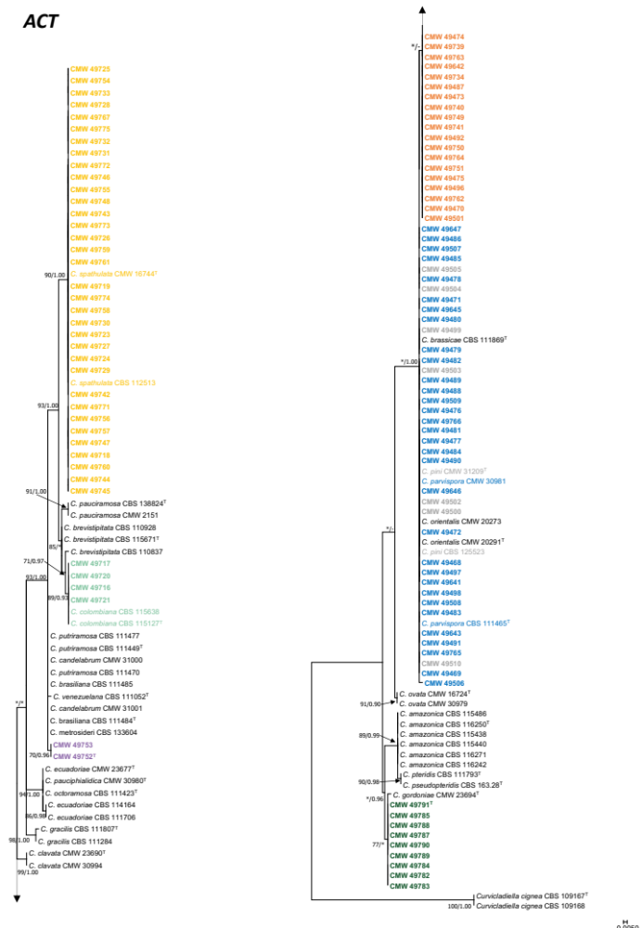

Figure S2.
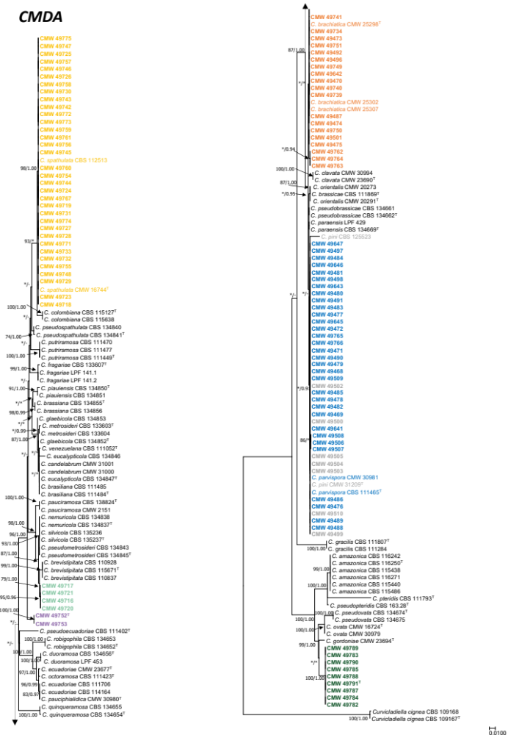

Figure S3.
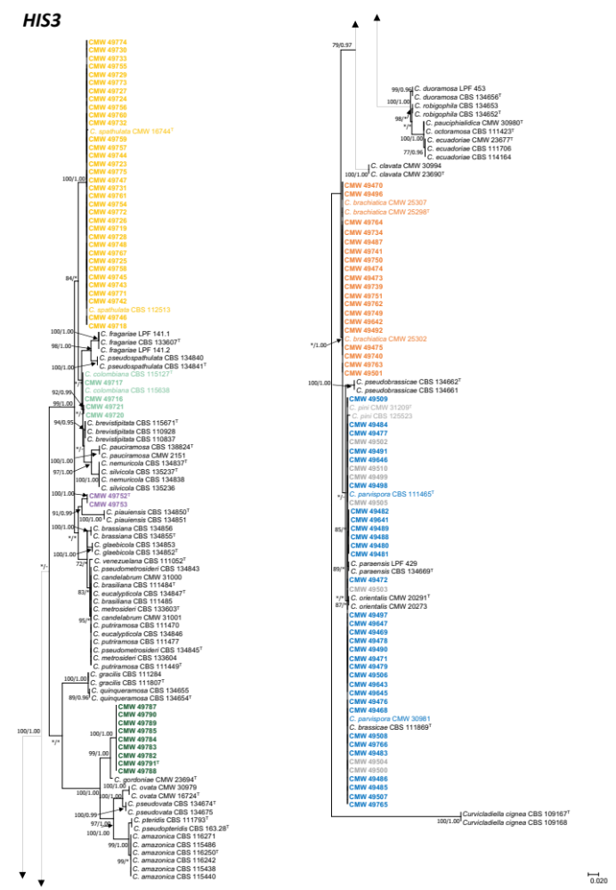

Figure S4.
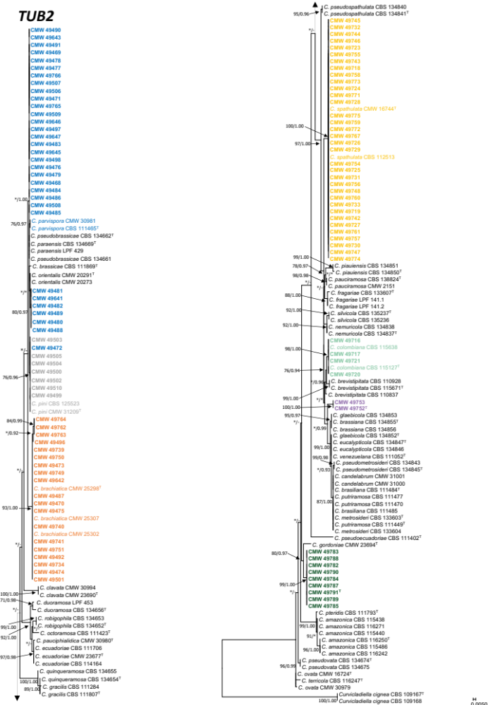

Figure S5.
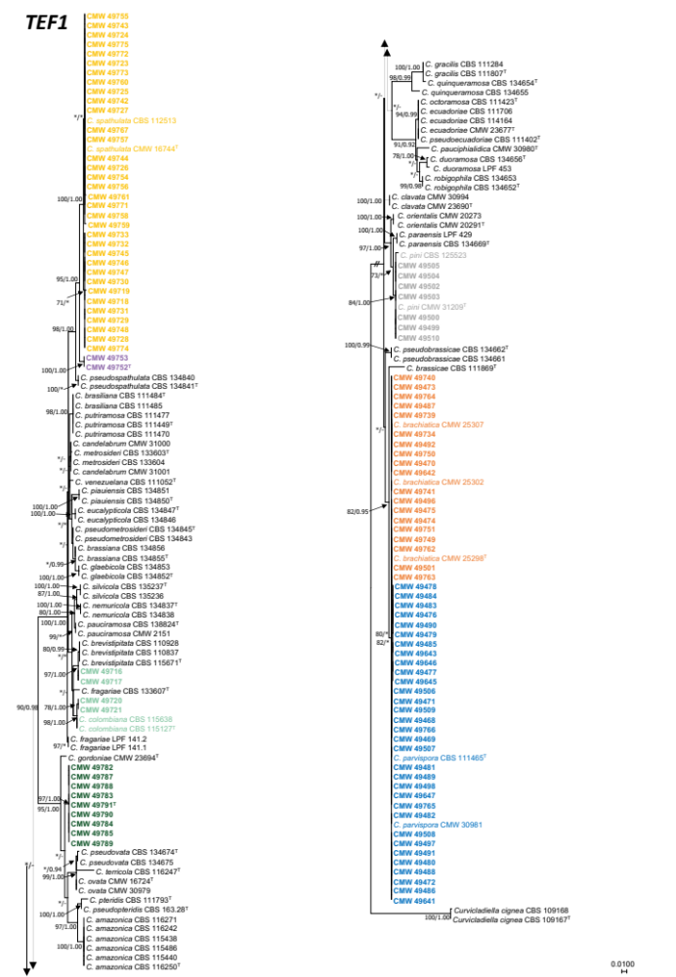

Figure S6.
