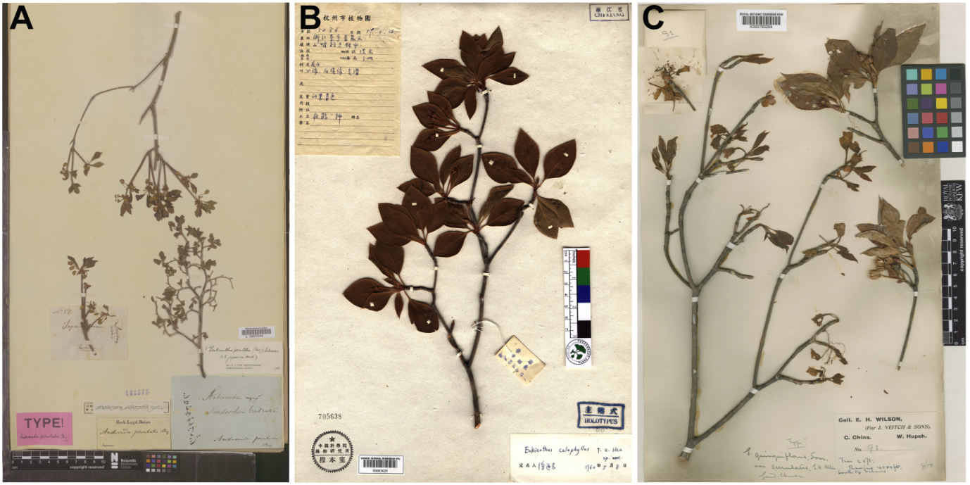
Figure S1. Type specimen of Enkianthus perulatus, E. calophyllus and E. serrulatus. A, holotype of E. perulatus (L-0007044); B, holotype of E. calophyllus (PE-00005629); C, holotype of E. serrulatus (K-000780284).

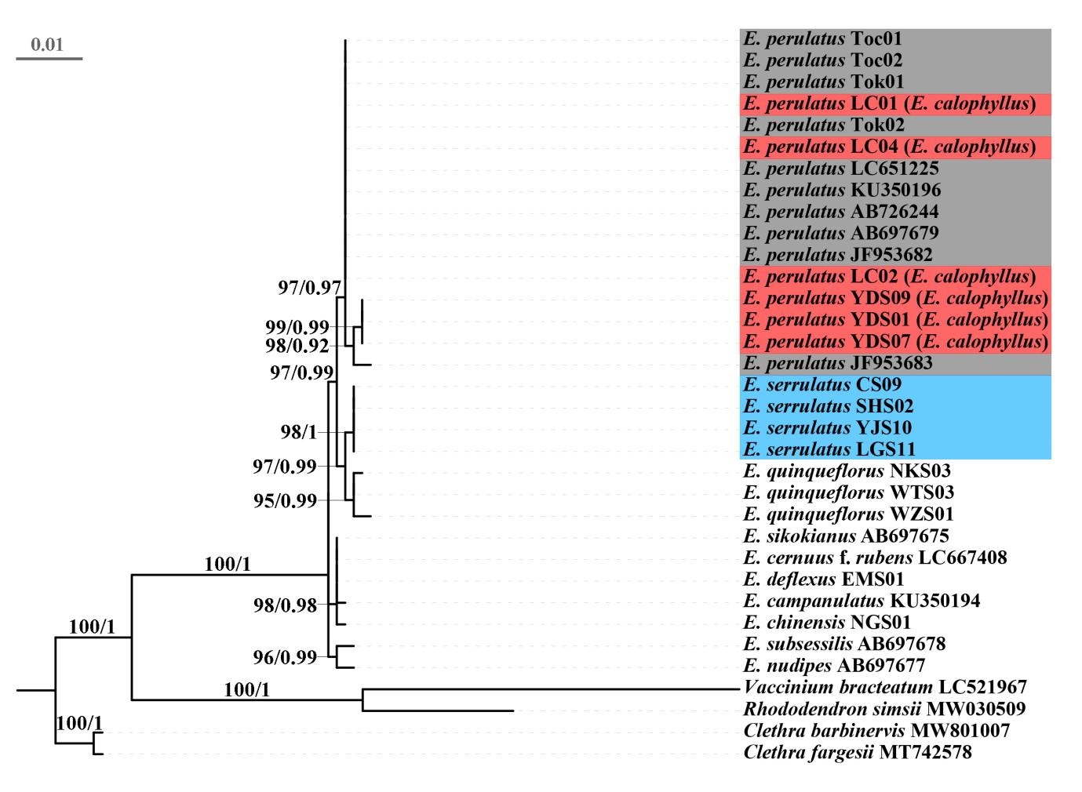
Figure S2. Phylogenetic relationships of Enkianthus based on matK. Numbers above branches are Maximum Likelihood bootstrap values /Bayesian posterior probability (> 50%). The phylogenetic position of E. perulatus, E. calophyllus (= E. perulatus) and E. serrulatus are highlighted in red, grey and blue, respectively.

Table S1. Sample collection information and GenBank accessions in this study.
Species | Source | Samples ID | GenBank number
Species | Source | Samples ID | psbA-trnH | rpl32-trnL | trnL-F | rps16-trnQ | psbJ-petA | matK | ITS
E. perulatus | Tokyo, Japan | Tok01 | OP024388 | OP024412 | OP024436 | OP024460 | OP024484 | OP024508 | OP002295
E. perulatus | Tokyo, Japan | Tok02 | OP024389 | OP024413 | OP024437 | OP024461 | OP024485 | OP024509 | OP002296
E. perulatus | Tochigi, Japan | Toc01 | OP024390 | OP024414 | OP024438 | OP024462 | OP024486 | OP024510 | OP002297
E. perulatus | Tochigi, Japan | Toc02 | OP024391 | OP024415 | OP024439 | OP024463 | OP024487 | OP024511 | OP002298
E. perulatus | GenBank |  | – | – | – | – | – | AB697679 | AB697671
E. perulatus | GenBank |  | – | – | – | – | – | JF953682 | JF976288
E. perulatus | GenBank |  | – | – | – | – | – | JF953683 | JF976289
E. perulatus | GenBank |  | – | – | – | – | – | LC651225 | JF976287
E. perulatus | GenBank |  | – | – | – | – | – | KU350196 | LC651259
E. perulatus | GenBank |  | – | – | – | – | – | AB726244 | –
E. calophyllus | Yueqing, Zhejiang, China | YDS01 | OP024377 | OP024401 | OP024425 | OP024449 | OP024473 | OP024497 | OP002289
E. calophyllus | Yueqing, Zhejiang, China | YDS04 | OP024378 | OP024402 | OP024426 | OP024450 | OP024474 | OP024498 | OP002290
E. calophyllus | Yueqing, Zhejiang, China | YDS09 | OP024379 | OP024403 | OP024427 | OP024451 | OP024475 | OP024499 | OP002291
E. calophyllus | Lichuan, Jiangxi, China | LC01 | OP024380 | OP024404 | OP024428 | OP024452 | OP024476 | OP024500 | OP002292
E. calophyllus | Lichuan, Jiangxi, China | LC02 | OP024381 | OP024405 | OP024429 | OP024453 | OP024477 | OP024501 | OP002293
E. calophyllus | Lichuan, Jiangxi, China | LC04 | OP024382 | OP024406 | OP024430 | OP024454 | OP024478 | OP024502 | OP002294
E. serrulatus | Yongxiu, Jiangxi, China | YJS10 | OP024395 | OP024419 | OP024443 | OP024467 | OP024491 | OP024515 | OP002285
E. serrulatus | Xinning, Hunan, China | SHS02 | OP024396 | OP024420 | OP024444 | OP024468 | OP024492 | OP024516 | OP002284
E. serrulatus | Leishan, Guizhou, China | LGS11 | OP024397 | OP024421 | OP024445 | OP024469 | OP024493 | OP024517 | OP002283
E. serrulatus | Chishui, Guizhou, China | CS09 | OP024398 | OP024422 | OP024446 | OP024470 | OP024494 | OP024518 | OP002282
E. quinqueflorus | Longmen, Guangdong, China | NKS03 | OP024392 | OP024416 | OP024440 | OP024464 | OP024488 | OP024512 | OP002286
E. quinqueflorus | Shenzhen, Guangdong, China | WTS03 | OP024393 | OP024417 | OP024441 | OP024465 | OP024489 | OP024513 | OP002287
E. quinqueflorus | Wuzhishan, Hainan, China | WZS01 | OP024394 | OP024418 | OP024442 | OP024466 | OP024490 | OP024514 | OP002288

Species | Source | samples name | GenBank number
Species | Source | samples name | psbA-trnH | rpl32-trnL | trnL-F | rps16-trnQ | psbJ-petA | matK | ITS
E. chinensis | Langao, Shaanxi, China | NGS01 | OP024385 | OP024409 | OP024433 | OP024457 | OP024481 | OP024505 | OP002301
E. deflexus | Emeishan, Sichuan, China | EMS01 | OP024386 | OP024410 | OP024434 | OP024458 | OP024482 | OP024506 | OP002302
E. campanulatus | GenBank |  | – | – | – | – | – | KU350194 | KF963947
E. sikokianus | GenBank |  | – | – | – | – | – | AB697675 | AB697667
E. cernuus f. rubens | GenBank |  | – | – | – | – | – | LC667408 | LC667414
E. nudipes | GenBank |  | – | – | – | – | – | AB697677 | AB697669
E. subsessilis | GenBank |  | – | – | – | – | – | AB697678 | AB697670
Rhododendron simsii | GenBank |  | MW030509 | MW030509 | MW030509 | MW030509 | MW030509 | MW030509 | KM605741
Vaccinium bracteatum | GenBank |  | LC521967 | LC521967 | LC521967 | LC521967 | LC521967 | LC521967 | KP092614
Clethra barbinervis | GenBank |  | MW801007 | MW801007 | MW801007 | MW801007 | MW801007 | MW801007 | AY190573
Clethra cubensis | GenBank |  | – | – | – | – | – | – | AY190560
Clethra fargesii | GenBank |  | MT742578 | MT742578 | MT742578 | MT742578 | MT742578 | MT742578 | –
“–”, the sequence is unavailable.

Table S2. Sequences of primers used for PCR amplification and sequencing.
Fragment | Forward primer (5’–3’) | Reverse primer (5’–3’) | Reference
psbA-trnH | GTTATGCATGAACGTAATGCTC | CGCGCATGGTGGATTCACAAATC | Sang et al. 1997
rpl32-trnL | CAGTTCCAAAAAAACGTACTTC | CTGCTTCCTAAGAGCAGCGT | Shaw et al. 2007
trnL-trnF | CGAAATCGGTAGACGCTACG | ATTTGAACTGGTGACACGAG | Taberlet et al. 1991
rps16-trnQ | GTTGCTTTYTACCACATCGTTT | GCGTGGCCAAGYGGTAAGGC | Shaw et al. 2007
psbJ-petA | ATAGGTACTGTARCYGGTATT | AACARTTYGARAAGGTTCAATT | Shaw et al. 2007
matK | TGGTTCAAACTATTCGCTACTG | ATAACAAACTTGCTCTTCCTCC | –
ITS | ACGAATTCATGGTCCGGTGAAGTGTTCG | TAGAATTCCCCGGTTCGCTCGCCGTTAC | Sun et al. 1994

