Supplementary Material to
Small but voracious: invasive generalist consumes more zooplankton in winter than native planktivore
Žiga Ogorelec^{1,2}, Alexander Brinker^{1,3}, Dietmar Straile¹
¹ Limnological Institute, University of Konstanz, Mainaustraße 252, 78464 Konstanz, Germany
² National Institute of Biology, Večna pot 111, Ljubljana 1000, Slovenia
³ Fisheries Research Station Baden-Württemberg, Argenweg 50/1, D-88085 Langenargen, Germany

Table S1. Number of sampled fish and fish with empty stomachs for each month. In May 2017, sticklebacks were caught on two occasions; 10.5.2017: 3 sticklebacks on the 10th and 2 sticklebacks on the 30th of May. Sticklebacks were also classified into a separate first-year-of-life (0+) group according to their sizes.
 | Whitefish |  | Sticklebacks
Month | N of sampled fish | N of fish with an empty stomach | N of sampled fish | N of 0+ | N of fish with an empty stomach
April | 2 | 0 | / | / | /
May | 20 | 0 | 5 (3+2) | / | 1
June | 21 | 0 | 17 | / | 0
July | 19 | 0 | 20 | 11 | 2
August | 20 | 0 | 19 | 19 | 0
September | 20 | 0 | 19 | 13 | 0
October | 20 | 1 | 19 | / | 1
November | 16 | 6 | 20 | / | 0
December | 20 | 7 | 20 | / | 2
January | 20 | 10 | 5 | / | 1
February | 20 | 0 | / | / | /
March | 3 | 0 | / | / | /
April | 1 | 0 | / | / | /
May | 19 | 0 | / | / | /

Table S2. Number of replicates for each sampling time point after pooling five samples for sticklebacks and whitefish.
Sampling time point | Season | N of sticklebacks | N of whitefish
May 2017 | Spring 2017 | 1 | 4
June 2017 | Spring 2017 | 3 | 4
July 2017 | Summer 2017 | 4 | 3
August 2017 | Summer 2017 | 3 | 4
September 2017 | Autumn 2017 | 3 | 4
October 2017 | Autumn 2017 | 3 | 4
November 2017 | Autumn 2017 | 4 | 3
December 2017 | Winter 2017/2018 | 4 | 4
January 2018 | Winter 2017/2018 | 1 | 4
February 2018 | Winter 2017/2018 | 0 | 4
May 2018 | Spring 2018 | 0 | 3
Table S3. Differences between whitefish and stickleback diets in each season. May and June refer to spring, July and August to summer, September, October and November to autumn and December, January and February to winter. The number of consumed prey species by both fish species is compared by the analysis of similarities (ANOSIM; one-way, 999 permutations). * = statistically significant after sequential Bonferroni correction.
Groups | R-value | P-value
Stickleback vs. whitefish: spring 2017 | 1 | 0.2
Stickleback vs. whitefish: summer 2017 | 0.537 | 0.001*
Stickleback vs. whitefish: autumn 2017 | 0.118 | 0.028
Stickleback vs. whitefish: winter 2017 | 0.545 | 0.001*

Table S4. The contribution of individual prey species to the differences between stickleback and whitefish diets (similarity percentages procedure; one-way, 70% cut-off). The average dissimilarity between the two fish species was 46.97%. Av. Ab. = average abundance, Av. Diss. = average dissimilarity, Diss./SD = dissimilarity / standard deviation.
Prey species | Av. ab. stickleback | Av. ab. whitefish | Av. Diss. | Diss./SD | Contribution [%] | Cumulative [%]
Cyclopoid copepods | 4.64 | 3.56 | 9.78 | 1.08 | 20.81 | 20.81
Daphnia longispina | 3.63 | 5.79 | 8.80 | 1.05 | 18.73 | 39.54
Leptodora kindtii | 0.75 | 1.95 | 5.63 | 0.90 | 11.99 | 51.53
Eudiaptomus gracilis | 2.04 | 1.36 | 5.42 | 0.95 | 11.54 | 63.07
Bosmina spp. | 3.43 | 1.76 | 5.23 | 1.25 | 11.14 | 74.21

Table S5. Results of beta regression relating relative zooplankton consumption to relative zooplankton density, fish species, and the interaction between relative density and fish species (see Fig. 5). The table shows p-values for i) the influence of in situ relative density of zooplankton, ii) the difference between whitefish and stickleback consumption, and iii) the different responses of both fish species to the increased relative zooplankton density in situ.
Zooplankton species | relative zooplankton density | Difference between fish species | Interaction
Bosmina spp. | < 0.0001 *** | < 0.0001 *** | 0.315
Cyclopoid copepods | 0.260 | 0.740 | 0.880
E. gracilis | 0.365 | 0.762 | 0.525
D. cucullata | 0.046 * | 0.232 | 0.639
D. longispina | 0.003 ** | 0.075 | 0.016 *
D. galeata | 0.108 | 0.250 | 0.122
B. longimanus | < 0.0001 *** | 0.080 | 0.051
L. kindtii | < 0.0001 *** | 0.004 ** | < 0.0001 ***

Table S6. Summary of the prey-specific index of relative importance (%PSIRI) for both fish predators for the compared period (May 2017 to January 2018). Asterisks mark calculations made for whitefish for the entire year (May 2017 to April 2018). sd = standard deviation, se = standard error, ci = confidence interval.
Zooplankton species | Fish | N | average_%PSIRI | sd | se | ci
B. longimanus | G. aculeatus | 7 | 0.232 | 0.142 | 0.054 | 0.132
Cyclopoid copepods | G. aculeatus | 9 | 0.231 | 0.260 | 0.087 | 0.200
Bosmina spp. | G. aculeatus | 9 | 0.190 | 0.216 | 0.072 | 0.166
D. longispina | G. aculeatus | 9 | 0.138 | 0.097 | 0.032 | 0.074
D. cucullata | G. aculeatus | 8 | 0.087 | 0.059 | 0.021 | 0.050
E. gracilis | G. aculeatus | 9 | 0.072 | 0.105 | 0.035 | 0.081
L. kindtii | G. aculeatus | 7 | 0.033 | 0.029 | 0.011 | 0.027
D. galeata | G. aculeatus | 6 | 0.002 | 0.001 | 0.001 | 0.002
B. longimanus | C. wartmanni | 7 | 0.269 | 0.207 | 0.078 | 0.192
D. longispina | C. wartmanni | 9 | 0.244 | 0.161 | 0.054 | 0.124
L. kindtii | C. wartmanni | 6 | 0.203 | 0.207 | 0.085 | 0.218
Cyclopoid copepods | C. wartmanni | 9 | 0.095 | 0.112 | 0.037 | 0.086
Bosmina spp. | C. wartmanni | 8 | 0.091 | 0.201 | 0.071 | 0.168
E. gracilis | C. wartmanni | 8 | 0.054 | 0.131 | 0.046 | 0.110
D. cucullata | C. wartmanni | 7 | 0.041 | 0.078 | 0.030 | 0.072
D. galeata | C. wartmanni | 5 | 0.003 | 0.001 | 0.000 | 0.001
D. longispina | C. wartmanni* | 12 | 0.398 | 0.312 | 0.090 | 0.199
B. longimanus | C. wartmanni* | 8 | 0.249 | 0.200 | 0.071 | 0.167
L. kindtii | C. wartmanni* | 6 | 0.203 | 0.207 | 0.085 | 0.218
Cyclopoid copepods | C. wartmanni* | 12 | 0.089 | 0.099 | 0.028 | 0.063
Bosmina spp. | C. wartmanni* | 10 | 0.073 | 0.181 | 0.057 | 0.130
E. gracilis | C. wartmanni* | 11 | 0.048 | 0.112 | 0.034 | 0.075
D. cucullata | C. wartmanni* | 8 | 0.036 | 0.074 | 0.026 | 0.062
D. galeata | C. wartmanni* | 5 | 0.003 | 0.001 | 0.000 | 0.001

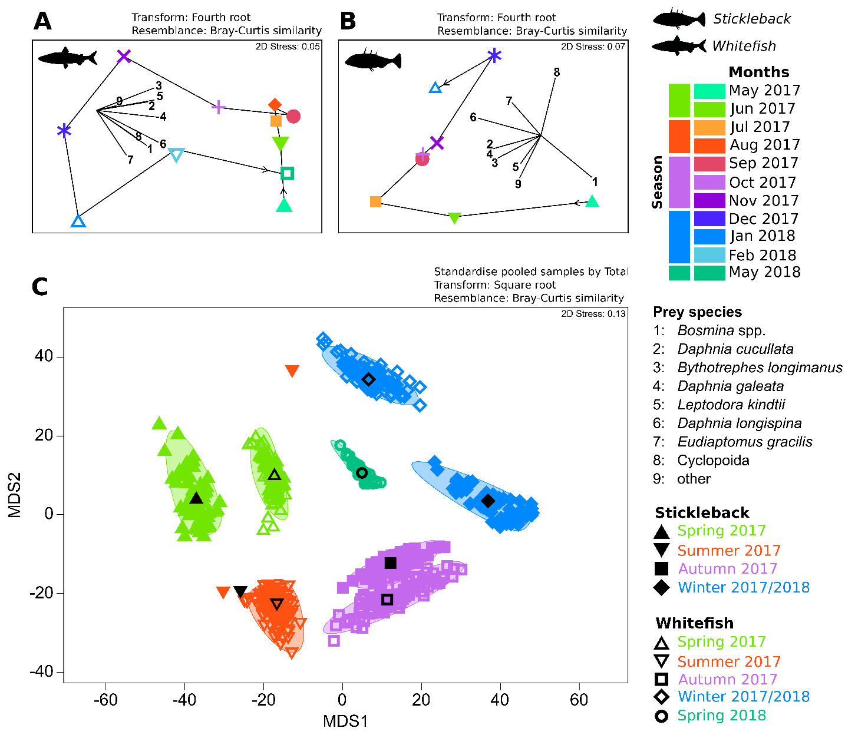
Figure S1. Seasonal changes in the diets of sticklebacks (excluding 0+) and whitefish in Lake Constance. Non-metric multidimensional scaling (NMDS) ordination plot for whitefish (A) and stickleback (B) data based on Bray-Curtis similarities. (C) NMDS ordination plot of bootstrapped averages of pooled samples for both species. Vectors indicate the direction and strength of individual prey species on orientation (Pearson correlation). Note that this analysis pooled four stickleback and four whitefish individuals and that the analysis of similarities (ANOSIM) showed (after sequential Bonferroni correction) statistically significant differences only in winter.

Figure S2. Whitefish and stickleback (excluding 0+ fish) relative consumption of zooplankton species depending on the proportional density of zooplankton species. The lines show the fits from beta regression based on the median diet contribution of zooplankton from fish sampled on the various sampling dates.

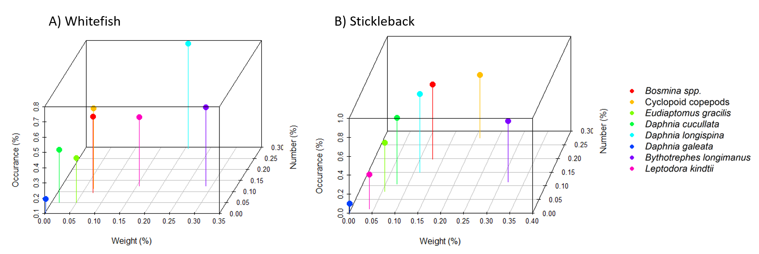
Figure S3. Annual averages of the three parameters (% occurrence, body weight and relative abundance (% number)) of the prey-specific index of relative importance for A) whitefish and B) sticklebacks.

