Supplementary Material
Invasive Drosophila suzukii outnumbers native controphics and causes substantial damage to fruits of forest plants

Irene Bühlmann¹ & Martin M. Gossner^{2,3}

Affiliations:
¹ Ökobüro Biotopia, Obertalacher 1, CH-6319 Allenwinden, Switzerland
² Forest Entomology, Swiss Federal Research Institute WSL, Zürcherstrasse 111, CH-8903 Birmensdorf, Switzerland
³ ETH Zurich, Department of Environmental Systems Science, Institute of Terrestrial Ecosystems, 8092 Zurich, Switzerland
Corresponding author: Martin M. Gossner (martin.gossner@wsl.ch)

Supplementary material S1
Supplementary information on potential host plant species of Drosophila suzukii in the study plots and Boxplots of proportions of fruits attacked by Drosophila suzukii per species, including fruits outside the plots, separated by forest community.
Table S1. Month of fruit maturity, number of fruits, and occurrence (volume) of potential host plant species of Drosophila suzukii in the study plots. The darker the squares are coloured, the more individuals were in fruit maturity. NA indicates that the fruiting plant could not be examined and x indicates that the potential host plant did not bear fruits.
19a – ABIETI-FAGETUM LUZULETOSUM (study sites 945 m – 1165 m a.s.l.)
potential host plant | maturity |  |  |  |  |  |  |  |  |  | volume (m³) | number of fruits
potential host plant | June |  | July |  | Aug. |  | Sept. |  | Oct. |  | volume (m³) | number of fruits
Fragaria vesca L. | x | x |  |  |  |  |  |  |  | x | 0.08 | 15
Ilex aquifolium L. | x | x | x | x | x | x | x | x | x | x | 5.4 | 0
Lonicera nigra L. | x | x |  |  |  |  |  |  |  | x | 16.74 | 1527
Rubus fruticosus corylifolius aggr. | x | x |  |  |  |  |  |  |  | x | 131.79 | 7585
Rubus idaeus L. | x | x |  |  |  |  |  |  |  | x | 3.15 | 60
Sorbus aucuparia L. | x | x |  |  |  |  |  |  |  | x | 12 | 240
Vaccinium myrtillus L. | x | x |  |  |  |  |  |  |  | x | 125.3 | 24580
19a – ABIETI-FAGETUM LUZULETOSUM |  |  |  |  |  |  |  |  |  | total | 294.46 | 34,007
7a - GALIO ODORATI-FAGETUM TYPICUM (study sites 440 m – 590 m a.s.l.)
potential host plant | maturity |  |  |  |  |  |  |  |  |  | volume (m³) | number of fruits
potential host plant | June |  | July |  | Aug. |  | Sept. |  | Oct. |  | volume (m³) | number of fruits
Atropa bella-donna L. | x |  |  |  |  |  |  |  |  | x | 2.46 | 70
Arum maculatum L. | x |  |  |  |  |  |  |  |  | x | 0.35 | 160
Crataegus laevigata (Poir.) DC. | x |  |  |  |  |  |  |  |  | x | 4.5 | 30
Fragaria vesca L. | x |  |  |  |  |  |  |  |  | x | 0.06 | 10
Frangula alnus Mill. | x |  |  |  |  |  |  |  |  | x | 2.5 | 27
Ilex aquifolium L. | x |  |  |  |  |  |  |  |  | x | 16.8 | 900
Ligustrum vulgare L. | x | x | x | x | x | x | x | x | x | x | 0.36 | 0
Lonicera xylosteum L. | x |  |  |  |  |  |  |  |  | x | 20.74 | 1690
Polygonatum multiflorum (L.) All. | x |  |  |  |  |  |  |  |  | x | 0.47 | 99
Prunus avium L. | x | NA | NA | NA | NA | NA | NA | NA | NA | x | 18 | 45
Punus spinosa L. | x | x | x | x | x | x | x | x | x | x | 2.4 | 0
Paris quadrifolia L. | x |  |  |  |  |  |  |  | x | x | 0.06 | 5
Prunus padus L. | x | x | x | x | x | x | x | x | x | x | 1.2 | 0
Rubus caesius L. | x |  |  |  |  |  |  |  |  | x | 2.79 | 75
Rubus fruticosus corylifolius aggr. | x |  |  |  |  |  |  |  |  | x | 1253.4 | 77200
Rubus idaeus L. | x |  |  |  |  |  |  |  |  | x | 4.1 | 170
Solanum dulcamara L. | x |  |  |  |  |  |  |  |  | x | 0.31 | 18
Sambucus ebulus L. | x |  |  |  |  |  |  |  |  | x | 185.64 | 50000
Sambucus nigra L. | x |  |  |  |  |  |  |  |  | x | 29.3 | 8100
Sambucus racemosa L. | x |  |  |  |  |  |  |  |  | x | 5.05 | 1500
Viburnum lantana L. | x |  |  |  |  |  |  |  |  | x | 10 | 400
7a – GALIO ODORATI-FAGETUM TYPICUM |  |  |  |  |  |  |  |  |  | total | 1560.49 | 140,499
26f/g – ACERI-FRAXINETUM MERCURIALIDETOSUM (study sites 400 m – 615 m a.s.l.)
potential host plant | maturity |  |  |  |  |  |  |  |  |  | volume (m³) | number of fruits
potential host plant | June |  | July |  | Aug. |  | Sept. |  | Oct. |  | volume (m³) | number of fruits
Atropa bella-donna L. | x |  |  |  |  |  |  |  |  | x | 52.17 | 1295
Arum maculatum L. | x |  |  |  |  |  |  |  |  | x | 2.2 | 865
Actaea spicata L. | x |  |  |  |  |  |  |  |  | x | 2.81 | 415
Berberis thunbergii DC. | x |  |  |  |  |  |  |  |  | x | 2.4 | 10
Cotoneaster divaricatus Rehder & E. H. Wilson | x |  |  |  |  |  |  |  |  | x | 1.46 | 30
Convallaria majalis L. | x |  |  |  |  |  |  |  |  | x | 0.28 | 20
Cornus sanguinea L. | x |  |  |  |  |  |  |  |  | x | 25.35 | 905
Daphne mezereum L. | x |  |  |  |  |  |  |  |  | x | 2.06 | 70
Fragaria vesca L. | x | NA | NA | NA | NA | NA | NA | NA | NA | x | 0.075 | 10
Hypericum androsaemum L. | x |  |  |  |  |  |  |  |  | x | 0.56 | 50
Ilex aquifolium L. | x |  |  |  |  |  |  |  |  | x | 16.8 | 900
Ligustrum vulgare L. | x | x | x | x | x | x | x | x | x | x | 0.9 | 0
Lonicera xylosteum L. | x |  |  |  |  |  |  |  |  | x | 161.34 | 8550
Paris quadrifolia L. | x |  |  |  |  |  |  |  |  | x | 7.695 | 167
Polygonatum multiflorum (L.) All. | x |  |  |  |  |  |  |  |  | x | 1.29 | 95
Prunus avium L. | x | NA | NA | NA | NA | NA | NA | NA | NA | x | 9 | 15
Punus spinosa L. | x | x | x | x | x | x | x | x | x | x | 1.05 | 0
Prunus padus L. | x |  |  |  |  |  |  |  |  | x | 95.1 | 3180
Rubus caesius L. | x |  |  |  |  |  |  |  |  | x | 26.74 | 360
Rubus fruticosus corylifolius aggr. | x |  |  |  |  |  |  |  |  | x | 390.05 | 16785
Rubus idaeus L. | x |  |  |  |  |  |  |  |  | x | 9.32 | 395
R.arvensis Huds. | x | x | x | x | x | x | x | x | x | x | 1 | 0
Rubus phoenicolasius Maxim. | x |  |  |  |  |  |  |  |  | x | 2.1 | 25
Sambucus nigra L. | x |  |  |  |  |  |  |  |  | x | 129.08 | 24000
Sambucus racemosa L. | x |  |  |  |  |  |  |  |  | x | 3.48 | 300
Solanum dulcamara L. | x |  |  |  |  |  |  |  |  | x | 0.48 | 32
Tamus communis L. | x |  |  |  |  |  |  |  |  | x | 2.12 | 470
Taxus baccata L. | x |  |  |  |  |  |  |  |  | x | 12.1 | 600
Viburnum lantana L. | x |  |  |  |  |  |  |  |  | x | 31.26 | 623
Viburnum opulus L. | x | x | x | x | x | x | x | x | x | x | 2.1 | 0
26f/g – ACERI-FRAXINETUM MERCURIALIDETOSUM |  |  |  |  |  |  |  |  |  | total | 992.37 | 60,167
Forest edge (study sites 445 m – 950 m a.s.l.)
potential host plant | maturity |  |  |  |  |  |  |  |  |  | volume (m³) | number of fruits
potential host plant | June |  | July |  | Aug. |  | Sept. |  | Oct. |  | volume (m³) | number of fruits
Arum maculatum L. | x |  |  |  |  |  |  |  |  |  | 0.42 | 270
Actaea spicata L. | x |  |  |  |  |  |  |  |  | x | 1.44 | 770
Cornus sanguinea L. | x |  |  |  |  |  |  |  |  | x | 151.4 | 7450
Daphne mezereum L. | x |  |  |  |  |  |  |  |  | x | 0.12 | 4
Fragaria vesca L. | x | NA | NA | NA | NA | NA | NA | NA | NA | x | 1.51 | 385
Frangula alnus Mill. | x |  |  |  |  |  |  |  |  | x | 45.1 | 2457
Ilex aquifolium L. | x |  |  |  |  |  |  |  |  | x | 2 | 8
Ligustrum vulgare L. | x |  |  |  |  |  |  |  |  | x | 2.88 | 20
Lonicera alpigena L. | x |  |  |  |  |  |  |  |  | x | 4.8 | 24
Lonicera nigra L. | x |  |  |  |  |  |  |  |  | x | 49.08 | 2320
Lonicera periclymenum L. | x |  |  |  |  |  |  |  |  | x | 0.9 | 60
Lonicera xylosteum L. | x |  |  |  |  |  |  |  |  | x | 108.04 | 9220
Malus x domestica | x |  |  |  |  |  |  |  |  | x | 21.6 | 50
Paris quadrifolia L. | x |  |  |  |  |  |  |  |  | x | 0.805 | 21
Polygonatum multiflorum (L.) All. | x |  |  |  |  |  |  |  |  | x | 0.36 | 40
Prunus avium L. | x |  |  |  |  |  |  |  |  | x | 254.2 | 1950
Prunus padus L. | x |  |  |  |  |  |  |  |  | x | 308.4 | 13700
Punus spinosa L. | x |  |  |  |  |  |  |  |  | x | 40.8 | 1050
Rosa arvensis Huds. | x |  |  |  |  |  |  |  |  | x | 1.26 | 30
Rosa canina aggr. | x |  |  |  |  |  |  |  |  | x | 4.02 | 37
Rubus caesius L. | x |  |  |  |  |  |  |  |  | x | 11.86 | 390
Rubus fruticosus corylifolius aggr. | x |  |  |  |  |  |  |  |  | x | 1005.23 | 56850
Rubus idaeus L. | x |  |  |  |  |  |  |  |  | x | 46.28 | 1345
Sambucus ebulus L. | x |  |  |  |  |  |  |  |  | x | 36.12 | 10000
Sambucus nigra L. | x |  |  |  |  |  |  |  |  | x | 167.69 | 38100
Sambucus racemosa L. | x |  |  |  |  |  |  |  |  | x | 10.95 | 1380
Solanum dulcamara L. | x |  |  |  |  |  |  |  |  | x | 0.3 | 50
Sorbus aucuparia L. | x |  |  |  |  |  |  |  |  | x | 58.75 | 8530
Tamus communis L. | x |  |  |  |  |  |  |  |  | x | 0.2 | 40
Vaccinium myrtillus L. | x |  |  |  |  |  |  |  |  | x | 5.865 | 335
Viburnum lantana L. | x |  |  |  |  |  |  |  |  | x | 10.2 | 510
Viburnum opulus L. | x |  |  |  |  |  |  |  |  | x | 69.64 | 3610
Forest edge (445 m – 950 m a.s.l.) |  |  |  |  |  |  |  |  |  | total | 2422.22 | 161,006

Explanation note: For the forest communities and the forest edge, there were four study sites with four plots each (64 plots). One plot = 25 m × 25 m (forest communities) or 12.5 m × 50 m (forest edge) = 625 m².

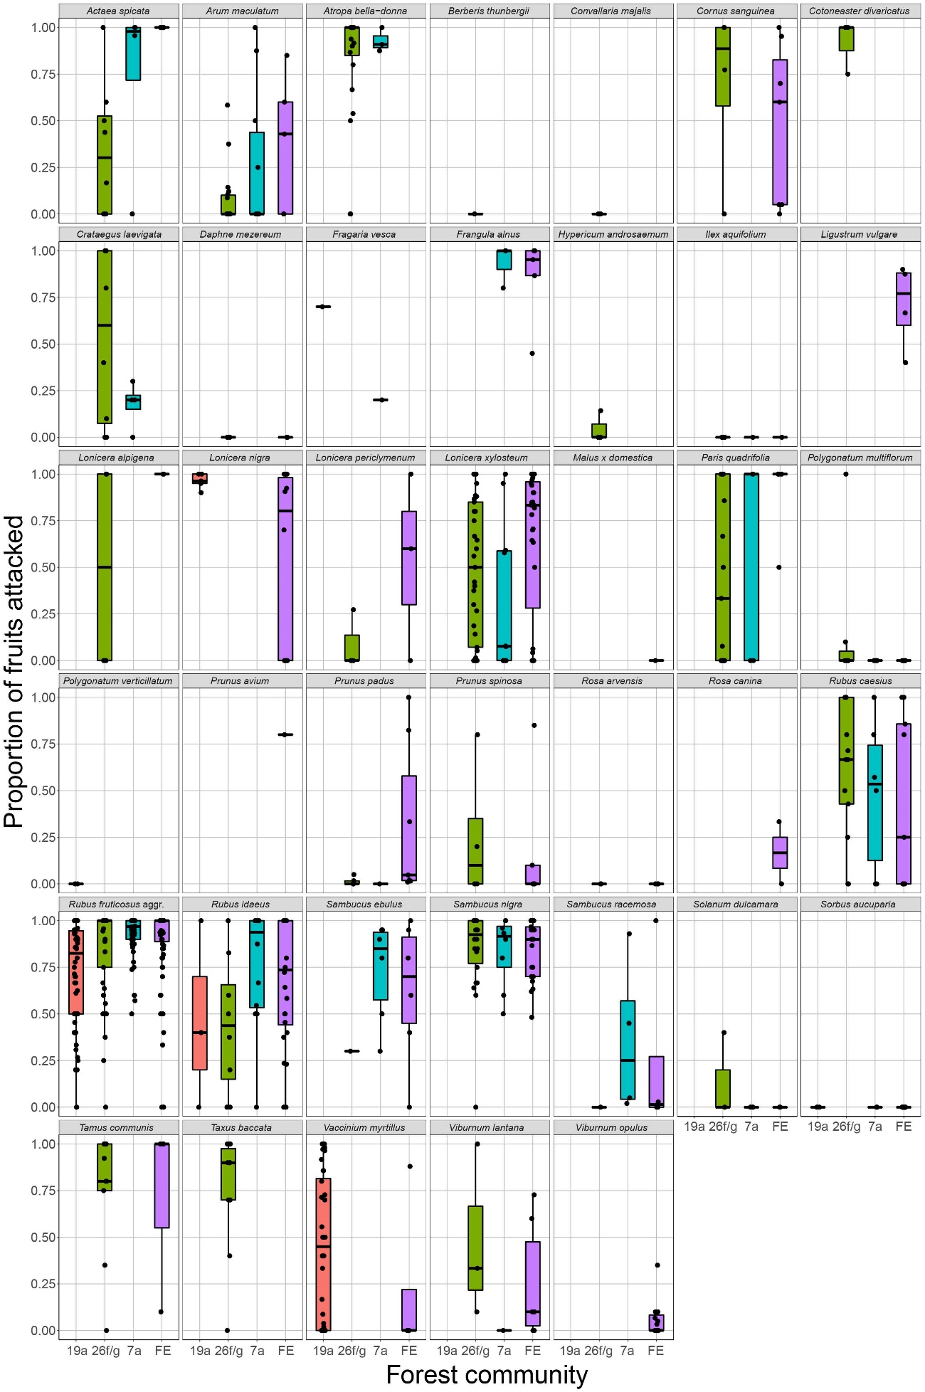
Figure S1. Boxplots (median, 25%/75% quantiles, min and max values) of proportions of fruits attacked by Drosophila suzukii per species, including fruits outside the plots, separated by forest community. 7a – GALIO ODORATI-FAGETUM TYPICUM, 19a – ABIETI-FAGETUM LUZULETOSUM, 26f/g – ACERI-FRAXINETUM MERCURIALIDETOSUM, FE = forest edge.
Supplementary material S2
Insect taxa abundances, based on catches from cup traps with 3 mm diameter entry holes baited with apple cider vinegar in different forest communities.

Table S2. Insect catches from cup traps with 3 mm diameter entry holes baited with apple cider vinegar in different forest communities. 7a – GALIO ODORATI-FAGETUM TYPICUM, 19a – ABIETI-FAGETUM LUZULETOSUM, 26f/g – ACERI-FRAXINETUM MERCURIALIDETOSUM, FE = forest edge.
Data type: xls
Explanation note: Diptera were identified to the family level. Within drosophilids, Drosophila suzukii was distinguished from “other drosophilids”. Hymenoptera were divided into Formicidae and “other Hymenoptera” (often parasitic wasps). Coleoptera were classified into Staphylinidae and “other Coleoptera” (mostly Nitidulidae). Further categories were Dermaptera (Forficulidae) and “other” (spiders, cockroaches etc.).

