Supporting Information

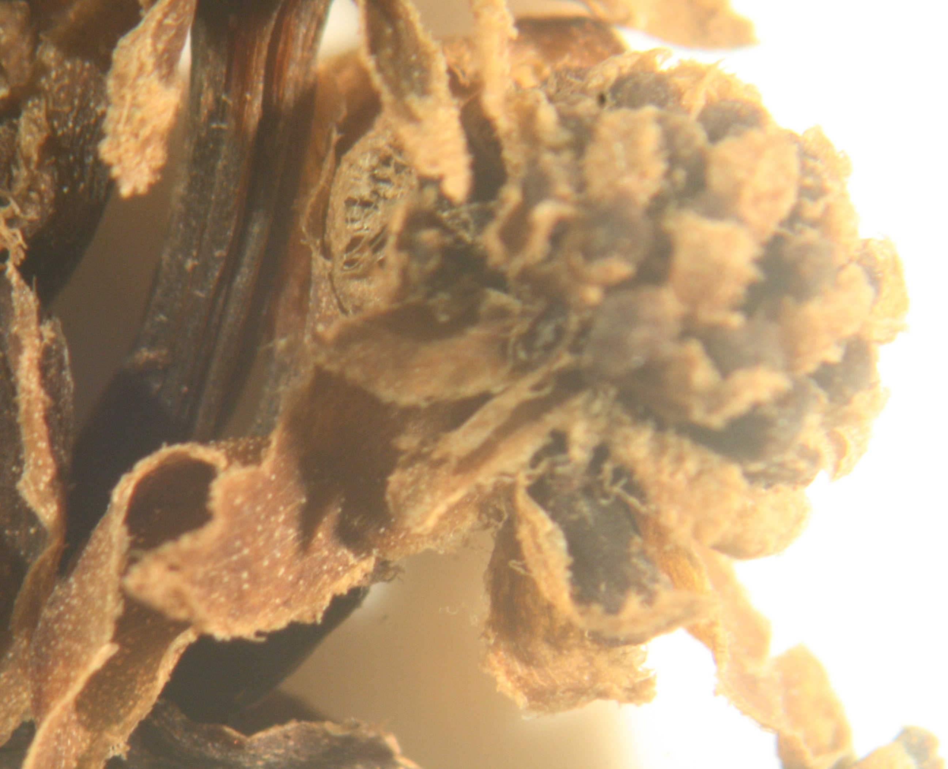
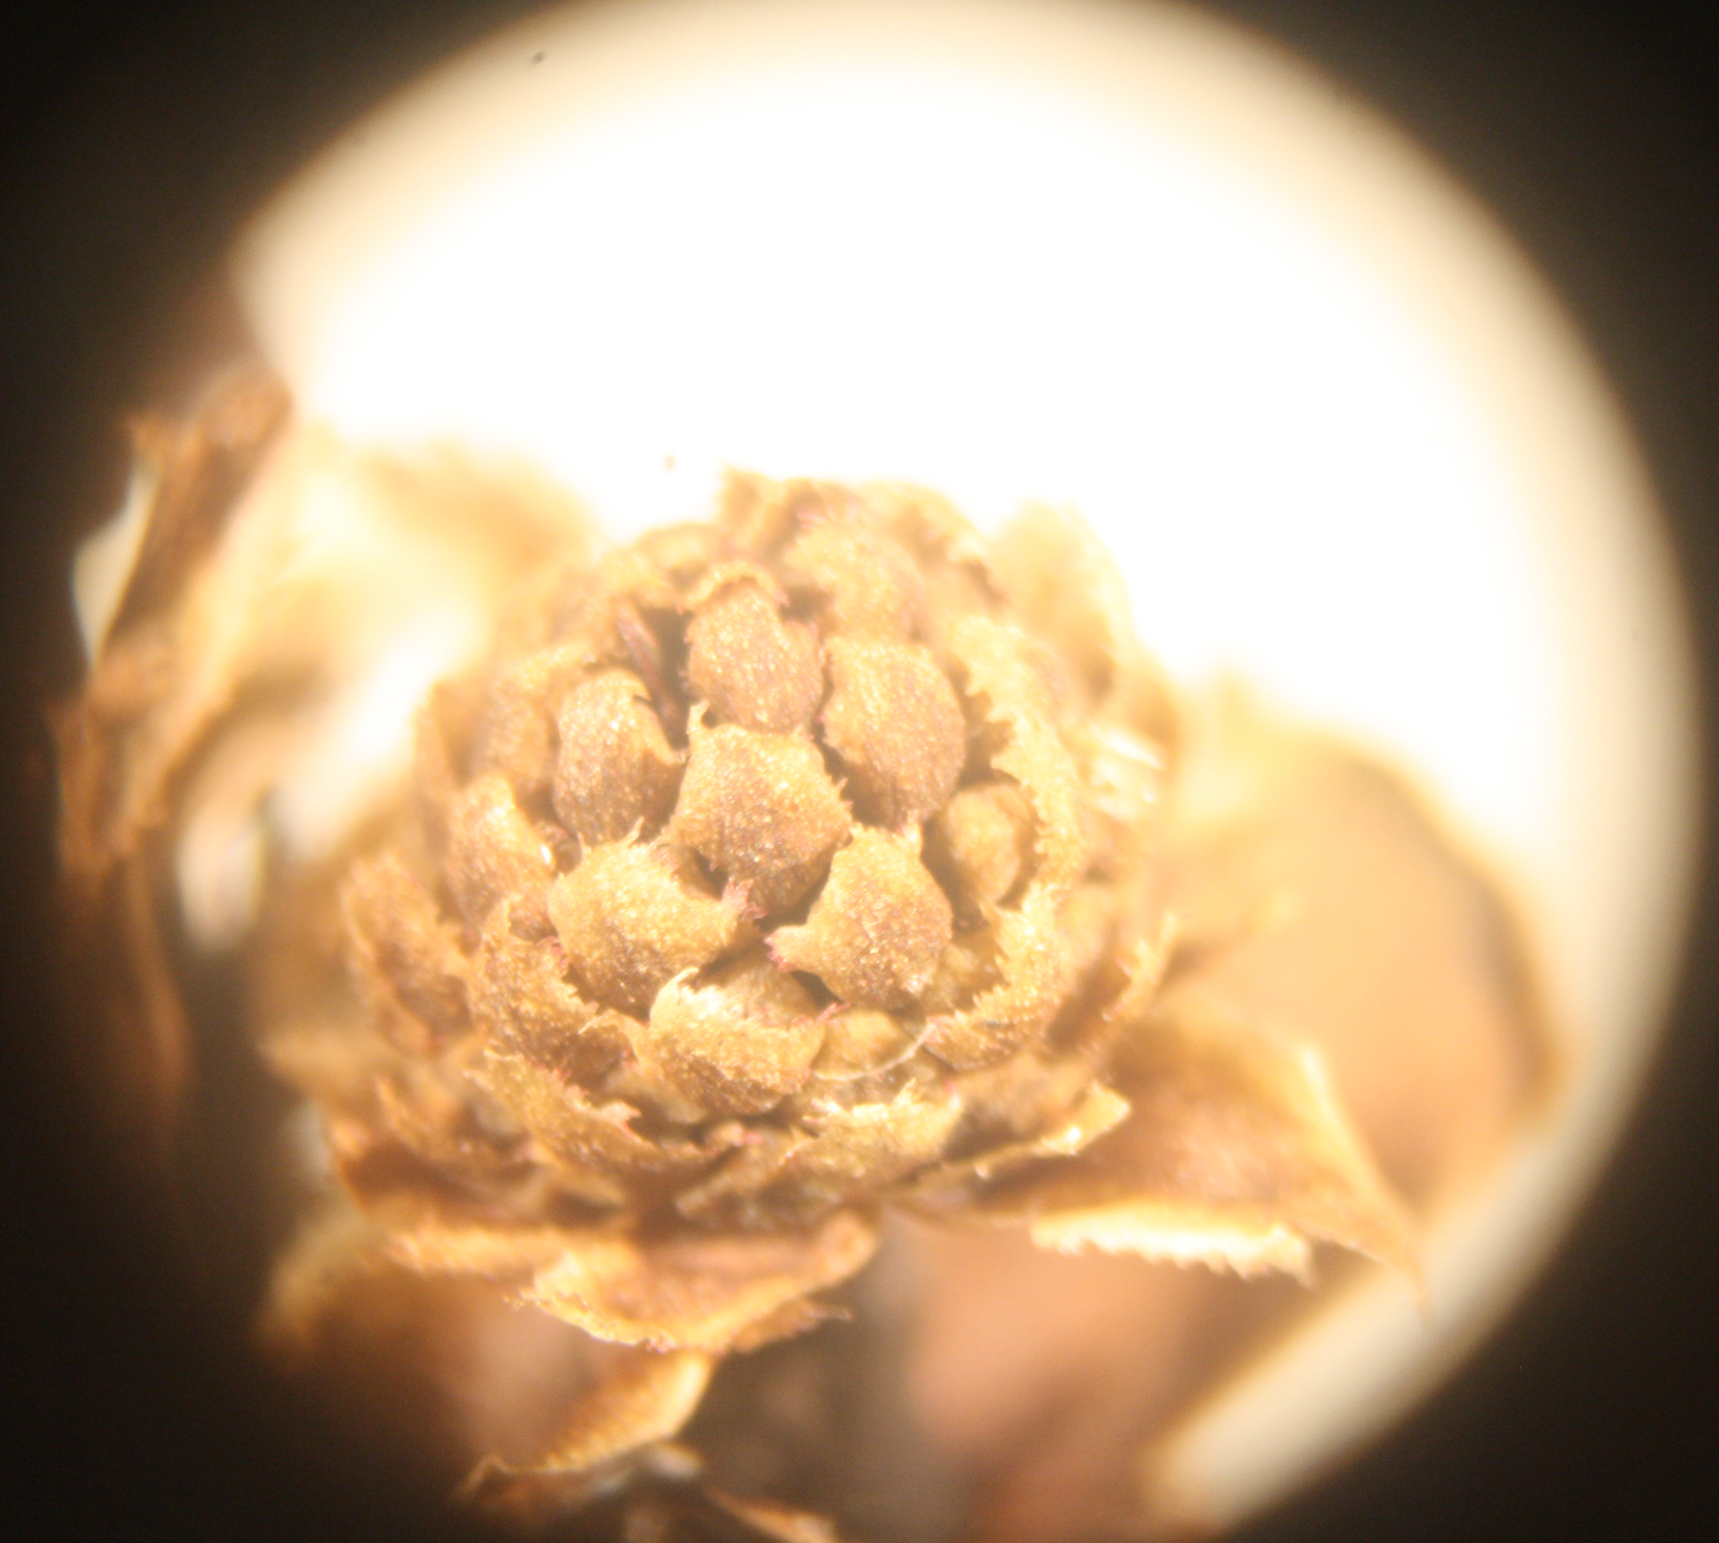

Figure S1: Immature flower of O. oliveri (left) and type specimen of O. truncatum (right)

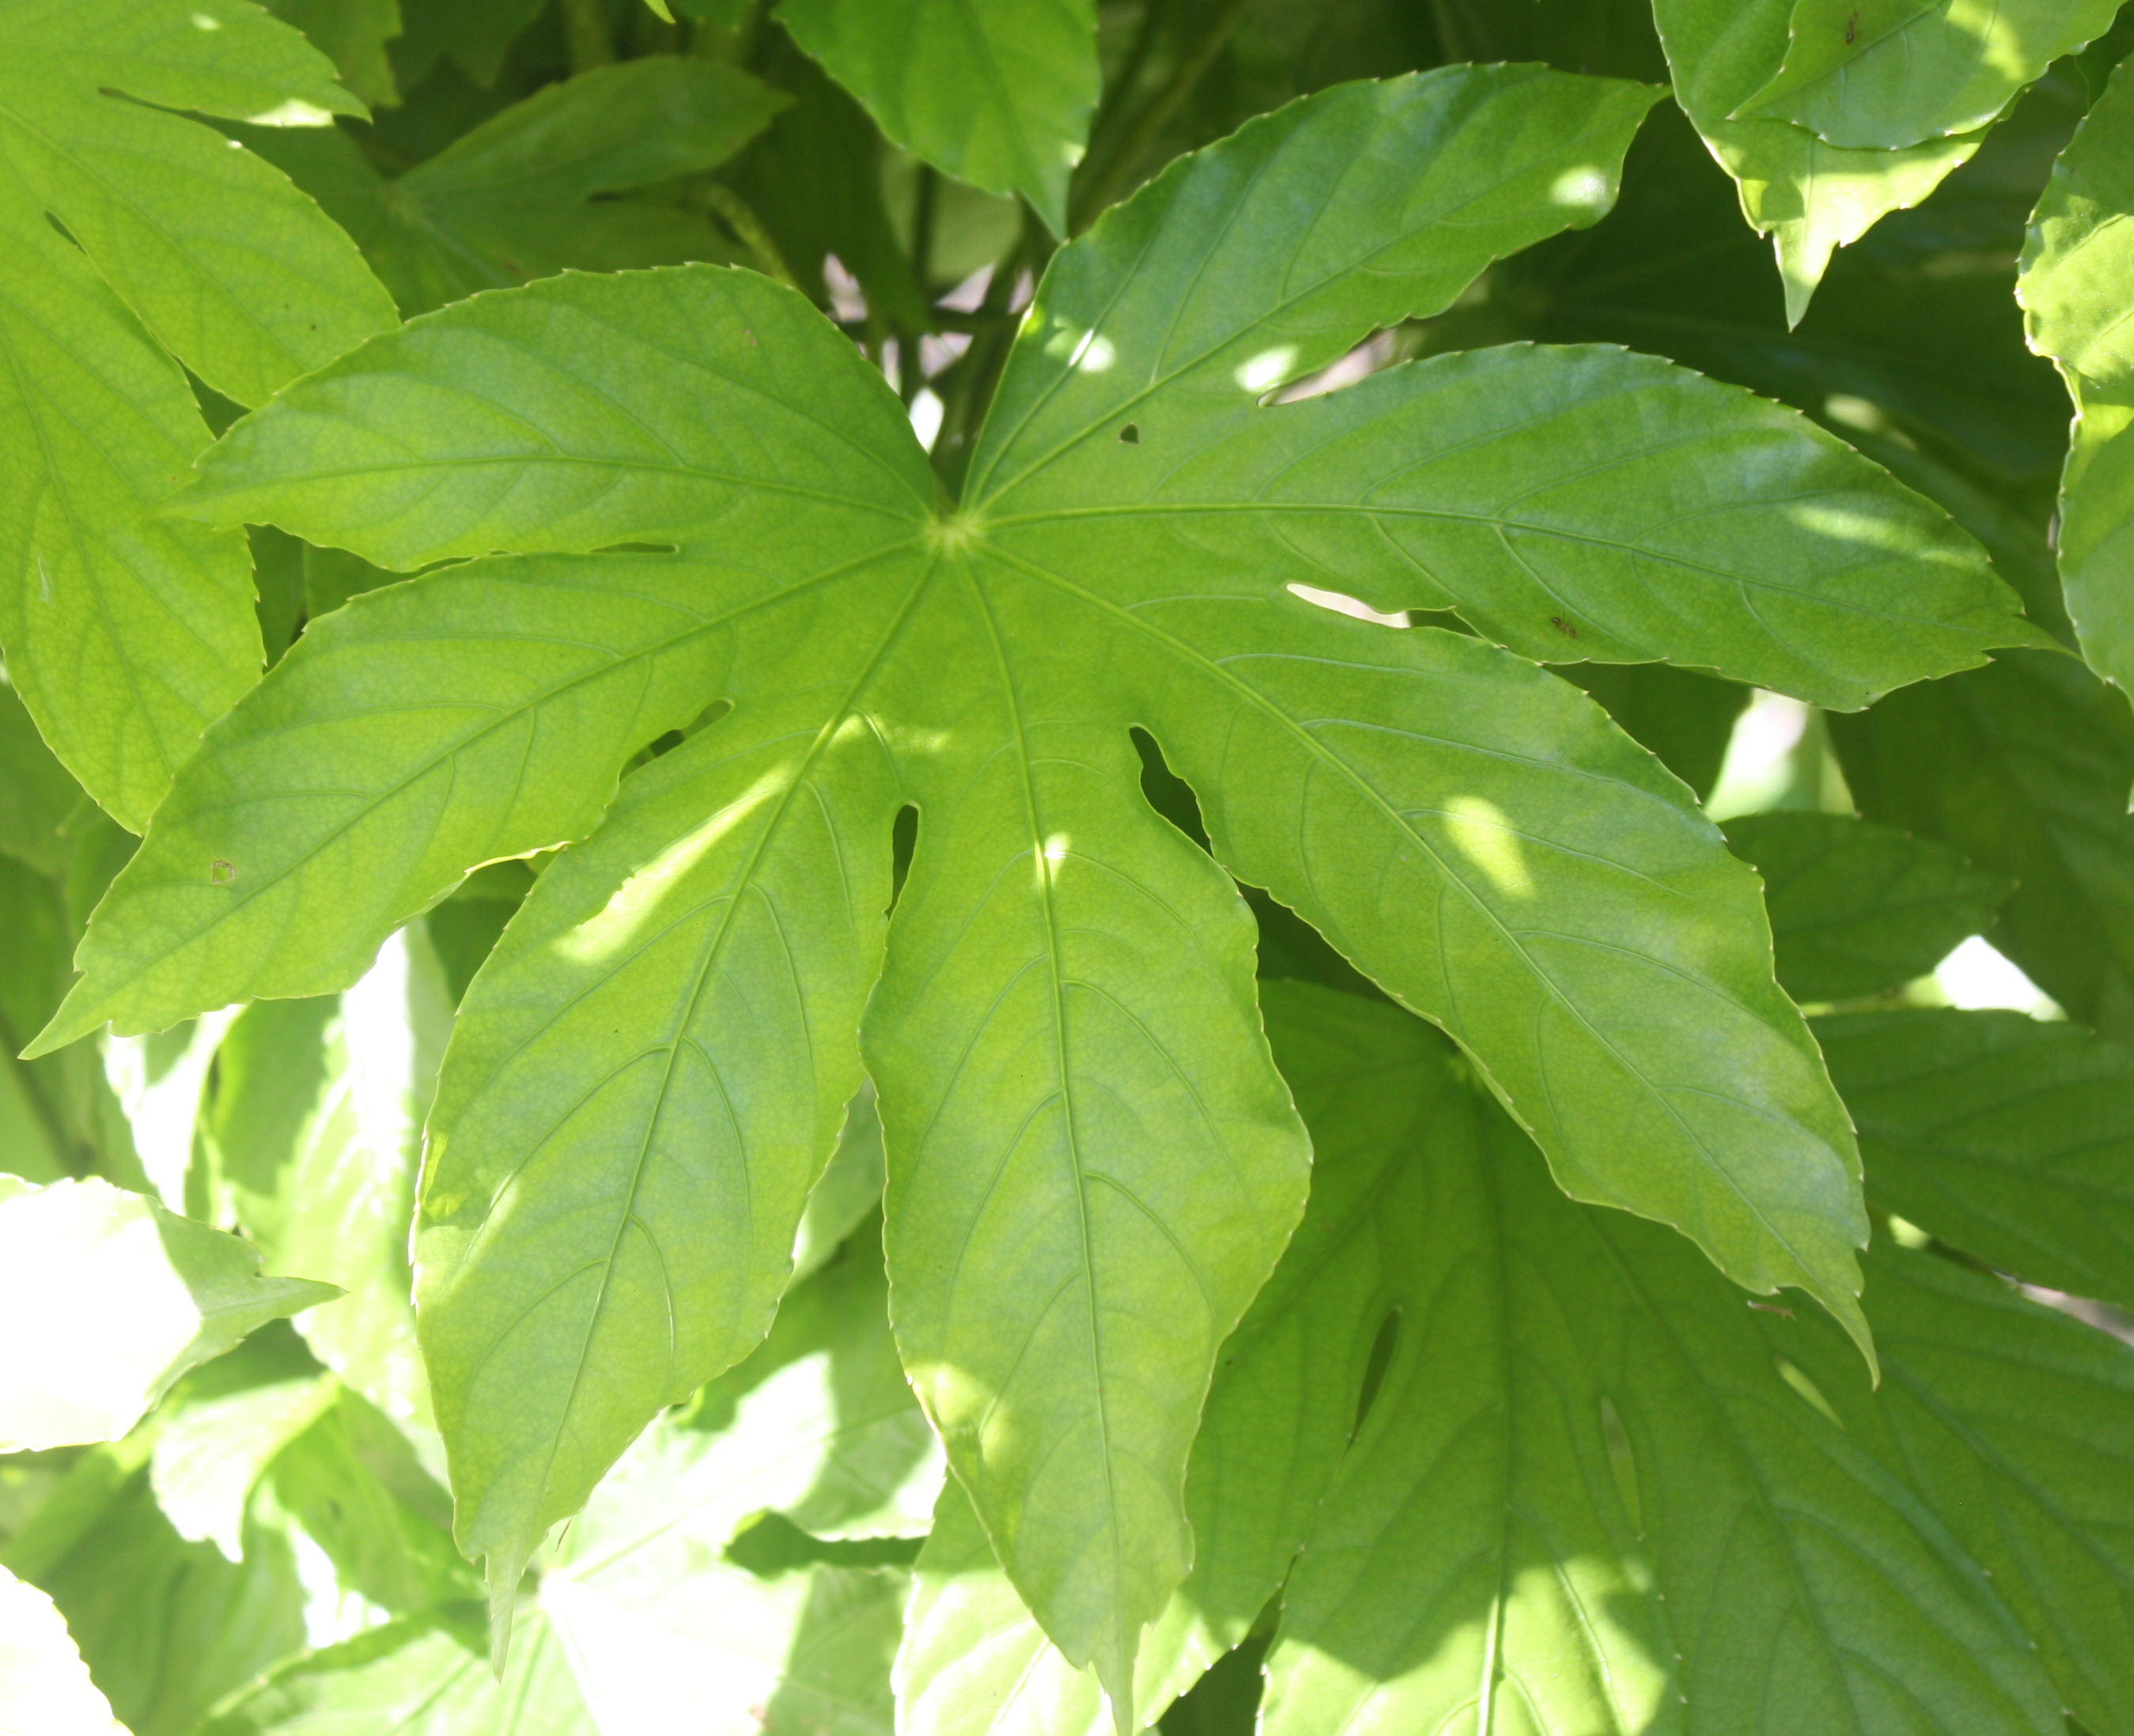
Figure S2: Costion 3987, Osmoxylon oliveri tree with re-emergent shoots having 7-lobed leaves

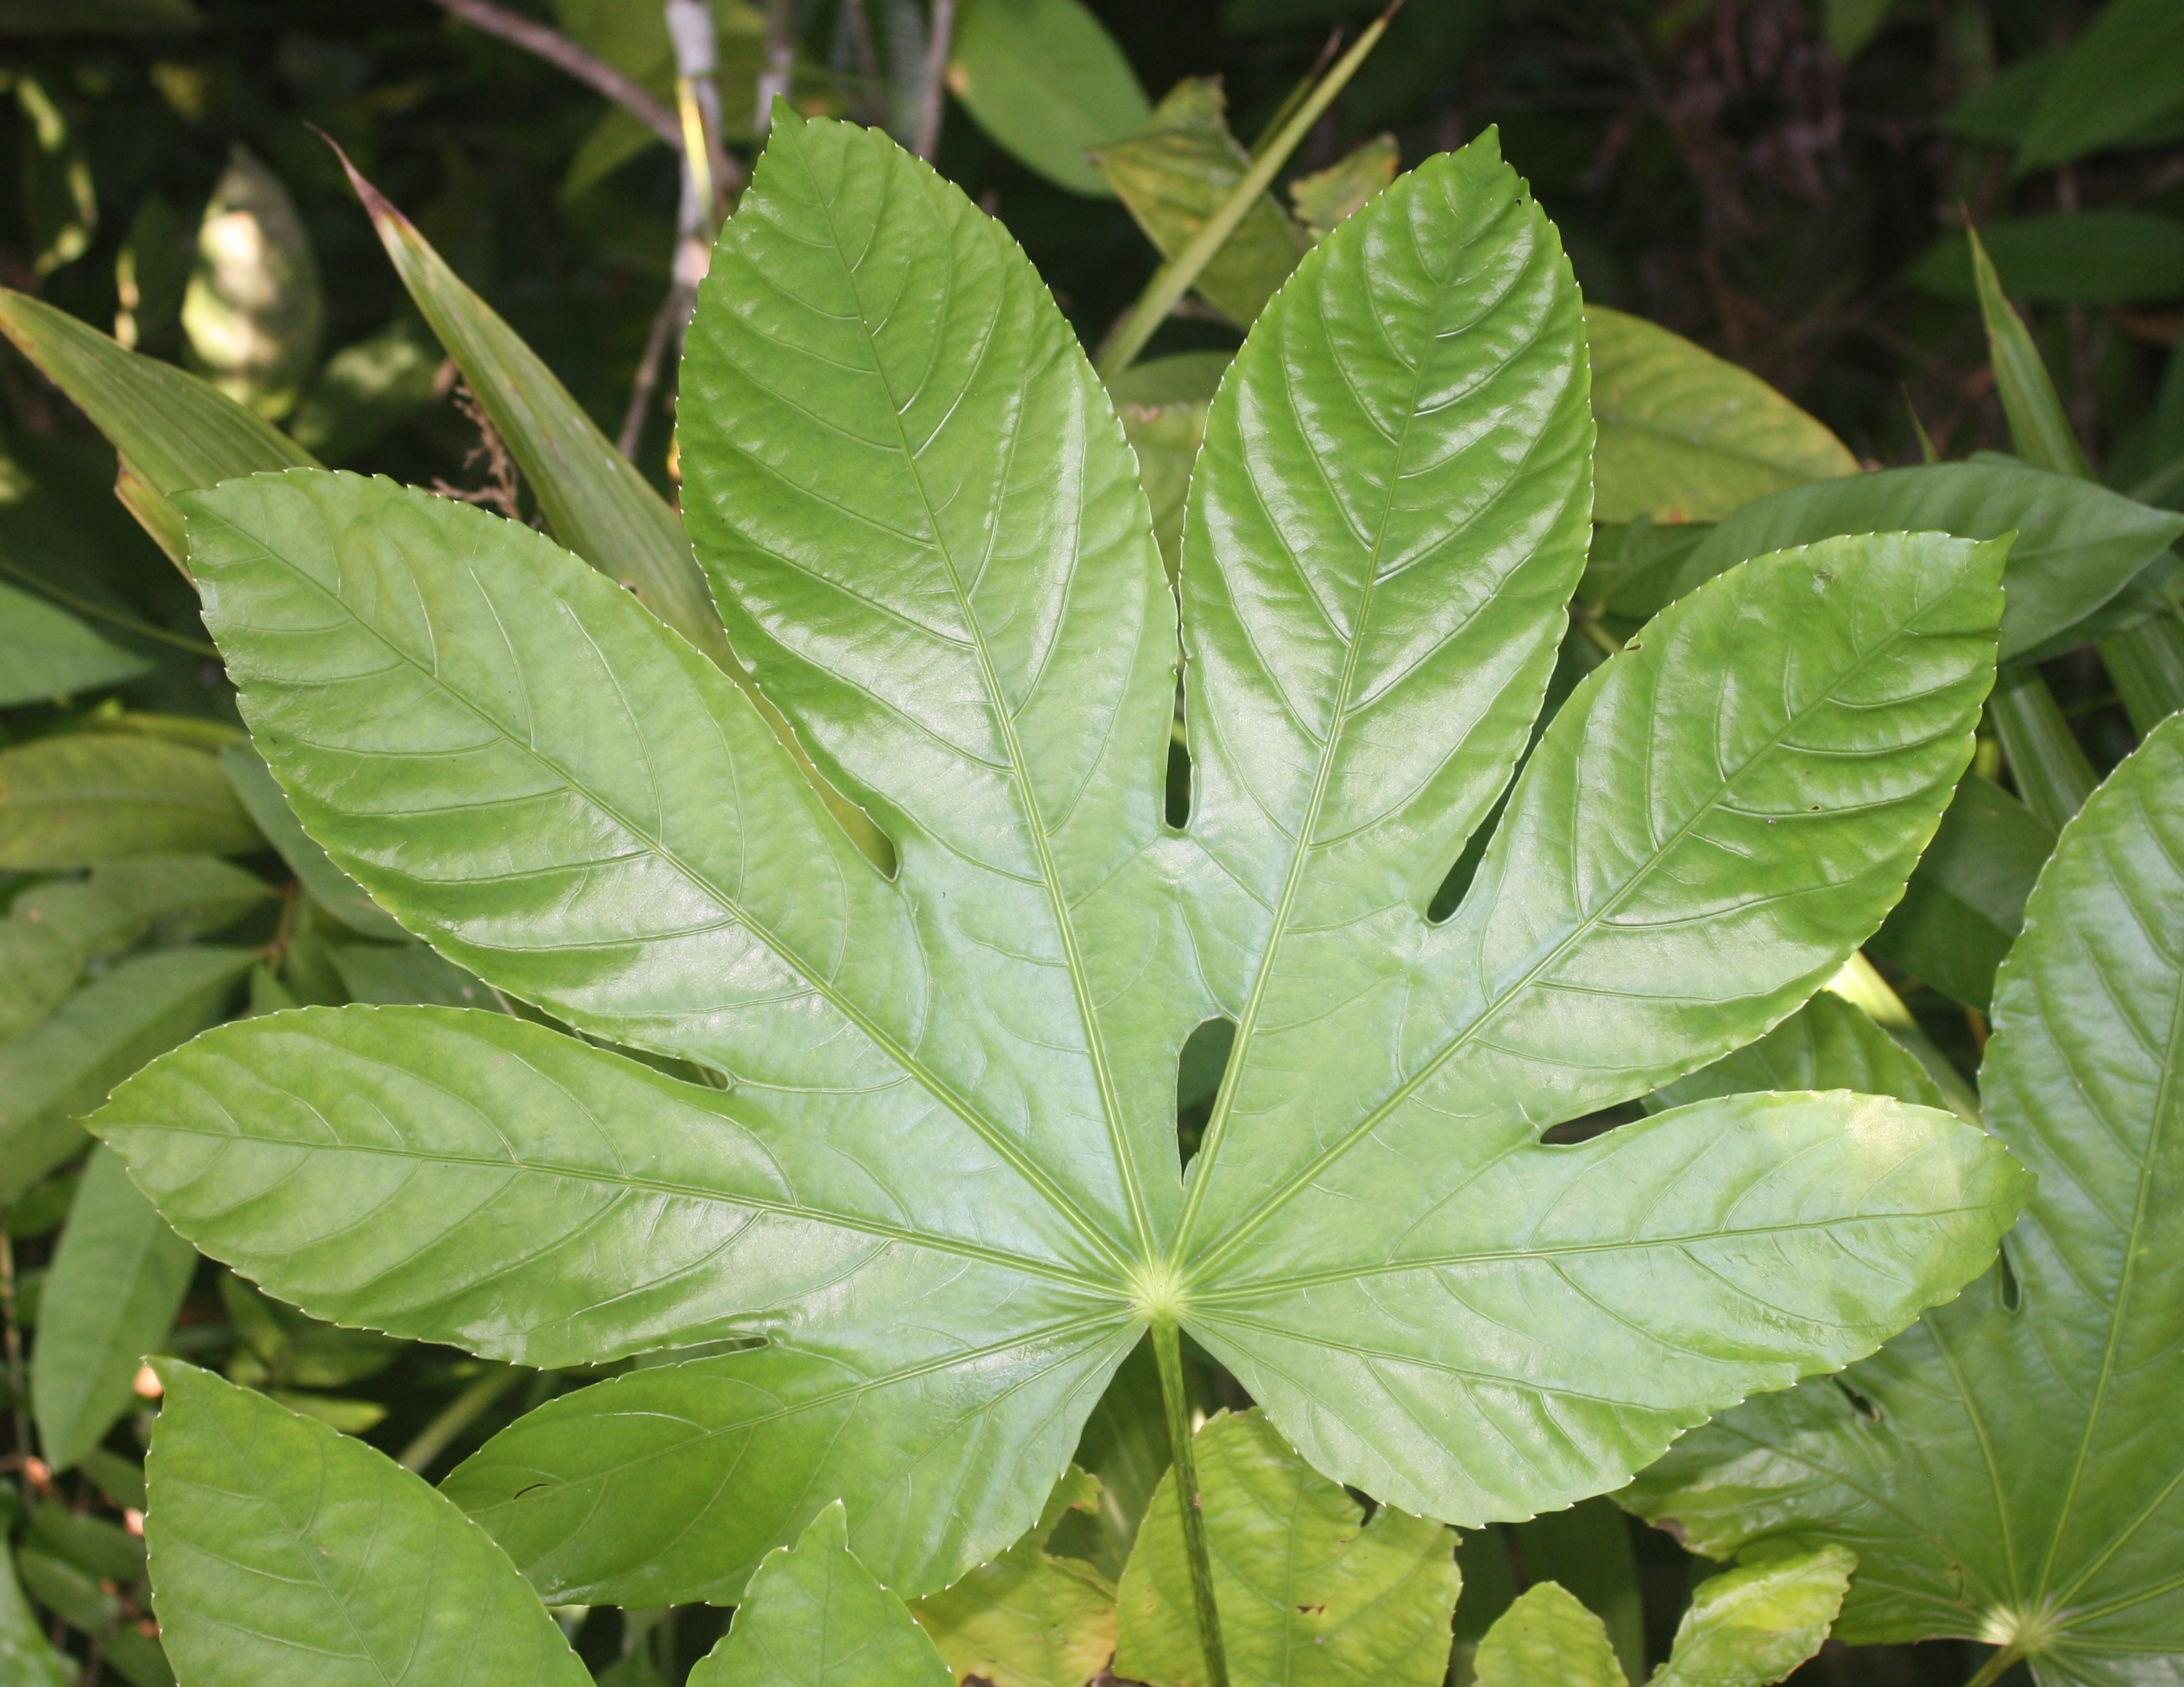
Figure S3: Costion 3988, Osmoxylon oliveri sapling with 7-lobed, truncate leaves

