Title: Comparing Field-Based Management Approaches for Invasive Winter Heliotrope (Petasites pyrenaicus: Asteraceae)
Journal: NeoBiota
Authors: Daniel Jones^{1,2}, Mike S. Fowler¹, Sophie Hocking¹ and Daniel Eastwood¹
¹Department of Biosciences, Swansea University, UK
²Advanced Invasives Ltd, Cardiff, UK
Corresponding author email address: daniel.ll.jones@gmail.com

Supplementary resource 2: Field trial site treatment group assignment.

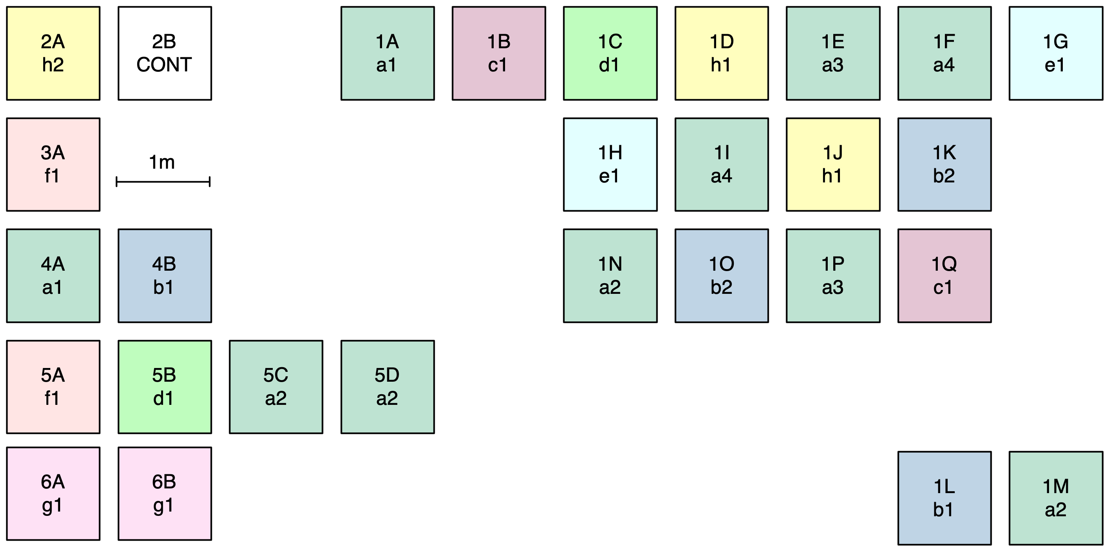

Supplementary Fig. S2.1 Schematic of Petasites pyrenaicus field trial at the Invasives Research Centre (IRC; Taffs Well) showing treatment and (untreated) control plot assignment across experimental blocks 1-6. Shading highlights different treatment groups; please refer to Table 1 for treatment group assignment.

