Tables

Table S1. Species and life stage included in the communities, and the origin of the specimens used in the experiment. Abbreviations: ¹: Reptilgrottan (Sweden); ²: Lindesro AB (Sweden); ³: Fibe AB (Sweden); UM: University of Montana; SU: Stockholm University.

Species | Order | Life stage | Origin
Acheta domesticus | Orthoptera | Adult | Commercially purchased ¹
Aphidius colemani | Diptera | Adult | Commercially purchased ²
Aphidius ervi | Diptera | Adult | Commercially purchased ²
Aphidoletes aphidimyza | Diptera | Adult | Commercially purchased ²
Blaptica dubia | Blattodea | Adult | Commercially purchased ¹
Bombus pascuorum | Hymenoptera | Adult | Collected in NRM surroundings
Calliphora vomitoria | Diptera | Adult | Commercially purchased ³
Chrysoperla carnea | Neuroptera | Nymph | Commercially purchased ²
Cryptolaemus montrouzieri | Coleoptera | Adult | Commercially purchased ²
Dacnusa sibirica | Hymenoptera | Adult | Commercially purchased ²
Dermestes haemorrhoidalis | Coleoptera | Adult | Donated by NRM vertebrate collection
Drosophila hydei | Diptera | Adult | Commercially purchased ¹
Drosophila melanogaster | Diptera | Adult | Donated by Brandon Cooper (UM)
Drosophila simulans | Diptera | Adult | Donated by Brandon Cooper (UM)
Drosophila yakuba | Diptera | Adult | Donated by Brandon Cooper (UM)
Encarsia formosa | Hymenoptera | Adult | Commercially purchased ²
Folsomia candida | Entomobryomorpha | Adult | Commercially purchased ¹
Formica lemani | Hymenoptera | Adult | Collected in NRM surroundings
Formica rufa | Hymenoptera | Adult | Collected in NRM surroundings
Locusta migratoria | Orthoptera | Adult | Commercially purchased ¹
Macrolophus pygmaeus | Hemiptera | Adult | Commercially purchased ²
Polygonia c-album | Lepidoptera | Adult | Donated by Laura van Dijk (SU)
Porcellionides pruinosus | Isopoda | Adult | Commercially purchased ¹
Tuberculatus annulatus | Hemiptera | Adult | Donated by Laura van Dijk (SU)

Table S2. Concentration and purity of the DNA extracts.

Sample | Concentration (ng/µL) | A260/A28
A1.1.1 | 7.6 | 1.336
B1.1.1 | 32 | 1.882
C1.1.1 | 52 | 1.857
D1.1.1 | 20 | 1.754
E1.1.1 | 32 | 1.882
F1.1.1 | 49 | 2
G1.1.1 | 25.5 | 1.835
H1.1.1 | 45 | 1.731
I1.1.1 | 37 | 1.805
J1.1.1 | 112 | 1.612
A1.1.2 | 4.6 | 1.444
B1.1.2 | 5.5 | 1.416
C1.1.2 | 8.4 | 1.615
D1.1.2 | 68 | 1.545
E1.1.2 | 5.6 | 1.436
F1.1.2 | 71 | 1.511
G1.1.2 | 5.4 | 1.672
H1.1.2 | 6.5 | 1.843
I1.1.2 | 5.7 | 1.638
J1.1.2 | 6.1 | 1.458
A1.2.1 | 21.5 | 1.83
B1.2.1 | 94.5 | 1.909
C1.2.1 | 79.5 | 1.963
D1.2.1 | 77.5 | 1.925
E1.2.1 | 87.5 | 1.944
F1.2.1 | 45.5 | 1.896
G1.2.1 | 59.5 | 1.983
H1.2.1 | 69.5 | 1.958
I1.2.1 | 138 | 1.663
J1.2.1 | 98.5 | 1.913
A1.2.2 | 5.3 | 1.472
B1.2.2 | 11.7 | 1.773
C1.2.2 | 84 | 1.57
D1.2.2 | 8.9 | 1.627
E1.2.2 | 6.6 | 1.517
F1.2.2 | 9.9 | 1.752
G1.2.2 | 80.5 | 1.519
H1.2.2 | 11.2 | 1.815
I1.2.2 | 8.8 | 1.676
J1.2.2 | 6 | 1.123
A2.1.1 | 22.5 | 1.047
B2.1.1 | 187 | 1.533
C2.1.1 | 74.5 | 1.49
D2.1.1 | 132.5 | 1.506
E2.1.1 | 77.5 | 1.55
F2.1.1 | 100 | 1.55
G2.1.1 | 63.5 | 1.396
H2.1.1 | 85.5 | 1.555
I2.1.1 | 121 | 1.541
J2.1.1 | 173 | 1.511
A2.1.2 | 11.7 | 1.721
B2.1.2 | 12.9 | 1.675
C2.1.2 | 85 | 1.545
D2.1.2 | 11 | 1.618
E2.1.2 | 80 | 1.569
F2.1.2 | 83.5 | 1.59
G2.1.2 | 14 | 1.75
H2.1.2 | 78 | 1.608
I2.1.2 | 84 | 1.585
J2.1.2 | 91.5 | 1.619
A2.2.1 | 120.5 | 1.746
B2.2.1 | 371.5 | 1.987
C2.2.1 | 228 | 1.953
D2.2.1 | 256.5 | 1.769
E2.2.1 | 269.5 | 1.739
F2.2.1 | 193.5 | 1.861
G2.2.1 | 170 | 1.838
H2.2.1 | 203 | 1.829
I2.2.1 | 223 | 1.702
J2.2.1 | 145.5 | 1.732
A2.2.2 | 8.7 | 1.45
B2.2.2 | 83 | 1.596
C2.2.2 | 91 | 1.685
D2.2.2 | 97.5 | 1.699
E2.2.2 | 23 | 1.749
F2.2.2 | 114.5 | 1.672
G2.2.2 | 21.5 | 1.748
H2.2.2 | 25.5 | 1.861
I2.2.2 | 95.5 | 1.619
J2.2.2 | 35.5 | 1.972

Table S3. Split-split-plot analysis of the concentration of the DNA extracts. Asterisks indicate levels of significance: * p-value < 0.05; ** p-value < 0.01; *** p-value < 0.001.

Factor | Df | Sum Sq | Mean Sq | F value | p
Buffer | 1 | 95358 | 95358 | 56.1690 | < 0.001 ***
Error | 9 | 15279 | 1698
Lysis time | 1 | 31745 | 31745 | 22.0823 | < 0.001 ***
Buffer*Lysis time | 1 | 7656 | 7656 | 5.3256 | 0.033 *
Error | 18 | 25876 | 1438
Purification | 1 | 100437 | 100437 | 69.0321 | < 0.001 ***
Buffer*Purification | 1 | 21347 | 21347 | 14.6719 | < 0.001 ***
Lysis time*Purification | 1 | 24964 | 24964 | 17.1583 | < 0.001 ***
Buffer*Lysis time*Purification | 1 | 24964 | 7734 | 5.3159 | 0.027 *
Error | 36 | 52378 | 1455

Table S4. Split-split-plot analysis of the purity of the DNA extracts. Asterisks indicate levels of significance: * p-value < 0.05; ** p-value < 0.01; *** p-value < 0.001.

Factor | Df | Sum Sq | Mean Sq | F value | p
Buffer | 1 | 0.04675 | 0.04675 | 3.1122 | 0.111
Error | 9 | 0.13521 | 0.01502
Lysis time | 1 | 0.42108 | 0.42108 | 64.9181 | < 0.001 ***
Buffer*Lysis time | 1 | 0.09059 | 0.09059 | 13.9656 | 0.001 **
Error | 18 | 0.11675 | 0.00649
Purification | 1 | 0.28322 | 0.28322 | 13.0630 | < 0.001 ***
Buffer*Purification | 1 | 0.41357 | 0.41357 | 19.0751 | < 0.001 ***
Lysis time*Purification | 1 | 0.17391 | 0.17391 | 8.0214 | < 0.007 **
Buffer*Lysis time*Purification | 1 | 0.03536 | 0.03536 | 1.6311 | 0.209
Error | 36 | 0.78052 | 0.02168

Table S5. Split-split-plot analysis of the species recovered by COI. Asterisks indicate levels of significance: * p-value < 0.05; ** p-value < 0.01; *** p-value < 0.001.

Factor | Df | Sum Sq | Mean Sq | F value | p
Buffer | 1 | 6.7919 | 6.7919 | 8.4006 | 0.017 *
Error | 9 | 7.2766 | 0.8085
Lysis time | 1 | 0.3807 | 0.3807 | 1.4283 | 0.247
Buffer*Lysis time | 1 | 0.7434 | 0.7434 | 2.7893 | 0.112
Error | 18 | 4.7972 | 0.2665
Purification | 1 | 3.9114 | 3.9114 | 5.8246 | 0.021 *
Buffer*Purification | 1 | 0.0005 | 0.0005 | 0.0008 | 0.977
Lysis time*Purification | 1 | 0.0627 | 0.0627 | 0.0934 | 0.761
Buffer*Lysis time*Purification | 1 | 1.3889 | 1.3889 | 2.0682 | 0.159
Error | 35 | 23.5038 | 0.6715

Table S6. Split-split-plot analysis of the species recovered by 16S. Asterisks indicate levels of significance: * p-value < 0.05; ** p-value < 0.01; *** p-value < 0.001.

Factor | Df | Sum Sq | Mean Sq | F value | p
Buffer | 1 | 3.6125 | 3.6125 | 1.8834 | 0.203
Error | 9 | 17.2625 | 1.9181
Lysis time | 1 | 2.1125 | 2.1125 | 2.4493 | 0.135
Buffer*Lysis time | 1 | 2.1125 | 2.1125 | 2.4493 | 0.135
Error | 18 | 15.5250 | 0.8625
Purification | 1 | 0.0125 | 0.0125 | 0.0857 | 0.771
Buffer*Purification | 1 | 0.0125 | 0.0125 | 0.0857 | 0.771
Lysis time*Purification | 1 | 0.0125 | 0.0125 | 0.7714 | 0.385
Buffer*Lysis time*Purification | 1 | 0.0125 | 0.0125 | 0.7714 | 0.385
Error | 36 | 5.2500 | 0.1458

Table S7. Split-plot analysis of the reduction in H’ between estimated community composition using COI metabarcoding and actual community composition based on biomass. Asterisks indicate levels of significance: * p-value < 0.05; ** p-value < 0.01; *** p-value < 0.001.

Factor | Df | Sum Sq | Mean Sq | F value | p
Buffer | 1 | 2.00363 | 2.00363 | 13.9469 | 0.004 **
Error | 9 | 1.29295 | 0.14366
Lysis time | 1 | 0.00655 | 0.00655 | 0.0571 | 0.813
Buffer*Lysis time | 1 | 0.09723 | 0.09723 | 0.8483 | 0.369
Error | 18 | 2.06321 | 0.11462

Table S8. Split-plot analysis of the reduction in H’ between estimated community composition using COI metabarcoding and actual community composition based on the number of specimens. Asterisks indicate levels of significance: * p-value < 0.05; ** p-value < 0.01; *** p-value < 0.001.

Factor | Df | Sum Sq | Mean Sq | F value | p
Buffer | 1 | 2.00363 | 2.00363 | 13.9469 | 0.004 **
Error | 9 | 1.29295 | 0.14366
Lysis time | 1 | 0.00655 | 0.00655 | 0.0571 | 0.813
Buffer*Lysis time | 1 | 0.09723 | 0.09723 | 0.8483 | 0.369
Error | 18 | 2.06321 | 0.11462

Table S9. Split-plot analysis of the reduction of H’ between estimated community composition using 16S metabarcoding and actual community composition based on biomass. Asterisks indicate levels of significance: * p-value < 0.05; ** p-value < 0.01; *** p-value < 0.001.

Factor | Df | Sum Sq | Mean Sq | F value | p
Buffer | 1 | 1.95750 | 1.95750 | 16.0041 | 0.003 **
Error | 9 | 1.1008 | 0.12231
Lysis time | 1 | 0.23279 | 0.23279 | 0.9474 | 0.343
Buffer*Lysis time | 1 | 0.21601 | 0.21601 | 0.8795 | 0.360
Error | 18 | 4.4209 | 0.24560

Table S10. Split-plot analysis of the reduction of H’ between estimated community composition using 16S metabarcoding and actual community composition based on the number of specimens. Asterisks indicate levels of significance: * p-value < 0.05; ** p-value < 0.01; *** p-value < 0.001.

Factor | Df | Sum Sq | Mean Sq | F value | p
Buffer | 1 | 1.95750 | 1.95750 | 16.0041 | 0.003 **
Error | 9 | 1.1008 | 0.12231
Lysis time | 1 | 0.23279 | 0.23279 | 0.9474 | 0.343
Buffer*Lysis time | 1 | 0.21601 | 0.21601 | 0.8795 | 0.360
Error | 18 | 4.4209 | 0.24560

Table S11. Split-plot analysis of the Kullback-Leibler divergences between estimated community composition using COI metabarcoding and actual community composition based on biomass. Asterisks indicate levels of significance: * p-value < 0.05; ** p-value < 0.01; *** p-value < 0.001.

Factor | Df | Sum Sq | Mean Sq | F value | p
Buffer | 1 | 1.38•10⁻⁴ | 1.38•10⁻⁴ | 9.0642 | 0.014 *
Error | 9 | 1.37•10⁻⁴ | 1.52•10⁻⁵
Lysis time | 1 | 6.26•10⁻⁷ | 6.26•10⁻⁷ | 0.0547 | 0.817
Buffer*Lysis time | 1 | 3.13•10⁻⁷ | 3.13•10⁻⁷ | 0.0274 | 0.870
Error | 18 | 2.05•10⁻⁴ | 1.14•10⁻⁵

Table S12. Split-plot analysis of the Kullback-Leibler divergences between estimated community composition using COI metabarcoding and actual community composition based on the number of specimens. Asterisks indicate levels of significance: * p-value < 0.05; ** p-value < 0.01; *** p-value < 0.001.

Factor | Df | Sum Sq | Mean Sq | F value | p
Buffer | 1 | 1.60•10⁻⁴ | 1.60•10⁻⁴ | 9.1374 | 0.014 *
Error | 9 | 1.58•10⁻⁴ | 1.76•10⁻⁵
Lysis time | 1 | 6.90•10⁻⁸ | 6.90•10⁻⁸ | 0.0047 | 0.946
Buffer*Lysis time | 1 | 1.70•10⁻⁷ | 1.70•10⁻⁷ | 0.0115 | 0.915
Error | 18 | 4.7507 | 0.26393

Table S13. Split-plot analysis of the Kullback-Leibler divergences between estimated community composition using 16S metabarcoding and actual community composition based on biomass. Asterisks indicate levels of significance: * p-value < 0.05; ** p-value < 0.01; *** p-value < 0.001.

Factor | Df | Sum Sq | Mean Sq | F value | p
Buffer | 1 | 9.99•10⁻⁵ | 9.99•10⁻⁵ | 8.1559 | 0.018 *
Error | 9 | 1.10•10⁻⁴ | 1.22•10⁻⁵
Lysis time | 1 | 8.86•10⁻⁶ | 8.86•10⁻⁶ | 0.2893 | 0.597
Buffer*Lysis time | 1 | 1.01•10⁻⁴ | 1.01•10⁻⁴ | 3.2862 | 0.086
Error | 18 | 5.51•10⁻⁴ | 3.06•10⁻⁵

Table S14. Split-plot analysis of the Kullback-Leibler divergences between estimated community composition using 16S metabarcoding and actual community composition based on the number of specimens. Asterisks indicate levels of significance: * p-value < 0.05; ** p-value < 0.01; *** p-value < 0.001.

Factor | Df | Sum Sq | Mean Sq | F value | p
Buffer | 1 | 1.23•10⁻⁴ | 1.23•10⁻⁴ | 9.4268 | 0.011 *
Error | 9 | 1.11•10⁻⁴ | 1.24•10⁻⁵
Lysis time | 1 | 1.17•10⁻⁵ | 1.17•10⁻⁵ | 0.3608 | 0.555
Buffer*Lysis time | 1 | 1.03•10⁻⁵ | 1.03•10⁻⁵ | 2.9277 | 0.104
Error | 18 | 6.14•10⁻⁵ | 3.41•10⁻⁵

Figures

Figure S1. Number of species recovered with COI and 16S with the different extraction methods. For 16S (blue) no differences were found between the treatments. For COI (orange), B2–P1 recovered the most species and B1–P2 the least, but the difference between both was of 1. Only Buffer and Purification combinations are shown, as they were the only factors with significant effect for COI.
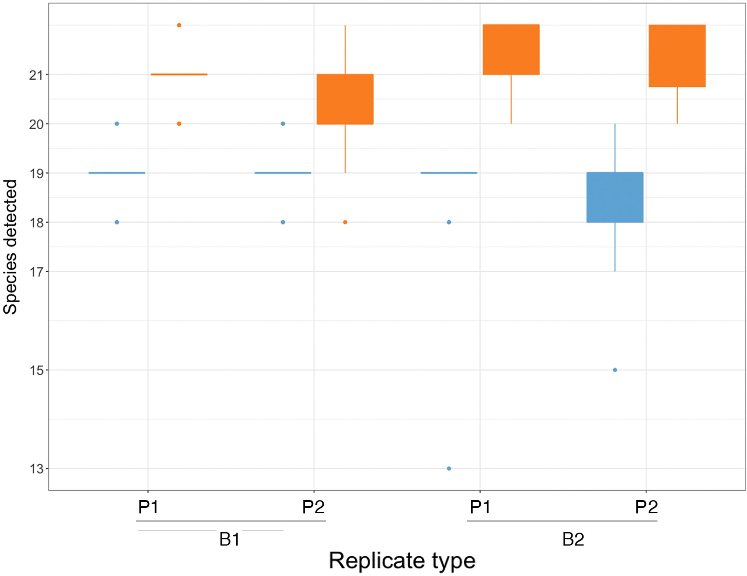

Figure S2. NDMS plot of the Bray-Curtis dissimilarities among the insect community composition recovered with 16S and COI metabarcoding and the actual community composition based on of biomass or number of individuals. The mock communities cluster together when measured in biomass (triangles) and number of individuals (crosses), while metabarcoding estimates of the composition of those communities clustered together regardless of the marker (16S, circles; COI, squares), separated from the actual communities. However, note that the mock communities were quite similar to each other in composition, making it challenging to distinguish them by metabarcoding. Stress = 0.189.
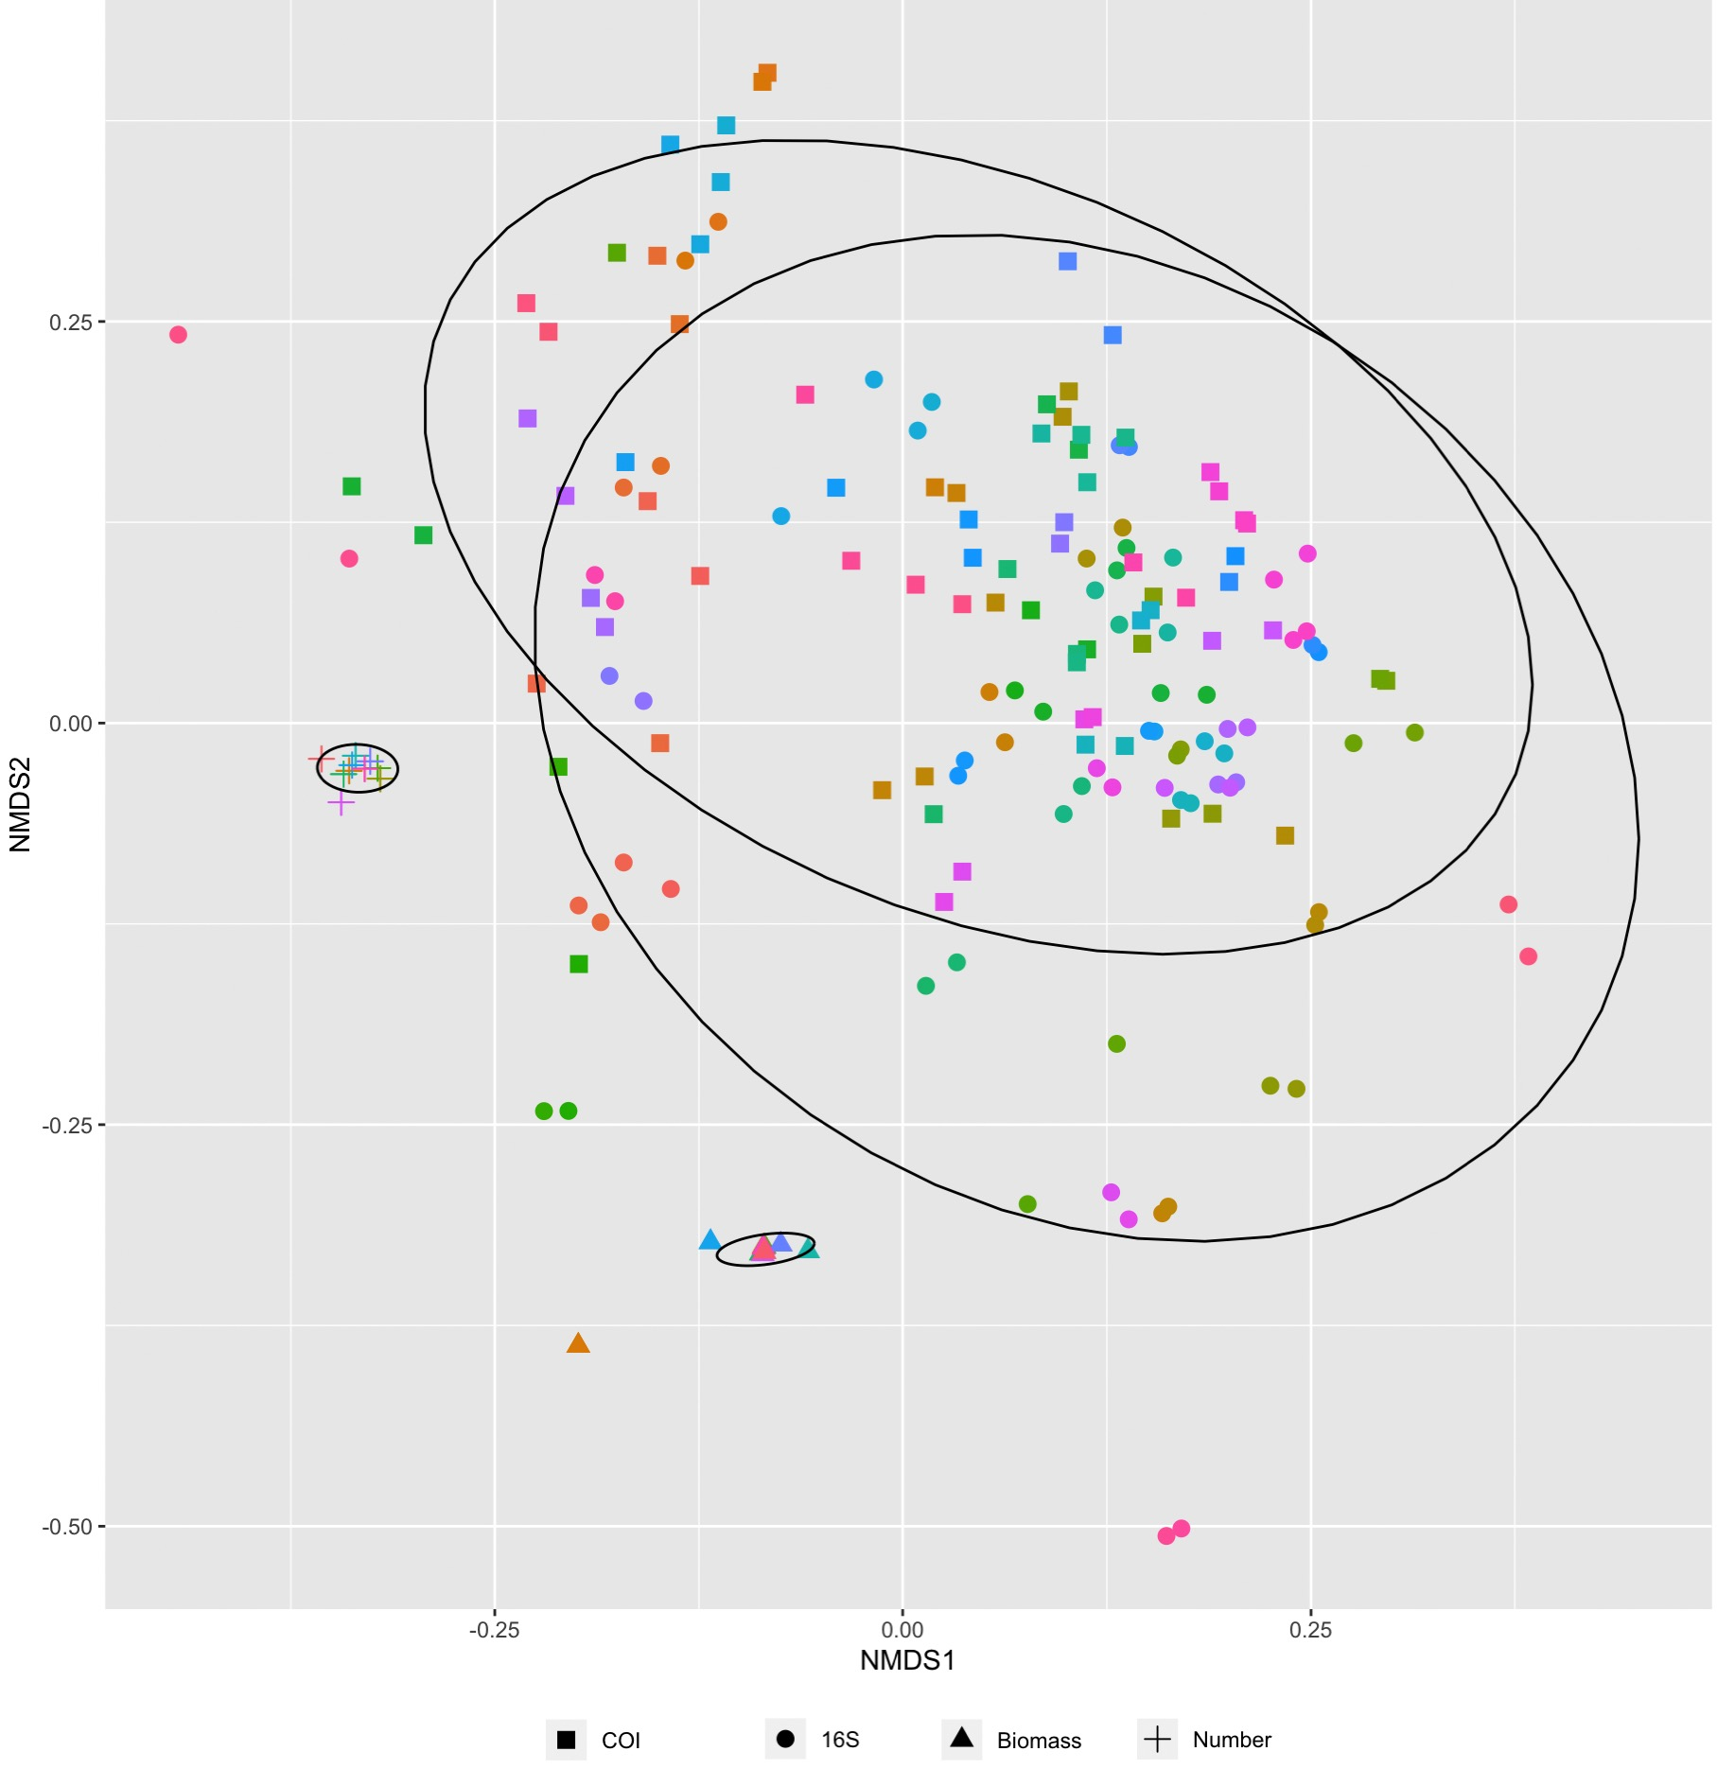

Figure S3. Composition of the samples as proportion of reads from the different communities in the COI dataset. The first two columns of each community represent the actual composition based on biomass and number of individuals. The number of species recovered per sample appears on the top of each bar.
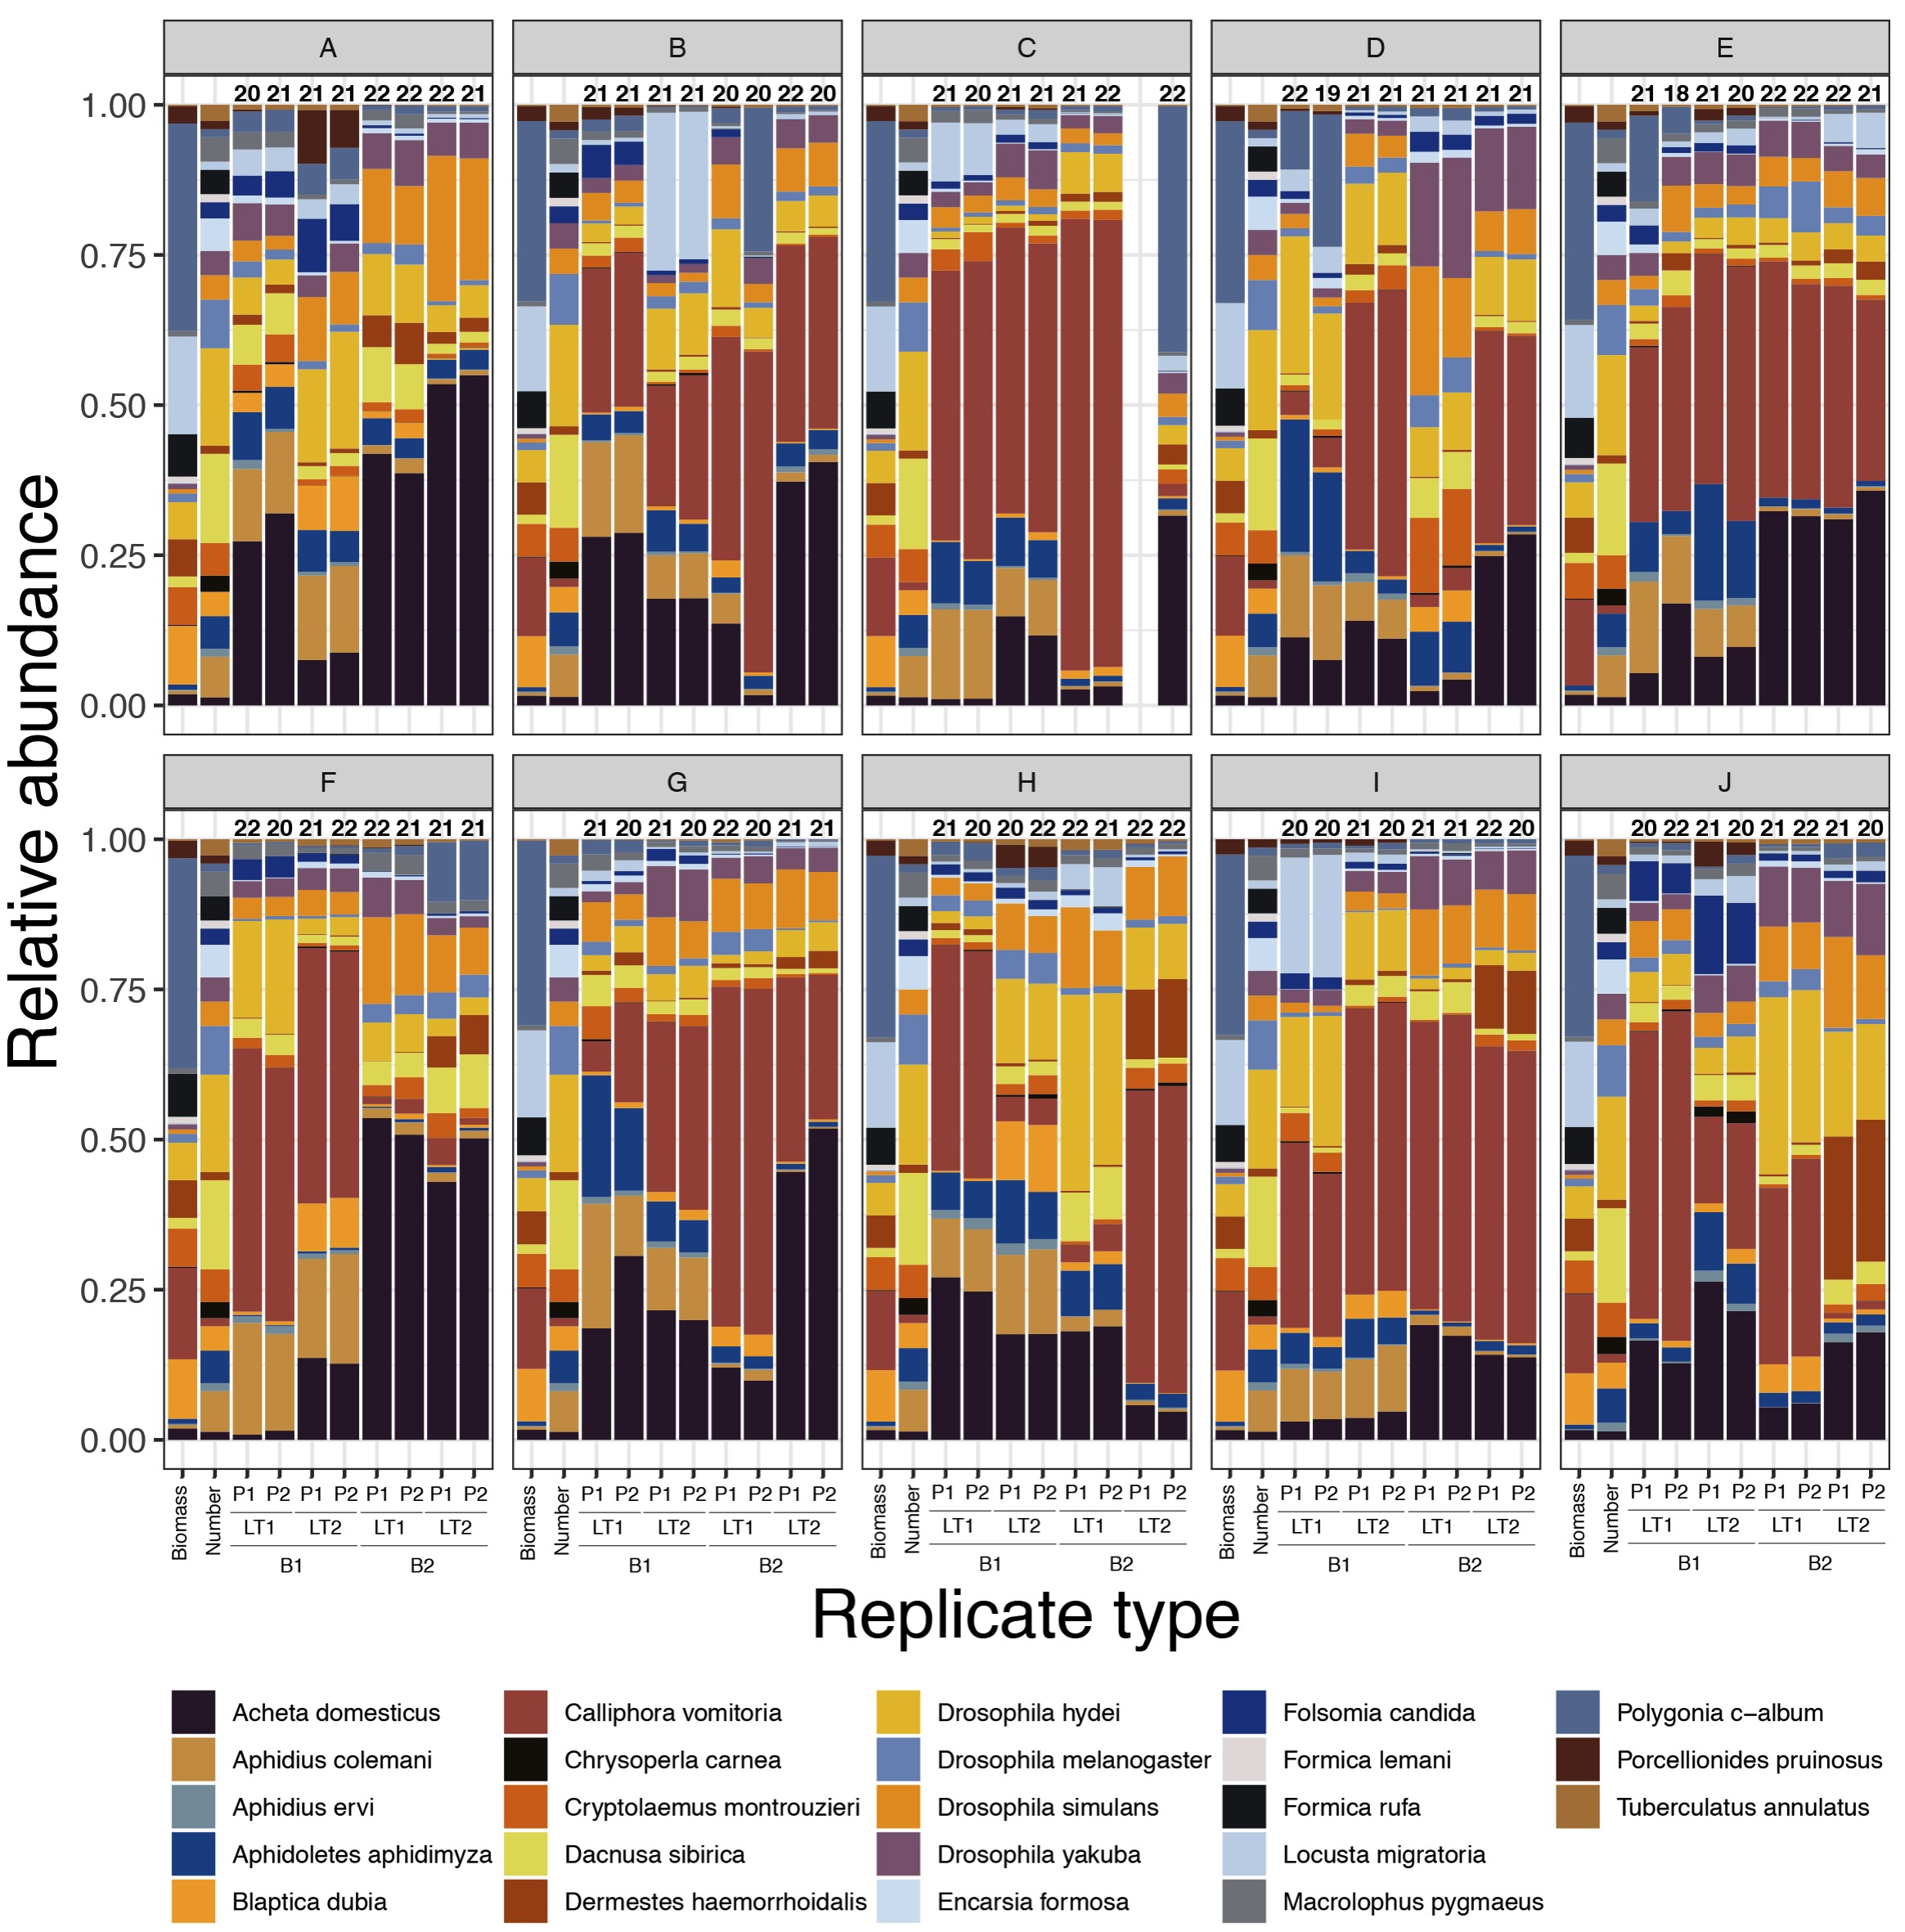

Figure S4. Composition of the samples as proportion of reads from the different communities in the 16S dataset. The first two columns of each community represent the actual composition based on biomass and number of individuals. The number of species recovered per sample appears on the top of each bar.
