Supplementary Information
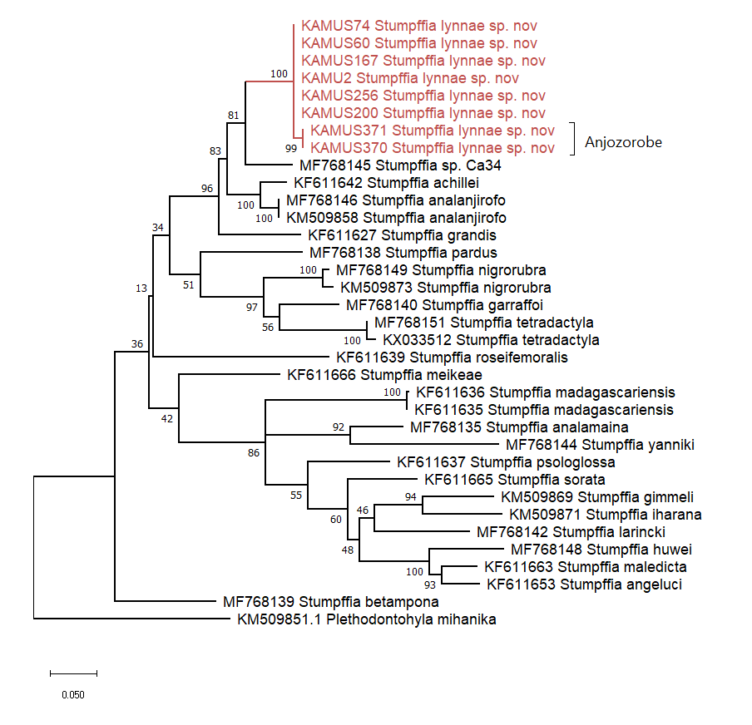
Figure S1. Maximum Likelihood phylogeny of selected Stumpffia species using a 624 bp region of the COI mitochondrial marker, using the HKY+G+I model with 1000 bootstrap replicates.

