Supplementary material

A reassessment of the origin and distribution of the subterranean genus Pseudolimnocythere Klie, 1938 (Ostracoda, Loxoconchidae), with description of two new species from Italy

Giampaolo Rossetti¹, Fabio Stoch², Ilaria Mazzini^{3*}

¹ Department of Chemistry, Life Science and Environmental Sustainability, University of Parma, 43124 Parma, Italy
² Evolutionary Biology & Ecology, Université libre de Bruxelles (ULB), C.P. 160/12, Avenue F.D. Roosevelt 50, 1050, Brussels, Belgium
³ CNR - Institute of Environmental Geology and Geoengineering, Area della Ricerca di Roma 1, Via Salaria km 29,300, 00015 Montelibretti, Rome, Italy

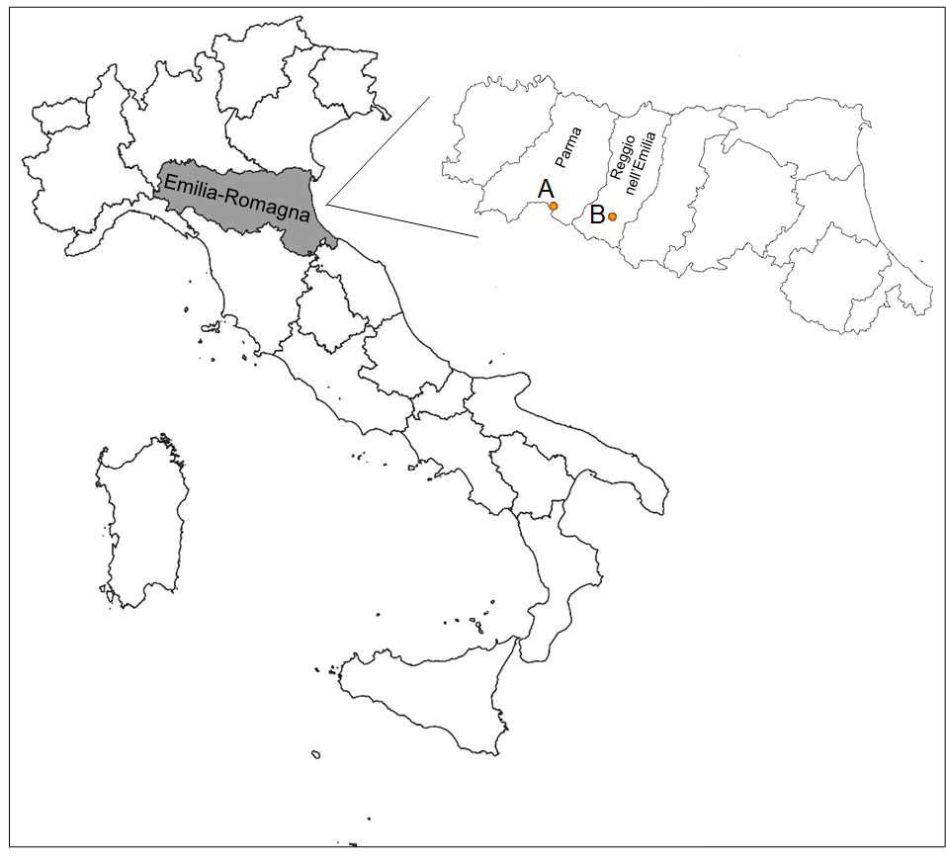

Figure S1 – Geographic location of the type localities of Pseudolimnocythere abdita sp. nov. (A) and P. sofiae sp. nov. (B).

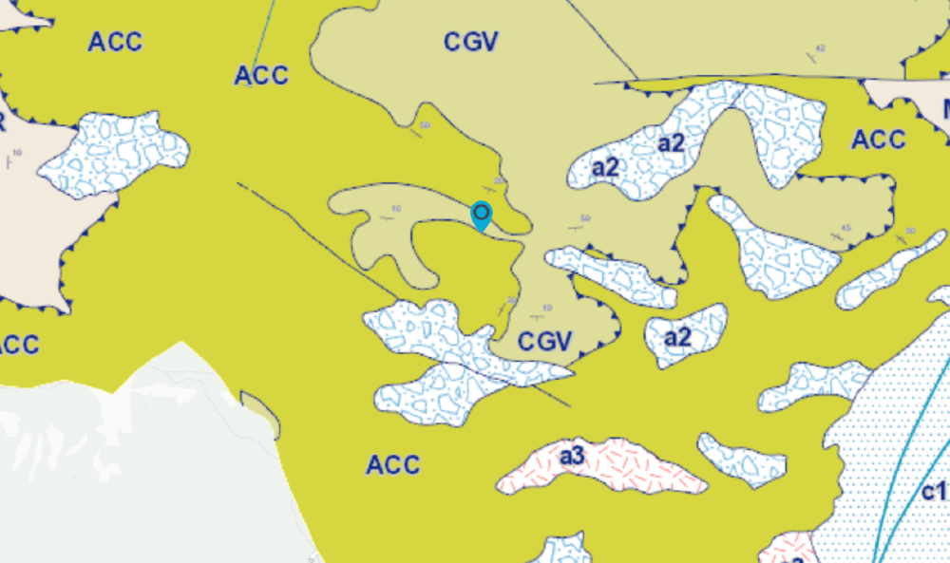
500 m

Figure S2 – Geological characteristics of the area surrounding the type locality of Pseudolimnocythere abdita sp. nov. ACC: Canetolo clays and limestones (Lower-Middle Eocene); CGV: Groppo del Vescovo limestones (Ypresian - Lutetian); a1: active landslide; a2: dormant landslide; a3: slope debris s.l. Geological map from the Geological Seismic and Soil Survey (SGSS) of the Emilia-Romagna Region (https://servizigis.regione.emilia-romagna.it). Geological map from the Geological Seismic and Soil Survey (SGSS) of the Emilia-Romagna Region (Geoportale 3D - Regione Emilia-Romagna, https://rer3d.regione.emilia-romagna.it). The source map scale is 1:10,000.

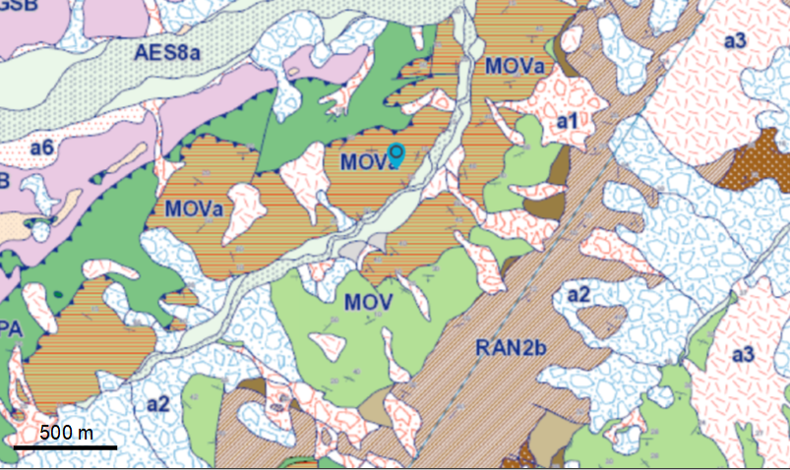

Figure S3 – Geological characteristics of the area surrounding the type locality of Pseudolimnocythere sofiae sp. nov. MOV: Monte Venere Formation (Upper Campanian - Maastrichtian; MOVa: Monte Venere Formation - Torrente Lucola lithofacies (Upper Campanian - Maastrichtian); APA: Palombini clays (Berrasian - Turonian); RAN2b: Ranzano Formation - Val Pessola Member - arenaceous-pelitic lithofacies (Lower Rupelian); AES8a: alluvial plain gravel; a1: active landslide; a2: dormant landslide; a3: slope debris s.l.; a6: debris talus. Geological map from the Geological Seismic and Soil Survey (SGSS) of the Emilia-Romagna Region (Geoportale 3D - Regione Emilia-Romagna, https://rer3d.regione.emilia-romagna.it). The source map scale is 1:10,000.

Figure S4 – The Cirone spring (A) and the major spring mouth of the Poiano spring system (B). Photographs taken on April 3, 2007, and October 19, 2013, respectively.
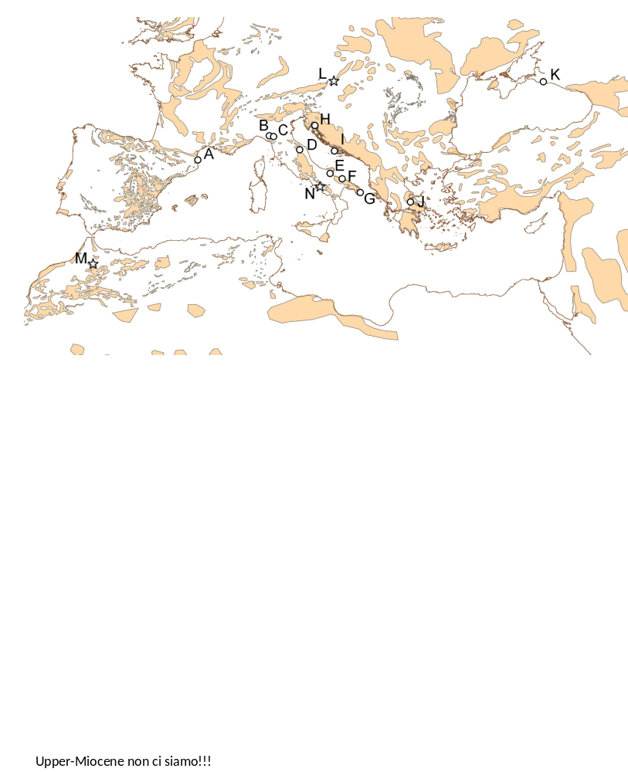

Figure S5 – Map of karst formations and distribution of Recent (open circles) and fossil (stars) species of Pseudolimnocythere. A) P. sp. (Danielopol and Bonaduce 1990); B) P. abdita sp. nov.; C) P. sofiae sp. nov.; D) P. sp. (Peterson et al. 2013); E) P. hypogaea (Karanovic and Pesce 2001); F) and G) P. hypogaea (Klie 1938); H) P. sp. (Danielopol 1980); I) P. sp. (Montanari et al. 2021); J) P. hartmanni (Danielopol 1979); K) P. sp. sensu Schornikov 2013 (Schornikov et al. 2014); L) P. hainburgensis (Danielopol et al. 1991; M) P. sp. (Bekkali and Nachite 2006); N) P. hartmanni (Aiello et al. 2020). The shapefile showing the occurrence of carbonate rocks was downloaded from the webpage of the Collaborative Research Centre 806, Department of Geography, University of Cologne (https://crc806db.uni-koeln.de/start). The map was produced using QGIS v. 3.4.15 (QGIS Development Team, 2018, available at: http://qgis.osgeo.org). For literature references see main text.

