Supplementary files

Title: Alien plants tend to occur in species-poor communities

Table of contents:

Appendix S1: Overview of vegetation plots included in the different vegetation types.
Appendix S2: Correlations between the median, range, and skewness of S_{c}.
Appendix S3: Results for invasive neophytes.
Appendix S4: The S_{c} statistics of individual naturalized neophytes.
Appendix S5: Results considering a cut-off of 25% of cover to determine dominance.

Appendix S1: Overview of vegetation plots included in the different vegetation types.

We aggregated plots from the different vegetation types into two major vegetation formations dominated by either trees and shrubs or herbaceous plants and dwarf shrubs (Table S1.1). Anthropogenic vegetation was classified as herbaceous because it was always dominated by this group of species (Chytrý 2007–2013). Human-influenced woody habitats with a high fraction of alien species were classified as forests and scrub.

Table S1.1: Number and proportion (%) of vegetation plots in the different vegetation types and major vegetation formations.

Vegetation formations | Vegetation types | Median plot size (m²) | Number of plots | % of plots
Forests | Forest | 250 | 3669 | 21.60
Forests | Scrub | 100 | 823 | 4.84
Grasslands | Grassland | 18 | 6083 | 35.81
Grasslands | Alpine vegetation | 16 | 167 | 0.98
Grasslands | Vegetation of rocks, screes, and walls | 5 | 322 | 1.90
Grasslands | Anthropogenic vegetation | 16 | 5923 | 34.87
Total |  |  | 16987 | 100

References:

Chytrý, M. (ed.). 2007–2013. Vegetace České republiky [Vegetation of the Czech Republic] 1–4. Academia (Praha).

Appendix S2: Correlations between the median, range, and skewness of S_{c}.

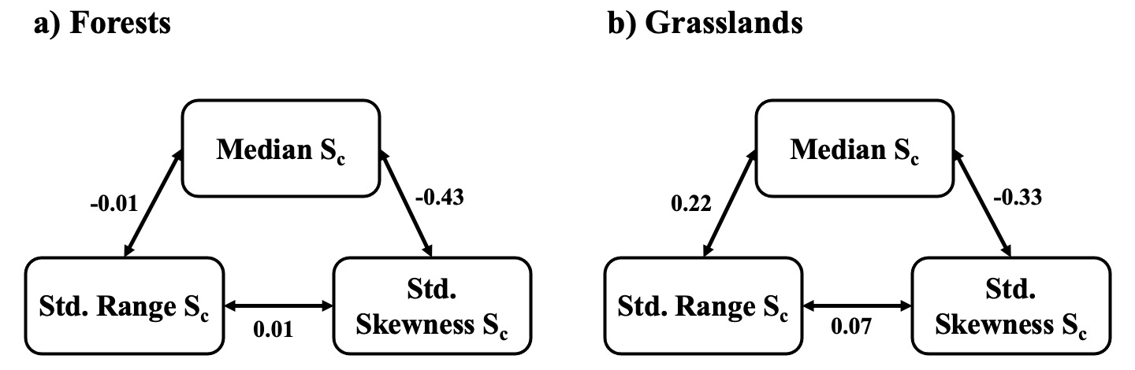
Figure S2.1: Pearson’s correlation coefficients (r) between the median, range, and skewness of S_{c} of species in (a) forests and (b) grasslands. The range and skewness of S_{c} were standardized (Std.) as described in the Materials and Methods.

Appendix S3: Results for invasive neophytes.

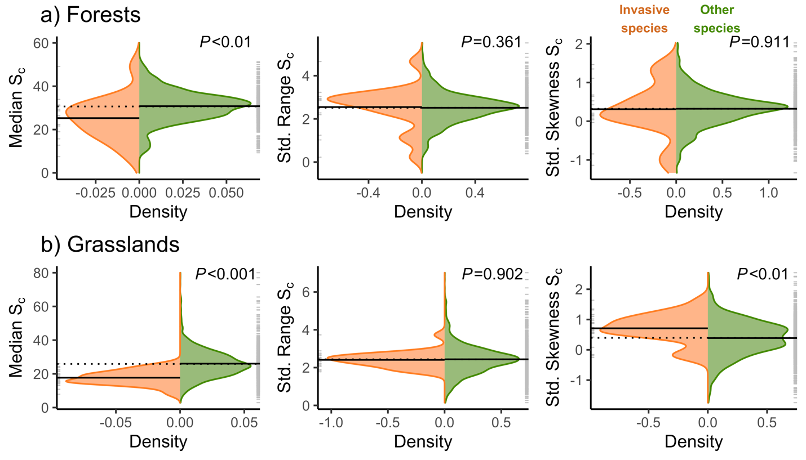
Figure S3.1: Density curves comparing the median (1st column), range (2nd column), and skewness (3rd column) of plot-size adjusted species richness (S_{c}) of invasive species with all other species in (a) forests and (b) grasslands. The dotted black line indicates the mean of the S_{c} values for each parameter across all species in the vegetation formation. The solid black line indicates the mean of the S_{c} values for each parameter of each group of species. Ticks on the left and right margins show S_{c} values for each parameter of individual species in each group. Density values of naturalized neophytes were multiplied by -1 to facilitate visual comparisons. The range and skewness of S_{c} were standardized (Std.) as described in the Materials and Methods. P-values correspond to Mann-Whitney Tests.

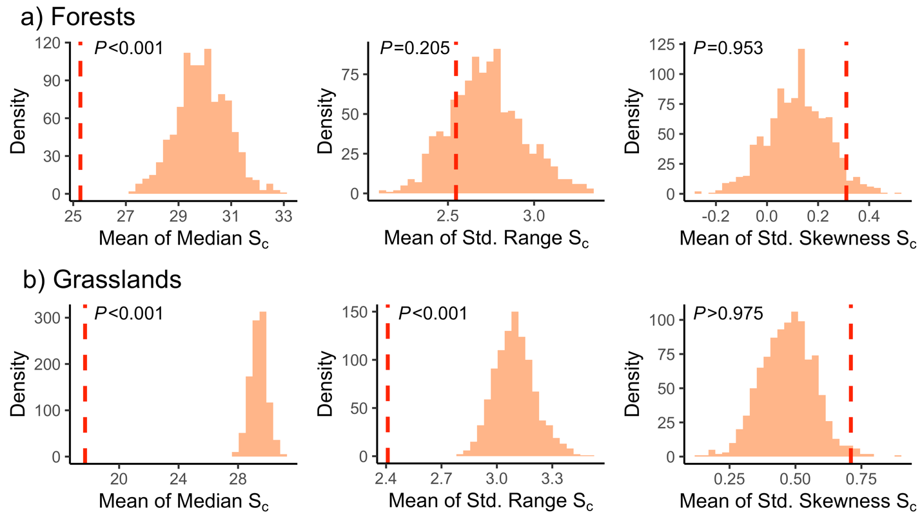
Figure S3.2: Comparison of mean observed values of the median (1st column), range (2nd column), and skewness (3rd column) of S_{c} of invasive species with the distribution of mean random values of S_{c} of the same parameters obtained from the null model. Results are for species in (a) forests and (b) grasslands. The dashed red line represents the mean observed S_{c} value of each parameter across all species. Bars show the distribution of random mean S_{c} values of each parameter. The range and skewness of S_{c} were standardized (Std.) as described in the Materials and Methods. P-values indicate the proportion of the randomized parameters that are lower than the observed value.
Appendix S4: The S_{c} statistics of individual naturalized neophytes.

Table S4.1: Different S_{c} statistics of individual naturalized neophytes in forests. We did not calculate S_{c} values for species occurring in less than five plots or less than 5% of the plots in each vegetation formation.

Species names | Number of plots | Mean S_{c} | Median S_{c} | Q1 | Q3 | Skewness
Acer negundo | 28 | 22.78 | 21.64 | 16.1 | 30.21 | 0.25
Aesculus hippocastanum | 7 | 40.28 | 41.49 | 33.47 | 45.66 | 0.05
Ailanthus altissima | 5 | 18.37 | 18.98 | 18.85 | 19.84 | -0.61
Asparagus officinalis | 11 | 36.24 | 34.96 | 24.62 | 47.09 | 0.13
Bidens frondosus | 47 | 31.61 | 30.85 | 21.64 | 38.02 | 0.6
Cytisus scoparius | 18 | 24.76 | 25.07 | 20.12 | 28.98 | 0.16
Digitalis purpurea | 7 | 29.69 | 27.89 | 23.81 | 31.94 | 0.97
Epilobium adenocaulon | 41 | 29.8 | 30 | 22.01 | 38.05 | -0.02
Impatiens glandulifera | 34 | 30.49 | 29.4 | 22.32 | 38.09 | 0.35
Impatiens parviflora | 741 | 27.26 | 26.4 | 19.19 | 33.95 | 0.72
Lycium barbarum | 29 | 20.38 | 22.27 | 11.46 | 25.38 | 0.43
Matteuccia struthiopteris | 7 | 34.99 | 25.79 | 21.4 | 49.43 | 0.57
Parthenocissus inserta | 9 | 21.78 | 18.98 | 17.58 | 23 | 1.68
Pinus nigra | 18 | 21.92 | 20.12 | 14.7 | 25.96 | 1
Pinus strobus | 13 | 7.56 | 7.46 | 6.17 | 8.97 | 0.5
Populus x canadensis | 12 | 30.15 | 28.61 | 19.42 | 33.08 | 0.83
Quercus rubra | 7 | 34.04 | 33.95 | 18.77 | 45.91 | 0.33
Reynoutria japonica | 12 | 44.5 | 49.11 | 36.97 | 54.78 | -0.99
Ribes rubrum | 51 | 28.44 | 26.14 | 19.02 | 35.6 | 0.79
Robinia pseudoacacia | 318 | 17.51 | 15.7 | 11.91 | 20.93 | 1.59
Solidago canadensis | 16 | 29.03 | 25.64 | 18.94 | 35.29 | 0.86
Solidago gigantea | 14 | 30.99 | 31.21 | 24.43 | 36.68 | 0.26
Symphoricarpos albus | 6 | 19.07 | 12.79 | 10.86 | 21.07 | 1.34
Symphyotrichum novi-belgii agg. | 28 | 30.59 | 31.36 | 20.91 | 39.02 | 0.15
Syringa vulgaris | 11 | 27.08 | 26.17 | 18.79 | 36.47 | 0.06

Table S4.2: Different S_{c} statistics of individual naturalized neophytes in grasslands. We did not calculate S_{c} values for species occurring in less than five plots or less than 5% of the plots in each vegetation formation (blank cells).

Species names | Number of plots | Mean S_{c} | Median S_{c} | Q1 | Q3 | Skewness
Acer negundo | 9 | 15.62 | 15.5 | 10.79 | 19 | 0
Agrostis gigantea | 163 | 27.06 | 26.66 | 20.47 | 33.02 | 0.11
Amaranthus albus | 24 | 22.68 | 19.81 | 15.1 | 28.64 | 0.87
Amaranthus powellii | 149 | 21.1 | 20.27 | 14.91 | 26.38 | 0.64
Amaranthus retroflexus | 457 | 21.4 | 19.73 | 15.02 | 26.29 | 0.95
Asclepias syriaca | 8 | 23.59 | 23.81 | 17.57 | 28.35 | 0.05
Asparagus officinalis | 32 | 29.41 | 30.17 | 25.33 | 32.91 | -0.09
Bassia scoparia | 20 | 17.37 | 15.8 | 12.56 | 20.06 | 0.66
Bidens frondosus | 113 | 27.16 | 26 | 15.99 | 35 | 0.73
Bunias orientalis | 41 | 18.44 | 17 | 12.21 | 23.1 | 0.8
Calystegia pulchra | 5 | 21.38 | 29 | 10.28 | 29.11 | -0.41
Cerastium tomentosum | 6 | 14.32 | 14.86 | 12.01 | 17.98 | -0.48
Consolida orientalis | 9 | 18.27 | 17.89 | 14.31 | 20.27 | 0.7
Cytisus scoparius | 26 | 23.1 | 21.76 | 15.18 | 28.25 | 0.6
Datura stramonium | 24 | 23.52 | 20.73 | 15.38 | 27.86 | 1.12
Digitalis purpurea | 41 | 13.87 | 13.01 | 9.7 | 15.87 | 1.25
Echinocystis lobata | 31 | 16.57 | 14 | 10.7 | 21 | 1.56
Echinops sphaerocephalus | 117 | 20.4 | 19.41 | 15.87 | 23.74 | 0.89
Epilobium adenocaulon | 280 | 23.91 | 22.21 | 16.57 | 29.98 | 0.96
Erigeron annuus | 110 | 22.74 | 21.41 | 15.83 | 26.04 | 1.11
Erigeron canadensis | 692 | 21.32 | 19.44 | 14.2 | 26.4 | 1.09
Galinsoga parviflora | 367 | 23.62 | 22.54 | 16.9 | 28.54 | 1.08
Galinsoga quadriradiata | 321 | 26.48 | 24.44 | 19.41 | 32.54 | 0.82
Geranium pyrenaicum | 20 | 24.74 | 25.34 | 19.36 | 28.89 | -0.23
Helianthus tuberosus | 127 | 16.41 | 14.99 | 11 | 20 | 1.6
Heracleum mantegazzianum | 26 | 12.61 | 10.88 | 6.82 | 15.65 | 1.43
Hesperis matronalis | 22 | 21.49 | 21.27 | 15.23 | 27.64 | 0.06
Impatiens glandulifera | 182 | 16.8 | 15 | 11 | 19.93 | 1.88
Impatiens parviflora | 342 | 19.54 | 18.35 | 13.46 | 23.42 | 1.25
Iva xanthiifolia | 6 | 28.45 | 27.64 | 27.33 | 28.73 | 1.12
Juncus tenuis | 77 | 18.81 | 16.82 | 11.87 | 22.73 | 1.11
Lathyrus aphaca | 5 | 36.8 | 33.02 | 30.99 | 40 | 0.85
Lepidium densiflorum | 8 | 17.42 | 15.35 | 12.38 | 23.41 | 0.37
Lolium multiflorum | 70 | 23.79 | 22.34 | 17.12 | 30.33 | 0.58
Lupinus polyphyllus | 18 | 23.47 | 22.2 | 19.3 | 27.66 | 0.01
Matricaria discoidea | 760 | 20.32 | 18.27 | 12.73 | 25.59 | 1.11
Medicago sativa | 132 | 25.85 | 24.71 | 18.45 | 32.97 | 0.3
Medicago x varia | 17 | 31.61 | 32.22 | 24.88 | 38 | 0.36
Mimulus guttatus | 9 | 32.35 | 25.35 | 18 | 45.49 | 0.47
Onobrychis viciifolia | 76 | 32.16 | 32.63 | 26.87 | 37.18 | 0.82
Oxalis stricta | 148 | 29.62 | 27.12 | 21.45 | 37.1 | 0.75
Panicum capillare | 10 | 21.76 | 19.41 | 17.41 | 22.55 | 1.05
Parthenocissus quinquefolia | 10 | 14.13 | 12.47 | 9.75 | 19.18 | 0.51
Peucedanum ostruthium | 15 | 20.06 | 16.02 | 14.07 | 25.8 | 0.3
Pseudofumaria lutea | 25 | 6.79 | 5.89 | 3.34 | 10.03 | 1.05
Reynoutria japonica | 104 | 15.01 | 13.07 | 8.22 | 18.65 | 1.23
Reynoutria sachalinensis | 7 | 8.43 | 7.94 | 5 | 11.03 | 0.43
Rudbeckia laciniata | 10 | 16.93 | 16.43 | 12.39 | 19.9 | 0.79
Rumex alpinus | 25 | 16.04 | 14.99 | 10.33 | 18.33 | 0.83
Rumex thyrsiflorus | 62 | 28.16 | 26.27 | 21.37 | 35.25 | 0.57
Sedum spurium | 13 | 21.44 | 22.84 | 13.62 | 25.89 | 0.14
Senecio vernalis | 7 | 16.23 | 14.91 | 12.1 | 19.68 | 0.62
Sisymbrium altissimum | 90 | 18.55 | 16.15 | 12.56 | 23 | 1.1
Sisymbrium loeselii | 177 | 20.55 | 18.33 | 14.11 | 24.69 | 1.32
Sisymbrium strictissimum | 7 | 21.09 | 18.58 | 11.74 | 29.69 | 0.22
Solidago canadensis | 240 | 21.13 | 19.24 | 14.51 | 25.41 | 1.38
Solidago gigantea | 124 | 16.46 | 15.14 | 11 | 20.41 | 0.88
Symphyotrichum novi-belgii agg. | 103 | 16.38 | 14.51 | 11.41 | 21.5 | 1.13
Trifolium hybridum | 378 | 30.94 | 31.27 | 23.98 | 38.21 | 0.1
Veronica persica | 935 | 24.53 | 23.47 | 18.48 | 29.17 | 0.7

Appendix S5: Results considering a cut-off of 25% of cover to determine dominance.

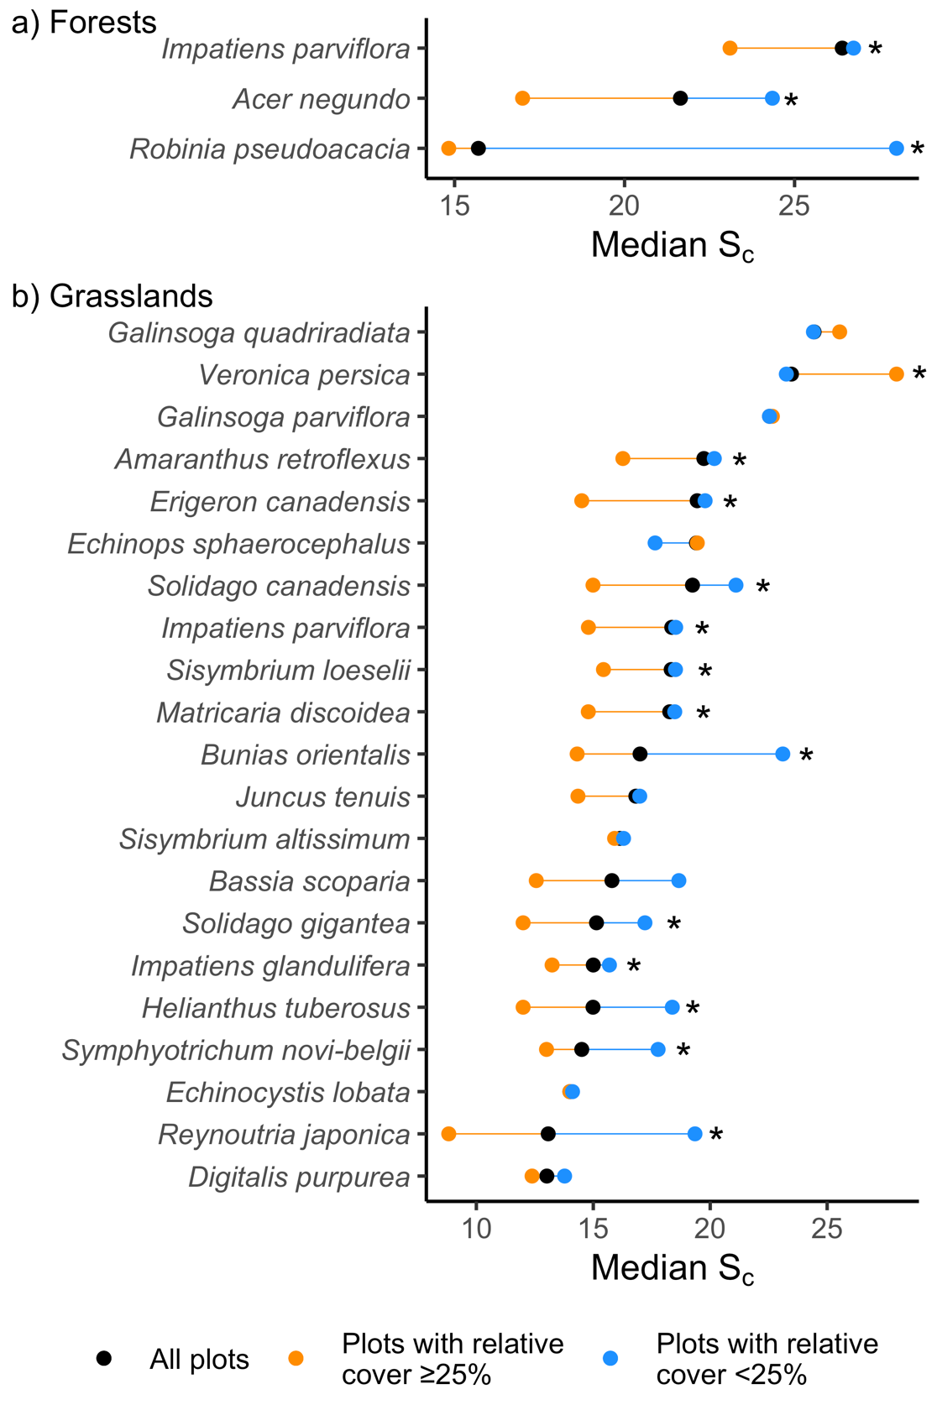
Figure S5.1: Median S_{c} of naturalized neophytes across all plots where they occurred and plots with relative cover higher or lower than 25%. Species are classified based on their occurrence in (a) forests and (b) grasslands. Only species present in at least ten plots in each group of plots (i.e., those with relative cover ≥25% vs. those with relative cover <25%) were considered. Asterisks (*) indicate significant (P<0.05) differences in median S_{c} between groups following Mann-Whitney U Tests. Median S_{c} values and the number of plots associated with each species can be found in Table S5.1.

Table S5.1: Median S_{c} and number of plots for naturalized neophytes in forests and grasslands. Results are separated considering all plots and plots where the species occurred with a relative cover < and ≥ than 25%. Only species present in at least ten plots in each group of plots (i.e., those with relative cover ≥25% vs. those with relative cover <25%) were considered (blank cells).

Species names | Forests |  |  |  |  |  |  | Grasslands
Species names | All plots |  | Plots with a relative cover <25% |  | Plots with a relative cover ≥25% |  |  | All plots |  | Plots with a relative cover <25% |  | Plots with a relative cover ≥25%
Species names | Median S_{c} | Number of plots | Median S_{c} | Number of plots | Median S_{c} | Number of plots |  | Median S_{c} | Number of plots | Median S_{c} | Number of plots | Median S_{c} | Number of plots
Acer negundo | 21.64 | 28 | 24.67 | 18 | 17.1 | 10
Amaranthus retroflexus |  |  |  |  |  |  |  | 19.73 | 457 | 20.17 | 438 | 16.27 | 19
Bunias orientalis |  |  |  |  |  |  |  | 17 | 41 | 23.1 | 17 | 14.31 | 24
Digitalis purpurea |  |  |  |  |  |  |  | 13.01 | 41 | 13.77 | 27 | 12.38 | 14
Echinops sphaerocephalus |  |  |  |  |  |  |  | 19.41 | 117 | 17.64 | 53 | 19.45 | 64
Erigeron canadensis |  |  |  |  |  |  |  | 19.44 | 692 | 19.78 | 659 | 14.51 | 33
Galinsoga parviflora |  |  |  |  |  |  |  | 22.54 | 367 | 22.54 | 327 | 22.66 | 40
Galinsoga quadriradiata |  |  |  |  |  |  |  | 24.44 | 321 | 24.41 | 294 | 25.54 | 27
Helianthus tuberosus |  |  |  |  |  |  |  | 14.99 | 127 | 18.38 | 63 | 12 | 64
Impatiens glandulifera |  |  |  |  |  |  |  | 15 | 182 | 15.69 | 73 | 13.24 | 109
Impatiens parviflora | 26.4 | 741 | 26.74 | 697 | 23.1 | 44 |  | 18.35 | 342 | 18.52 | 314 | 14.79 | 28
Juncus tenuis |  |  |  |  |  |  |  | 16.82 | 77 | 16.99 | 59 | 14.35 | 18
Matricaria discoidea |  |  |  |  |  |  |  | 18.27 | 760 | 18.48 | 715 | 14.79 | 45
Reynoutria japonica |  |  |  |  |  |  |  | 13.07 | 104 | 19.35 | 45 | 8.82 | 59
Robinia pseudoacacia | 15.7 | 318 | 28 | 33 | 14.83 | 285
Sisymbrium altissimum |  |  |  |  |  |  |  | 16.15 | 90 | 16.29 | 77 | 15.91 | 13
Sisymbrium loeselii |  |  |  |  |  |  |  | 18.33 | 177 | 18.52 | 157 | 15.44 | 20
Solidago canadensis |  |  |  |  |  |  |  | 19.24 | 240 | 21.1 | 173 | 14.99 | 67
Solidago gigantea |  |  |  |  |  |  |  | 15.14 | 124 | 17.21 | 70 | 12 | 54
Symphyotrichum novi-belgii agg. |  |  |  |  |  |  |  | 14.51 | 103 | 17.77 | 51 | 13 | 52
Veronica persica |  |  |  |  |  |  |  | 23.47 | 935 | 23.25 | 922 | 27.97 | 13

Table S5.2: Median S_{c} and number of plots for naturalized neophytes in forests and grasslands. Results are separated considering all plots and plots where the species occurred with a relative cover < and ≥ than 12%. Only species present in at least ten plots in each group of plots (i.e., those with relative cover ≥12% vs. those with relative cover <12%) were considered (blank cells).

Species names | Forests |  |  |  |  |  |  | Grasslands
Species names | All plots |  | Plots with relative cover <12% |  | Plots with relative cover ≥12% |  |  | All plots |  | Plots with relative cover <12% |  | Plots with relative cover ≥12%
Species names | Median S_{c} | Number of plots | Median S_{c} | Number of plots | Median S_{c} | Number of plots |  | Median S_{c} | Number of plots | Median S_{c} | Number of plots | Median S_{c} | Number of plots
Acer negundo | 21.64 | 28 | 24.51 | 16 | 17.7 | 12
Agrostis gigantea |  |  |  |  |  |  |  | 26.66 | 163 | 26.33 | 132 | 26.66 | 31
Amaranthus powellii |  |  |  |  |  |  |  | 20.27 | 149 | 20.7 | 133 | 16.1 | 16
Amaranthus retroflexus |  |  |  |  |  |  |  | 19.73 | 457 | 20.66 | 389 | 16.87 | 68
Bassia scoparia |  |  |  |  |  |  |  | 15.8 | 20 | 18.46 | 10 | 13.23 | 10
Bidens frondosus |  |  |  |  |  |  |  | 26 | 113 | 26 | 102 | 24.32 | 11
Bunias orientalis |  |  |  |  |  |  |  | 17 | 41 | 24.11 | 16 | 13.78 | 25
Digitalis purpurea |  |  |  |  |  |  |  | 13.01 | 41 | 12.37 | 18 | 14.11 | 23
Echinops sphaerocephalus |  |  |  |  |  |  |  | 19.41 | 117 | 20.08 | 48 | 19.26 | 69
Epilobium adenocaulon |  |  |  |  |  |  |  | 22.21 | 280 | 22.48 | 269 | 16.99 | 11
Erigeron canadensis |  |  |  |  |  |  |  | 19.44 | 692 | 19.73 | 625 | 17 | 67
Galinsoga parviflora |  |  |  |  |  |  |  | 22.54 | 367 | 22.84 | 304 | 21.35 | 63
Galinsoga quadriradiata |  |  |  |  |  |  |  | 24.44 | 321 | 25.03 | 266 | 24.41 | 55
Helianthus tuberosus |  |  |  |  |  |  |  | 14.99 | 127 | 18.38 | 58 | 12.21 | 69
Impatiens glandulifera |  |  |  |  |  |  |  | 15 | 182 | 16 | 67 | 13.4 | 115
Impatiens parviflora | 26.4 | 741 | 26.74 | 609 | 24.52 | 132 |  | 18.35 | 342 | 18.52 | 280 | 17.08 | 62
Juncus tenuis |  |  |  |  |  |  |  | 16.82 | 77 | 16.99 | 53 | 16.41 | 24
Matricaria discoidea |  |  |  |  |  |  |  | 18.27 | 760 | 19.28 | 656 | 14.18 | 104
Medicago sativa |  |  |  |  |  |  |  | 24.71 | 132 | 25.78 | 122 | 20.48 | 10
Pseudofumaria lutea |  |  |  |  |  |  |  | 5.89 | 25 | 5.02 | 11 | 6.11 | 14
Reynoutria japonica |  |  |  |  |  |  |  | 13.07 | 104 | 21.16 | 39 | 9 | 65
Robinia pseudoacacia | 15.7 | 318 | 30.65 | 28 | 14.91 | 290
Sisymbrium altissimum |  |  |  |  |  |  |  | 16.15 | 90 | 16.15 | 70 | 16.83 | 20
Sisymbrium loeselii |  |  |  |  |  |  |  | 18.33 | 177 | 18.52 | 146 | 15.87 | 31
Solidago canadensis |  |  |  |  |  |  |  | 19.24 | 240 | 20.83 | 159 | 15.74 | 81
Solidago gigantea |  |  |  |  |  |  |  | 15.14 | 124 | 17.29 | 61 | 12.47 | 63
Symphyotrichum novi-belgii agg. |  |  |  |  |  |  |  | 14.51 | 103 | 20.8 | 38 | 13 | 65
Trifolium hybridum |  |  |  |  |  |  |  | 31.27 | 378 | 31.99 | 348 | 25.82 | 30
Veronica persica |  |  |  |  |  |  |  | 23.47 | 935 | 23.45 | 823 | 24.15 | 112

