Integrated taxonomy unveils new species of Trigonalyidae (Insecta, Hymenoptera) from Yunnan, China

Bing-Lan Zhang¹, Cheng-Jin Yan², Cornelis van Achterberg³, Yan-Qiong Peng⁴, Hua-Yan Chen^{5*}

1 State Key Laboratory of Biocontrol, School of Life Sciences / School of Ecology, Sun Yat-sen University, Guangzhou 510275, China (zhbingl@mail.sysu.edu.cn)
2 Wenzhou Vocational School of Science and Technology/Wencheng Modern Agriculture and Health Industry Research Institute, Wenzhou 325300, China
3 State Key Laboratory of Rice Biology and Ministry of Agriculture / Key Lab of Agricultural Entomology, Institute of Insect Sciences, Zhejiang University, Hangzhou 310058, China (kees@vanachterberg.org)
4 CAS Key Laboratory of Tropical Forest Ecology, Xishuangbanna Tropical Botanical Garden, Chinese Academy of Sciences, Mengla 666303, China (pengyq@xtbg.ac.cn)
5 Key Laboratory of Plant Resources Conservation and Sustainable Utilization, South China Botanical Garden, Chinese Academy of Sciences, Guangzhou 510650, China

Supplement figures
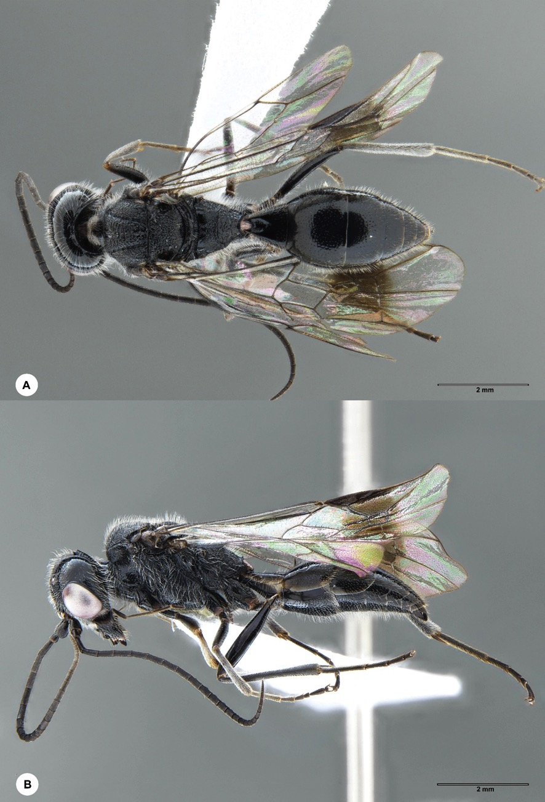
Figure S1. Jezonogonalos jiangliae, male (En-419953). A Habitus, dorsal aspect B habitus, lateral aspect.
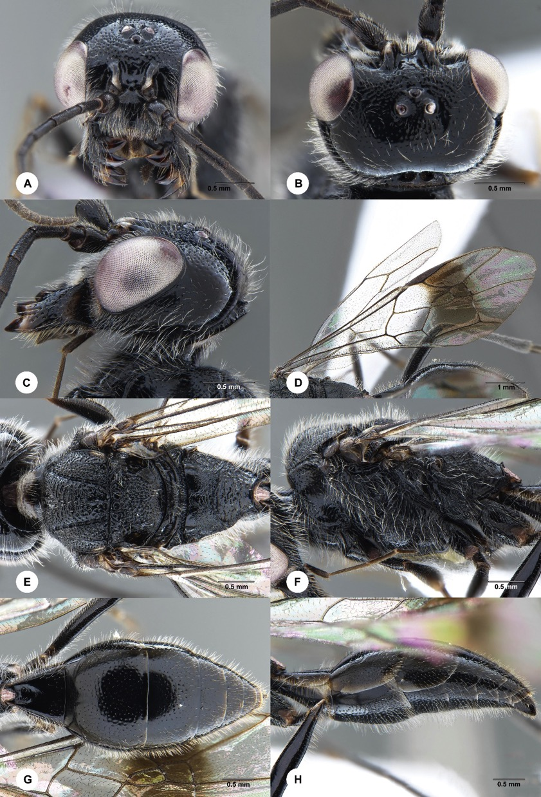
Figure S2. Jezonogonalos jiangliae, male (En-419953). A Head, anterior aspect B head, dorsal aspect C head, lateral aspect D wings E mesosoma, dorsal aspect F mesosoma, lateral aspect G metasoma, dorsal aspect H metasoma, lateral aspect.

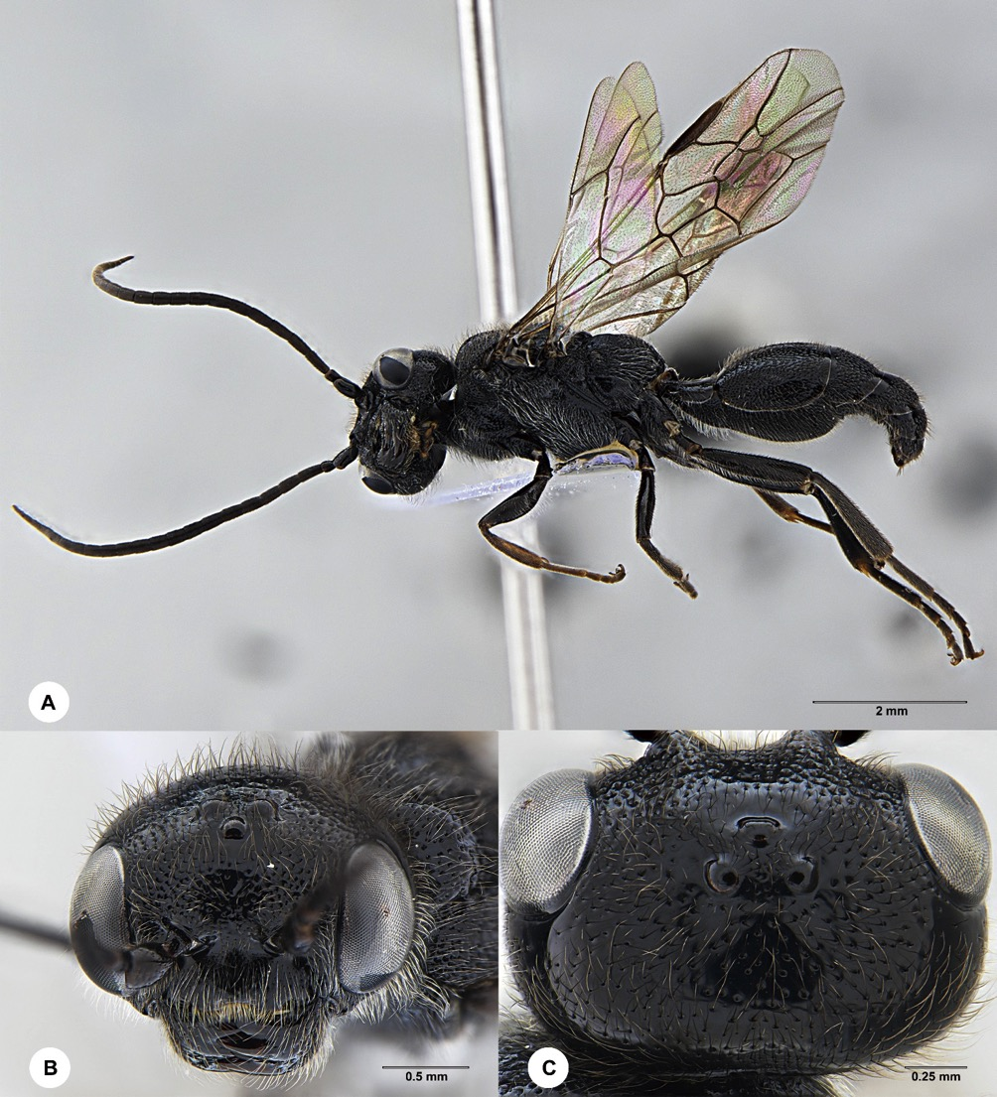
Figure S3. Lycogaster angustula, male (En-419959). A Habitus, lateral aspect B head, anterior aspect C head, dorsal aspect.

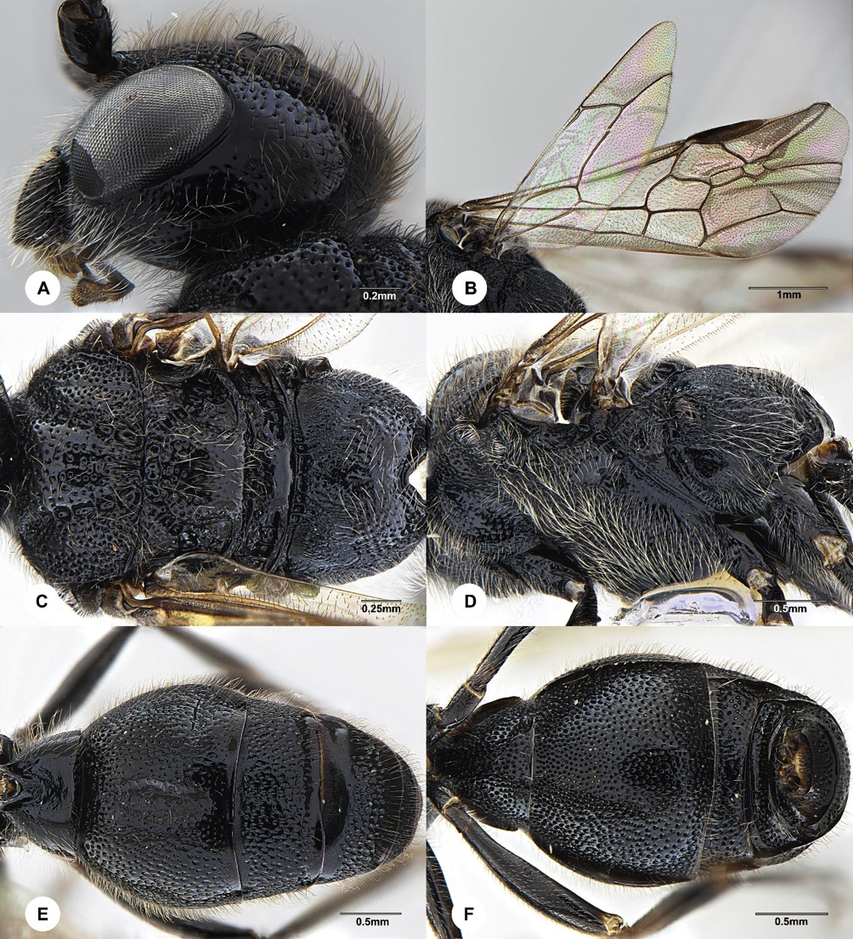
Figure S4. Lycogaster angustula, male (En-419959). A head, lateral aspect B wings C mesosoma, dorsal aspect D mesosoma, lateral aspect E metasoma, dorsal aspect F metasoma, ventral aspect.

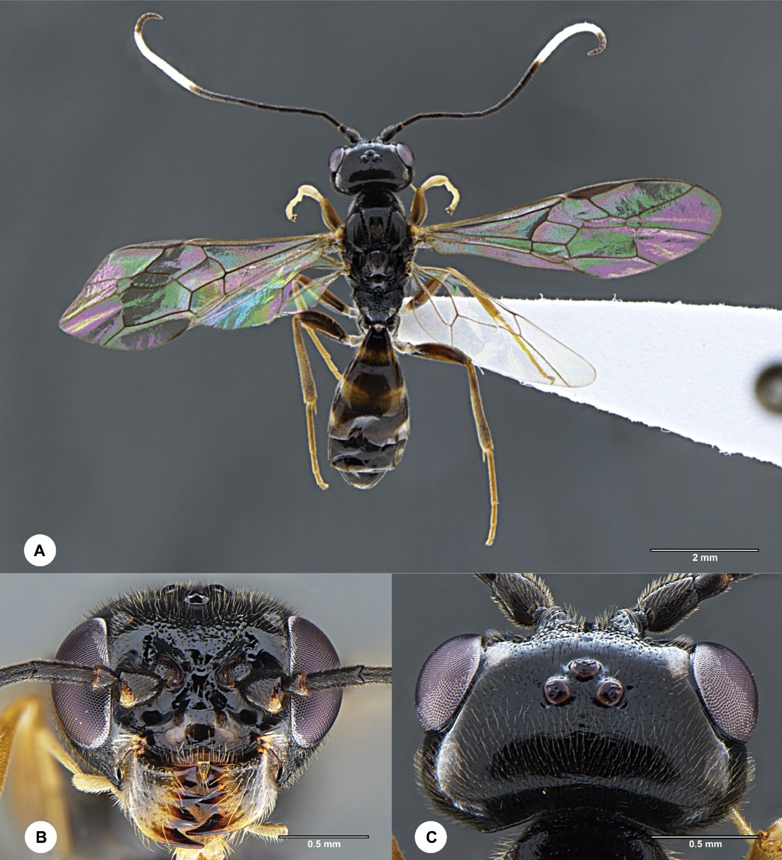
Figure S5. Orthogonalys elongata, female (En-419955). A Habitus, lateral aspect B head, anterior aspect C head, dorsal aspect.

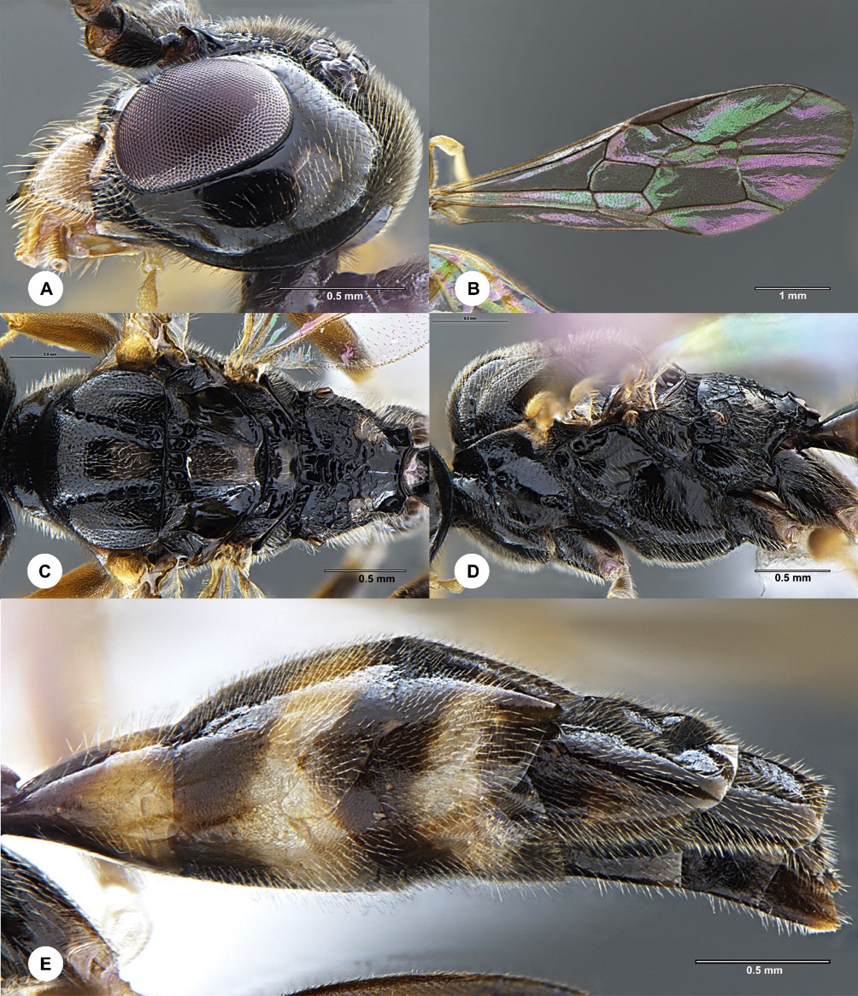
Figure S6. Orthogonalys elongata, female (En-419955). A Head, lateral aspect B wings C mesosoma, dorsal aspect D mesosoma, lateral aspect E metasoma, lateral aspect.

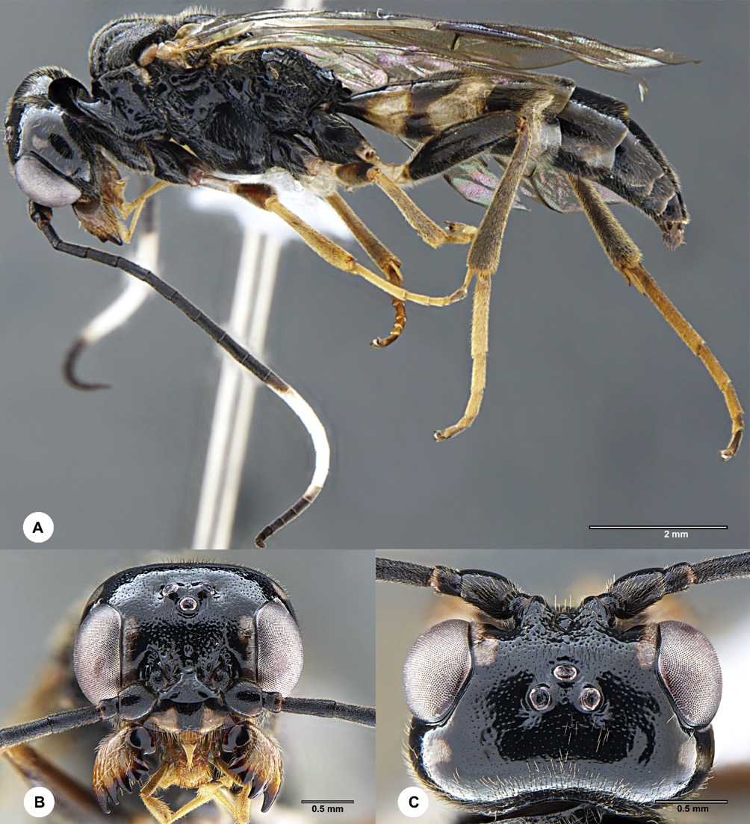
Figure S7. Orthogonalys elongata, male (En-419957). A Habitus, lateral aspect B head, anterior aspect C head, dorsal aspect.

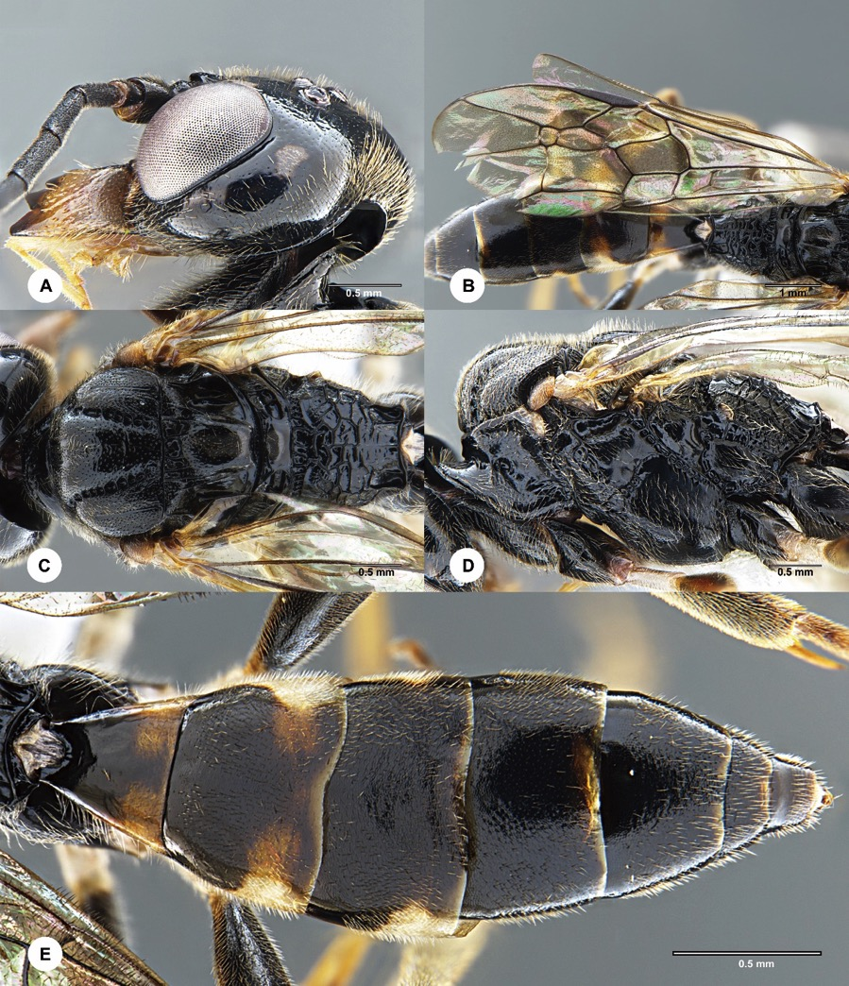
Figure S8. Orthogonalys elongata, male (En-419957). A Head, lateral aspect B wings C mesosoma, dorsal aspect D mesosoma, lateral aspect E metasoma, dorsal aspect.

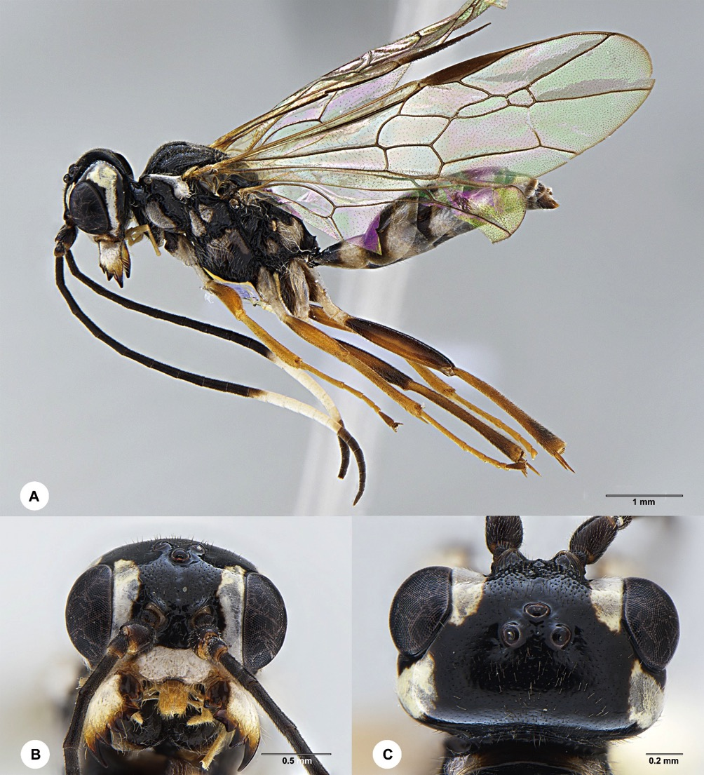
Figure S9. Orthogonalys hirasana, female (En-419964). A Habitus, lateral aspect B head, anterior aspect C head, dorsal aspect.

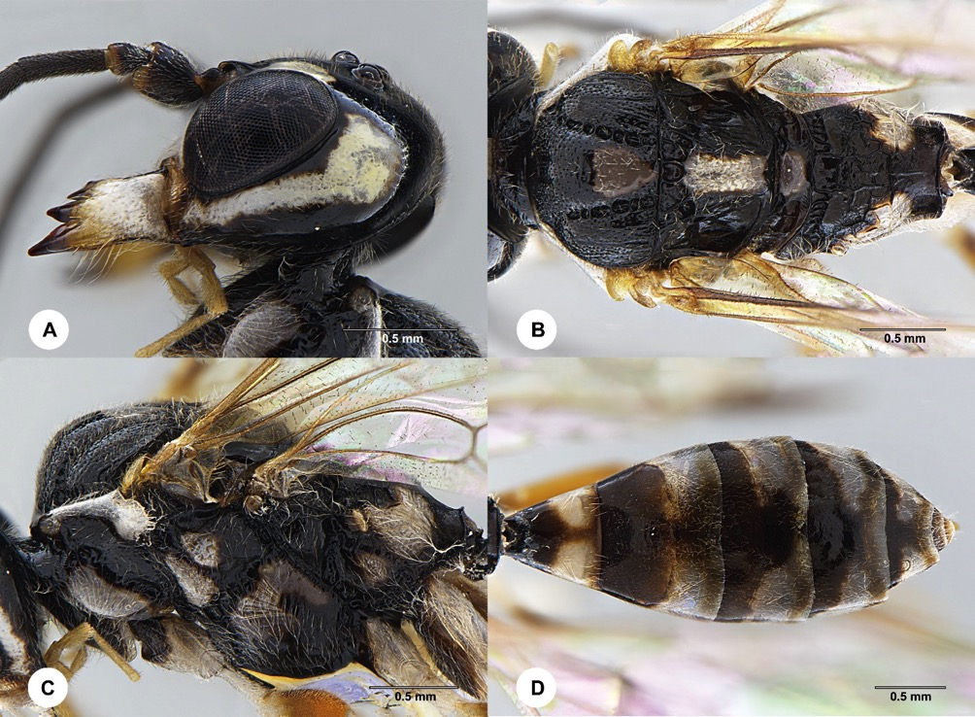
Figure S10. Orthogonalys hirasana, female (En-419964). A Head, lateral aspect B mesosoma, dorsal aspect C mesosoma, lateral aspect D metasoma, dorsal aspect.

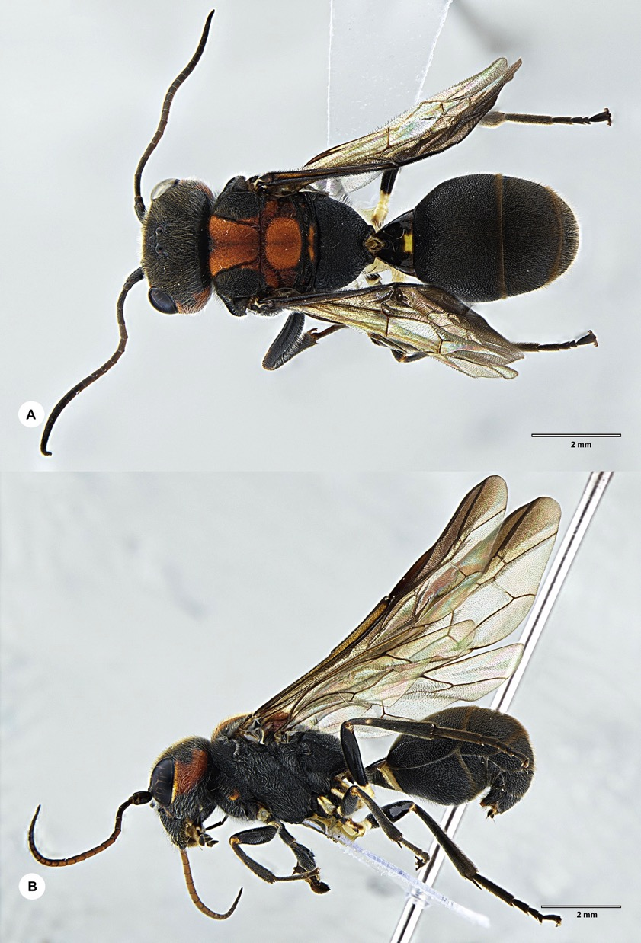
Figure S11. Taeniogonalos cordata, female (En-419958). A Habitus, dorsal aspect B habitus, lateral aspect.

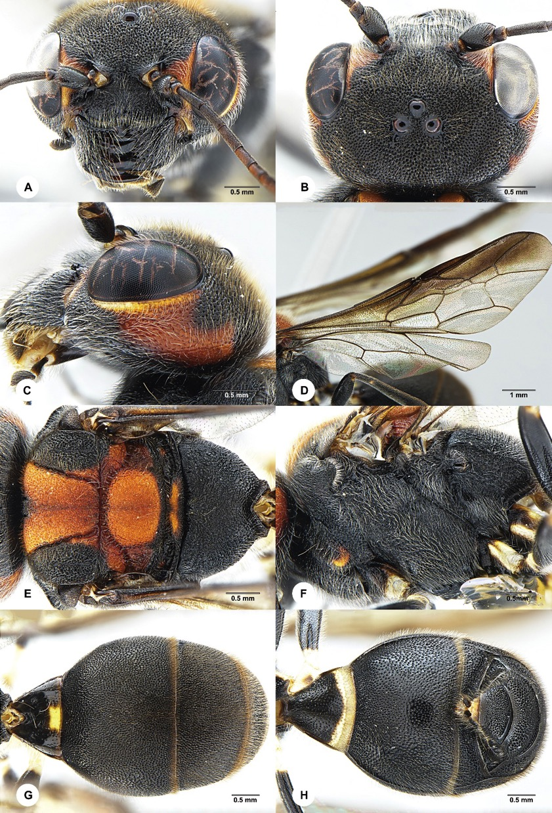
Figure S12. Taeniogonalos cordata, female (En-419958). A Head, anterior aspect B head, dorsal aspect C head, lateral aspect D wings E mesosoma, dorsal aspect F mesosoma, lateral aspect G metasoma, dorsal aspect H metasoma, ventral aspect.

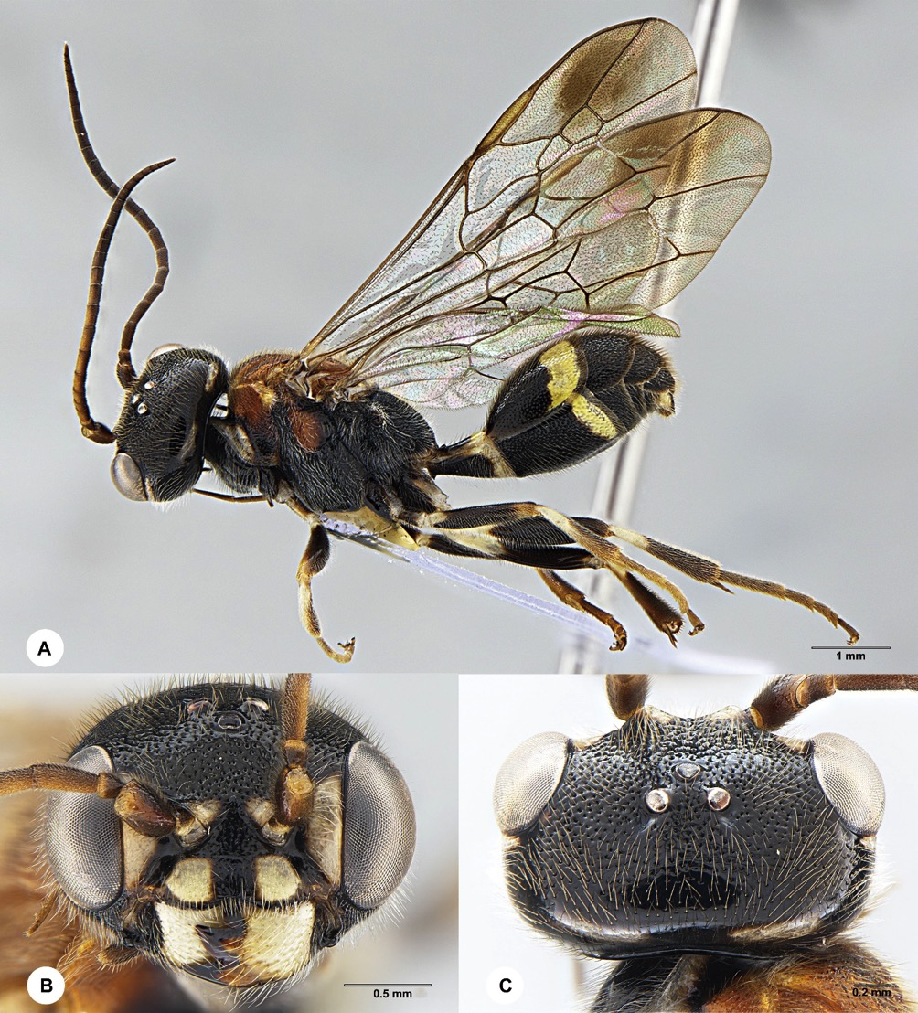
Figure S13. Taeniogonalos fasciata, male (En-419960). A Habitus, lateral aspect B head, anterior aspect C head, dorsal aspect.

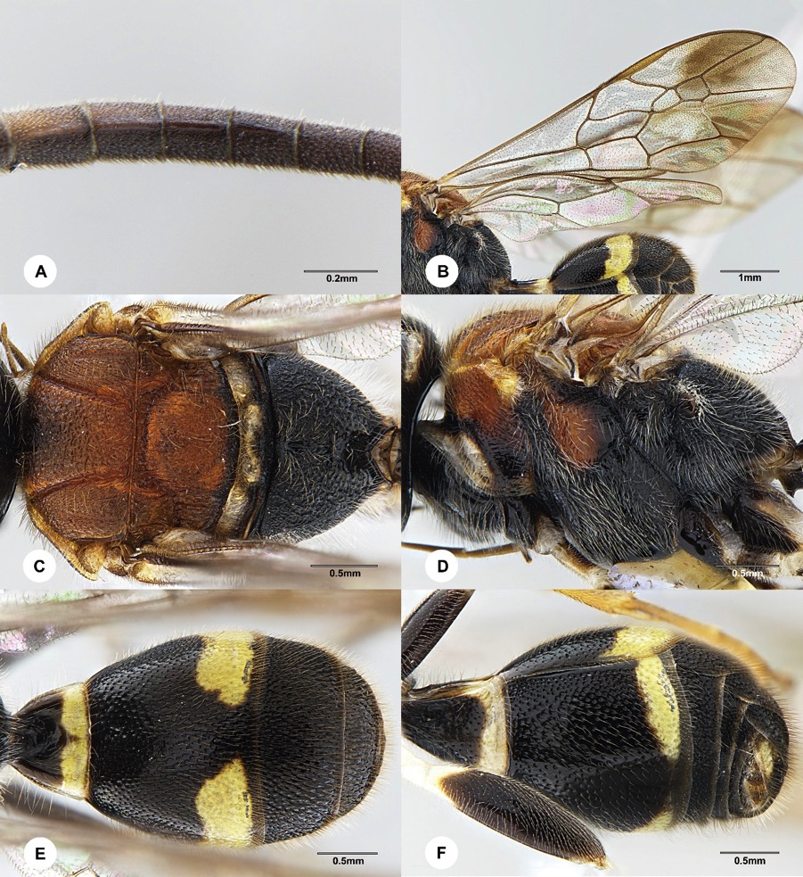
Figure S14. Taeniogonalos fasciata, male (En-419960). A Tyloids on antenna B wings C mesosoma, dorsal aspect D mesosoma, lateral aspect E metasoma, dorsal aspect F metasoma, ventral-lateral aspect.

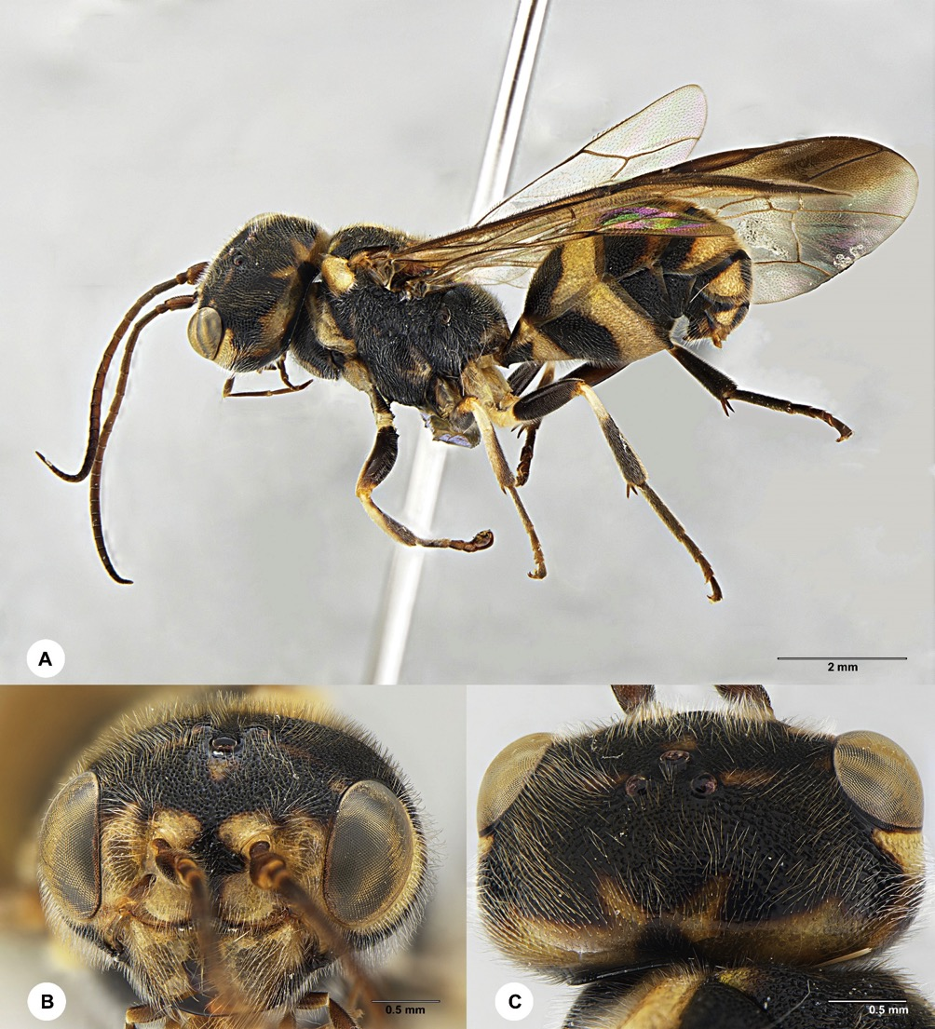
Figure S15. Taeniogonalos flavoscutellata, female (En-419967). A Habitus, lateral aspect B head, anterior aspect C head, dorsal aspect
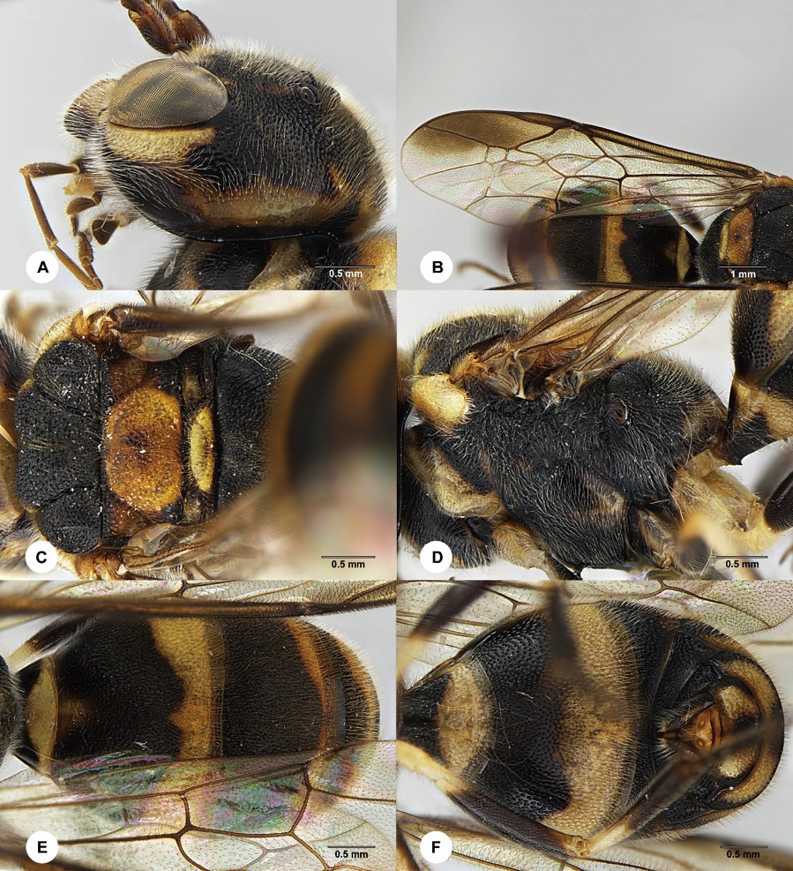
Figure S16. Taeniogonalos flavoscutellata, female (En-419967). A Head, lateral aspect B wings C mesosoma, dorsal aspect D mesosoma, lateral aspect E metasoma, dorsal aspect F metasoma, ventral aspect.
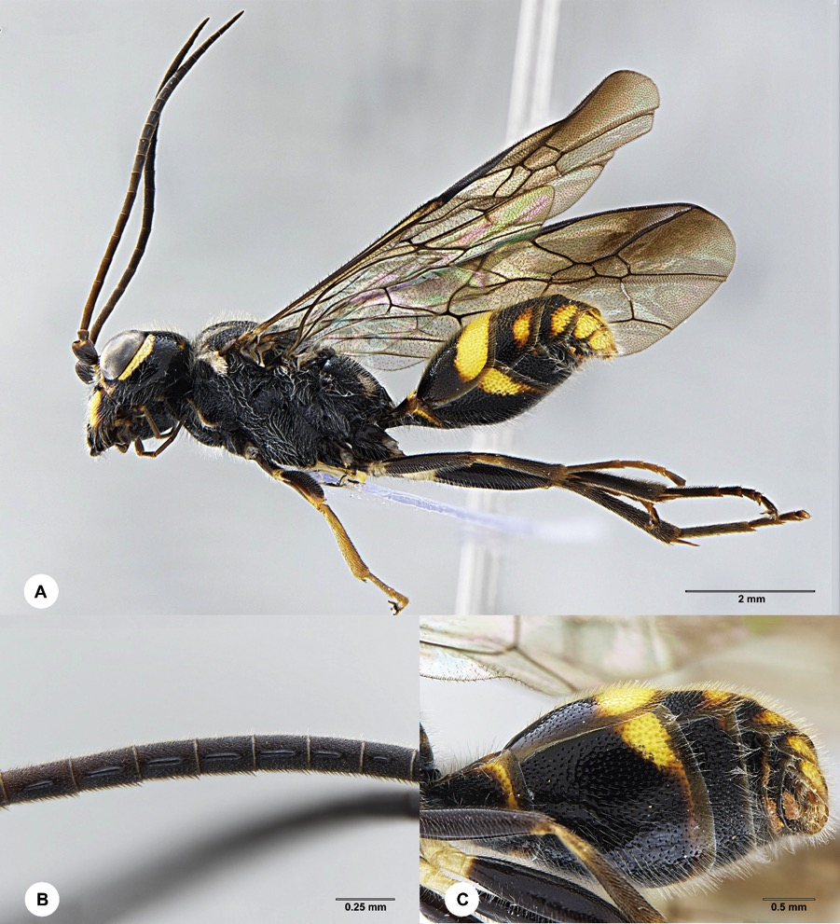
Figure S17. Taeniogonalos formosana, male (En-419025). A Habitus, lateral aspect B tyloids on antenna C metasoma, ventral-lateral aspect.

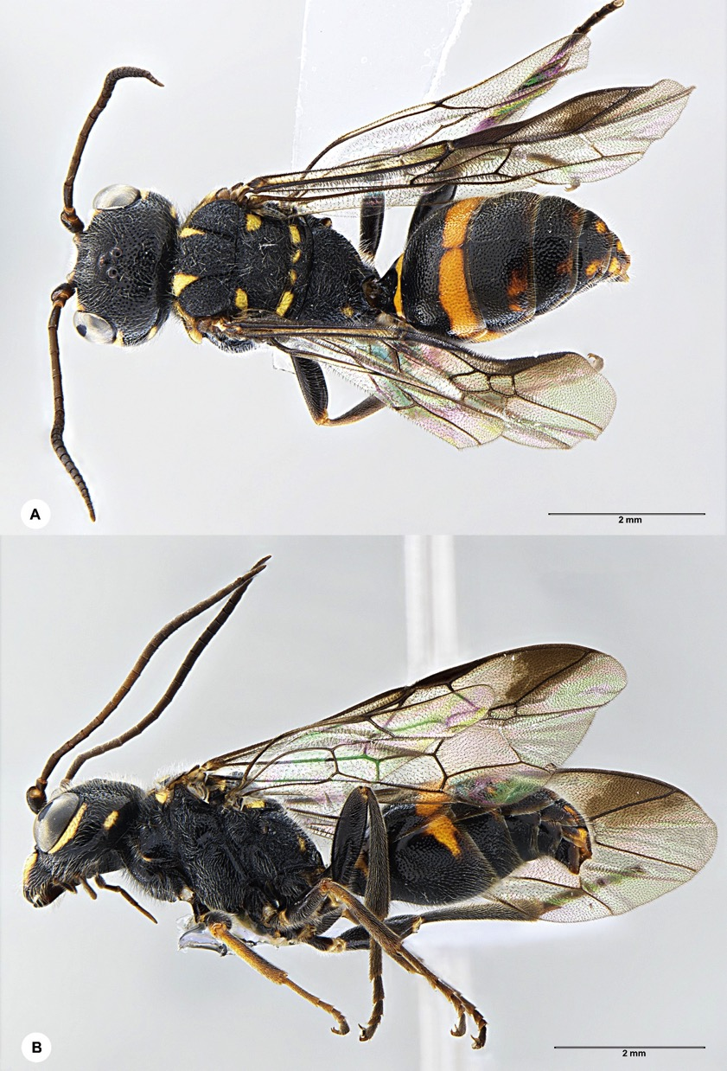
Figure S18. Taeniogonalos formosana, female (En-419962). A Habitus, dorsal aspect B habitus, lateral aspect.

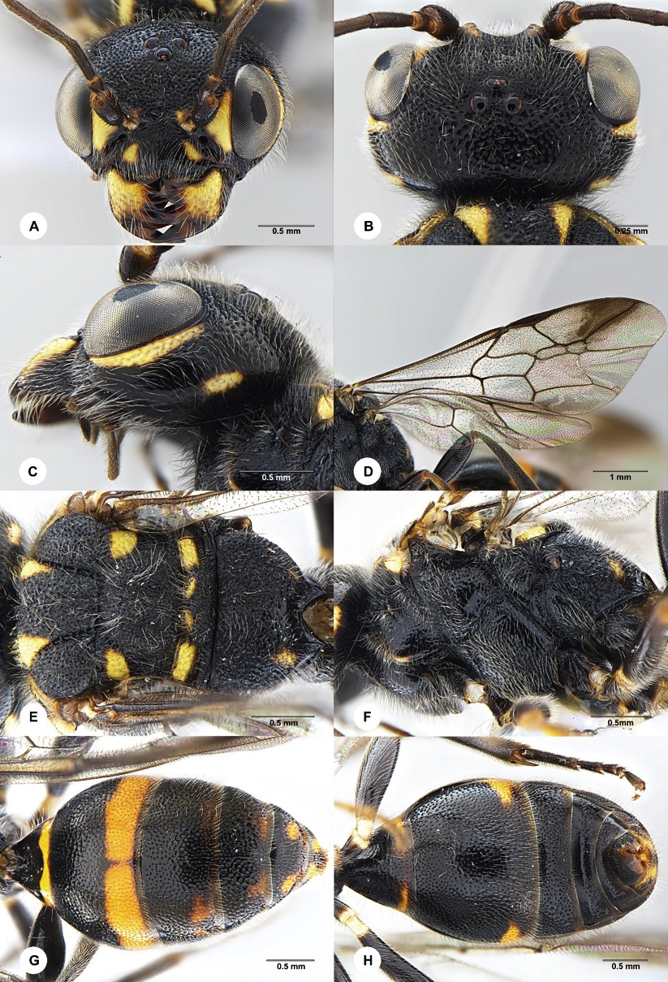
Figure S19. Taeniogonalos formosana, female (En-419962). A Head, anterior aspect B head, dorsal aspect C head, lateral aspect D wings E mesosoma, dorsal aspect F mesosoma, lateral aspect G metasoma, dorsal aspect H metasoma, ventral aspect.
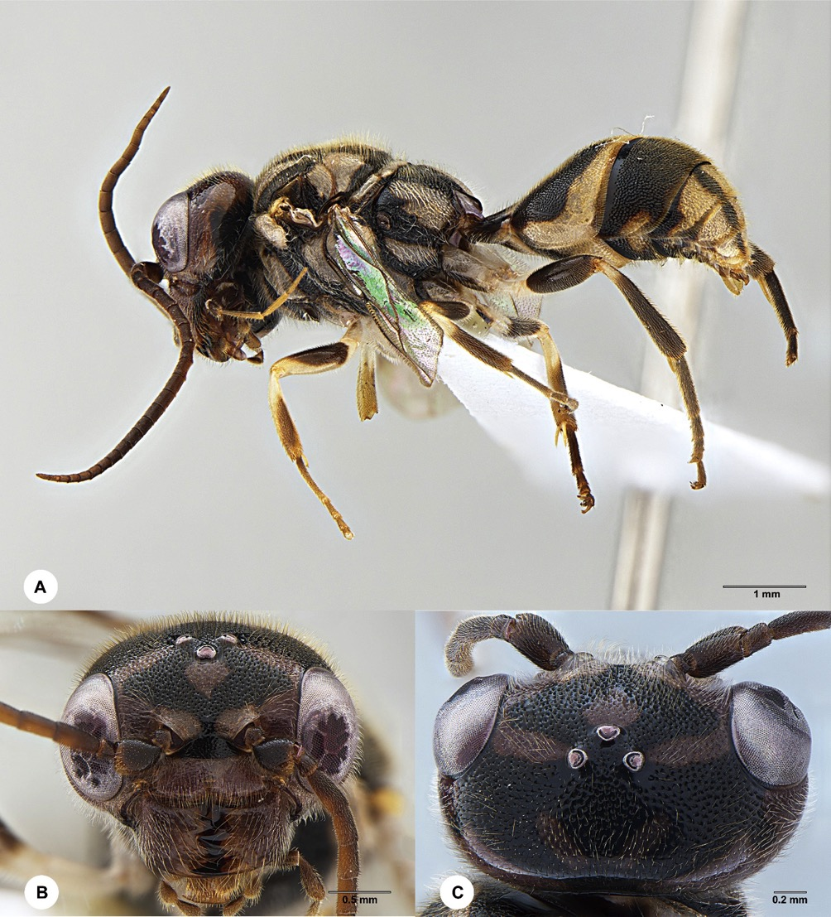
Figure S20. Taeniogonalos gestroi, male (En-419956). A Habitus, lateral aspect B head, anterior aspect C head, dorsal aspect.

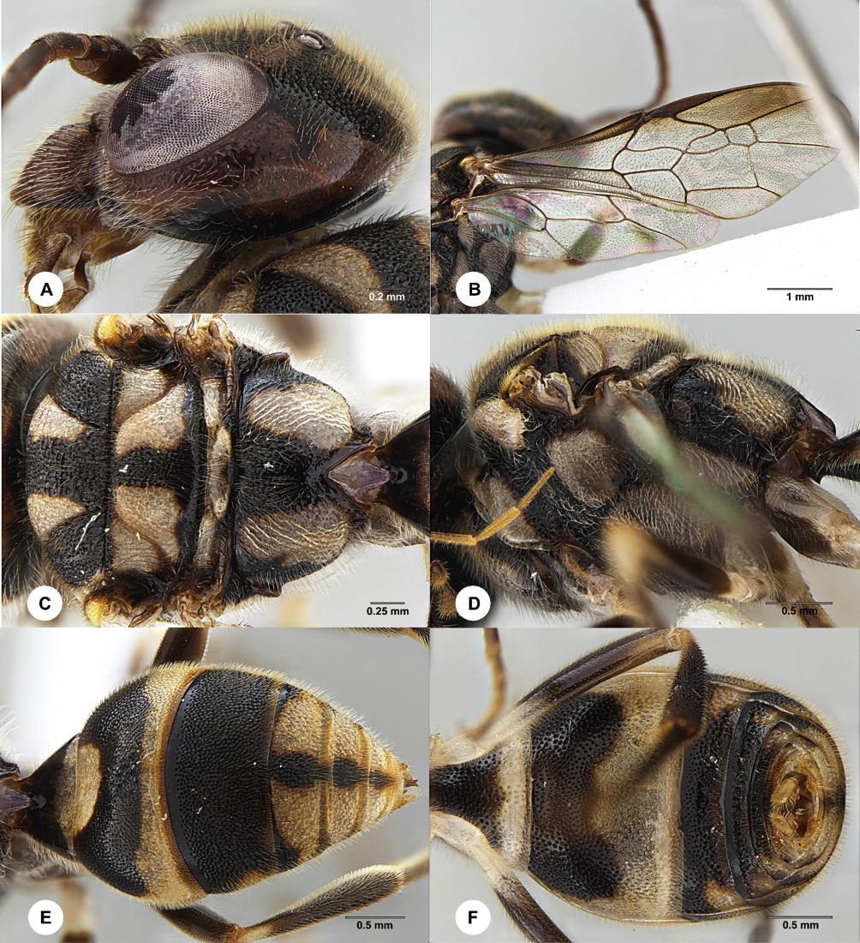
Figure S21. Taeniogonalos gestroi, male (En-419956). A Head, lateral aspect B wings C mesosoma, dorsal aspect D mesosoma, lateral aspect E metasoma, dorsal aspect F metasoma, ventral aspect.

