Appendix

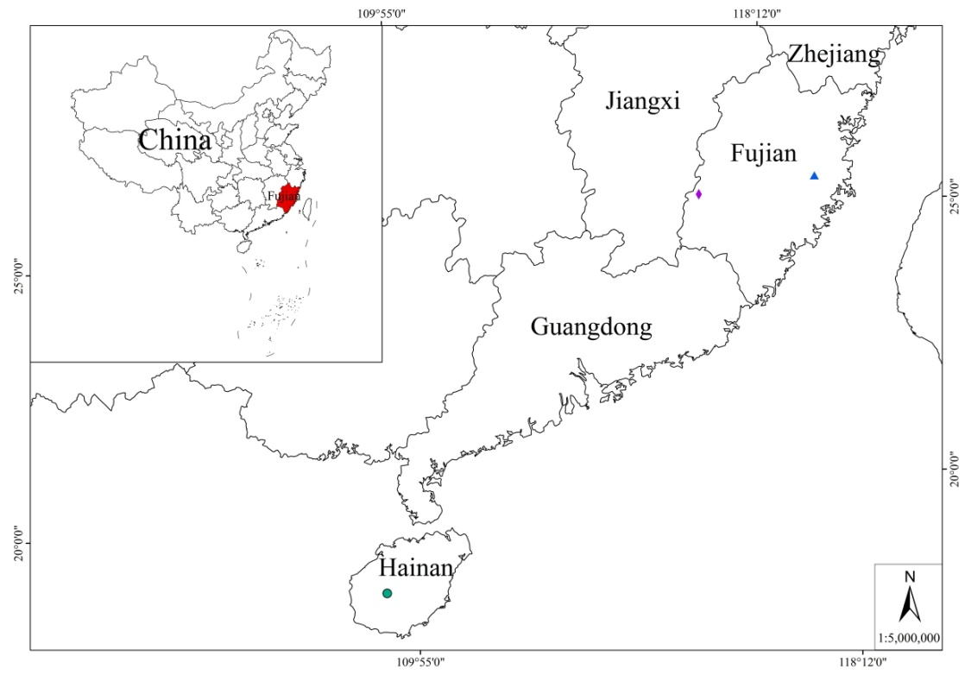
Figure S1 Distribution of Terniopsis yongtaiensis, T. sessilis and T. daoyinensis of genus Terniopsis from China. Legend ▲T. yongtaiensis, ◆T. sessilis, ●T. daoyinensis
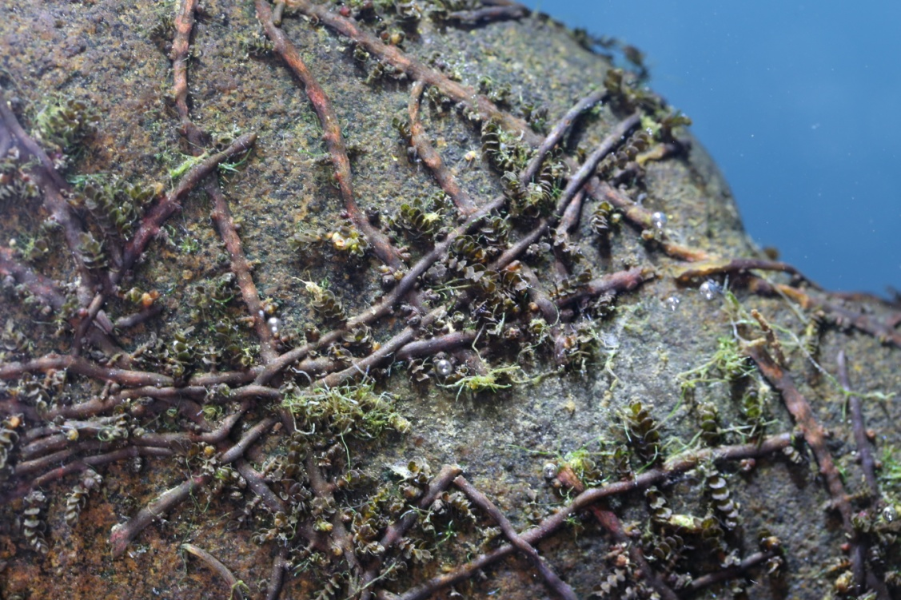
Figure S2 Habit and habitat of Terniopsis sessilis

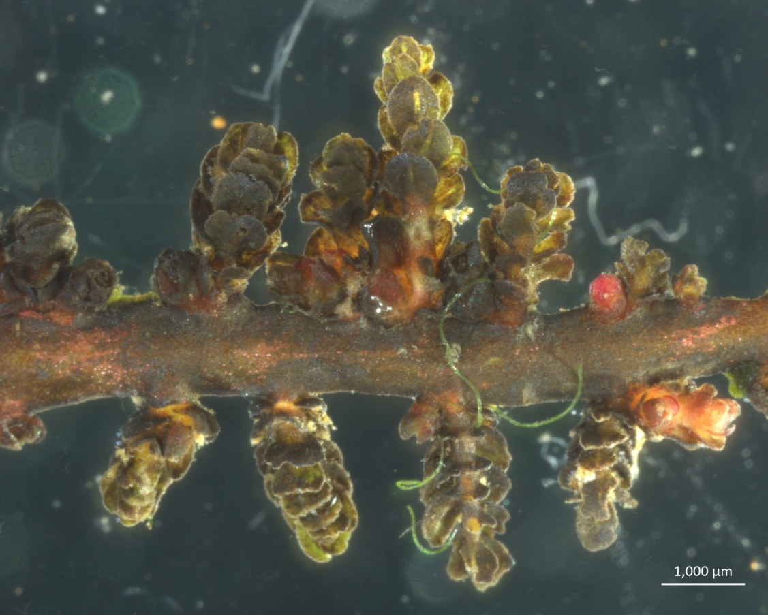
Figure S3 Terniopsis sessilis, showing stems (ramuli) arising laterally from root, distichous and leaves borne on ramuli in 3 ranks.
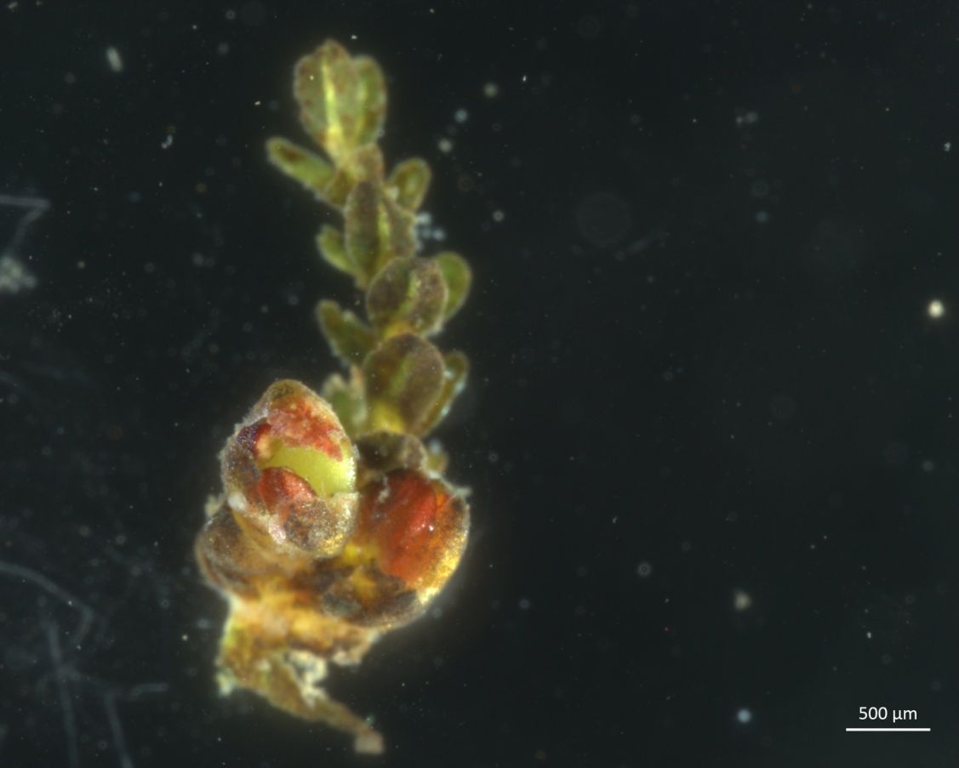
Figure S4 Terniopsis sessilis, showing two flower buds axillary to the basal leaf, sessile.

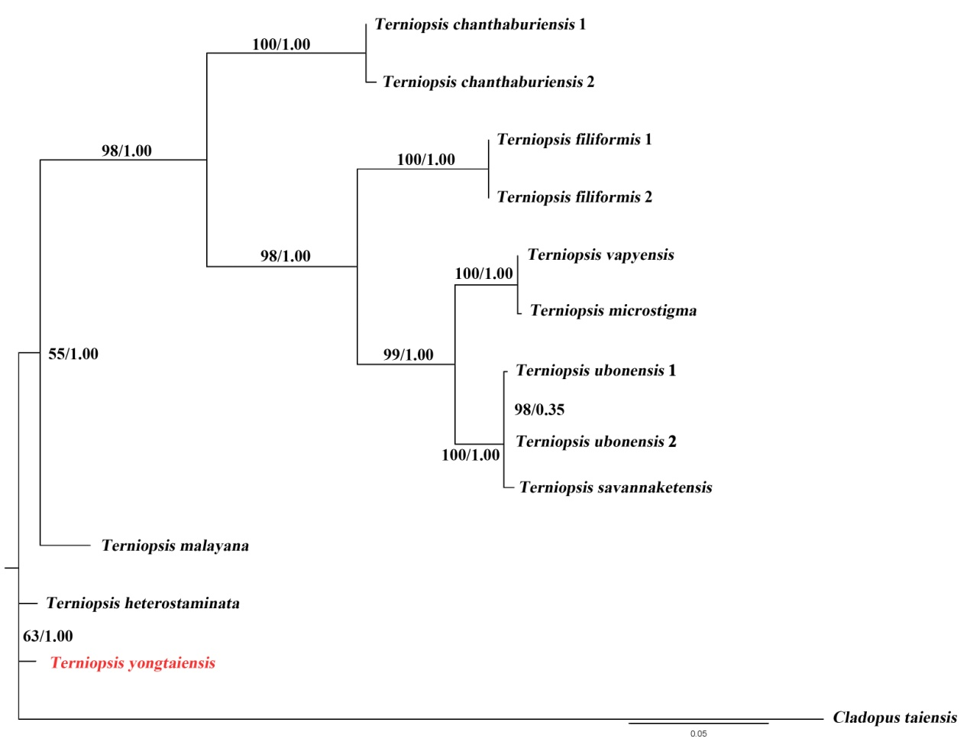
Figure A5 Phylogenetic tree of Asian Podostemaceae based on Bayesian Inference of nrITS sequences. Numbers above and below branches indicate RAxML (left) bootstrap probabilities (BP) and Bayesian (right) posterior probabilities (PP), respectively.

Table S1 List of taxa from Podostemaceae and NCBI accession numbers (matK)
- No. | Taxa | NCBI accession no.
1 | Terniopsis yongtaiensis | OM953517.1
2 | Terniopsis chanthaburiensis 1 | LC625800.1
3 | Terniopsis chanthaburiensis 2 | LC384161.1
4 | Terniopsis brevis 1 | LC342961.1
5 | Terniopsis brevis 2 | LC342884.1
6 | Terniopsis heterostaminata 1 | LC342918.1
7 | Terniopsis heterostaminata 2 | LC342903.1
8 | Terniopsis filiformis 1 | LC384159.1
9 | Terniopsis filiformis 2 | LC384156.1
10 | Terniopsis vapyensis | LC342923.1
11 | Terniopsis minor 1 | LC342893.1
12 | Terniopsis minor 2 | LC342891.1
13 | Terniopsis ubonensis 1 | AB450500.1
14 | Terniopsis ubonensis 2 | AB698146.1
15 | Terniopsis malayana 1 | AB450034.1
16 | Terniopsis malayana 2 | AB698132.1
17 | Terniopsis microstigma 1 | LC342922.1
18 | Terniopsis microstigma 2 | LC342919.1
19 | Terniopsi ssessilis | AB048377.1
20 | Tristicha trifaria | AB113745.1
21 | Dalzellia ubonensis | AB450027.1
22 | Dalzellia angustissima | AB450016.1
23 | Dalzellia kailarsenii | AB450017.1
24 | Weddellinas quamulosa | AB038206.1
25 | Polypleurum wallichii | LC380633.1
26 | Zeylanidiumlic henoides | AB048828.1
27 | Tristellateia madagascariensis | AF344584.1

Table S2 List of taxa from Podostemaceae and NCBI accession numbers (nrITS)
- No. | Taxa | NCBI accession no.
1 | Terniopsis yongtaiensis | OM949049.1
2 | Terniopsis chanthaburiensis 1 | LC625816.1
3 | Terniopsis chanthaburiensis 2 | LC625815.1
4 | Terniopsis heterostaminata | LC625821.1
5 | Terniopsis filiformis 1 | LC625817.1
6 | Terniopsis filiformis 2 | LC625820.1
7 | Terniopsis vapyensis | LC625826.1
8 | Terniopsis ubonensis 1 | LC625825.1
9 | Terniopsis ubonensis 2 | LC625824.1
10 | Terniopsis malayana | AB083103.1
11 | Terniopsis microstigma | LC625822.1
12 | Terniopsiss avannaketensis | LC625823.1
13 | Cladopus taiensis | LC380644.1

